**Research and Development of NodeJs and MongoDb**

**How to integrate NodeJs and MongoDB**

**Setup:**

We should use “mongodb” Node JS module to develop Node JS Applications using MongoDB NoSQL Data Store. As this module is not a Default Node JS Module, we need to install this package using NPM

To install “mondgodb” module:

npm install -g mongodb

Now Observe Node “mongodb” module in our local NPM Repository as shown below.

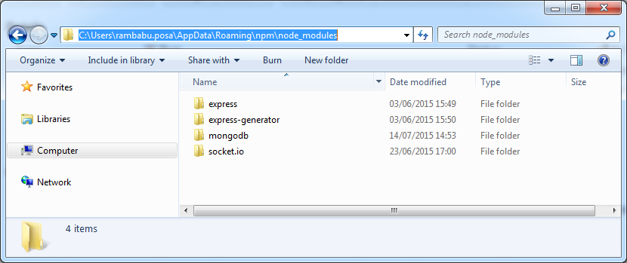

Here we can observe new “mongodb” folder is added at “/node_modules” that means our installation is done successfully.

**Node JS and MongoDB Example**

Node JS and MongoDB setup is done. Now it’s time to develop a simple application to store data in MongoDB Store using Node JS Scripts.

* Create a Node JS Project

Project Name : “node-mongodb”

* Add “mongodb” module library to our project.

Open command prompt

Install “npm install –save mongodb” command to

Here option “–save” means pickup “mongodb” module library from our local NPM modules and add that library to our project.

we can observe that “mongodb” library was added to the project build path as shown below:

[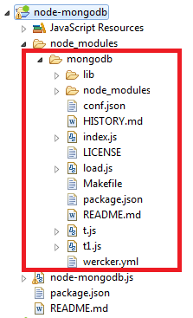](https://cdn.journaldev.com/wp-content/uploads/2015/07/node-mongodb-libs1.png)

**Building website with node.js**

* Node.js server with counter
* Adds express framework and HTML Pages
* Adds Database service.

**Existing framework which can help me with this project**

**React.js**

ReactJS is a Javascript library for creating user interfaces. It is the view layer in MVC (Model, View, Controller). ReactJS gives you a template language and some function hooks to output HTML.

**Express.js**  
A perfect framework for those who think less is more! Yes, if you are looking for a flexible and minimalistic open-source framework, Express.js is what you should go for. Developers love to use it as it is very easy to develop and flexible. With the help of NPM modules, they enhance the functionality of your website framework.

**Laravel**

It is used PHP development framework. It is quite versatile and developers can use it for creating web and mobile frameworks for an array of businesses. It offers several advantages not just to the app owners but also to developers.

**Django** – Python

**Existing web applications that do the same thing which we are doing**

* canvas
* ERP
* Edmodo
* Skyward