**Sql query report on crime data analysis**

1. . What is the major reason people being kidnapped in each and every state?

SELECT * from(select Area_Name,Group_Name,sum(Cases_Reported) as total_case from Specific_purpose_of_kidnapping_and_abduction GROUP by Area_Name,

Group_Name order by sum(Cases_Reported) DESC) group by Area_Name order by total_case desc;

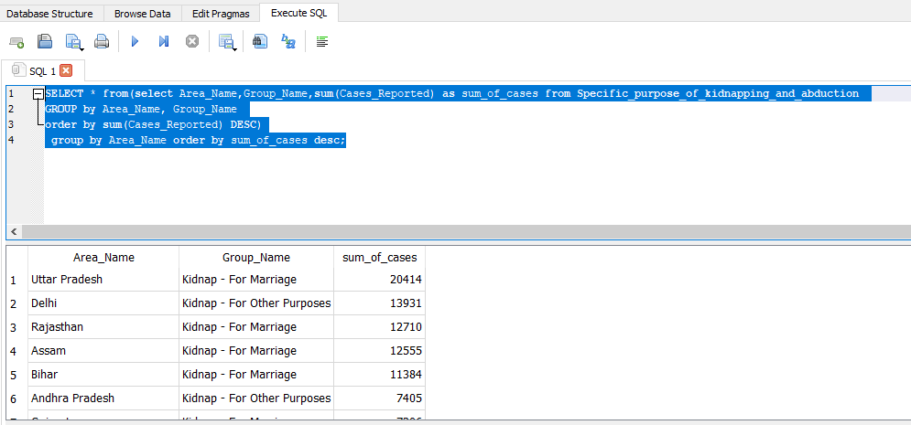

1. Offenders relation to the rape victim

SELECT sum(No_of_Cases_in_which_offenders_were_Neighbours) as Neighbour,sum(No_of_Cases_in_which_offenders_were_Other_Known_persons) as known,\

sum(No_of_Cases_in_which_offenders_were_Parentsclose_family_members) as Parentsclose_family_members ,sum(No_of_Cases_in_which_offenders_were_Relatives) as offenders_were_Relatives,\

sum(No_of_Cases_in_which_offenders_were_known_to_the_Victims) as known_to_the_Victims from Offenders_known_to_the_victim;

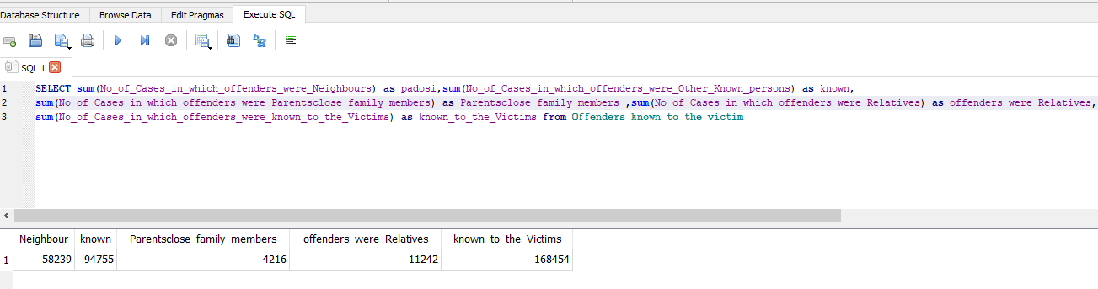

1. Juveniles family background, education and economic setup.

SELECT  d.Area_Name , e.income_upto_25k , e.income_25k_50k , e.income_50k_1L ,e.income_1L_2L , e.income_2L_3l , e.income_above_3L , f.homless , f.living_wd_guardians , f.living_wd_parents , d.illetrate , d.upto_Primary , d.below_higerSecondary , d.higher_secondary_above FROM   (SELECT sum(Family_back_ground_Homeless) as homless,      \

  sum(Family_back_ground_Living_with_guardian) as living_wd_guardians,      \

  sum(Family_back_ground_Living_with_parents) as living_wd_parents ,      \

  Area_Name\

  FROM EBJuveniles_arrested_Family_background       \

  GROUP BY Area_Name ) as f   \

  join \

  (SELECT    \

  sum(Economic_Set_up_Annual_Income_250001_to_50000) as income_25k_50k,      \

  sum(Economic_Set_up_Annual_Income_upto_Rs_25000) as income_upto_25k,      \

  sum(Economic_Set_up_Middle_income_from_100001_to_200000) as income_1L_2L,      \

  sum(Economic_Set_up_Middle_income_from_50001_to_100000) as income_50k_1L ,      \

  sum(Economic_Set_up_Upper_income_above_Rs_300000)as income_above_3L,      \

  sum(Economic_Set_up_Upper_middle_income_from_200001_to_300000)as income_2L_3l,      \

  Area_Name       \

  FROM ESJuveniles_arrested_Economic_setup       \

  GROUP BY Area_Name      \

  ) as e      \

  ON      \

  f.Area_Name = e.Area_Name       \

  JOIN      \

  (SELECT sum(Education_Illiterate) as illetrate ,      \

  sum(Education_Upto_primary) as upto_Primary,      \

  sum(Education_Above_Primary_but_below_Matric_or_Higher_Secondary) as below_higerSecondary,      \

  sum('Education_Matric_or_Higher_Secondary_&_above') as higher_secondary_above,      \

  Area_Name      \

  FROM EJuveniles_arrested_Education      \

  GROUP BY Area_Name      \

  ) as d      \

  ON      \

  e.Area_Name = d.Area_Name

1. Which state has more crime against children and women?

SELECT c.STATE_UT,(w.total_crime_on_women+c.total_crime_on_children) as Total_Crime from(SELECT STATE_UT,(sum(rape)+sum(KidnappingandAbduction)+sum(DowryDeaths)+sum(Assaultonwomenwithintenttooutragehermodesty)+sum(InsulttomodestyofWomen)+sum(CrueltybyHusbandorhisRelatives)+sum(ImportationofGirls)) as total_crime_on_women from District_wise_crimes_committed_against_women_2001_2012 GROUP by STATE_UT order by total_crime_on_women DESC) as W join (SELECT STATE_UT,sum(total) as total_crime_on_children from District_wise_crimes_committed_against_children_2001_2012 GROUP by STATE_UT order by sum(total) desc)as C on c.STATE_UT=W.STATE_UT ORDER by (w.total_crime_on_women+c.total_crime_on_children) DESC limit 5;

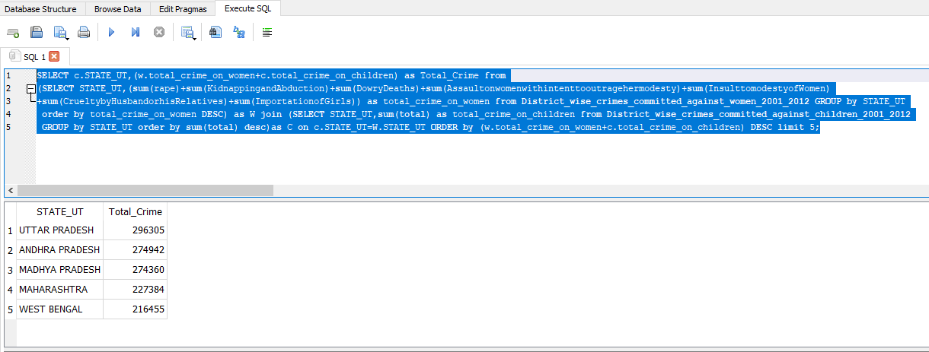

1. Age group wise murder victim

select sum(Victims_Above_50_Yrs)as total_Above_50Yrs,sum(Victims_Upto_10_15_Yrs) as total_Victims_between_10to15Yrs,sum(Victims_Upto_10_Yrs) as total_Victims_Upto_10_Yrs,sum(Victims_Upto_15_18_Yrs) as total_Victims_Upto_15_18_Yrs,sum(Victims_Upto_18_30_Yrs) as total_Victims_Upto_18_30_Yrs,sum(Victims_Upto_30_50_Yrs) as total_Victims_Upto_30_50_Yrs from Murder_victim_age_sex ;

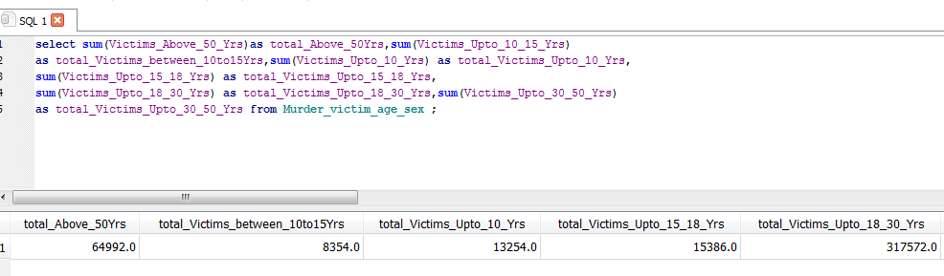

6.Crime by place of occurrence.

SELECT sum(RESIDENTIALPREMISES_Dacoity) as Total_RESIDENTIALPREMISES_Dacoity,sum(RESIDENTIALPREMISES_Robbery) as Total_RESIDENTIALPREMISES_Robbery,sum(RESIDENTIALPREMISES_Theft)as Total_RESIDENTIALPREMISES_Theft,sum(RESIDENTIALPREMISES_Burglary) as Total_RESIDENTIALPREMISES_Burglary,sum(HIGHWAYS_Burglary) as Total_HIGHWAYS_Burglary,sum(HIGHWAYS_Dacoity)as Total_HIGHWAYS_Dacoity,sum(HIGHWAYS_Robbery) as Total_HIGHWAYS_Robbery,sum(HIGHWAYS_Theft)as Total_HIGHWAYS_Theft,sum(RIVERandSEA_Theft) as Total_RIVERandSEA_Theft,sum(RIVERandSEA_Burglary) as Total_RIVERandSEA_Burglary,sum(RIVERandSEA_Dacoity) as Total_RIVERandSEA_Dacoity,sum(RIVERandSEA_Robbery) as Total_RIVERandSEA_Robbery,sum(RAILWAYS_Burglary) as Total_RAILWAYS_Burglary,sum(RAILWAYS_Dacoity) as Total_RAILWAYS_Dacoity,sum(RAILWAYS_Robbery) as Total_RAILWAYS_Robbery,sum(RAILWAYS_Theft) as Total_RAILWAYS_Theft,sum(BANKS_Burglary)as Total_BANKS_Burglary ,sum(BANKS_Dacoity) as Total_BANKS_Dacoity,sum(BANKS_Robbery) as Total_BANKS_Robbery,sum(BANKS_Theft) as Total_BANKS_Theft,sum(COMMERCIALESTABLISHMENTS_Burglary) as Total_COMMERCIALESTABLISHMENTS_Burglary,sum(COMMERCIALESTABLISHMENTS_Dacoity) as Total_COMMERCIALESTABLISHMENTS_Dacoity,sum(COMMERCIALESTABLISHMENTS_Robbery) as Total_COMMERCIALESTABLISHMENTS_Robbery,sum(COMMERCIALESTABLISHMENTS_Theft)as Total_COMMERCIALESTABLISHMENTS_Theft,sum(OTHERPLACES_Burglary)as Total_OTHERPLACES_Burglary,sum(OTHERPLACES_Dacoity) as Total_OTHERPLACES_Dacoity,sum(OTHERPLACES_Robbery) as Total_OTHERPLACES_Robbery,sum(OTHERPLACES_Theft) as Total_OTHERPLACES_Theft from Crime_by_place_of_occurrence_2001_2012 ;

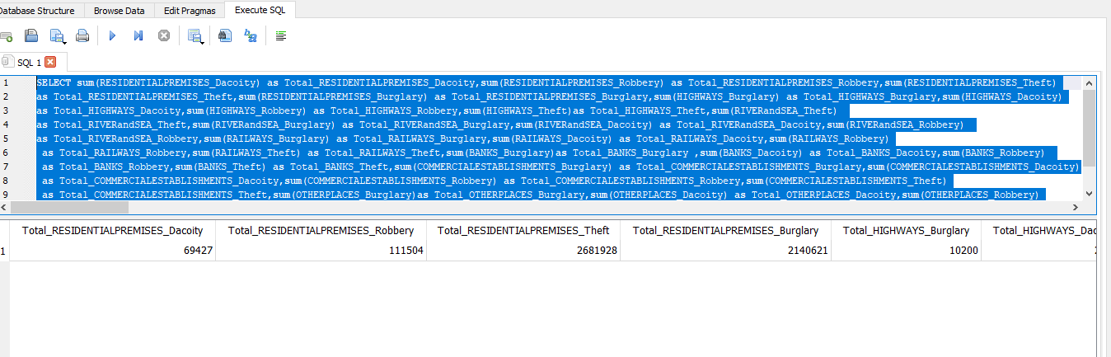7. Anti corruption cases vs arrests.

SELECT a.Area_Name, a.Year, a.ACA01_No_of_persons_in_custody_or_on_bail_during_the_stage_of_investigation_at_the_beginning_of_the_year as Toatl_Jail, c.AC02_No_of_cases_registered_during_the_year as Total_Case FROM Anti_corruption_arrests a join Anti_corruprion_cases c USING(Area_Name) group by a.Area_Name;

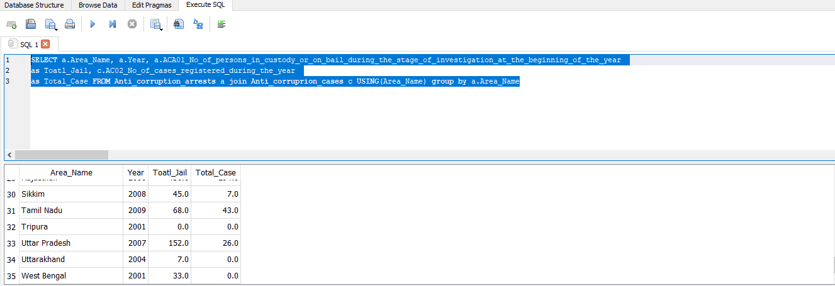

1. Which state has more number of complaints against police?

select Area_Name,Year,Cases_Registered from Complaints_against_police GROUP by Area_Name order by Cases_Registered DESC LIMIT 5;

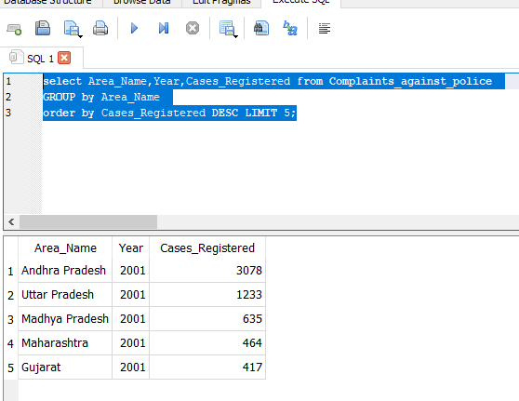

1. Which state is the safest for foreigners?

SELECT STATE_UT,TOTALIPCCRIMES FROM District_wise_crimes_committed_IPC_2001_2012 GROUP by STATE_UT order by TOTALIPCCRIMES  ;

