Eon Consulting

Tobie Nortje

IPython had become a popular choice for doing interactive scientific work. It extends the standard Python interpreter and adds many useful new futures. There is really no need to use the standard Python interpreter anymore. In addition to this IPython offers a web based Notebook that makes interactive work much easier, and have been used to write repeatable scientific papers and more recently a book has been written using this platform, the online Notebook Viewer and GitHub.

IPython Notebooks

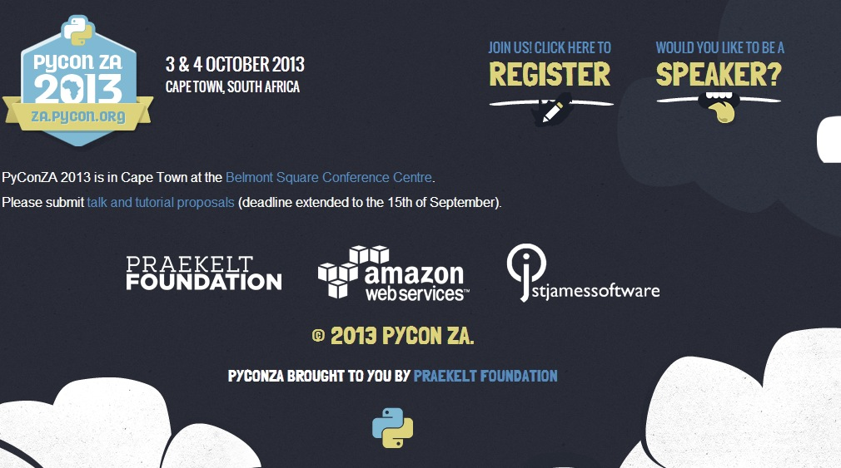

Beautiful is better than ugly. Explicit is better than implicit. Simple is better than complex. Complex is better than complicated. Flat is better than nested. Sparse is better than dense. Readability counts. Special cases aren't special enough to break the rules. Although practicality beats purity. Errors should never pass silently. Unless explicitly silenced. In the face of ambiguity, refuse the temptation to guess. There should be one-- and preferably only one --obvious way to do it. Although that way may not be obvious at first unless you're Dutch. Now is better than never. Although never is often better than \*right\* now. If the implementation is hard to explain, it's a bad idea. If the implementation is easy to explain, it may be a good idea. Namespaces are one honking great idea -- let's do more of those!