Catalytic discrimination enables highly specific detection of nucleic acid mutations over wide concentration ranges
Dan Huang,^{1,2,#} Guan Alex Wang,^{2,#} Ruicen Li,^{3,#} Jing Yang,^{4,5,#} Yun Tan,² Gongshuang Zhang,⁵ Yao Liu,² Binwu Ying^{1,6}, Yanping Gong,^{4,5,}* Han Luo,^{4,5,}* and Feng Li^{2,6,}*

¹Department of Laboratory Medicine, West China Hospital, Sichuan University, Chengdu, Sichuan, P. R. China, 610041
²Key Laboratory of Green Chemistry and Technology of Ministry of Education, College of Chemistry, Sichuan University, Chengdu, Sichuan, P. R. China, 610064
³Health Management Center, General Practice Medical Center, West China Hospital, Sichuan University, Chengdu, Sichuan, P. R. China, 610041
⁴Department of General Surgery, West China Hospital, Sichuan University, Chengdu, Sichuan, P. R. China, 610041
⁵Division of Thyroid and Parathyroid Surgery, Laboratory of Thyroid and Parathyroid Disease, Frontiers Science Center for Disease-related Molecular Network, West China Hospital, Sichuan University, Chengdu, Sichuan, P. R. China, 610041
⁶Med+X Center for Manufacturing, West China Hospital, Sichuan University, Chengdu, Sichuan, P. R. China, 610041
# These authors contributed equally
*Corresponding authors: gongyanping@wchscu.cn; luohan-hx@scu.edu.cn; windtalker_1205@scu.edu.cn

Abstract
Detection of genetic mutations, such as single-nucleotide variants (SNVs), plays an essential role in molecular diagnosis and precision medicine. Conventionally, SNV detection uses nucleic acid hybridization probes or primers that bind differentially to SNVs and their wild-type (WT) counterparts. However, because of the inherent trade-off between binding affinity and sequence selectivity, optimal assay specificity can often be achieved only at a narrow concentration range, limiting their applications to clinical scenarios involving little sample input and low SNV abundance. Herein, we introduce catalytic discrimination, a kinetics-based design principle that overcomes the thermodynamic limit of conventional binding-based SNV detection approaches. It possesses two orthogonal discrimination mechanisms, including 1) kinetic discrimination that selectively amplifies the detection signals of minute SNVs through noncovalent DNA catalysis, and 2) stochiometric tuning that drastically suppresses interfering signals of high concentrations of WTs. By simultaneously monitoring the two mechanisms followed by signal integration through a mathematical algorithm, we demonstrate the highly sensitive and specific detection of SNVs across wide concentration ranges. Leveraging catalytic discrimination, we achieved the detection of malignancy-related SNVs in thyroid fine-needle aspiration specimens, with required sample input reduced by 25 times over existing clinical tests, improving the test confirmatory rate from 46.1% to 90.3% in a cohort of 52 indeterminate cases defined by thyroid cytopathology.

Introduction
Single-nucleotide variants (SNVs) comprise more than 50% of genetic alterations, many of which are essential biomarkers for molecular diagnosis, precision medicine, and drug resistance screening.¹⁻⁴ Discrimination of a given SNV from its wild-type (WT) counterpart relies primarily on their differences in standard Gibbs free energies (∆∆G°), with typical values ranging from 1.5 kcal/mol to 7.0 kcal/mol.^{4,5} A general design principle is to reduce the complementarity of nucleic acid hybridization probes or primers to enlarge the impact of ∆∆G° during the processes of sequence recognition.⁴⁻¹⁵ This can be achieved either by tuning the environmental factors, such as the elevation of the reaction temperatures and the addition of denaturing chemicals,⁶ or by engineering structured hybridization probes via the incorporation of auxiliary complementary domains, such as the stem domains of molecular beacons and the reverse toehold domains of toehold-exchange probes.^{5, 7-13} Because the reduction of sequence complementarity weakens the bindings between hybridization probes and their target sequences, current approaches achieve improved assay specificity at the cost of reduced detection sensitivity and thus disfavor the detection of SNVs with concentrations approaching the limit of detection (LOD) of the chosen method.⁵ On the other hand, poor discrimination is often inevitable at high concentration ranges, as WT with concentrations approaching or above the upper limit of the detection method can eventually override the small ∆∆G° and lead to the massive production of spurious hybridization products.^{14, 15} This is also the reason why many signal amplification strategies are not applicable for discriminating SNVs, that is, signal amplification may further worsens the assay specificity in the presence of high concentrations of WT.^{16, 17} Collectively, for a given hybridization probe, maximal discrimination can only be achieved at an optimal target concentration, which decays sharply when target concentrations deviate from the optimal value (Fig. 1a, Supplementary Fig. 1, and simulation results in Supplementary Materials Section S1).
The concentration-dependency of the assay specificity is an underlying mechanism attributing to the poor performance of many clinical SNV tests. For example, the discrimination of B-Raf Proto-Oncogene, Serine/Threonine kinase (BRAF) V600E mutation in thyroid fine-needle aspiration (FNA) specimen can effectively improve the diagnostic accuracy of thyroid cancer but often fails for samples with little DNA input (e.g. < 50 ng for Sanger Sequencing and < 10 ng for qPCR).^{18, 19} Similar issues span to clinical scenarios where abundances of SNVs are below 1% and/or amounts of sample inputs are limited.²⁰⁻²³ So far, strategies allowing optimal discrimination of SNVs across wide concentration ranges are highly desired but remain difficult to achieve.
Here, we introduce catalytic discrimination as a kinetics-based design principle that overcomes the thermodynamic limit of conventional binding-based nucleic acid recognition techniques and thus effectively expands the optimal concentration ranges for discriminating SNVs (Fig. 1b). In catalytic discrimination, the hybridization probe, termed as CD-probe (CP), is facilitated using a fuel strand (F) based on the principle of non-covalent DNA catalysis²⁴. Each cycle of SNV recognition reaction generates a thermodynamic intermediate (CT) that rapidly reaches equilibrium and a catalytic product (CF) that can be accumulated for signal amplification (Fig. 1c and 1d). By differentially labeling and monitoring the intermediate and final product, a single CD-probe simultaneously offers two orthogonal discrimination mechanisms, including 1) stochiometric tuning that drastically suppresses interfering signals of WTs at submicromolar concentrations, and 2) kinetic discrimination that selectively amplifies the detection signals of minute SNVs through noncovalent DNA catalysis. A further integration of the two fluorescence channels via a mathematical algorithm enables 10-time enhancement in assay sensitivity and robust SNV discrimination over the entire concentration ranges without significant decay in sequence selectivity. More excitingly, our catalytic discrimination strategy significantly improves the clinical outcome of SNV test in thyroid FNA biopsy by reducing the required sample input by over 25 times. As a result, we have clinically confirmed 47 cases of papillary thyroid cancer out of 52 suspected cases classified between grade III to grade V in the Bethesda System for Reporting Thyroid Cytology (TBSRTC), corresponding to a 2-time improvement in confirmatory rate over existing clinical tests.

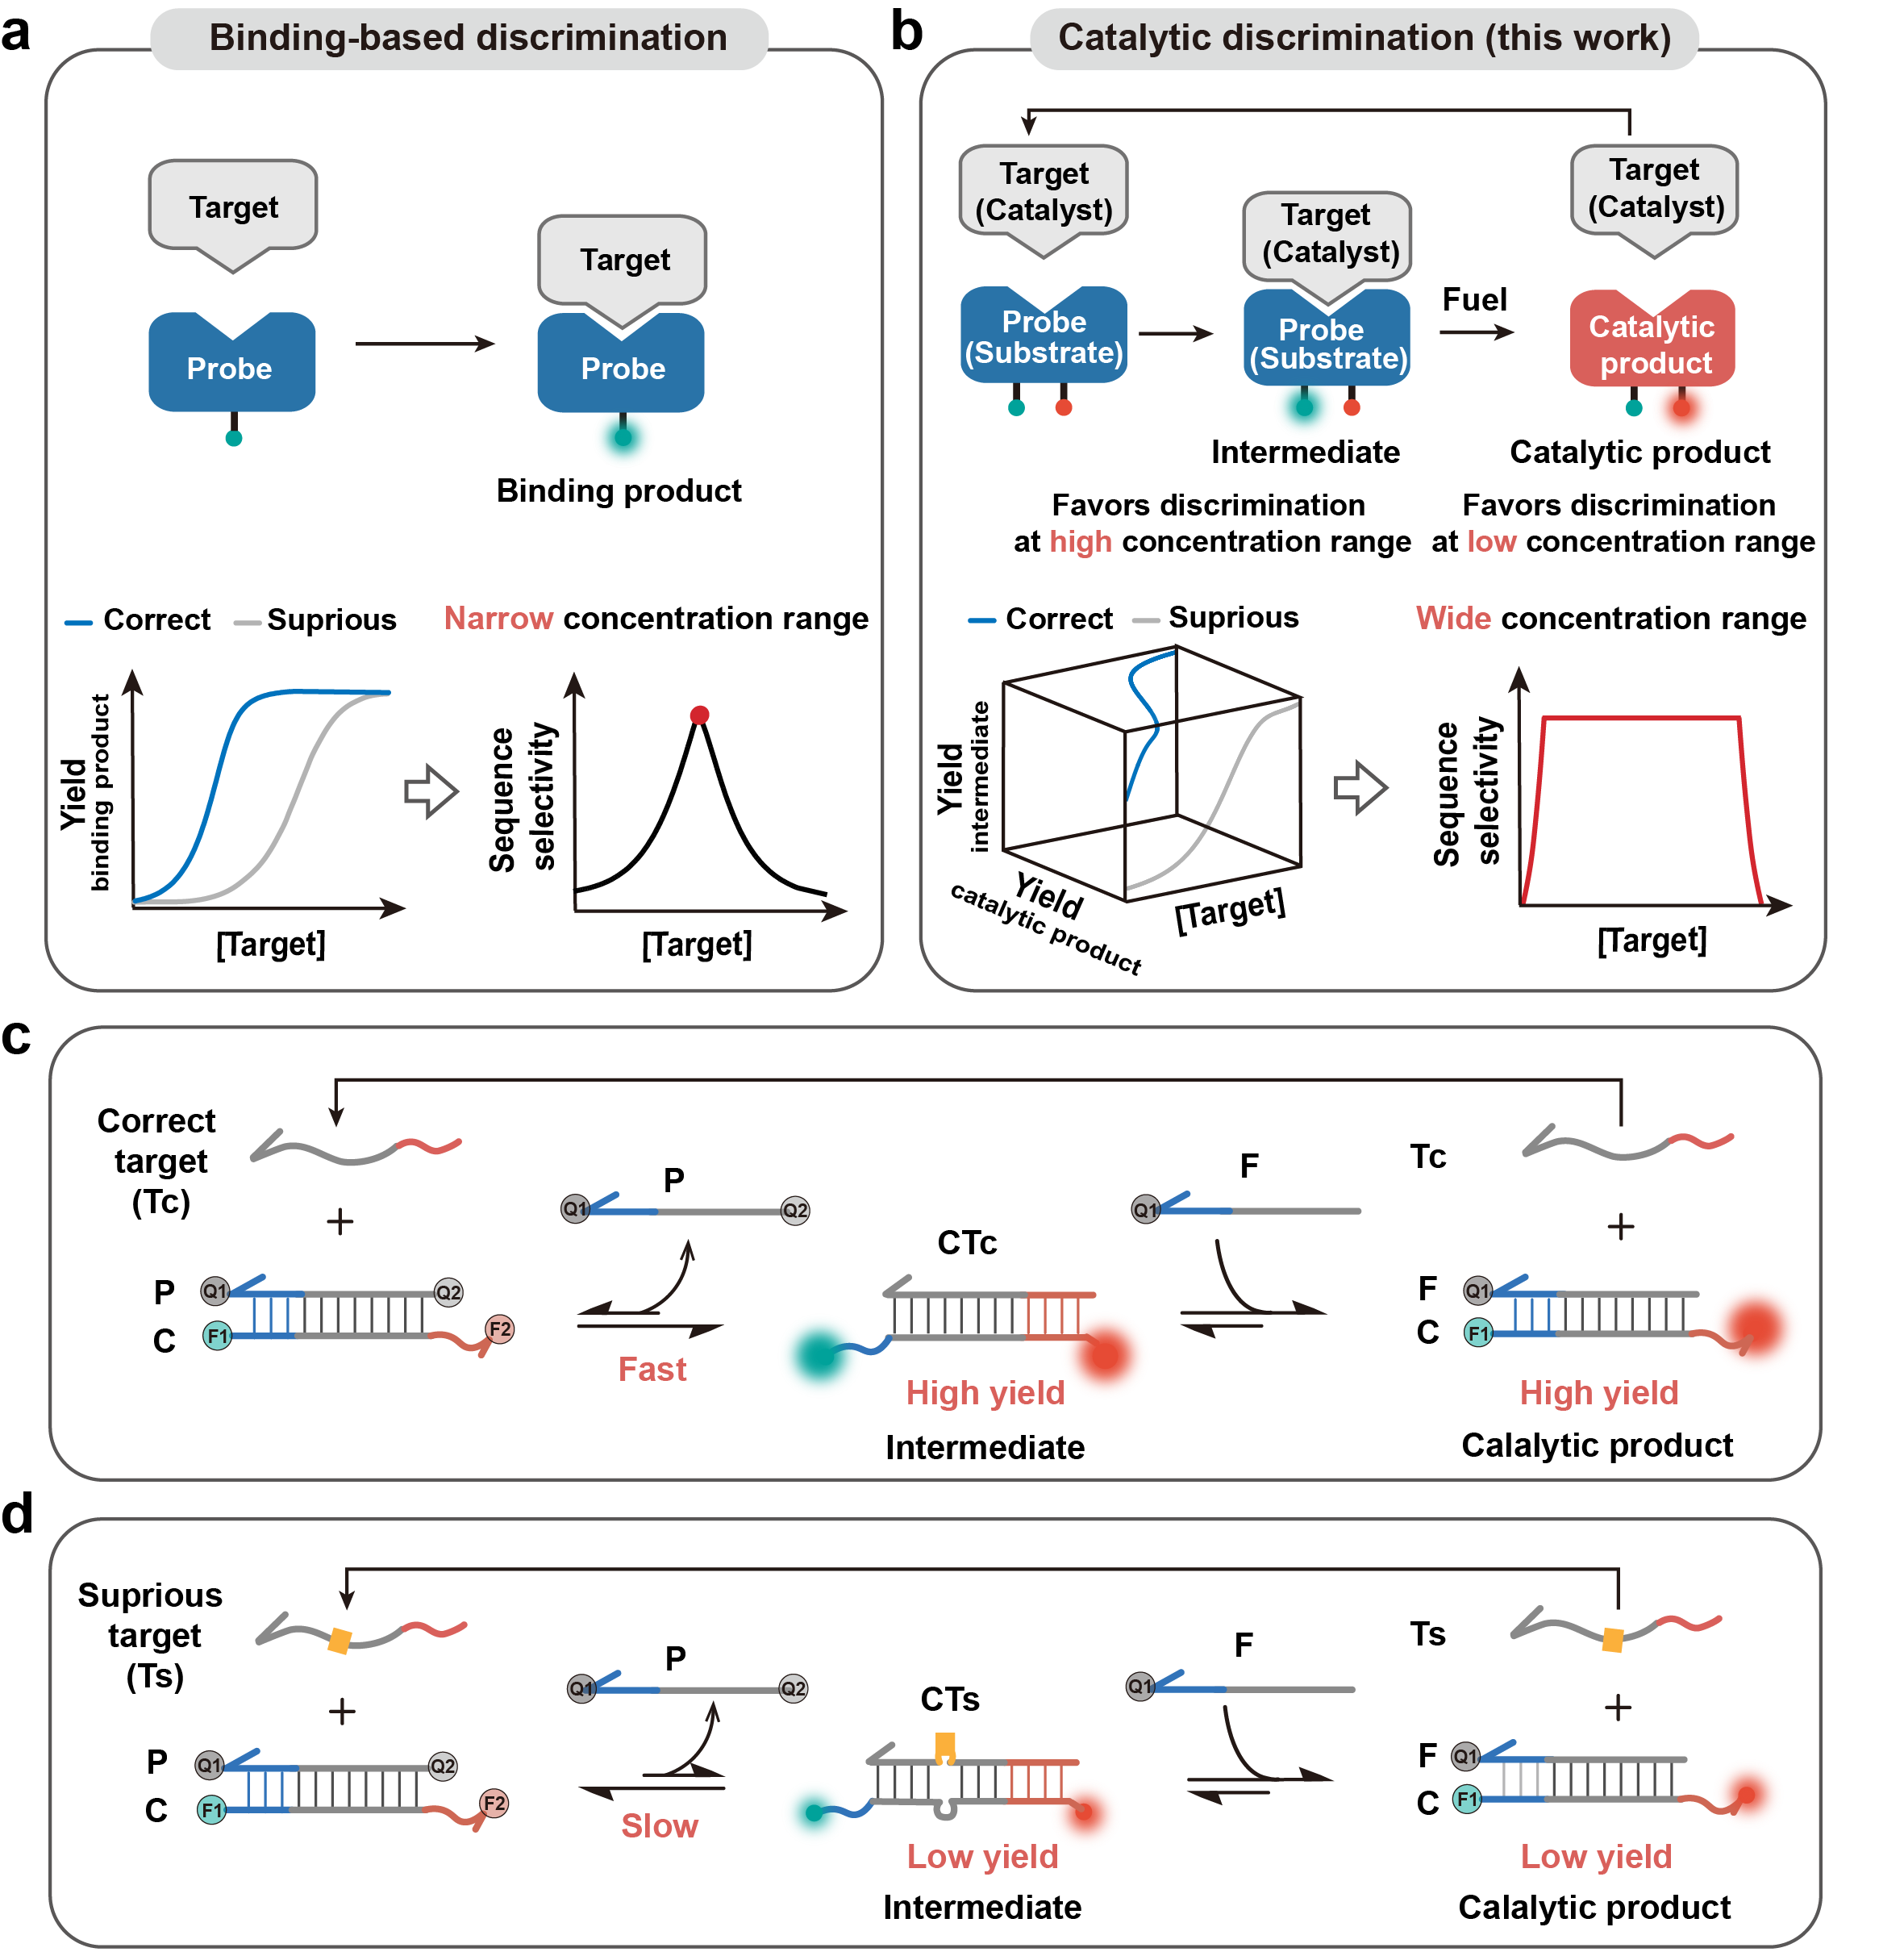
Fig. 1 | Schematic illustration of catalytic discrimination that significantly expands concentration ranges for discriminating single nucleotide variants. a. Conventional binding-based SNV discrimination strategies are of narrow effective concentrations due to their intrinsic thermodynamic limit. b. Catalytic discrimination expands the concentration range with optimal sequence selectivity by simultaneously monitoring the production of an intermediate that rapidly reaches equilibrium and a catalytic product that amplifies the detection signal. c. d. Realization of catalytic discrimination using a noncovalent DNA catalysis design, where a correct target serves a good catalyst (c) and a spurious target carrying a single nucleotide mismatch is a poor catalyst (d).

Results
Design Principle
CD-probe is operated using the principle of non-covalent DNA catalysis, where a target (T) and a probe (CP) form an intermediate CT through toehold-exchange and a catalytic product CF upon the subsequent reaction between CT and F. The correct target (Tc) with full sequence complementarity to the CD-probe serves as a good catalyst that accelerates the generation of multiple catalytic products (Fig. 1c). By contrast, the spurious target (Ts) with a single nucleotide mismatch is a poor catalyst and thus results in slow kinetics (Fig. 1d). Because of the signal amplification capacity, CD-probe offers both high sensitivity and high specificity for low concentrations of SNVs upon real-timely monitoring the catalytic product CF as a signal output. To address the issue of the interfering signal caused by high concentrations of WT, we also independently labeled and monitored the production of the intermediate CT. When monitoring CT as a signal output, F serves as a molecular competitor that competes with the target for binding to the CD-probe. Such a stoichiometric tuning mechanism significantly suppressed interfering signals generated by WT and thus ensures the accurate discrimination of SNVs in the presence of high concentrations of WT. By simultaneously monitoring the production of both CT and CF, and then integrating signals of the two fluorescence channels, highly sensitive and specific detection of SNVs across wide concentration ranges can be achieved.
To be sensitive to single nucleotide mismatches, both forward and reverse toeholds of the toehold exchange element (Reaction 1) are designed to be of similar binding strength, and the overall reaction free energy (∆G°_{rxn}) is slightly lower than zero for the correct target, and that for the spurious target containing a single nucleotide mismatch is higher than zero. CT further reacts with F via a newly exposed toehold domain to form the final product CF (Reaction 2), the process of which also regenerates T. As such, T serves as a catalyst for accelerating the reaction between CP and F (Reaction 3). Because each T leads to the generation of multiple CF, signal amplification can be achieved by monitoring the production of CF.
$$\begin{aligned}T+CP↔CT+P\#\left(1\right)\end{aligned}$$
$$\begin{aligned}F+CT↔CF+T\#\left(2\right)\end{aligned}$$
$$\begin{aligned}F+CP↔CF+P\#\left(3\right)\end{aligned}$$
Here, we propose that it is possible to expand the concentration range with optimal sequence specificity for discriminating SNVs by monitoring the production of both CT and CF. To do so, we labeled C with two fluorophores, where a ROX dye was labeled at 3` end and a FAM dye was labeled at 5` end, respectively. Both 3` and 5` ends of P were labeled with molecular quenchers (BHQ1 at 3` end and BHQ2 at 5` end, respectively), so that both fluorophores were quenched when forming the CP duplex (Fig. 1c). Upon forming CT, both fluorophores were turned on, as both quenchers were removed through strand displacement. On the other hand, the formation of CF duplex could be monitored when only fluorescence at the ROX channel was turned on, which was achieved by labeling F with a BHQ1 at the 3` end to quench the FAM dye on C. By differentially labeling CT and CF and monitoring the two fluorescence channels in real time, we were able to obtain the kinetic profiles of both intermediate and catalytic product in a single reaction.

In silico and experimental validation of CD-probe
To test the ability of CD-probe for discriminating SNVs, we designed a CD-probe for a 20-nt model target (Tc) (Supplementary Table 1). The forward and reverse toeholds of the CD-probe were designed to be 7 nt and 5 nt, respectively, and ∆G°_{rxn} for forming CT duplex was predicted to be -3.46 kcal/mol by NUPACK software. A spurious target (Ts) containing a single C to A mismatch was also designed, and a free energy difference (∆∆G° = 4.35 kcal/mol) exists between Tc and Ts, which forms the thermodynamic basis for discriminating Tc from Ts using toehold exchange. F was designed to be of the same sequence with P, except that the 5` end of F was unlabeled. As such, the driving force of the overall catalytic reaction (reaction-3) is the concentration difference between F and P, and the concentration of F is thus a key parameter to determine the amplification efficiency of the CD-probe.
We first simulated the production of both CT and CF in the presence of Tc or Ts as a function of time (Fig. 2a and 2b). The simulated kinetic profiles in Fig. 2a, Supplementary Fig. 2, and Supplementary Fig. 3 revealed that both CTc and CTs reached equilibrium rapidly throughout a concentration range from 0 nM to 500 nM. Significant differences in the equilibrium concentrations were observed for CTc and CTs when the target concentrations were above 10 nM. Upon adding increasing concentrations of F from 0 nM to 1000 nM, we observed significant suppression of the production of both CTc and CTs, suggesting that F served as a molecular competitor, weakening the binding affinity of the CD-probe and meanwhile enhancing the sequence selectivity.
Unlike CT, which rapidly reached equilibrium, the production of CF remained in the kinetic regime within 120 min, evidenced by the constantly changing yields in Fig. 2b and Supplementary Fig. 4. Signal amplification was achieved by increasing concentrations of F from 20 nM to 1000 nM, where the minimal detectable concentration of target was pushed from 10 nM to 0.5 nM. The simulation also revealed that the signal amplification was highly specific to Tc over Ts containing the single C to A mismatch at a target concentration range below 10 nM. Nevertheless, when the target concentration was above 10 nM, both Tc and Ts generated massive catalytic products, suggesting that the catalytic reaction worsens the sequence selectivity at high concentrations.
Having characterized the catalytic discrimination in silico, we next evaluated the performance of CD-probe in experiment (Fig. 2c and 2d). To do so, we fixed concentrations of CD-probe and F at 20 nM and 380 nM, respectively, and varied the target concentrations from 0.5 nM to 125 nM for both Tc and Ts. The production of CT was monitored by collecting fluorescence signals at FAM channel over a period of 120 min, which revealed the rapid establishment of equilibrium for both CTc and CTs. As a result, the optimal assay specificity, characterized as the discrimination factor (DF), was achieved at a concentration range from 8 nM to 32 nM. By monitoring the production of CF in the ROX channel in response to varying concentrations of Tc or Ts, we observed significant signal enhancement at low target concentration ranges at 120 min (Fig. 2d). The optimal assay specificity was also shifted from high concentrations to low concentrations as a function of reaction time. Eventually, the optimal specificity characterized with the top DF values was achieved at a range of 1 nM to 4 nM at 120 min, confirming that the catalytic product favors the discrimination of SNVs at low target concentrations.
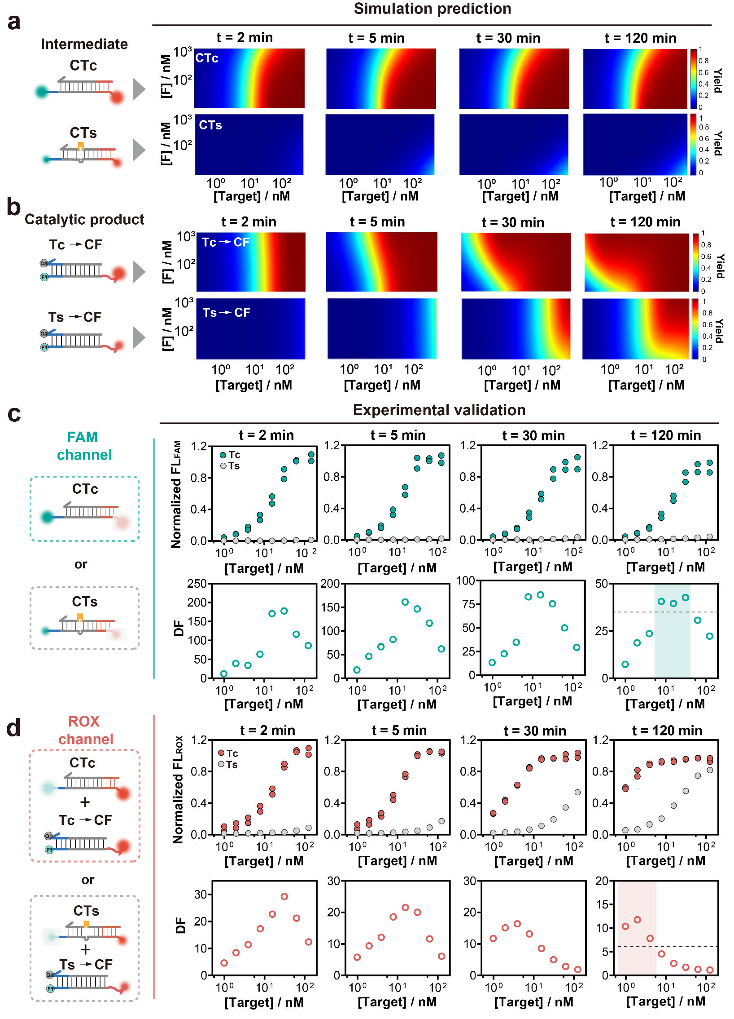
Fig. 2 | In silico prediction and experimental characterization of CD-probe. a. Simulated reaction yields of intermediates (CTc or CTs) produced in response to varying concentrations of correct (Tc) and spurious (Ts) targets at varying time points, revealing that both CTc and CTs rapidly reach equilibrium in the presence of varying fuel (F) concentrations. Ts contained a single C to A mismatch with ΔΔG° = −4.35 kcal/mol. b. Simulated reaction yields of catalytic product (CF) produced in response to varying concentrations of Tc and Ts at varying time points, revealing that CF is a kinetic product and can be massively produced for amplifying detection signals of low concentrations of Tc. c. Experimental validation of the assay sensitivity (upper panel) and specificity (lower panel) by monitoring the production of the intermediate as a signal readout. The shaded region indicated the concentration range with top three DF values, where a threshold was set at 40. d. Experimental validation of the assay sensitivity (upper panel) and specificity (lower panel) by monitoring the production of the catalytic product as a signal readout. The shaded region indicated the concentration range with top three DF values, where a threshold was set at 5. The concentration of Tc and Ts varied from 0.5 nM to 125 nM. [CP]=20 nM and [F]=380 nM for all experiments.

Signal integration to expand the concentration range with optimal assay specificity
As revealed by both simulation and experimental results, the detection of the intermediate at the FAM channel favors the discrimination of SNVs at a high concentration range, whereas the monitoring of catalytic products at the ROX channel favors the discrimination of SNVs at a low concentration range. We further propose that the integration of fluorescence signals at both FAM and ROX channels into a singlet readout would significantly expand the target concentration range with optimal assay specificity. To do so, we plot the detection signals in both FAM and ROX channels against the target concentrations to form a three-dimensional (3D) coordinate (Fig. 3a). In this coordinate, the distance between origin and any point (dp), mathematically expressed using equation 1, can be used to characterize the detection signal of the CD-probe for a target of a given concentration.
$$dp= \sqrt{({{[Target]}/{{[Target]}_{max}})}^{2}+{Yield}_{FAM}^{2}{+Yield}_{ROX}^{2}} (1)$$
The relative distance (dr) between an SNV and a WT at any given concentration, mathematically expressed using equation 2, can be used to characterize the sequence specificity of the CD-probe.
$$dr=\sqrt{{(\frac{\left[SNV\right]-[WT]}{{[Target]}_{max}})}^{2}{{+(Yield}_{SNV}^{FAM}-{Yield}_{WT}^{FAM})}^{2}+{{(Yield}_{SNV}^{ROX}-{Yield}_{WT}^{ROX})}^{2}} (2)$$
The simulation results in Fig. 3b and Supplementary Fig. 5 demonstrate that dr is an effective parameter to characterize the assay specificity as a function of varying F concentrations and time. More importantly, the simulation results suggest that wider target concentration with optimal assay specificity could be achieved with high concentrations of F and longer reaction time (Fig. 3b).
Guided by the simulation, we further examined the catalytic discrimination with dr as a readout for the assay specificity in the experiment. The experimental results (scattered spots) were highly consistent with the simulation (dashed line), both revealed wide concentration ranges with optimal assay specificity at 120 min (Fig. 3c). This feature is also applicable to the detection of single-nucleotide mutations with varying types and locations (Fig. 3d, 3e, Supplementary Fig. 6, and Supplementary Table 2). We also show that signal amplification capacity is preserved when signals from the two fluorescence channels were integrated. Using dp’ as a signal readout, the limit-of-detection (LOD) of the CD-probe was estimated to be 0.24 nM, corresponding to over 8 times enhancement compared to the conventional toehold-exchange probe (LOD = 1.95 nM) (Supplementary Fig. 7).
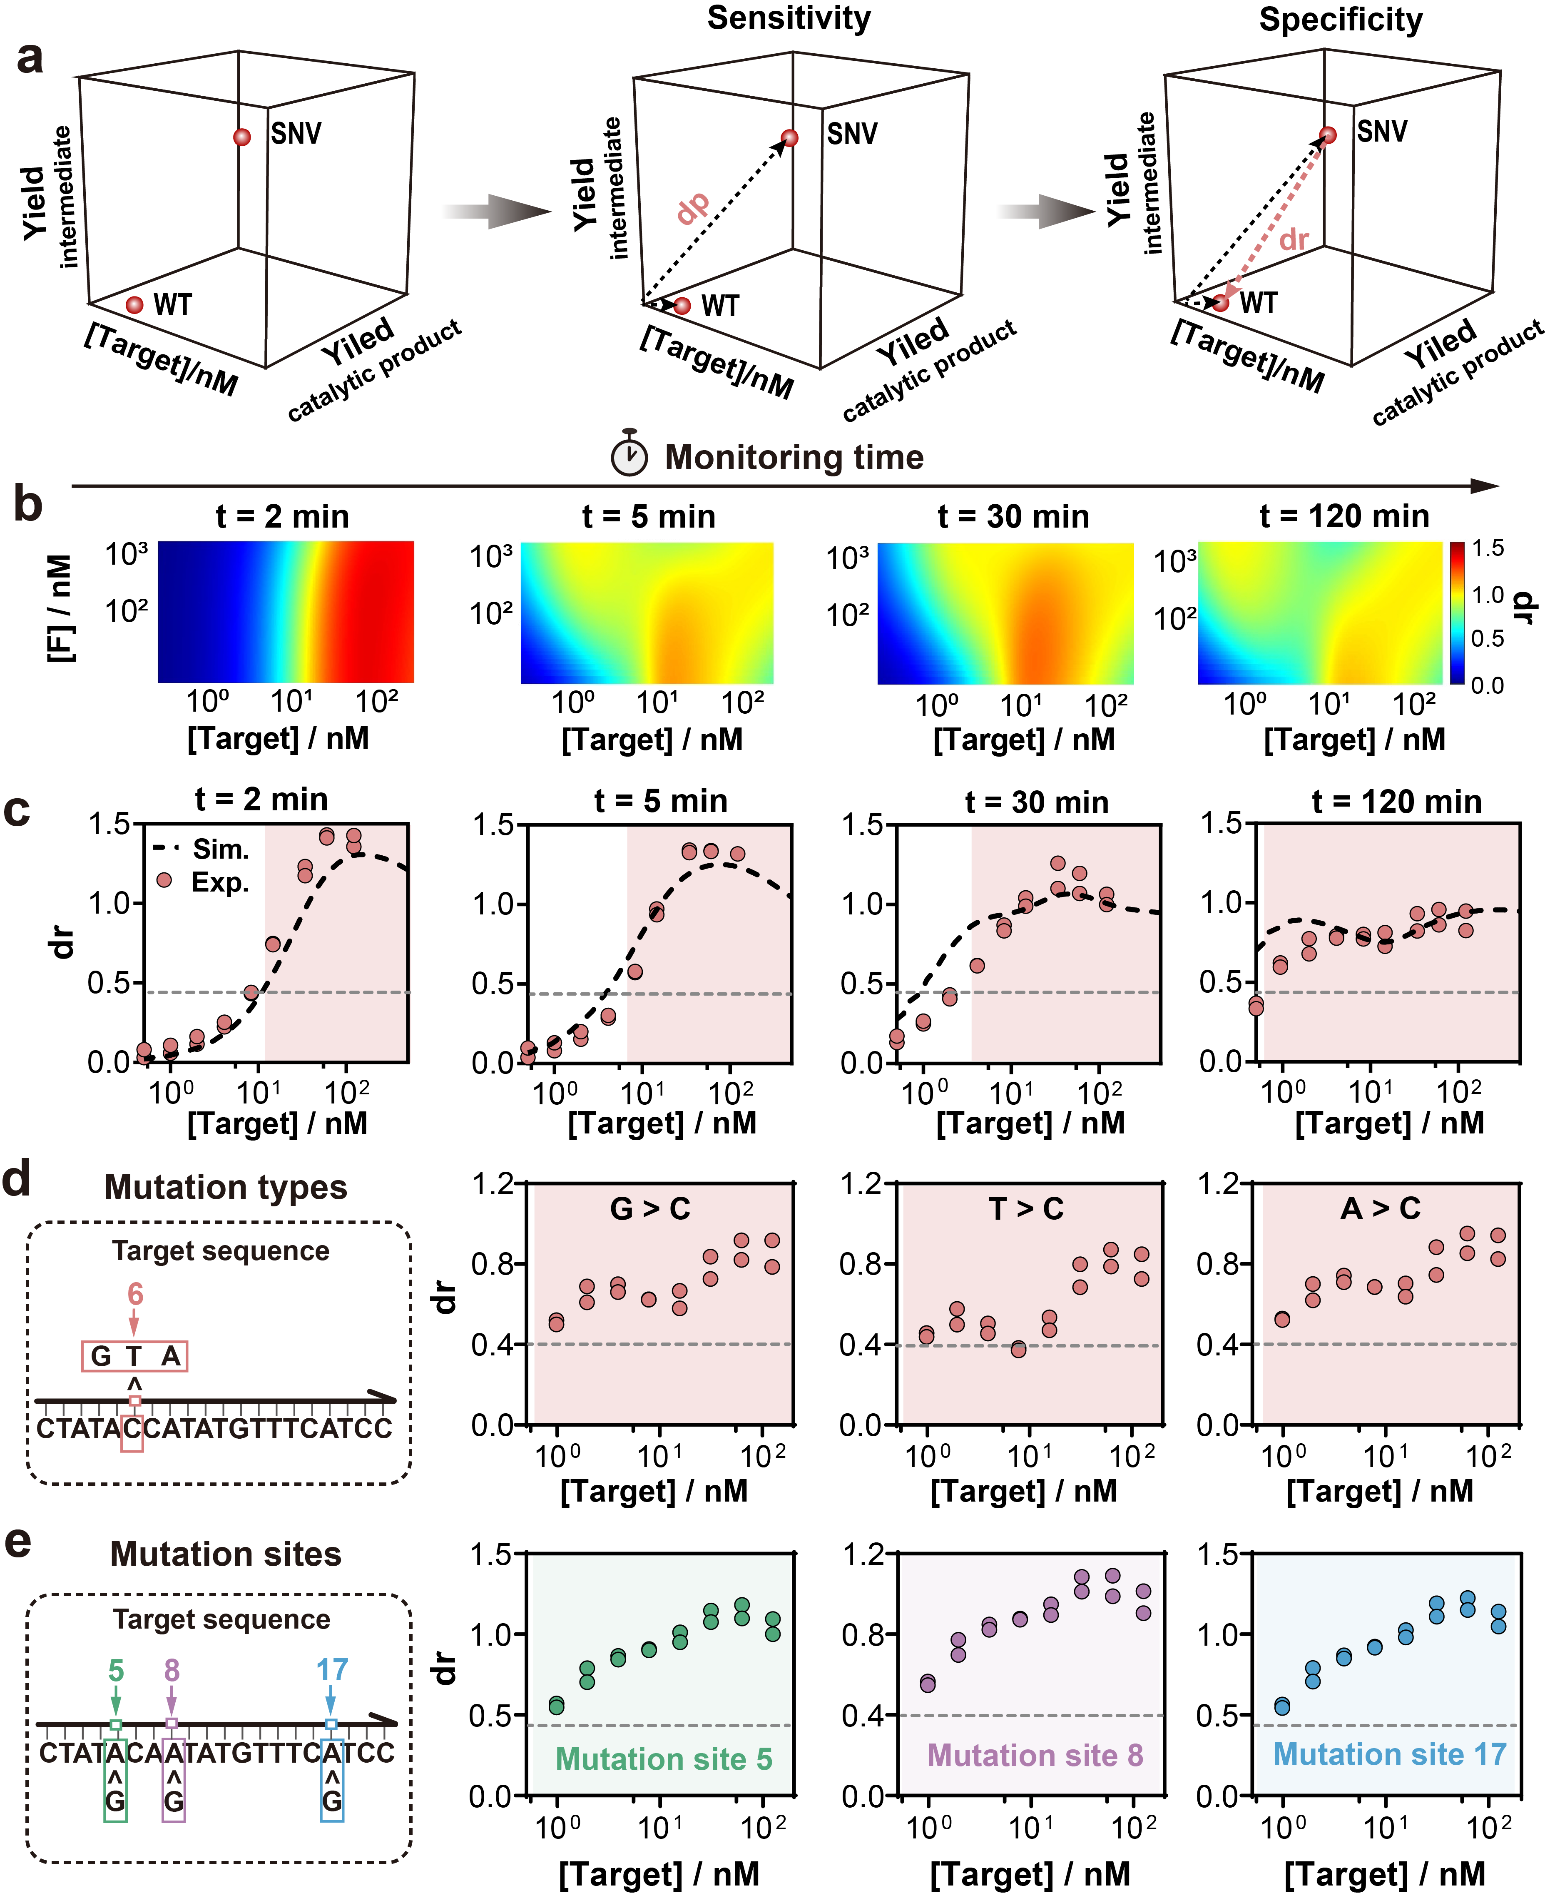
Fig. 3 | Integrating fluorescence signals to expand concentration ranges with optimal assay specificity. a. Schematic illustration of the discrimination of SNV against WT in a 3D coordinate with the yields of both intermediate and catalytic product plotted against target concentrations. Two parameters, dp and dr, were defined to quantify the assay sensitivity and specificity, respectively. b. In silico prediction of assay specificity in terms of dr values at varying target and fuel concentrations. c. Experimental validation of dr as an analytic parameter for characterizing assay specificity when using CD-probe to discriminate A to T mutation. d. e. Assay specificity as a function of target concentrations for different types (d) and positions (e) of mutations. The shaded regions indicate the concentration ranges with dr value above 0.4. The concentration of Tc and Ts varied from 0.5 nM to 125 nM. [CP]=20 nM and [F]=380 nM for all experiments.

Catalytic discrimination of low-abundant SNVs
We next evaluate CD-probe towards real clinical scenarios. Compared to well-controlled experimental conditions in research laboratories, discrimination of SNVs in clinical samples faces two challenges, including 1) the presence of high concentrations of WT interferences, and 2) unknown concentrations of either SNVs or WTs in real clinical samples. Mathematically, we could remove all concentration information by projecting detection signals from the 3D coordinate into a 2D coordinate containing only signals from the two fluorescence channels (Fig. 4a). Fig 4b and 4c revealed that samples containing a single C to A mutation at varying fractions from 0.1% to 10% were well distinguished in the 2D coordinate. Effective discrimination was also achieved for a more challenging T to A mutation (ΔΔG° = −2.77 kcal/mol) at varying abundances (Supplementary Fig. 8 and Supplementary Table 3). For both mutations, the relative distance (dr’) between each SNV sample and the WT in the 2D coordinate was quantitatively determined by the mutation fraction (Fig. 4d and Supplementary Fig. 8d), indicating that dr’ could be used as an effective parameter for analyzing SNVs in real clinical samples.
With dr’ as a quantitative parameter, we further designed and evaluated the CD-probe for 17 biologically relevant SNVs (Supplementary Table 4). Enhancement in sequence specificity was achieved for all 17 SNVs with enhancement factors ranging from 2.1 to 31.4 (mean = 14) (details of calculation were listed in Supplementary Information Section S3), confirming that CD-probe is a universal strategy generalizable to diverse clinically or biologically relevant mutations (Fig. 4e and Supplementary Fig. 9).
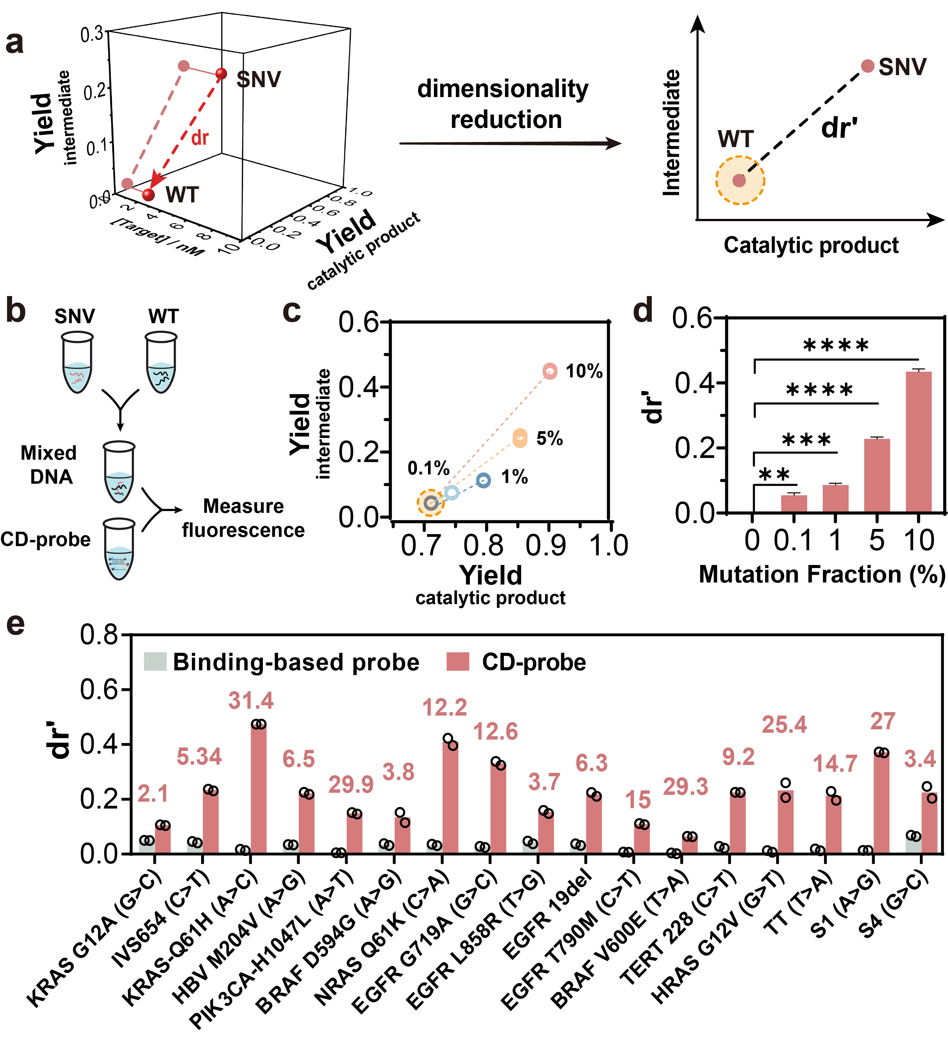
Fig. 4 | Validation of CD-probe for analyzing low-abundant SNVs. a. Schematic illustration of the dimensionality reduction for analyzing targets with unknown concentrations. An analytical parameter, dr’, is defined to characterize assay specificity in the 2D coordinate. b. Workflow for preparing and analyzing samples containing varying SNV abundances. c. Characterization of assay specificity by analyzing samples containing varying abundances of SNV (C to A mismatch with ΔΔG° = −4.35 kcal/mol) from 0.1% to 10%. d. dr’ plotted against percentage mutation fractions. Each sample mixture contained a total of 100 nM synthetic target. Technical triplicates were performed for each sample (n = 3). Unpaired two-tailed t-tests were used to evaluate statistical differences between samples. ns: p > 0.05, *p < 0.05, **p < 0.01, ***p < 0.001, and ****p < 0.0001. Technical triplicates were performed for each sample (n = 3). e. Comparison between CD-probe and a classic toehold-exchange probe for analyzing 17 clinically relevant SNVs, where dr’ was employed as a readout for both assays. The concentrations of all targets were fixed at 1 nM. Technical replicate was performed for each sample (n = 2). [CP]=20 nM and [F]=380 nM for all experiments.

Clinical validation of CD-probe
A final step to deploy catalytic discrimination of SNVs in real clinical settings is the integration of CD-probe with PCR, so that minute SNVs in clinical samples could be amplified and analyzed with high sensitivity and specificity. Here, the integration was achieved using a post-amplification SNV-specific DNA assembly (PANDA) strategy previously introduced by our group (Fig. 5a),¹⁵ as PANDA not only opens a single-stranded detection window for mutation analysis, but also suppresses the detection signals generated by high concentrations of WT. With catalytic discrimination, CD-probe further improves the assay sensitivity and expands the optimal concentration range over PANDA (Supplementary Fig. 10 and Supplementary Table 5). As shown in Fig. 5b, Supplementary Fig. 11 and Supplementary Table 6, the integration of CD-probe with PCR enabled the discrimination of as low as 1 aM SNV from an equal molar concentration of WT, representing a 10-time improvement over a commercial kit relying on ARMS-PCR (Supplementary Fig. 12a-12c and Supplementary Table 7). By further mixing SNV with WT at varying fractions, we were able to discriminate SNVs with allele frequences as low as 0.1% (Fig. 5c), which was also 10 times lower than that of ARMS-PCR (Supplementary Fig. 12d-12f and Supplementary Table 7).
We next challenged PCR-CD-probe protocol for analyzing SNVs in real clinical samples. We chose BRAF V600E as a target SNV because it is one of the most frequently used genetic markers for diagnosis, prognosis, and treatment of thyroid cancer.^{25, 26} Testing for the BRAF V600E mutation has been extensively used to improve the diagnostic accuracy of thyroid malignancy in nodules.²⁷⁻²⁹ We analyze a total of 117 clinical tissue samples collected from thyroid patients at the West China Hospital of Sichuan University, including 25 pairs of surgical frozen tumor tissue and the adjacent normal tissue (NAT) samples, and 67 surgical formalin fixed paraffin embedded (FFPE) samples (Supplementary Table 8 and Table 9). After extracting gDNA from fresh tissues using a commercial kit, gDNA containing target SNVs were PCR amplified and analyzed using the PANDA and CD-probe protocol (Fig. 5d). The test results using CD-probes were then benchmarked against standard Sanger Sequencing and digital droplet PCR (ddPCR).
For clinical testing, we first established a threshold value for distinguishing BRAF V600E positives and negatives by analyzing the 25 NAT samples that were confirmed to be negatives by both Sanger Sequencing (Supplementary Table 10) and ddPCR (Supplementary Table 11). Out of the 25 frozen tumor tissue samples, CD-probe identified 22 BRAF V600E positives, whereas Sanger Sequencing identified 20 positives (Fig. 5e, Fig. 5f, Supplementary Fig. 13 and Fig. 14). A further examination using ddPCR revealed consistent results with our test (Supplementary Fig. 15 and Fig. 16), indicating that CD-probe is clinically more sensitive than Sanger Sequencing for analyzing BRAF V600E in frozen tissues.
Compared to frozen tissues, FFPE samples represent a more challenging clinical scenario because of the reduced total gDNA input and low DNA quality (Supplementary Fig. 17).³⁰ Indeed, out of 67 FFPE samples, direct Sanger Sequencing without DNA repair only identified 7 BRAF V600E positives (Supplementary Fig. 18). With the CD-probe, we first analyzed 22 FFPE samples collected from benign thyroid nodules as negative controls (Supplementary Fig. 19). The threshold value determined for FFPE agreed well with that determined for frozen tissue, confirming the overall robustness of the CD-probe. The subsequent analysis of the 45 FFPE tumor samples using both CD-probe and ddPCR uncovered 40 positives, corresponding to 100% consistency (Fig. 5e, Fig. 5g, and Supplementary Fig. 20). Collectively, our CD-probe demonstrates 100% clinical sensitivity and specificity when benchmarking against ddPCR (Fig. 5h and Fig. 5i), one of the most sensitive tests for clinical mutations. Nevertheless, CD-probe only requires a regular thermocycler and fluorescence spectrometer and is thus of much less instrumental and consumable cost than ddPCR.

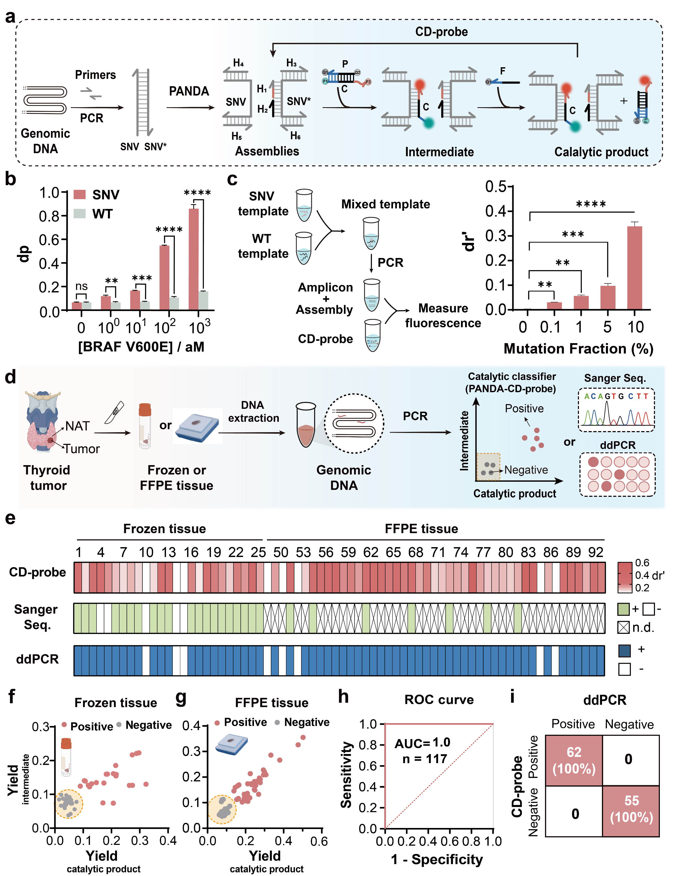
Fig. 5 | Clinical validation of CD-probe. a. A workflow for analyzing SNVs using CD-probe in clinical samples, where PCR was used to amplify the gDNA and PANDA protocol was used to create the detection window in PCR amplicons. b. Characterization of assay sensitivity by plotting dp’ as a function of varying target concentrations. c. Characterization of assay specificity for low abundant mutations by plotting dr’ against varying mutation fractions. The total target concentration was fixed at 100 fM. Unpaired two-tailed t-tests were used to evaluate statistical differences between samples. ns: p > 0.05, *p < 0.05, **p < 0.01, ***p < 0.001, and ****p < 0.0001. Technical triplicates were performed for each sample (n = 3). d. A workflow for analyzing frozen surgical tissue samples and FFPE samples of thyroid cancer using catalytic discrimination, the results of which were then benchmarked against Sanger Sequencing and ddPCR. e. Heatmap results for analyzing BRAF V600E mutation in 25 frozen tumor tissues and 45 FFPE tumor tissue samples collected from thyroid cancer patients. f. Distribution of test results using CD-probes in the 2D coordinate for 25 pairs of frozen tumor and adjacent normal tissue samples. g. Distribution of test results using CD-probes in the 2D coordinate for 45 tumor and 22 benign FFPE samples. h. ROC curves of the CD-probe assay for detecting BRAF V600E in 117 thyroid cancer samples that combined all frozen tissue and FFPE samples. Optimal cutoff fluorescence values were selected through ROC analysis. i. Evaluation of clinical sensitivity and specificity of catalytic discrimination against ddPCR using a confusion matrix (n = 117).

Detection of BRAF V600E mutation for thyroid FNA biopsy
We finally demonstrated the clinical impact of our catalytic discrimination approach by analyzing BRAF V600E mutations in clinical thyroid fine needle aspiration biopsy (FNAB). By obtaining pathological cells from thyroid nodules through fine needle aspiration for histological diagnosis, FNAB is one of the most accurate methods for evaluating thyroid nodules, aiding in preoperative characterization and providing a basis for precise treatment of thyroid cancer.³¹ The TBSRTC, commonly used as the classification basis for cytological diagnosis of thyroid FNAB, classifies cytological findings into six categories, where categories I and II indicate benign nodules and category VI signifies malignant nodules requiring surgery.³² Nodules with undetermined characteristics, including those classified as TBSRTC III, IV, and V, may have malignant potential, causing anxiety in patients, repetitive FNAB, and unnecessary thyroid surgeries (Supplementary Fig. 21a and 21b).³³ A retrospective analysis of 5,298 thyroid nodule samples from West China Hospital in 2022 revealed more than 21% (1,123) cases of TBSRTC III to V, presenting an urgent need for further confirmatory tests (Supplementary Fig. 21c).
Although BRAF V600E is a confirmatory genetic marker that can significantly enhance the diagnostic accuracy of FNAB, the current qPCR-based molecular test finds limited success due to the low total DNA input and low mutation abundance. Indeed, by analyzing 52 FNAB samples classified between TBSRTC III to V by the West China Hospital of Sichuan University (Supplementary Table 12), we found that the available amount of genomic DNA (gDNA) ranged from 2 ng to 34 ng with a mean value of 9.21 ng (Fig. 6b). The abundance of BRAF V600E mutation was determined to be between 0% and 37%, with a mean value of 9.35%, using ddPCR (Fig. 6c). By diluting gDNA extracted from FFPE samples, we quantified the minimal total DNA input required for varying molecular tests. Results in Fig. 6d revealed a minimal required gDNA input extracted from a clinical FFPE sample with a BRAF V600E variant allele frequency (VAF) of 20.9%, returning a minimal input of 50 ng for Sanger Sequencing and 5 ng for qPCR, respectively. With significantly improved test sensitivity and specificity via catalytic discrimination, our CD-probe demonstrated a better performance with ddPCR, which required only 0.2 ng gDNA input, corresponding to a 25-time improvement over current clinical qPCR test (Supplementary Fig. 22-25).
To further evaluate the clinical impact of catalytic discrimination, we analyzed the 52 FNAB samples with undetermined nodule characteristics using the CD-probe. By detecting BRAF V600E, our test identified 86.5% (45/52) malignant tumors, all of which were confirmed after thyroidectomy (Fig. 6h). By contrast, the conventional qPCR-based clinical test only identified 46.1% (24/52) malignant tumors (Fig. 6g). Besides BRAF V600E, we also designed a CD-probe for HRas proto-oncogene (HRAS) G12V mutation, another frequently occurring mutation that has been clinically tested in thyroid cancer.³⁴ By analyzing the 7 BRAF V600E negative FNAB samples, our test revealed 2 HRAS G12V positives, which were further confirmed to be malignant tumors after thyroidectomy (Supplementary Fig. 26 and Supplementary Table 13). By labeling three sets of CD-probes with six spectroscopically distinct fluorescent dyes, we further demonstrate the simultaneous detection of three high-prevalent BRAF and RAS mutations (BRAF V600E, HRAS G12V, and NRAS Q61R) in FNAB samples using a 3-plex PCR-CD-probe assay (Supplementary Fig. 27 and Supplementary Table 14).³² Collectively, our catalytic discrimination strategy offers a highly effective and economical solution for FNAB and other challenging SNV test scenarios where sample amounts are limited and mutation abundances are low.

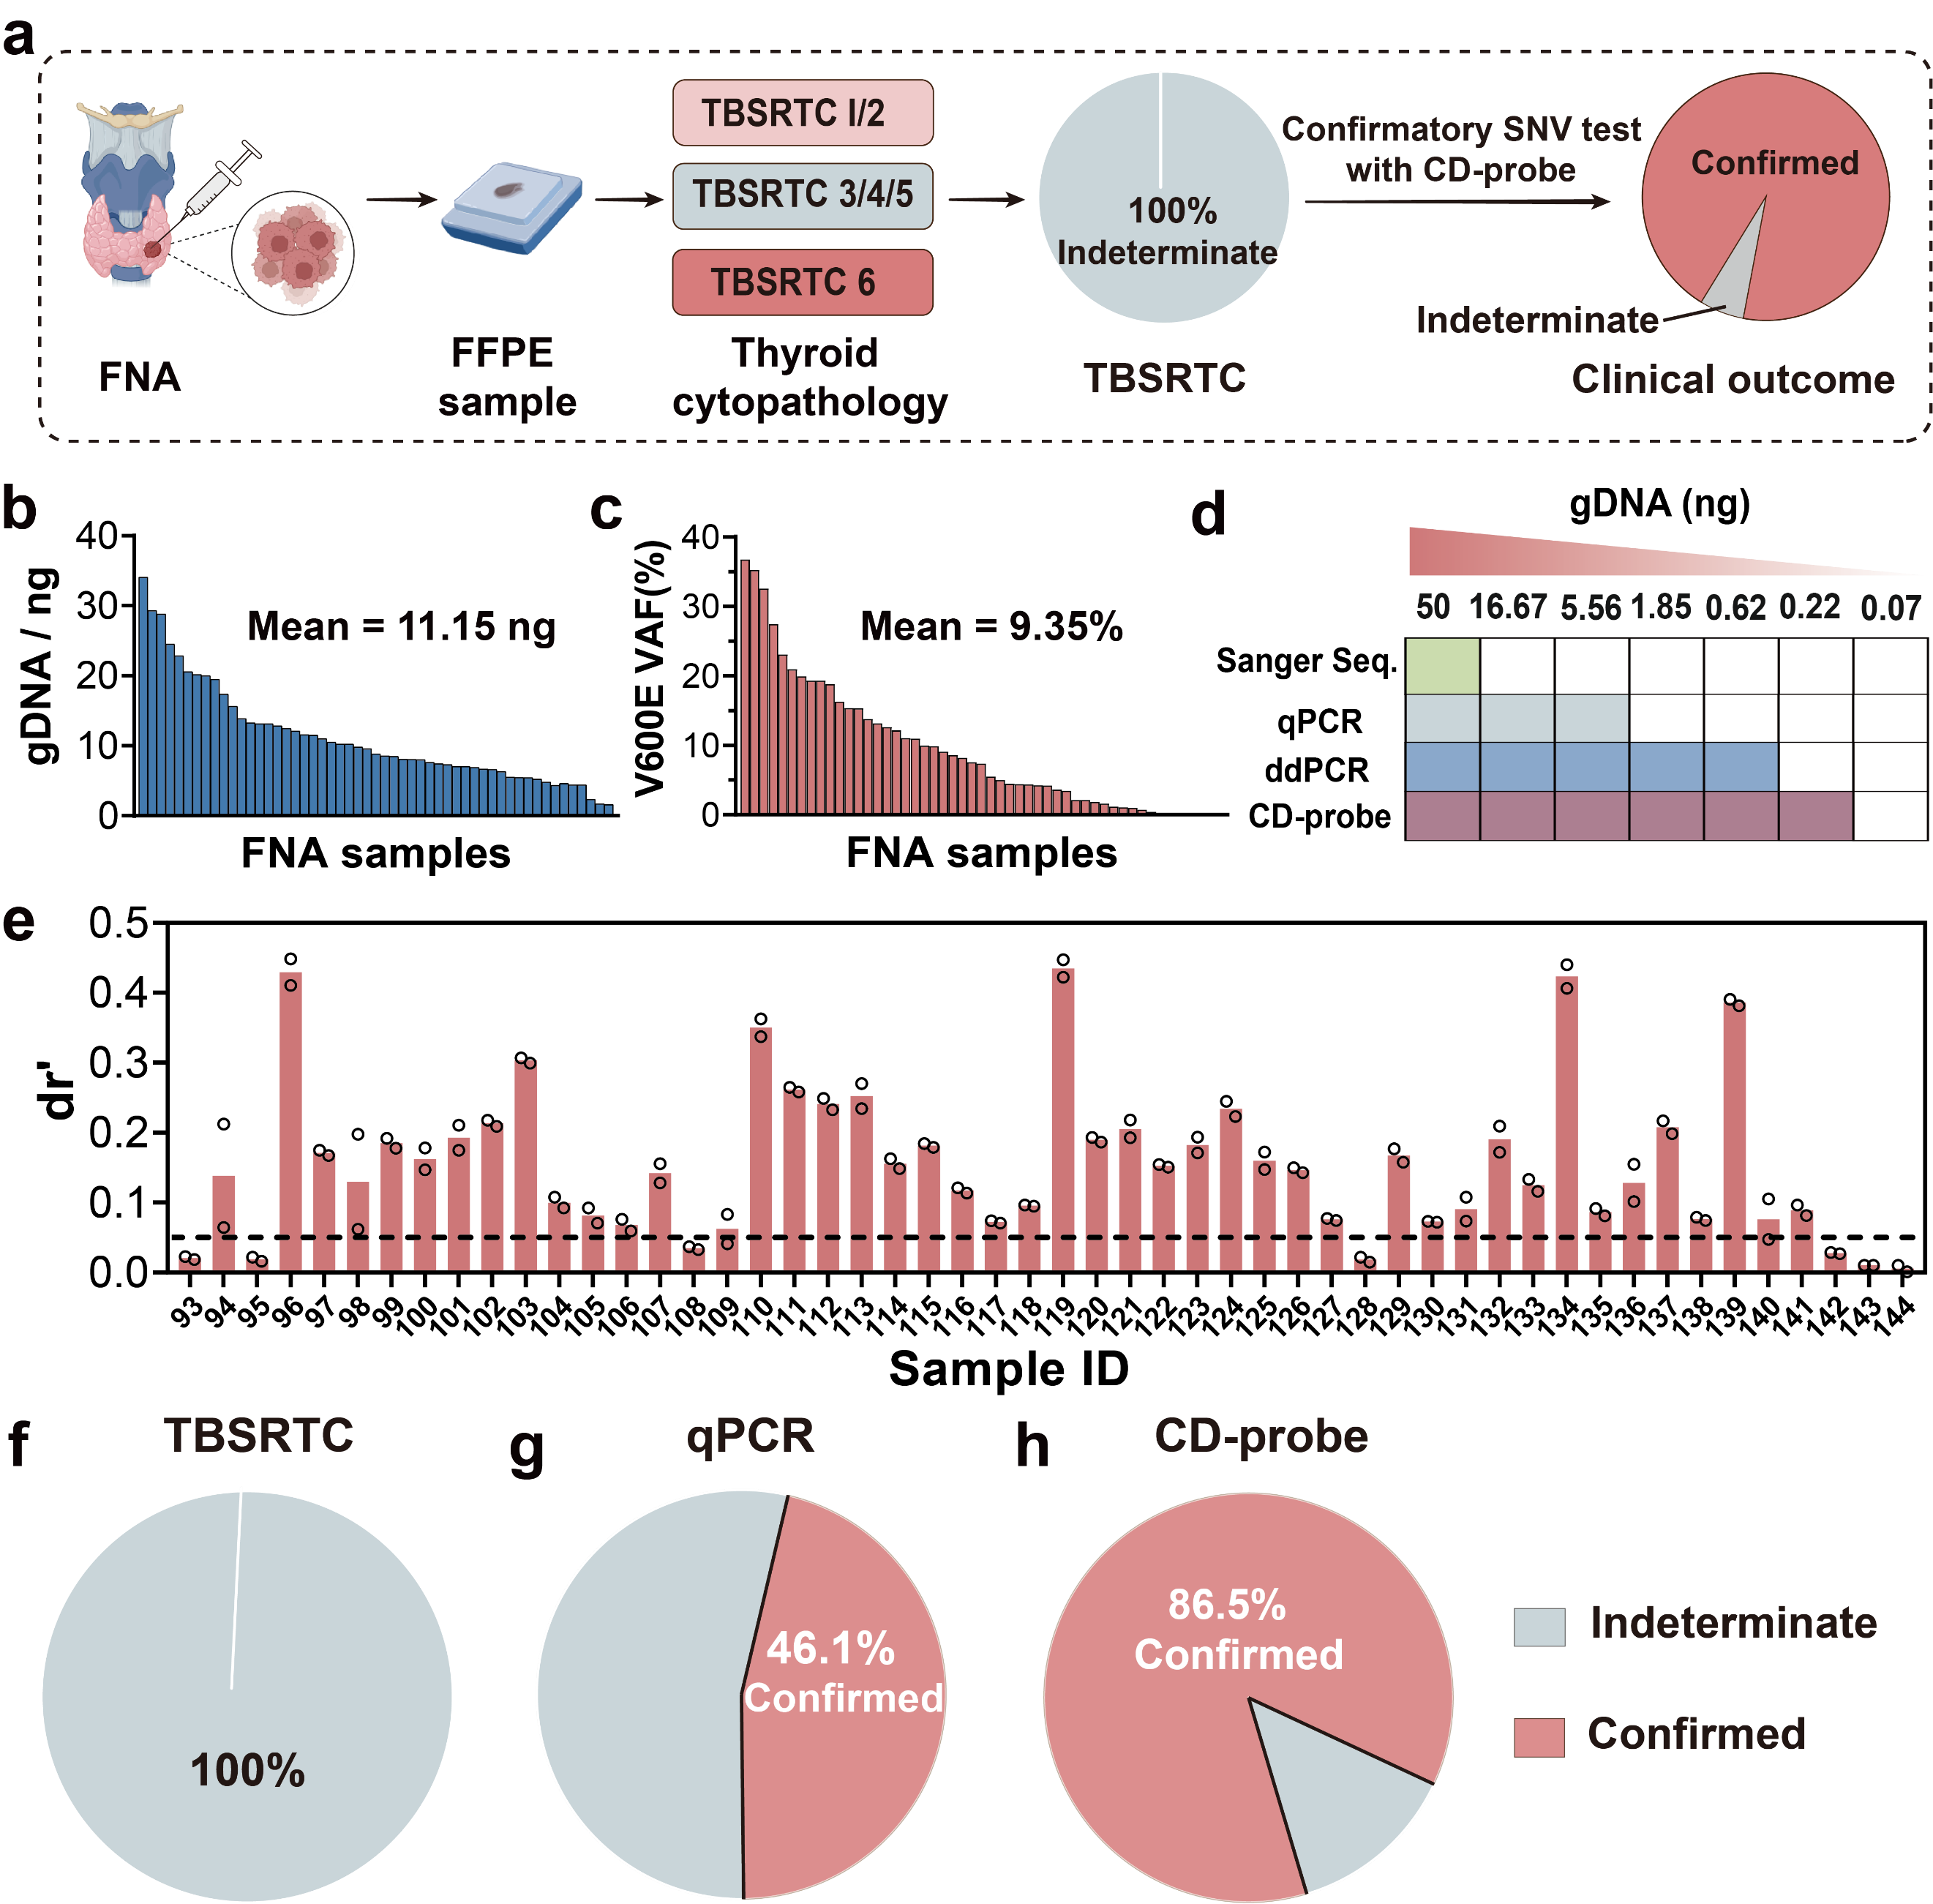
Fig. 6 | Catalytic discrimination as a confirmatory SNV test to facilitate thyroid fine-needle aspiration biopsy. a. A workflow for detecting BRAF V600E and other hotspot SNVs using catalytic discrimination in FNA samples with undetermined nodule characteristics by TBSRTC. b. Distribution of total gDNA input extracted from 52 clinical FNA samples. c. Distribution of mutation fractions of BRAF V600E determined using ddPCR in 52 clinical FNA samples. d. Characterization and comparison of minimal gDNA input for SNV tests, including Sanger Sequencing, qPCR, ddPCR, and catalytic discrimination. e. Test results of catalytic discrimination for analyzing BRAF V600E in 52 clinical FNA samples. f.-h. Percentages of confirmed cases of thyroid cancers after TBSRTC (f), qPCR-based BRAF V600E test (g), and catalytic discrimination-based BRAF V600E test (h).

Discussion
In summary, we demonstrated that catalytic discrimination overcomes the thermodynamic limit of conventional binding-based nucleic acid recognition and thus effectively expands the optimal concentration ranges for discriminating SNVs. Compared to existing hybridization probes, CD-probe offers several notable advantages. First, unlike binding-based nucleic acid hybridization probes that trade assay sensitivity for enhanced sequence selectivity, CD-probe ensures highly sensitive detection of low concentrations of SNVs via noncovalent DNA catalysis. Meanwhile, through stoichiometric tuning achieved by monitoring the intermediate, CD-probe remains highly specific even in the presence of high concentrations WT interferences. Second, by simultaneously monitoring the production of intermediate and catalytic product and then integrating the two fluorescence channels, CD-probe effectively expands target concentration ranges with optimal assay specificity. The concentration-dependency of sequence selectivity is another intrinsic issue of binding-based probes for discriminating SNVs. As far as we know, catalytic discrimination is the first design strategy that enhances sequence selectivity for targets both at high and low concentrations via two orthogonal discrimination mechanisms. Third, as demonstrated both in silico and experimentally, catalytic discrimination is a universal design principle generalizable to diverse clinically and biologically significant SNVs. It is also readily adaptable to PCR and other nucleic acid amplification techniques for analyzing challenging SNVs in clinical samples. As demonstrated in this study, CD-probe outperformed Sanger Sequencing and qPCR in samples including frozen tissues, FFPE, and FNA, indicating the broad clinical potential of catalytic discrimination.
On top of the technical advancement, catalytic discrimination also demonstrates immediate clinical impact for thyroid FNAB. Although genetic SNV markers, such as BRAF V600E and HRAS G12V, have long been recognized to improve the diagnostic outcome of FNAB, the clinical impact of current SNV tests remains limited. For example, out of the 1,123 patients with undetermined nodule characteristics in the West China Hospital of Sichuan University in 2022, only 154 patients received confirmatory test results after a BRAF V600E test adjunct to cytopathologic examination (Supplementary Fig. 28). The limited total gDNA input and low mutation abundance represent major obstacles of current molecular tests (Supplementary Table 15). With both enhanced sensitivity and specificity via catalytic discrimination, we successfully reduced the minimal gDNA input for BRAF V600E test by 25 times, which significantly improved clinical outcome with 2-time confirmed cases of papillary thyroid cancer in a cohort of 52 patients over the existing clinical test.
By addressing intrinsic challenges of binding-based nucleic acid recognition, we anticipate that catalytic discrimination will find wide applications to clinical scenarios, such as FNAB, cancer liquid biopsy, minimal residual disease, and the detection of donor-derived cell-free DNA for organ transplantation, where detection of low-abundant SNVs in limited sample input is required. Catalytic discrimination offers a highly cost-effective choice in such scenarios with sensitivity comparable to those of the most advanced molecular techniques, such as the next generation of sequencing (NGS) and ddPCR, yet upfront cost at the level of conventional PCR technology (Supplementary Table 16). Also, as catalytic discrimination only requires regular thermocycler and fluorescence spectrometer or microplate reader without specialized equipment, it is accessible to any diagnostic laboratories with regular thermocycler and fluorescent spectrometer or microplate readers. By further integrating catalytic discrimination with isothermal nucleic amplification and portable readers, it can be further translated for applications in point-of-care settings. Moreover, multiple sets of CD-probes can work independently without interfering with one another, allowing multiplexed discrimination of several low-abundant SNVs in a single test without substantially increasing the overall testing cost. Besides using multiple sets of CD-probes with spectroscopically distinct fluorescent dyes, our current efforts also involve the design of microfluidic chips and detection systems with spatial coding capabilities to further enhance the assay multiplexity and accessibility. We also work on the integration of PCR and catalytic discrimination in a fully sealed microfluidic device to avoid open-lid contamination, as well as the automation of the PCR-CD-probe protocol to ensure user-friendly clinical applications.
Methods
Ethical statement. This study was approved by the Ethics Committee of West China Hospital, Sichuan University (No. 2023. 2069 and No. 2023. 461). Informed, written consents were obtained from all participants. All research was carried out under relevant guidelines and regulations.
Materials. All DNA oligonucleotides (Supplementary Tables 1-10) were synthesized and modified by Sangon Biotech Co., Ltd. (Shanghai, China), and were purified by high-performance liquid chromatography (HPLC). Sequences and modifications of all oligonucleotides are listed in Supplementary Tables. Magnesium chloride hexahydrate (MgCl₂∙6H₂O), TWEEN20, 1 × Tris EDTA (TE) buffer, and Taq PCR Master Mix (2×, without Dye) were purchased from Sangon Biotech Co., Ltd. (Shanghai, China). Ultrapure H₂O (18.25 MΩ) was purified using an ULUPURE ultrapure water system (Chengdu, China).
Buffer conditions. DNA sequences were dissolved in ultrapure water to make stock solutions and were stored at -20 °C until use. The concentrations of all DNA stock solutions were quantified using the BioTek microplate reader equipped with a Take 3 micro-volume microplate and adjusted to 100 μM. 1 × TE buffer (10 mM, pH = 7.4) containing 12.5 mM MgCl₂ and 0.5% (v/v) TWEEN20 was used for all reactions.
Preparation of CD-probe. All CD-probes were prepared by mixing 10 μM fluorophore-labeled reporter strand C and 10 μM quencher-labeled complementary strand P in 1×Tris EDTA (TE) buffer containing 10 mM Tris-HCl (pH = 7.4), 1 mM EDTA, 10 mM MgCl₂, and 0.5% (v/v) TWEEN 20. The reaction mixture was heated to 95 °C for 5 min and then cooled gradually to room temperature at a constant rate over a period of 1 h.
SNV analysis using CD-probe. A reaction mixture containing 20 nM CP, an optimal concentration of F, and varying concentrations of target DNA was added to the well of a 96-well microplate and was incubated at 37 °C. The fluorescence was measured immediately upon preparing the reaction mixture with a data acquisition rate of one read per two minutes for 2 hrs using a BioTek Cytation 5 cell imaging multimode microplate reader (Agilent Technologies, Inc., USA) with excitation/emission at 485/525 nm for FAM and 585/616 nm for ROX, respectively. The reaction yield was determined using the following equation:
$\begin{aligned}Yield= \frac{F-Fb}{Fm-Fb}\#（S1）\end{aligned}$where the F represent the fluorescence of a given sample at equilibrium, Fm denotes the maximum fluorescence achievable for a given concentration of CD-probe, and Fb is the background fluorescence of CD-probe in the absence of the target.
To determine the sensitivity of the CD-probe, a stock solution of single-stranded SNV or WT target was diluted into a series of concentrations and then analyzed according to the assay protocol outlined above. To determine the limit of detectable VAFs, SNV was mixed with WT at varying percentage compositions, and then analyzed using the CD-probe according to the above-mentioned assay protocol.
Integration of CD-probe with PCR. The target nucleic acids were PCR amplified using the Eppendorf Mastercycler Nexus gradient thermal cycler. PCR amplification was initiated with a 4 min incubation step at 94 °C for polymerase activation, followed by 35 thermal cycles (denaturation at 94 °C for 30 s, annealing at 52 °C for 30 s, and extension at 72 °C for 30 s) and a final extension at 72 °C for 5 min. The primer concentrations were fixed at 400 nM. After PCR amplification, 15 μL PCR amplicons were mixed with 35 μL helper strands (final concentration of 500 nM for each helper) and heated to 95 °C for 5 min, followed by a snap cooling step at 4 °C in a metal bath. This reaction mixture was then analyzed using CD-probe according to the abovementioned assay protocol.
Collection of clinical samples from thyroid cancer patients. For frozen tissue samples, a total of 25 pairs of tumor tissues and NATs were collected from 25 thyroid cancer patients who underwent thyroidectomy in the West China Hospital of Sichuan University between November 2022 and March 2023. Genomic DNAs were extracted from the frozen tissues using the Blood & Tissue Kit (Qiagen, cat. no. 69504) according to the manufacturer’s instructions.
For FFPE tissue samples, a total of 67 FFPE tissues were collected from 45 thyroid cancer patients and 22 benign thyroid nodules in the West China Hospital of Sichuan University between July 2023 and November 2023. Genomic DNAs were extracted from the FFPE tissues using QIAamp DNA FFPE Tissue Kit (Qiagen, cat. no. 56404) according to the manufacturer’s instructions.
Clinical FNA samples were collected from a cohort of 52 patients with thyroid nodules in the West China Hospital of Sichuan between July 2023 and November 2023. FNA samples were made into FFPE samples according to the reported protocol. gDNA of FFPE samples was extracted from 30 pieces FFPE samples using QIAamp DNA FFPE Tissue Kit (Qiagen, cat. no. 56404) according to a protocol provided by the manufacturer. The elution volume for each sample was 50 µL in ATE buffer (Qiagen) and stored at -20 °C until use.
For gDNA samples obtained from fresh tissue, FFPE, or FNA, they were analyzed using PCR amplification and CD-probe detection according to the assay protocol outlined above.
Digital PCR assays. Droplet digital PCR (ddPCR) was performed using a Sniper DQ24 All-in-one Digital PCR System (Sniper Medical Technology Co., Ltd. Suzhou, China). The sequences of primers and TaqMan probes for BRAF V600E mutation were designed according to previous studies. In a typical ddPCR assay, a 22 µL reaction mixture containing 2 µL of 5 µM primers, 1 µL of 5 µM VIC-labeled TaqMan probes for WT, and 1 µL of 5 µM FAM-labeled TaqMan probes for SNV was mixed with 2 µL of gDNA sample (with a total amount less than 60 ng) and 11 µL Sniper dPCR Supermix (cat. no. RC00101016) and adjusted to a final volume of 22 µL using sterilized water. The mixture was divided into about 20, 000 droplets at 60 °C for 5 min by the vibrant injection technique developed by Sniper. Droplets were amplified at 95 °C for 15 min, then 95 °C for 30 s, and 60 °C for 1 min with 40 cycles. Following thermal cycling, droplets were individually scanned at 60 °C using the Sniper built-in scanning system. The ddPCR test results were analyzed using SightPro software.
Sanger Sequencing. For analyzing tissue samples using Sanger Sequencing, the extracted genomic DNA from tissue samples was PCR amplified in an Eppendorf Mastercycler Nexus gradient thermal cycler. 2 μL of genomic DNA, 25 μL Taq PCR Master Mix (2 ×, without dye), and 2 μL of 10 μM primers were mixed, and sterilized water was used to adjust the final volume to 50 μL. PCR amplification was initiated with a 4 min incubation step at 94 °C for polymerase activation, followed by 35 thermal cycles (denaturation at 94 °C for 30 s, annealing at 50 °C for 30 s, and extension at 72 °C for 30 s) and a final extension at 72 °C for 10 min. After PCR, PCR amplicons were purified using SanPrep Column PCR Product Purification Kit (Sangon Biotech, cat. no. B518141) and analyzed using BigDye terminator v3.1 Cycle Sequencing Kit (Thermo Fisher, cat. no. 4337458) in an Applied Biosystems 3730xl genetic analyzer (Thermo Fisher Scientific Inc., USA).
qPCR assay. qPCR assay was performed on a qTOWER3G Real-Time thermal cyclers from Analytik Jena (Jena, Germany) using PCR 8-strip tube (Kirgen, cat. no. KG2542). In a typical ARMS-PCR assay, the 20 μL reaction contained 10 μL 2x TaqMan Fast qPCR Master Mix (Sangon Biotech, cat. no. B639274), 6.8 μL of RNase-free water, 0.4 μL of 10 μM forward primer, 0.4 μL of 10 μM reverse primer, 0.4 μL of 10 μM TaqMan probe labelled with FAM, and 2 μL of genomic DNA. 2x TaqMan Fast qPCR Master Mix (Sangon Biotech, cat. no. B639274) was used for enzymatic amplification; and TaqMan probe was used for fluorescence signal generation. qPCR cycling conditions were as follows: 3 min at 95 °C, followed by 40 cycles of 95 °C for 30 s, annealing, extension, and signal collection at 56 °C for 30 s). Fluorescence signals were collected at 60 °C by the qPCR's built-in FAM channel. Ct values were obtained via the above-mentioned software.
Data analysis. Data analysis was performed using Microsoft 365 Excel, SnapGene 4.2.4, Chromas 2.22, and GraphPad Prism 8.0.1. Unpaired two-tailed t-tests were conducted using Microsoft 365 Excel software. The receiver operating characteristics (ROC) curve that assessed the diagnostic accuracy of the CD-probe assay was produced using GraphPad Prism 8.0.1. A confusion matrix was performed using Microsoft 365 Excel to evaluate the performance of CD-probe in comparison with ddPCR. The ddPCR data were analyzed using SightPro software.
Data availability. All data associated with this study are present in the paper or the Supplementary Materials. Source data are provided with this paper.
Code availability. All code created in this work is available on GitHub (https://github.com/Crown1983/Catalytic_Discrimination_SI_Codes).
References
1. Song, P. et al. Limitations and opportunities of technologies for the analysis of cell-free DNA in cancer diagnostics. Nat. Biomed. Eng. 6, 232-245 (2022).
2. Wang, Q. et al. Rare variant contribution to human disease in 281,104 UK Biobank exomes. Nature 597, 527-532 (2021).
3. Liu, M.H. et al. DNA mismatch and damage patterns revealed by single-molecule sequencing. Nature 630, 752-761 (2024).
4. Yu, Z. et al. Genetic variation across and within individuals. Nat. Rev. Genet. 25, 548-562 (2024).
5. Zhang, D.Y., Chen, S.X. & Yin, P. Optimizing the specificity of nucleic acid hybridization. Nat. Chem. 4, 208-214 (2012).
6. Li, J. et al. Replacing PCR with COLD-PCR enriches variant DNA sequences and redefines the sensitivity of genetic testing. Nat. Med. 14, 579-584 (2008).
7. Wang, J.S. & Zhang, D.Y. Simulation-guided DNA probe design for consistently ultraspecific hybridization. Nat. Chem. 7, 545-553 (2015).
8. Zhang, T. et al. A paper-based assay for the colorimetric detection of SARS-CoV-2 variants at single-nucleotide resolution. Nat. Biomed. Eng. 6, 957-967 (2022).
9. Guo, C. et al. Coding Intrinsic Disorder into DNA Hybridization Probes Enables Discrimination of Single Nucleotide Variants over Wide and Tunable Temperature Ranges. Angew. Chem. Int. Ed. 62, e202314386 (2023).
10. Tyagi, S., Bratu, D.P. & Kramer, a.F.R. Multicolor molecular beacons for allele discrimination. Nat. Biotechnol.16, 49-53 (1998).
11. Chen, S.X., Zhang, D.Y. & Seelig, G. Conditionally fluorescent molecular probes for detecting single base changes in double-stranded DNA. Nat. Chem. 5, 782-789 (2013).
12. Chen, X. et al. Thermodynamics and kinetics guided probe design for uniformly sensitive and specific DNA hybridization without optimization. Nat. Commun. 10, 4675 (2019).
13. Wu, L.R. et al. Continuously tunable nucleic acid hybridization probes. Nat. Methods 12, 1191-1196 (2015).
14. Wang, G.A. et al. Expanding detection windows for discriminating single nucleotide variants using rationally designed DNA equalizer probes. Nat. Commun. 11, 5473 (2020).
15. Huang, D. et al. Mismatch-Guided Deoxyribonucleic Acid Assembly Enables Ultrasensitive and Multiplex Detection of Low-Allele-Fraction Variants in Clinical Samples. J. Am. Chem. Soc. 145, 20412-20421 (2023).
16. Li, Y. et al. Simulation-guided engineering of an enzyme-powered three dimensional DNA nanomachine for discriminating single nucleotide variants. Chem. Sci.9, 6434-6439 (2018).
17. Chen, S.X. & Seelig, G. An Engineered Kinetic Amplification Mechanism for Single Nucleotide Variant Discrimination by DNA Hybridization Probes. J. Am. Chem.Soc.138, 5076-5086 (2016).
18. Yu, S. et al. Integrative metabolomic characterization identifies plasma metabolomic signature in the diagnosis of papillary thyroid cancer. Oncogene 41, 2422-2430 (2022).
19. Eszlinger, M. et al. Molecular profiling of thyroid nodule fine-needle aspiration cytology. Nat. Rev. Endocrinol. 13, 415-424 (2017).
20. Gydush, G. et al. Massively parallel enrichment of low-frequency alleles enables duplex sequencing at low depth. Nat. Biomed. Eng. 6, 257-266 (2022).
21. Chen, W. et al. Detection of low-frequency mutations in clinical samples by increasing mutation abundance via the excision of wild-type sequences. Nat. Biomed. Eng. 7, 1602-1613 (2023).
22. Song, P. et al. Selective multiplexed enrichment for the detection and quantitation of low-fraction DNA variants via low-depth sequencing. Nat. Biomed. Eng. 5, 690-701 (2021).
23. Wan, J.C.M. et al. Liquid biopsies come of age: towards implementation of circulating tumour DNA. Nat. Rev. Cancer 17, 223-238 (2017).
24. Wang, C., Bae, J.H. & Zhang, D.Y. Native characterization of nucleic acid motif thermodynamics via non-covalent catalysis. Nat. Commun. 7, 10319 (2016).
25. M, X., AS, A. & KA, C. Association between BRAF V600E mutation and mortality in patients with papillary thyroid cancer. JAMA 309, 1493-1501 (2013).
26. Haugen, B.R. et al. 2015 American Thyroid Association Management Guidelines for Adult Patients with Thyroid Nodules and Differentiated Thyroid Cancer: The American Thyroid Association Guidelines Task Force on Thyroid Nodules and Differentiated Thyroid Cancer. Thyroid 26, 1-133 (2016).
27. Zhang, B. et al. Analysis of BRAF V600E mutation and DNA methylation improves the diagnostics of thyroid fine needle aspiration biopsies. Diagn. Pathol. 9, 2-9 (2014).
28. Zatelli, M.C. et al. BRAF V600E mutation analysis increases diagnostic accuracy for papillary thyroid carcinoma in fine-needle aspiration biopsies. Eur. J. Endocrinol. 161, 467-473 (2009).
29. Fu, G. et al. Facilitation of Definitive Cancer Diagnosis With Quantitative Molecular Assays of BRAF V600E and TERT Promoter Variants in Patients With Thyroid Nodules. JAMA Netw. Open 6, e2323500 (2023).
30. Hosein, A.N. et al. Evaluating the repair of DNA derived from formalin-fixed paraffin-embedded tissues prior to genomic profiling by SNP–CGH analysis. Lab. Invest. 93, 701-710 (2013).
31. Wolinski, K., Stangierski, A. & Ruchala, M. Comparison of diagnostic yield of core-needle and fine-needle aspiration biopsies of thyroid lesions: Systematic review and meta-analysis. Eur. Radiol. 27, 431-436 (2016).
32. Ali, S.Z. et al. The 2023 Bethesda System for Reporting Thyroid Cytopathology. Thyroid® (2023).
33. Grani, G., Sponziello, M., Filetti, S. & Durante, C. Thyroid nodules: diagnosis and management. Nat. Rev. Endocrinol. 20, 715-728 (2024).
34. Sfreddo, H.J. et al. RAS-Mutated Cytologically Indeterminate Thyroid Nodules: Prevalence of Malignancy and Behavior Under Active Surveillance. Thyroid 34, 450-459 (2024).

Acknowledgements
We thank the financial supports by the National Key R&D Program of China (No. 2023YFB3208303), the National Natural Science Foundation of China (No. 22474082, No. 82502842, No. 82422050, No. 82503955, and No. 82272933), the Sichuan Science and Technology Program (No. 2025NSFJQ0019, No. 2025NSFTD0001, and No. 2025ZNSFSC1559), 1.3.5 project for disciplines of excellence, West China Hospital, Sichuan University (ZYYC25006), and the Institutional Research Fund from Sichuan University (2021SCUNL105).

Author contributions
F. L., H. L., and Y. G. conceived the idea, supervised the overall project, and finalized the manuscript. D. H., G. A. W., R. L., and J. Y. designed all experiments, collected experimental data, and performed data analysis. G. A. W. built the theoretical model and completed all simulation work. Y. T., G. Z., Y. L., and B. Y. collected all clinical samples, designed clinical tests, and validated the CD-probe against clinical samples. All authors participated in the drafting and revision of the manuscript.

Competing interests
Feng Li, Dan Huang, Han Luo, and Binwu Ying are inventors of a pending patent for catalytic discrimination technology. All other authors declare no competing interests.

