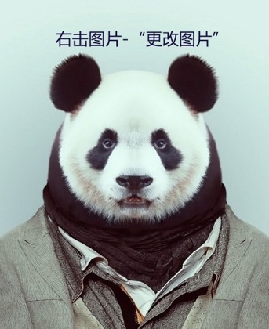

Resume
Job objective: Graphic Designer
(+86) 188-0000-1111 office@microsoft.com http://o.msn.com.cn/

EDUCATION
OfficeUniversity Bachelor of Art Design 2010.09-2014.06
- Office University Scholarship（top 20% students of Art Institute in 2010, 2011 and 2012）
- Majors: Introduction to Art Design, Graphic Composition and Design, Color Composition and Design
SKILLS
- Image Manipulation Software: Photoshop, Illustrator
- Website Production Software: DreamWeaver, Fireworks
- English Ability: CET4
PERSONAL WORKS
- Poster Design: Zhongcui 25th Anniversary poster (2014.02)
- Poster Design: Recruiting poster for Seven Leaves Anime Club, recruiting poster with the anime characters in the background (2012.12)
- Logo Design: Jingyuan Hall Jinling Restaurant Logo (2013.10)
- Logo Design: Happy Drink Tea Shop Logo (2011.05)
- VI Design: Jasmine Fairy VI (2013.11)
- Hand-drawn Comic: Story of Adai, the description of Adai's life (2011-2014)
PRACTICE/INTERN
Beijing Microsoft Media Co., Ltd. Graphic design intern 2013.02-2014.05
Offic Taobao Shop Art designer 2012.07-2012.08
Seven Leaves Anime Club Vice president 2011.10-2012.10
HOBBIES
- Drawn comics since primary school
- 若要添加项目，点击项目标题，单击左上角出现的十字标选中整个标题，复制，粘贴在此行后。

