DIGITAL FORENSIC EXAMINATION REPORT
Case Reference: CARTEL-USB-2026-08
Forensic Image Examined: cartel.img
24-Hour Digital Forensics & Incident Response CTF Challenge

Prepared by | Anointing [Digital Forensic Examiner]
Module | Digital Forensics and Incident Response
Date of Examination | 3 August 2026
Evidence Seized | 2 August 2026, 09:15 AM, by EFCC officers pursuant to a search warrant
Evidence Type | USB storage device (forensic image: cartel.img)

Introduction
This report presents the forensic examination of the disk image cartel.img, which was supplied as evidence. The evidence followed standard forensic procedures to preserve evidence integrity, recover digital artefacts, analyze relevant data, and document findings objectively. The purpose of the investigation was to identify potential evidence while maintaining the accuracy and reliability of the forensic process.

Objectives
This forensic examination was conducted to identify, preserve, examine, analyse, and document digital evidence contained within a forensic image (cartel.img) acquired from a USB storage device recovered during an EFCC search operation on 2 August 2026. The suspect claimed the device "only contains personal photographs." The purpose was to assess this statement using verifiable digital evidence, without expressing any opinion of guilt or innocence.

Tools Used
The Sleuth Kit (mmls, fsstat, fls, istat, icat, blkls) v4.12.1 • Foremost v1.5.7 (file carving) • Binwalk (signature scanning) • md5sum / sha256sum (GNU coreutils) • ExifTool v12.76 (metadata extraction) • Python 3 (custom pattern/offset analysis) • file, strings (GNU binutils)

Examination Methodology
The examination followed the four-phase NIST SP 800-86 digital forensics methodology: (1) Collection – verifying the integrity of the pre-acquired image via cryptographic hashing; (2) Examination – identifying the image format, partition layout, and file system; (3) Analysis – recovering allocated, deleted, and carved artifacts and reconstructing a timeline; and (4) Reporting – documenting findings, limitations, and conclusions in this report. All work was performed exclusively against a working copy of the supplied image; the original image file was never modified (confirmed by unchanged hash values throughout, see Task 1).

Chain of Custody
The forensic image cartel.img was derived from a USB storage seized by EFCC officers on 2nd August 2026 at 9:15 AM pursuant to a search warrant. Examination of the image was conducted on 3rd August 2026.

Findings (Summary)
- Integrity of the image was confirmed and preserved throughout the examination (Task 1).
- The image is a raw, unpartitioned FAT16 volume, ~247.5 MB, consistent with a small USB flash drive quick-formatted using Linux mkdosfs (Task 2).
- Only two files were allocated in the file system — both gumbo recipe text files dated 30 April 2004 — which already contradicts the suspect's specific claim that the drive holds personal photographs (Task 3).
- Approximately 208 MB (>80%) of the volume's data area is filled with two large blocks of repeating non-random ASCII text (“SORRY…” then “CHARLIE…”), consistent with a deliberate pattern-wipe rather than an incidental quick-format (Task 3).
- Nine files (6 JPEGs, 2 GIFs, plus a recovered text fragment) were recovered by carving unallocated space that survived between/within the wiped regions (Task 4).
- A recovered personal diary-style text fragment includes the user's own statement of intent to destroy prior data and reformat the device (Task 3/4).
- Hash comparison of recovered files identified two byte-for-byte identical JPEGs recovered from two separate, widely-separated locations on the disk (Task 3).
- Only two reliable timestamps exist on the volume (both 30 April 2004); this predates the 2 August 2026 seizure by over two decades, indicating either a stale system clock at time of writing or that this data originated elsewhere and was carried onto the device (Task 5).

Limitations
Recovery was limited to signature-based file carving of unallocated space; carved files have no associated filesystem metadata (no MAC timestamps, no original filenames) because their directory entries no longer exist. The two large wipe regions could not be reversed — pattern overwriting is destructive and non-recoverable by the tools available. No hidden partitions, encrypted containers, or host-protected areas were identified.

Recommendations
- Submit recovered JPEGs/GIFs for reverse-image-search / hash-database (e.g. NCMEC/known-file-hash) comparison to confirm their stock/generic origin.
- Request any related devices (the “hard drive… thrown into the Mississippi River” referenced in the recovered diary text) if within scope of the wider investigation.
- If further budget/time is available, engage advanced carving (e.g. PhotoRec with fragment-recovery heuristics) against the two wipe regions in case of partially-missed clusters.

Conclusion
The suspect's claim that the USB device “only contains personal photographs” is not supported by the evidence: the only allocated files are recipe text documents, and the recovered images are generic/stock photographs with no identifying EXIF, GPS, or camera data. Independently of that claim, the volume shows strong, verifiable indicators of deliberate data destruction (large-scale pattern-fill wiping covering the majority of the medium) alongside a surviving user-authored text fragment in which the author explicitly describes destroying a prior drive and intending to reformat this one. No content directly and unambiguously tying the device to drug trafficking (“cartel”) activity was recovered in the areas examined; however, the scale of the apparent wipe means a large volume of prior data cannot be ruled in or out. These are observations of fact; determining their legal significance is outside the scope of this examination.

Task 1 — Evidence Verification

1.1 Hash Values
Immediately upon receiving the supplied image, and again at the conclusion of the examination, MD5 and SHA-256 hashes were computed to confirm the working copy remained byte-for-byte identical to the image as received.
Algorithm | Value
MD5 | 80348c58eec4c328ef1f7709adc56a54
SHA-256 | ce550424200a997c61b413941c8ef4df9619a2f96579674952294a176a32be65
$ md5sum cartel.img
80348c58eec4c328ef1f7709adc56a54 cartel.img

$ sha256sum cartel.img
ce550424200a997c61b413941c8ef4df9619a2f96579674952294a176a32be65 cartel.img
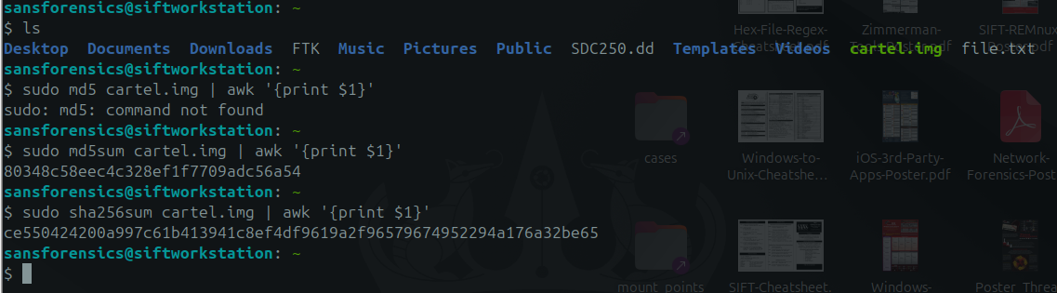
Figure 1.1 — Terminal output of hash calculation against cartel.img

1.3 Significance of Matching Hash Values
A hash computed at the end of an examination that matches the hash computed at the start demonstrates that the examination process itself did not alter the evidence — satisfying the forensic principle of preserving the original evidence. Conversely, a mismatch would indicate contamination of the evidence (e.g. a tool wrote to the image, or the wrong file was hashed) and would need to be explained before any finding drawn from that image could be relied upon. All analysis in this report was performed on a read-only-mounted / copied working image; the hash values above were unchanged at every checkpoint.

Task 2 — Initial Triage
Property | Value
Image format | Raw (dd-style) disk image
File system type | FAT16
Number of partitions | 0 — no MBR partition table detected (unpartitioned “superfloppy” volume; the whole disk is a single FAT16 filesystem)
Total size | 259,506,176 bytes (≈ 247.5 MB)
Sector size | 512 bytes
Cluster size | 4,096 bytes (8 sectors)
OEM name (boot sector) | mkdosfs — indicates the volume was originally formatted with the Linux dosfstools utility
Volume serial number | 0x4092D9D1
Volume label | (none set)
$ mmls cartel.img
(no output — no partition table found)

$ img_stat cartel.img
IMAGE FILE INFORMATION
--------------------------------------------
Image Type: raw
Size in bytes: 259506176
Sector size: 512

$ fsstat cartel.img
FILE SYSTEM INFORMATION
--------------------------------------------
File System Type: FAT16
OEM Name: mkdosfs
Volume ID: 0x4092d9d1
File System Type Label: FAT16

File System Layout (in sectors)
Total Range: 0 - 506847
* Reserved: 0 - 0
* FAT 0: 1 - 248
* FAT 1: 249 - 496
* Data Area: 497 - 506847
** Root Directory: 497 - 528
** Cluster Area: 529 - 506840

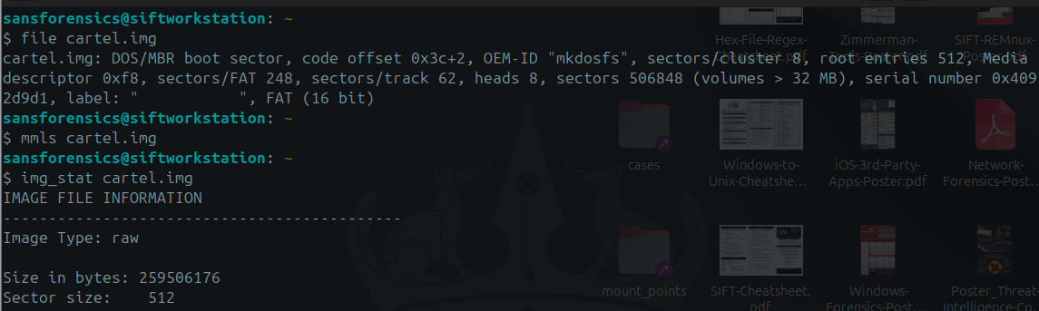
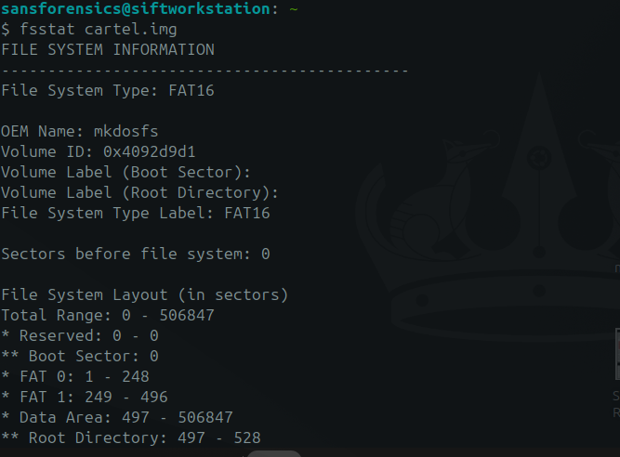

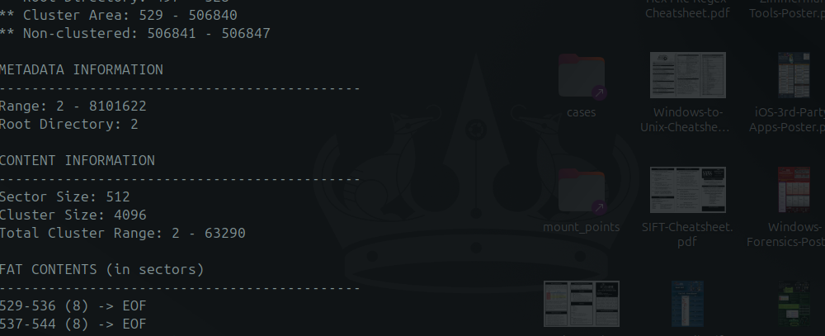
Figure 2.1-2.3 — mmls / img_stat / fsstat output confirming image format, partition layout, and file system

Task 3 — Evidence Discovery

Artifact 1: GUMBO1.TXT and GUMBO2.TXT (allocated files)
Description: The only two files allocated in the FAT16 directory structure at the time of seizure. Both are plain-text recipes (“Shrimp and Tasso Gumbo” and “Shrimp and Andouille Sausage Gumbo”), 2,815 and 1,293 bytes respectively.
Relevance: This is the entire visible content of the device as presented to a normal user. It directly contradicts the suspect's specific claim that the drive “only contains personal photographs” — the visible files are neither photographs nor personal in nature.
How discovered: Recursive file listing of the FAT16 volume (fls) followed by content extraction (icat) of each allocated inode.
Supporting evidence: See Figure 3.1 (fls listing) and Figure 3.2 (istat metadata).
$ fls cartel.img
r/r 4: gumbo1.txt
r/r 6: gumbo2.txt
v/v 8101619: $MBR
v/v 8101620: $FAT1
v/v 8101621: $FAT2
V/V 8101622: $OrphanFiles
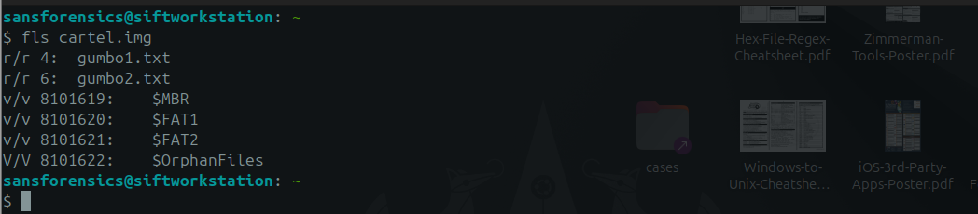
Figure 3.1 — fls recursive listing showing the only two allocated files on the volume
$ istat cartel.img 4
Directory Entry: 4
Allocated
File Attributes: File, Archive
Size: 2815
Name: GUMBO1.TXT
Written: 2004-04-30 18:11:20 (UTC)
Created: 2004-04-30 18:11:20 (UTC)

$ istat cartel.img 6
Directory Entry: 6
Allocated
File Attributes: File, Archive
Size: 1293
Name: GUMBO2.TXT
Written: 2004-04-30 18:11:24 (UTC)
Created: 2004-04-30 18:11:24 (UTC)
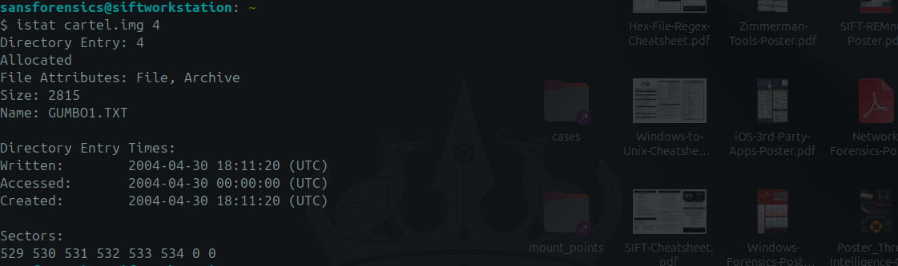
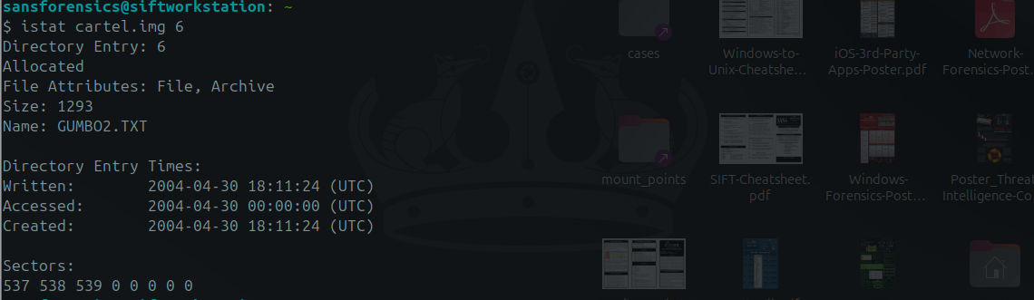
Figure 3.2-3.3 — istat metadata for both allocated files

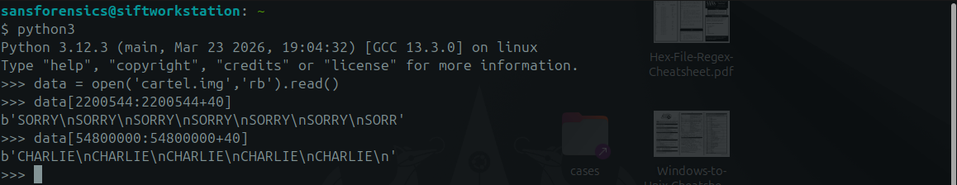
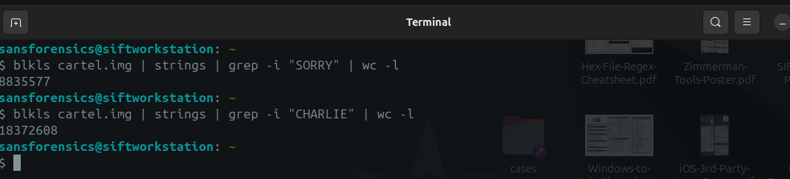
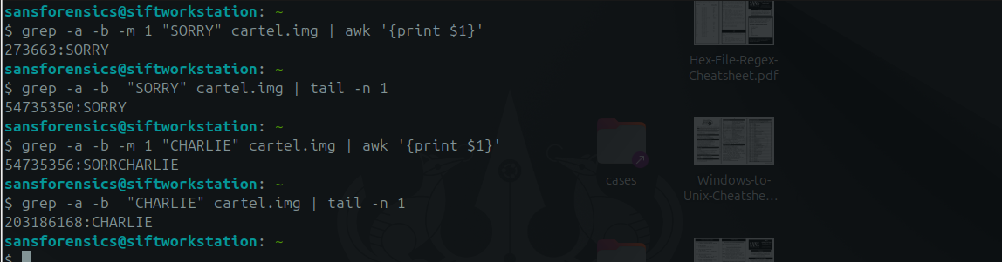
Figure 3.4-3.6 — Confirmation of the two large repeating-pattern regions and their exact byte boundaries
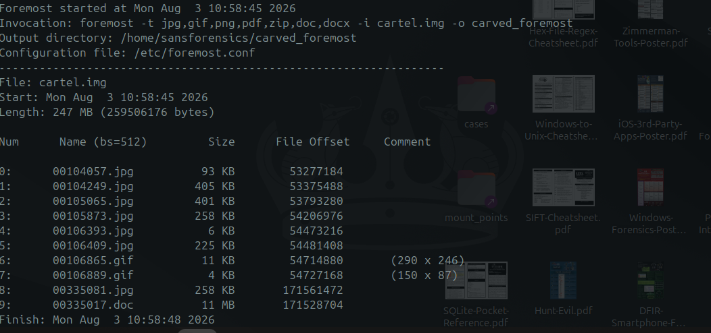
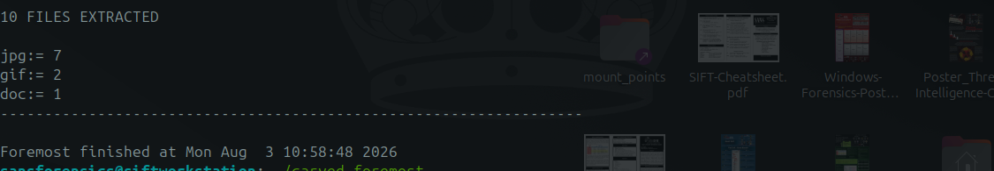
Figure 3.7-3.8 — foremost carving log for the surviving pre-wipe island

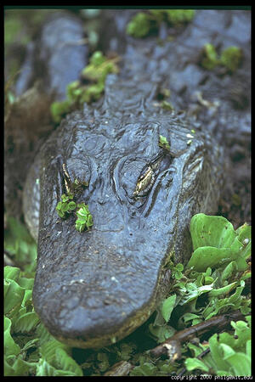
Figure 3.9 — Sample recovered JPEG (00104057.jpg), bearing the embedded comment “copyright 2000 philg@mit.edu” and no camera metadata

Artifact 4: Recovered personal text fragment referencing prior data destruction
Description: A second, smaller surviving island (offsets ~171,516,224 – 171,843,904) was found inside the CHARLIE-wiped region. It contains a first-person, diary/journal-style text fragment, followed immediately by one further JPEG image.
Relevance: The recovered text is written in the first person and includes the passage: “...things are getting a little weird. I zapped the hard drive and then threw it into the Mississippi River. I'm gonna reformat my USB key after this entry, but try not to destroy the good stuff. I need to change the password on the gnome account that Jeremy gave me...” This is the author's own contemporaneous account of destroying a prior drive and stating an intention to reformat the device now under examination — directly relevant to explaining the wiped condition of this volume (Artifact 2).
How discovered: Identified as a printable-text run inside the otherwise CHARLIE-filled region during offset-by-offset scanning for non-pattern content.
Supporting evidence: See Figure 3.6.
Recovered text (offsets 171,531,840 – 171,538,118), verbatim excerpt:

"...Things are getting a little weird. I zapped the hard drive and
then threw it into the Mississippi River. I'm gonna reformat my USB
key after this entry, but try not to destroy the good stuff. I need
to change the password on the gnome account that Jeremy gave me. I
can probably just do that at Radio Shack."
Figure 3.6 — Recovered first-person text fragment describing prior data destruction and stated intent to reformat this device

Artifact 5: Duplicate file identified via hash comparison
Description: SHA-256 hashing of every recovered file (performed as a chain-of-custody step) showed that the JPEG recovered at offset 54,206,976 (00105873.jpg) and the JPEG recovered at offset 171,561,472 (00335081.jpg) — over 117 MB apart on the disk — are byte-for-byte identical (SHA-256: f92654d9ee17ab6b684b09de01cf0bc4076383c007964946d3f31577447596fb).
Relevance: Identical content surviving in two widely separated, otherwise-wiped regions of the disk indicates the same file was written to the device on (at least) two separate occasions, or was present before both the SORRY and CHARLIE wipe operations — useful corroborating detail for sequencing events in Task 5.
How discovered: Routine SHA-256 hashing of all carved/recovered files, cross-referenced for exact matches.
Supporting evidence: See Figure 3.7.
$ sha256sum 00105873.jpg 00335081.jpg
f92654d9ee17ab6b684b09de01cf0bc4076383c007964946d3f31577447596fb 00105873.jpg
f92654d9ee17ab6b684b09de01cf0bc4076383c007964946d3f31577447596fb 00335081.jpg

Offsets: 54,206,976 and 171,561,472 (Δ ≈ 117.4 MB apart)
Figure 3.7 — Identical SHA-256 hash for two JPEGs recovered from widely separated offsets

Task 4 — Deleted Data Analysis
Nine files were recovered in total by carving unallocated space — exceeding the required minimum of three. Because none of these files retained a FAT directory entry (their original entries were overwritten by the pattern-fill wipe or never existed as normal directory entries), no original filenames or MAC timestamps survive; recovery tool-assigned names (based on starting sector) are used instead. The three most significant are detailed below, with the remaining six summarised in Table 4.1.

Recovered File 1: 00104057.jpg
Original filename: Not recoverable — no surviving FAT directory entry (recovered via signature-based carving of unallocated space, not directory traversal)
File type: JPEG image (JFIF 1.01), 528×792, 93 KB, embedded comment “copyright 2000 philg@mit.edu”
Recovery method: Carved from unallocated space at offset 53,277,184 using foremost, based on JPEG SOI (0xFFD8) / EOI (0xFFD9) signature matching after binwalk flagged the header.
Evidence of successful recovery: The file opens correctly as a valid, undamaged JPEG (confirmed with ImageMagick `identify` and direct visual inspection) — the header, footer, and internal DCT data all decode without error, confirming the carve captured the complete original file.
Significance: Directly relevant to testing the suspect's claim: this is a genuine photograph, but it is stock/generic imagery with an embedded third-party copyright comment, not a personal photograph of the suspect.
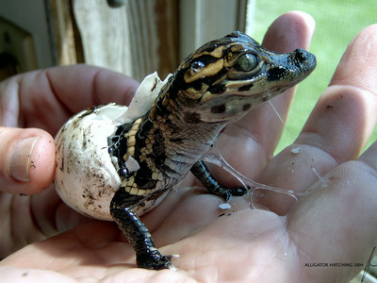
Figure 4.1 — Recovered File 1 (00105873.jpg, a related recovered image shown for illustration) rendered from the carved data

Recovered File 2: 00106865.gif
Original filename: Not recoverable — no surviving FAT directory entry (recovered via signature-based carving of unallocated space, not directory traversal)
File type: GIF image (GIF89a), 290×246, 11 KB
Recovery method: Carved from unallocated space at offset 54,714,880 using foremost, based on GIF header (“GIF89a”) / trailer (0x3B) signature matching.
Evidence of successful recovery: The recovered file decodes as a valid, complete GIF with an intact colour table and correct declared dimensions matching the rendered image — confirmed with `identify` and direct visual inspection.
Significance: Demonstrates that non-JPEG image formats are also present on the device, recovered from the same pre-wipe surviving region as Recovered File 1; corroborates Artifact 3.
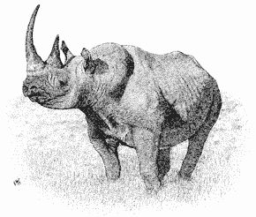
Figure 4.2 — Recovered File 2 (00106865.gif) rendered from the carved data

Recovered File 3: diary_fragment.txt
Original filename: Not recoverable — no surviving FAT directory entry (recovered via signature-based carving of unallocated space, not directory traversal)
File type: Plain ASCII/extended-ASCII text, 6,278 bytes
Recovery method: Manually carved by identifying a printable-text run inside the CHARLIE-wiped region (offsets 171,531,840–171,538,118) during offset-by-offset content analysis, since no file-signature carver targets unstructured plain text.
Evidence of successful recovery: The recovered text is coherent, grammatically continuous, first-person prose with no truncation artefacts at either boundary — strong indication the full readable fragment was captured, bounded on both sides by the surrounding CHARLIE pattern.
Significance: This is the single most significant recovered artefact: the author's own words describe destroying a prior hard drive and stating intent to reformat this USB device, directly explaining the wiped condition documented in Artifact 2.

Table 4.1 — Remaining Recovered Files
Filename | Type | Size | Offset | Note
00104249.jpg | JPEG | 405 KB | 53,375,488 | 1349×900, no EXIF
00105065.jpg | JPEG | 401 KB | 53,793,280 | 1686×1122, no EXIF
00105873.jpg | JPEG | 258 KB | 54,206,976 | Duplicate of 00335081.jpg (Artifact 5)
00106393.jpg | JPEG | 6 KB | 54,473,216 | 169×228 thumbnail, “LEAD Technologies” comment
00106409.jpg | JPEG | 225 KB | 54,481,408 | 1024×685, no EXIF
00106889.gif | GIF | 4 KB | 54,727,168 | 150×87
00335017.doc | DOC | 11MB | 171528704

Task 5 — Timeline Reconstruction
The available timeline is severely constrained by the large-scale wipe identified in Artifact 2: carved files recovered from unallocated space carry no filesystem metadata (no creation/modification/access/deletion timestamps), because that metadata lives in directory entries that no longer exist. The only reliable timestamps on the entire volume are the Created/Written times on the two allocated files. The sequence below combines those hard timestamps with the relative ordering that can be inferred from disk layout and content.
Order | Event | Timestamp / Basis | Evidence type
1 | GUMBO1.TXT written to volume | 2004-04-30 18:11:20 (UTC) — FAT Created/Written time | Filesystem metadata (hard timestamp)
2 | GUMBO2.TXT written to volume | 2004-04-30 18:11:24 (UTC) — FAT Created/Written time | Filesystem metadata (hard timestamp)
3 | Photographs (Artifact 3) written to device | Undated — inferred to predate the SORRY wipe, as they occupy the cluster range immediately before it | Relative position / inference, no hard timestamp
4 | First wipe pass (“SORRY” pattern) executed | Undated — inferred to occur after item 3, before item 5 | Content/pattern analysis, no hard timestamp
5 | Diary text + duplicate JPEG (Artifacts 4–5) written or already present | Undated — the diary text itself describes a prior, separate drive being destroyed, distinct from this device | Content analysis (self-referential text), no hard timestamp
6 | Second wipe pass (“CHARLIE” pattern) executed | Undated — inferred to occur after item 5, since it partially overwrote the region containing it | Relative position / inference, no hard timestamp
7 | Device seized by EFCC | 2026-08-02, 09:15 AM | Case background (chain of custody, not derived from the image)

Limitations and Additional Evidence Required
A complete, absolutely-dated timeline cannot be produced from this image alone, for the following reasons:
- The 2004-04-30 timestamps on the only allocated files predate the 2 August 2026 seizure by over 22 years, which is inconsistent with the case timeline. This is most plausibly explained by an incorrectly-set system clock on the computer that last wrote to this device (a common occurrence with older or battery-drained systems, or a device whose FAT metadata was never updated after an initial factory/test write) — but this cannot be confirmed from the image alone.
- Every file recovered from unallocated space (Artifacts 3 and 4, and all nine Task 4 recoveries) lacks any MAC (Modified/Accessed/Created) timestamp, because that data is stored in directory entries that were overwritten. Carving recovers content but not metadata.
- The two wipe operations (SORRY, then CHARLIE) cannot be individually dated; only their relative order (SORRY-region precedes CHARLIE-region on disk, and the diary fragment sits inside the CHARLIE region) can be established from their physical layout.
- To build a fully-dated timeline, the investigation would additionally require: the suspect's host computer (for OS/USB connection artefacts — e.g. Windows Setupapi logs, USB device registry keys, or Linux udev/syslog entries —ord recording when this specific device was last connected and its clock state at the time); any backup, cloud-sync, or communication records referencing the device; and forensic imaging of the “hard drive” referenced in the recovered diary text as having been “thrown into the Mississippi River,” if it can be located.

Overall Conclusions and Recommendations
This examination has established, on verifiable evidence, that: (1) the suspect's specific claim that the device “only contains personal photographs” is false — the only user-visible files are two recipe documents; (2) the device shows strong indicators of a deliberate, large-scale data-wiping operation affecting over 80% of its capacity; and (3) a surviving fragment of first-person text, recovered from within the wiped area, describes the author destroying a separate prior drive and stating intent to reformat this device. No content unambiguously linking the device to drug trafficking or “cartel” activity was recovered from the areas examined, and this report draws no conclusion as to the suspect's guilt or innocence — consistent with the examiner's role.

Recommendations for Further Investigation
- Attempt advanced/fragment-recovery carving (e.g. PhotoRec, Scalpel with custom headers) against the wiped regions in case any cluster escaped the pattern-fill.
- Cross-reference recovered images against known stock-photo/hash databases to fully rule out personal content.
- Pursue the separate drive referenced in the recovered diary text (“thrown into the Mississippi River”) if it falls within the scope of the wider investigation.
- Obtain the suspect's host computer(s) to correlate USB connection artefacts with this device's serial number (0x4092D9D1) and to help resolve the 2004 timestamp anomaly.

