

ENTERPRISE THREAT INTELLIGENCE ASSESSMENT REPORT
Open-Source Exposure and Security Intelligence Assessment

Anointing Ademola
anointingmola_18@yahoo.com | 08120134200

Contents
- Introduction
- Overview
- Objectives
- Scope
- Tools Used
- Methodology
- Findings
- Intelligence correlation
- Intelligence Assessment
- Risk Analysis
- Recommendation

1. Report Purpose and Data Provenance
This report presents a professional restatement and analytical consolidation of an Open-Source Intelligence (OSINT) assessment conducted on NIIT Port Harcourt. It is compiled exclusively from the findings, tables, and supporting screenshots contained in the source assessment materials provided for this exercise.
In line with professional threat intelligence reporting standards, this document does not introduce new findings, infer additional compromise, or speculate beyond what was explicitly recorded in the source material. Where a section of the source document existed only as a heading with no populated content (for example, the original Risk Analysis, Recommendation, and References sections), this is explicitly stated below rather than filled in with assumed content. Where this report offers remediation recommendations, these are clearly identified as the reporting analyst's professional guidance derived directly from the stated findings, not as additional findings.
Note: The source document also contained a second, separate OSINT exercise concerning Dr. Martha Ozohu Musa and Wigwe University, which is unrelated to the NIIT Port Harcourt organizational assessment. That material is presented separately in Appendix A so it is not conflated with the NIIT Port Harcourt findings.

2. Introduction
This Threat Intelligence Report presents the findings of a structured Open-Source Intelligence (OSINT) assessment conducted on NIIT Port Harcourt. The organization reported suspicious login attempts and increased targeted communication directed at employees, while maintaining that no confirmed breach has occurred at the time of assessment.

3. Overview
NIIT Port Harcourt is an education/training-sector organization operating a public web presence (niitph.com) and associated communication channels. The assessment was commissioned to determine the extent to which information about the organization, its infrastructure, and its personnel is discoverable through publicly available, passive intelligence-gathering techniques, and to evaluate what risk this exposure represents given the organization's reported security concerns.
Note: No further organizational background (e.g., size, industry classification, prior incident history) was provided in the source material beyond what is stated above.

4. Assessment Objectives
- Identify publicly available information relating to the organization.
- Assess employee and organizational exposure.
- Discover digital assets and online footprints.
- Investigate publicly available infrastructure.
- Correlate intelligence findings into meaningful relationships.
- Assess security risk based on collected intelligence.
- Produce a professional intelligence report.

5. Scope
This assessment was limited to passive Open-Source Intelligence (OSINT) activities using publicly available information. No intrusive or unauthorized activities were performed.

6. Tools Used
Tool | Purpose
Google Dorking | Advanced search
Whois | Domain information
theHarvester | Email and subdomain discovery
Wayback Machine | Historical website analysis
Maltego | Relationship mapping
HTTrack | Offline website analysis
Shodan | Internet-facing asset discovery
OSINT Framework | Domain registration research

7. Methodology
This assessment followed the intelligence cycle methodology to ensure a structured and repeatable intelligence process:
- 1. Planning
- 2. Collection
- 3. Processing
- 4. Analysis
- 5. Dissemination
Note: The source material lists these five phases as the methodology framework but does not provide phase-by-phase narrative detail; no additional detail has been added here.

8. Findings

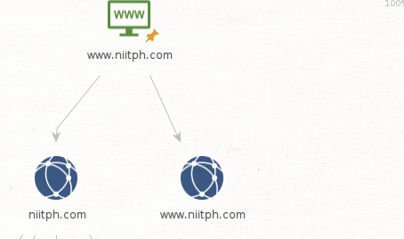

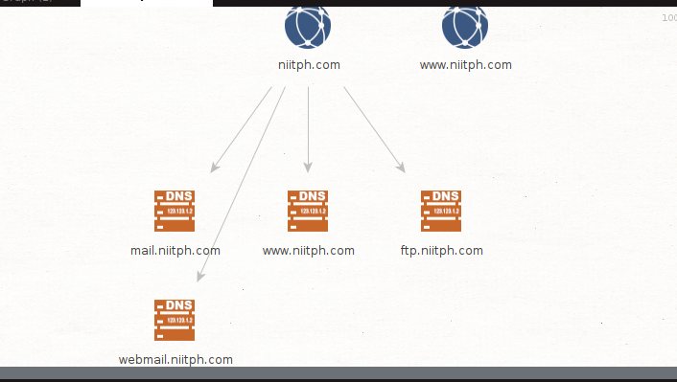

8.1 Human Attack Surface
NIIT Port Harcourt has information available on its website, email addresses, and system details that is accessible to anyone on the internet. This gives attackers a starting point from which to understand the organization. NIIT Port Harcourt maintains a measurable and indexed online presence across multiple platforms:
- Primary website: www.niitph.com
- Subdomains discovered: mail.niitph.com and webmail.niitph.com
- Active Instagram account: @niitphc
- LinkedIn company page: ng.linkedin.com/company/niit-port-harcourt — exposing organizational structure and employee roles
- Contact mailbox: niitportharcourtenquiries@gmail.com
- Alternative domain: niitph.work
Some staff members of NIIT Port Harcourt can be found online with their names and job roles, using the tools and platforms listed above (findings elaborated further in Section 8.3).

8.2 Infrastructure Accessibility
Infrastructure reconnaissance was performed using Maltego to identify the organization's IP address, servers, and ports. The resulting attributes are summarized below:
Attribute | Value
Primary IP Address | 176.123.0.55
Host Status (Nmap) | UP — server is active and reachable
IP Range / CIDR | 176.123.0.0/24
Hosting Provider | ALEXHOST SRL (Moldova-based)
Region Assignment | RIPE NCC — allocated IP block 176.0.0.0/8
Name Servers | ns3.alexhost.md / ns4.alexhost.md
Registrar | Hosting Concepts B.V. d/b/a Registrar.eu
Domain Creation Date | 2025-05-19
Domain Expiry Date | 2026-05-19
DNSSEC Status | UNSIGNED — no cryptographic domain validation
SSL/TLS (niitph.com) | SSL disabled on port 80 — HTTP only
Registrant Country | NG (Nigeria / Rivers State)
Network and Infrastructure Analysis (Nmap)
The target infrastructure was scanned to identify active hosts and exposed services. The scan reported a total of 256 live hosts within the identified range.
Note: 256 addresses is the full size of the stated 176.123.0.0/24 block; the source material does not clarify whether all 256 addresses were individually confirmed live or whether this figure reflects the scanned range size. This observation is an arithmetic note on the data provided, not an additional finding.
Several open ports were detected, including: 21, 53, 143, 443, 444, 465, 587, 880, 993, 995, and 8080. These correspond to commonly used services:
- FTP (21)
- DNS (53)
- IMAP (143, 993)
- POP3 (995)
- SMTP (465, 587)
- HTTP/HTTPS (443, 8080, 444)
- Other SSL-enabled services (as noted in source; specific service not further identified)
NIIT has systems such as websites and email servers that are accessible on the internet. If these systems are not well protected, threat actors can attempt to gain entry through them.

8.3 Personnel Exposure and Email Pattern Analysis
Confirmed Personnel Exposure
Name | Role | Email Identified | Source
Ibigbari Eretoru | Chief Counsellor | ibigbareretoru@niitph.com | niitph.com/about
[Multiple staff — individual names not itemized in source] | Various (Instructors, Admin, IT) | Pattern inferable (no individual addresses confirmed in source) | LinkedIn / Instagram
Email Pattern Analysis
Based on the single confirmed email format observed (ibigbareretoru@niitph.com), the following naming conventions were inferred by the source assessment for other staff:
- Format 1: firstname.lastname@niitph.com
- Format 2: firstnamelastname@niitph.com (concatenated, as seen in the confirmed example)
- Format 3: firstname@niitph.com (short form)
Attack implication: once an attacker identifies a staff member's name via LinkedIn or Instagram, likely email addresses can be generated using these inferred patterns and targeted with spear-phishing, or validated through email-verification services without ever contacting the organization directly.

8.4 High-Value Target (HVT) Classification
Role Category | Attack Vector | Risk Level
IT Administrators | System credential compromise, remote access hijacking | CRITICAL
Finance / Admin Staff | Business Email Compromise (BEC), payment fraud | HIGH
Management / Coordinators | Authority impersonation, executive spear phishing | HIGH
Instructors | Student data access, learning portal credential harvesting | MEDIUM
Chief Counsellor (confirmed) | Directly targeted — identity and email are public | CRITICAL

8.5 Social Engineering Risk Profile
The combination of organizational hierarchy visibility, named individuals, known email patterns, and public communication samples enables the following attack techniques, as identified in the source assessment:
- Spear Phishing — personalized emails using staff names, roles, and organizational context.
- Impersonation — attackers can pose as IT administrators or management using observed communication styles from social media.
- Business Email Compromise (BEC) — finance staff can be targeted with fraudulent payment requests appearing to come from senior management.
- Pretexting — the organization's training program details, events, and student activities create realistic cover stories for social engineering calls or messages.
Threat actors can use the information gathered online about NIIT Port Harcourt — including staff details and email formats — in combination with visible systems such as login portals, to carry out attacks such as phishing or credential (password) theft.

9. Intelligence Correlation
The source material includes one populated correlation entry, mapping a finding to a MITRE ATT&CK technique identifier:
Finding | ATT&CK Technique | Evidence
Employee email addresses are publicly exposed | T1589 — Gather Victim Identity Information | Not provided in source material
Note: T1589 is a publicly defined MITRE ATT&CK technique identifier cited directly in the source document; its official name is provided here for clarity. No further correlation entries, and no supporting evidence text for this entry, were included in the source material.

10. Intelligence Assessment
NIIT Port Harcourt is currently experiencing increased visibility due to its publicly exposed digital and human assets. This exposure will enable threat actors to prepare for, and potentially execute, attacks without a prior breach, and aligns with the organization's own observations of suspicious login attempts and targeted communications.
Conclusion
This assessment confirms that NIIT Port Harcourt currently presents a moderate-to-high pre-breach exposure profile. An adversary operating exclusively through open-source, publicly available information has already achieved the reconnaissance necessary to mount high-confidence attacks.
The suspicious login attempts and targeted employee communications the organization has observed are consistent with an adversary in the reconnaissance-to-weaponization transition phase. This was assessed as a present-state condition rather than a purely theoretical future risk.
The three most critical issues identified in the source assessment as requiring immediate attention are:
- The unencrypted login portal, which exposes credentials in transit.
- The absence of enforced email authentication (DMARC set to reject), which enables domain spoofing.
- The publicly indexed identity and email address of a named senior employee, enabling direct, personalized targeting.
Note: The source material states the DMARC finding as a conclusion-level statement; it does not include the underlying DMARC lookup, record value, or tool output as supporting evidence.

11. Risk Analysis
The source document's dedicated "Risk Analysis" section contained only a heading with no populated content. The table below consolidates the risk ratings that were explicitly stated elsewhere in the source material (Sections 8.1–8.4 and Section 10), so that all rated risks are visible in one place. No new risk ratings have been assigned beyond what the source material stated.
Risk Item | Associated Finding | Stated Risk Level | ATT&CK Ref.
Publicly exposed employee email addresses | Human attack surface (8.1, 8.3) | T1589 (technique, not a severity rating) | T1589
IT administrator compromise | HVT classification (8.4) | CRITICAL | Not provided
Finance/Admin BEC exposure | HVT classification (8.4) | HIGH | Not provided
Management impersonation / spear phishing | HVT classification (8.4) | HIGH | Not provided
Instructor credential harvesting | HVT classification (8.4) | MEDIUM | Not provided
Direct targeting of named Chief Counsellor | HVT classification (8.4), confirmed personnel exposure (8.3) | CRITICAL | Not provided
Unencrypted login portal (HTTP only) | Infrastructure accessibility (8.2); flagged in Section 10 conclusion | Described as a critical issue; no formal severity label assigned in source | Not provided
Absence of enforced DMARC (reject policy) | Section 10 conclusion | Described as a critical issue; no formal severity label assigned in source | Not provided
DNSSEC unsigned | Infrastructure accessibility (8.2) | Not rated in source | Not provided
Broad open-port footprint (11 ports incl. plaintext FTP) | Infrastructure accessibility (8.2) | Not rated in source | Not provided

12. Recommendations
The source document's "Recommendation" section contained only a heading with no populated content. The recommendations below are the reporting analyst's professional guidance, each mapped directly to a finding stated in Sections 8 and 10 above. These are remediation suggestions, not additional findings, and no new exposure or compromise is implied beyond what was already stated.
- Enforce TLS/HTTPS on the organization's login portal and redirect all HTTP traffic to HTTPS.
Rationale: Addresses the unencrypted login portal / credentials-in-transit issue (Sections 8.2, 10).
- Implement and enforce a DMARC policy at p=reject, together with correctly aligned SPF and DKIM records.
Rationale: Addresses the absence of enforced email authentication flagged as a critical issue (Section 10).
- Enable DNSSEC on niitph.com to provide cryptographic validation of DNS responses.
Rationale: Addresses the unsigned DNSSEC status recorded in Section 8.2.
- Review the open ports identified (21, 53, 143, 443, 444, 465, 587, 880, 993, 995, 8080), close or restrict any that are not operationally required, and prioritize replacing plaintext FTP (port 21) with an encrypted file-transfer method.
Rationale: Addresses the broad open-port footprint recorded in Section 8.2.
- Deliver targeted security-awareness training to staff — particularly IT, Finance/Admin, and Management personnel — covering spear phishing, BEC, impersonation, and pretexting scenarios.
Rationale: Addresses the HVT classification and social-engineering risk profile in Sections 8.4–8.5.
- Review the volume and specificity of organizational structure and personnel detail published on the corporate LinkedIn page and other public profiles, and consider reducing role-identifying detail where feasible.
Rationale: Addresses human attack surface exposure recorded in Section 8.1.
- Establish monitoring for look-alike or spoofed domains, given that an alternative domain (niitph.work) is already in active use alongside the primary domain.
Rationale: Addresses the alternative-domain exposure recorded in Section 8.1.
- Correlate the previously reported suspicious login attempts and targeted communications with the OSINT exposure identified in this assessment, to determine whether they share a common origin or campaign.
Rationale: Addresses the organization's originally reported security concern described in Section 2.
- Establish periodic re-assessment or continuous monitoring of the organization's external OSINT footprint, given that domain, DNS, and public-profile exposure can change over time.
Rationale: General good practice supporting the overall exposure profile described in Section 10.

13. Conclusion
Based exclusively on the passive OSINT activities and data recorded in the source material, NIIT Port Harcourt's publicly discoverable digital and human footprint provides a meaningful starting point for an adversary to conduct reconnaissance, identify high-value personnel, and prepare targeted social-engineering or credential-based attacks. The source assessment characterized this as a present-state, moderate-to-high pre-breach exposure profile, and identified the unencrypted login portal, the absence of enforced email authentication, and the public identity/email of a named senior employee as the three most urgent issues. Remediation of these items, together with the broader recommendations in Section 12, is a reasonable next step for the organization to reduce its externally observable attack surface.

14. References
No references were provided in the source assessment material.

Appendix A — Supplementary OSINT Case Study (Unrelated to NIIT Port Harcourt)
Note: This case study was labelled "Assignment Two" in the source material and concerns a separate organization (Wigwe University) and individual (Dr. Martha Ozohu Musa). It is not part of the NIIT Port Harcourt exposure assessment and is included here only for completeness, exactly as it appeared in the source document.

Verification of Staff Affiliation Using Archived Web Data
Introduction
This case study documents an independent verification carried out on previously published content from the official website of Wigwe University, specifically relating to Dr. Martha Ozohu Musa. The aim of the review was to confirm whether the stated association with the institution had ever been publicly documented.
Background
At an earlier point, the university's website contained information suggesting that Dr. Martha Ozohu Musa was linked to the institution, either in a formal staff capacity or as a prospective appointee. The published content included her academic credentials and presented the relationship in a manner that implied official recognition. This information was subsequently removed, and the institution later stated that such content was not part of its official records.
Verification Method
To validate the historical presence of the information, the Wayback Machine was used. This platform stores historical snapshots of web pages, allowing previously published content to be reviewed even after it has been altered or removed from the live site.
Findings
An archived version of the institution's website was successfully retrieved through the Wayback Machine. The snapshot displayed references to Dr. Martha Ozohu Musa along with her listed credentials, indicating an association with the institution at the time of publication. The layout, structure, and styling of the archived page were consistent with the official website, supporting its authenticity as a genuine historical record of the institution's web content.
The archived records indicate that the institution had previously published content implying that Dr. Martha Ozohu Musa was either engaged with, or expected to join, the organization in an official capacity. This contrasts with the institution's subsequent position, in which the existence of such information was denied, despite evidence that it was publicly accessible at the time.
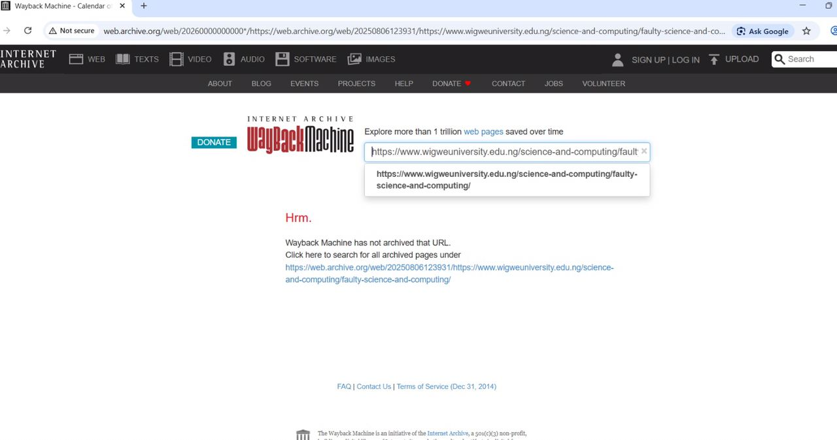
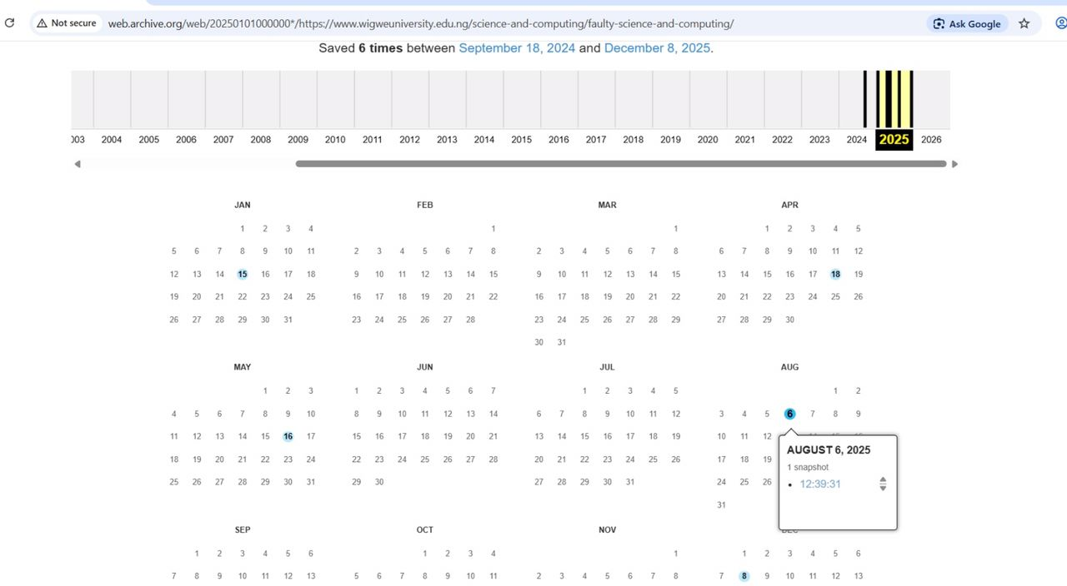
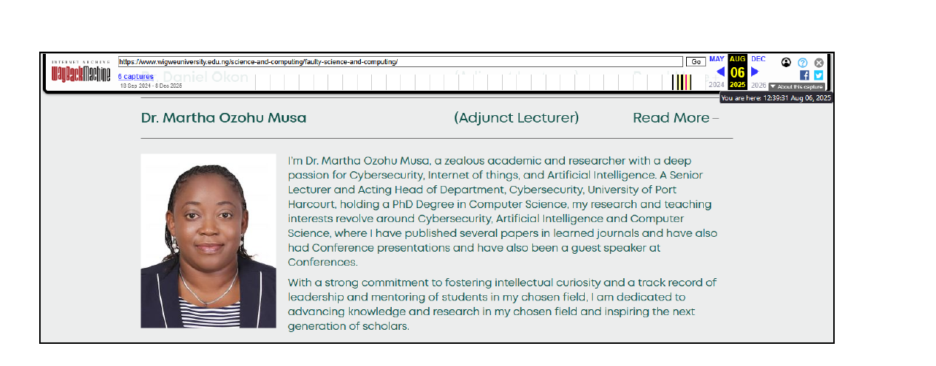
Closing Statement
This case underscores the value of open-source intelligence tools such as the Wayback Machine in verifying historical web content. By preserving earlier versions of websites, such tools make it possible to independently confirm past publications, support transparency, and ensure that changes to publicly available information can still be traced and validated when necessary.

