Blockchain and Machine Learning in Health Care and Management

In propose paper author is combining two technologies such as Blockchain and Machine Learning to secure patient health care records and to predict patient condition so on time treatment can be started and save patient life.

In health care patients may visit different hospitals to get treatment done and all details of patients will be recorded in different hospitals and hackers or hospital peoples may misuse that data and to secure that data author is saving that data in Blockchain Decentralized (data will be stored at multiple nodes) servers. Blockchain store data in immutable Consensus format which ensure that data is secured and legitimate. Blockchain associate each record (also named as block or transaction) with hash code and prior to store new record Blockchain will verify existing records to check any alteration in hash code and if hash code not altered then data is secured otherwise data is altered. By using this hash code verification Blockchain can detect data alteration. So it’s not possible to alter Blockchain data.

Machine learning algorithm will collect all patient’s data from Blockchain as Bag Of Words features and then predict patient condition, and by seeing patient condition prediction output from Machine Learning and patient health data from Blockchain doctors can start treatment and saved patient life. If patient unconscious then he can’t give all health condition details so by collecting data from Blockchain Doctor can take quick action.

If Blockchain not apply on Health care data then patient data will be at risk and can get leak or steal by hackers. In paper author gave lots of details on Health care data hack.

To implement this project we have designed following modules

1. Register or Signup: using this module different hospitals doctors may signup with the application
2. Login: using this module doctors can login to application
3. Add Patient Condition: after login doctors can add patient details. If any patient visited to doctor then doctor will collect his patient ID and add all his health details and this details will be stored in Blockchain
4. Check Patient Records from Blockchain: if any patient condition worsen then doctors just enter his patient ID and all details will be retrieve from Blockchain and input to machine learning algorithm as Bag of words features. By using this features machine learning algorithm will predict patient condition and display all details to doctors. By seeing this details doctor will take quick action to saved patient.

We designed below Blockchain Smart Contract to store patient health care record in database

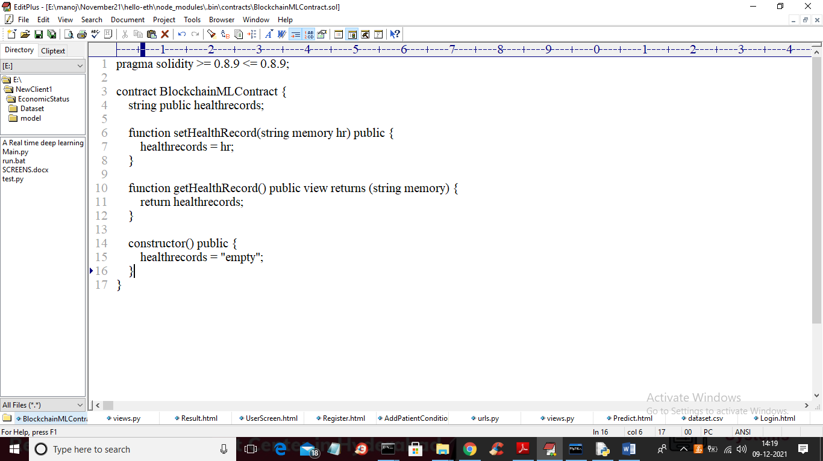

By using above contract Blockchain will call SetHealthRecord to store patient data and getHealthRecord to get record from Blockchain. By using below command we can deploy above contract to Blockchain to get private and public keys.

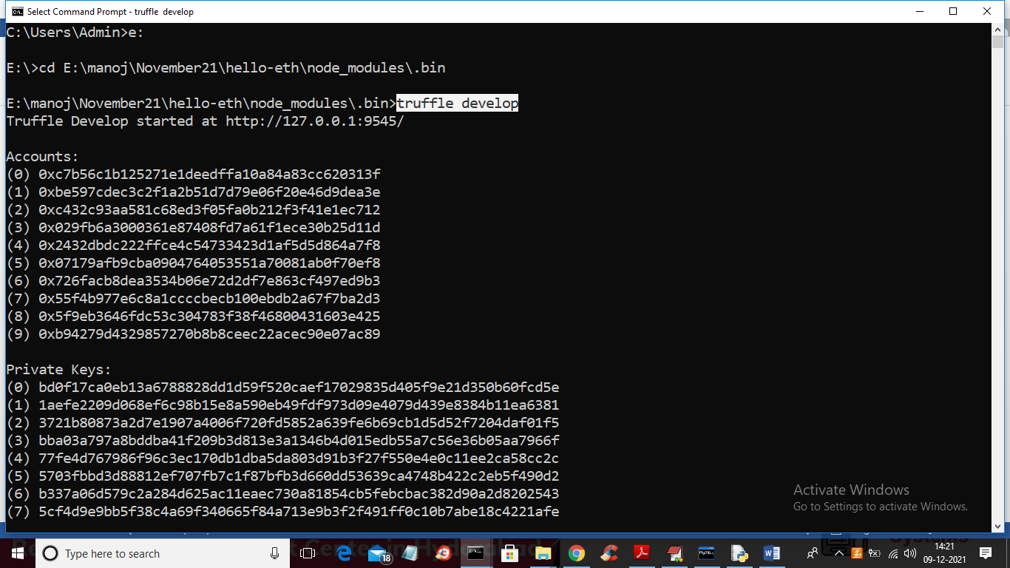

In above screen we need to execute ‘truffle develop’ command to compile smart contract and to get keys. In above screen we can see Blockchain Ethereum generated Accounts Hash Code and private keys and now execute ‘migrate’ command to developed compiled smart contract to Blockchain

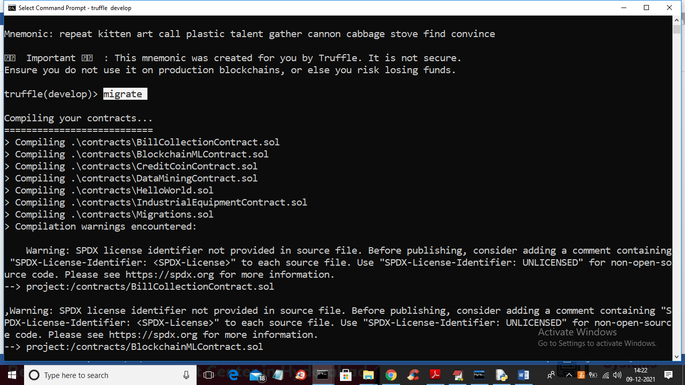

In above screen in white colour text I executed ‘migrate’ command then will get below details

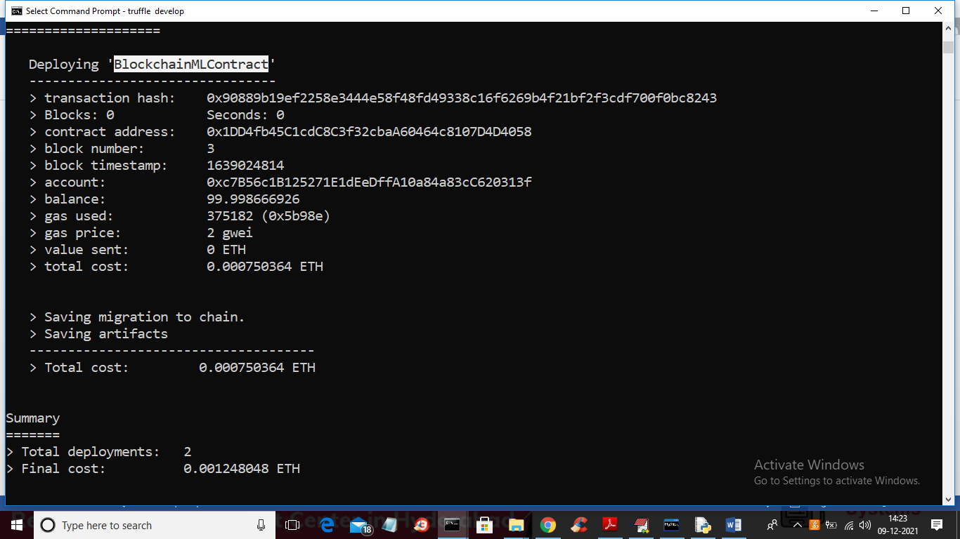

In above screen we can see ‘BlockchainMLContract’ deployed to Blockchain and we got account address and Hash codes and this account address we need to specify in Python program to store and read records.

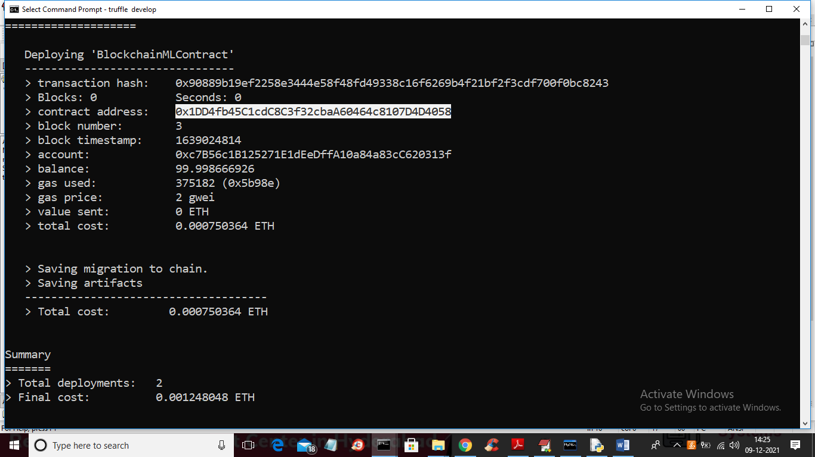

In above screen in white colour text we can see account address where BlockchainMLContract deployed and we use this address in below Python code

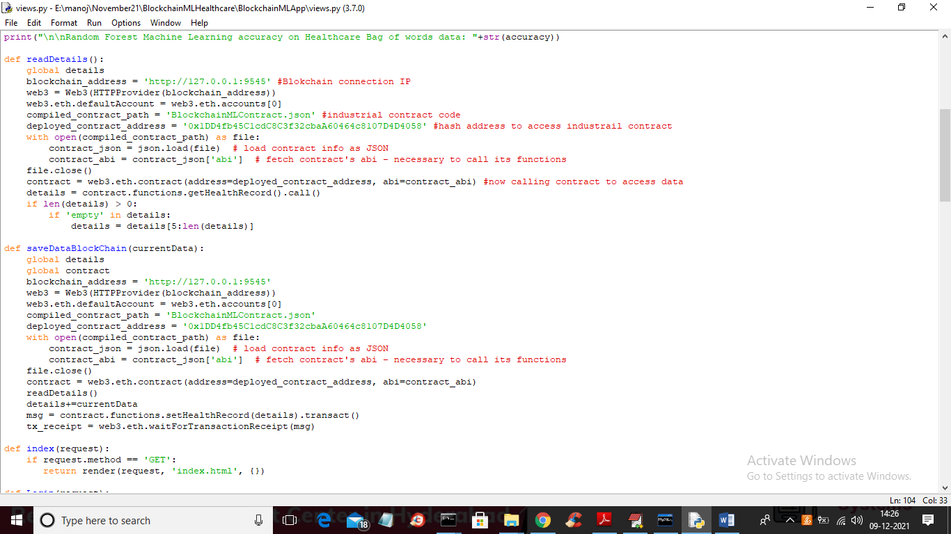

In above screen you can read red colour comments and you can see specify account address also to access Blockchain to store and read records.

SCREEN SHOTS

To run project double click on ‘run.bat’ file to start python DJANGO server and to get below screen

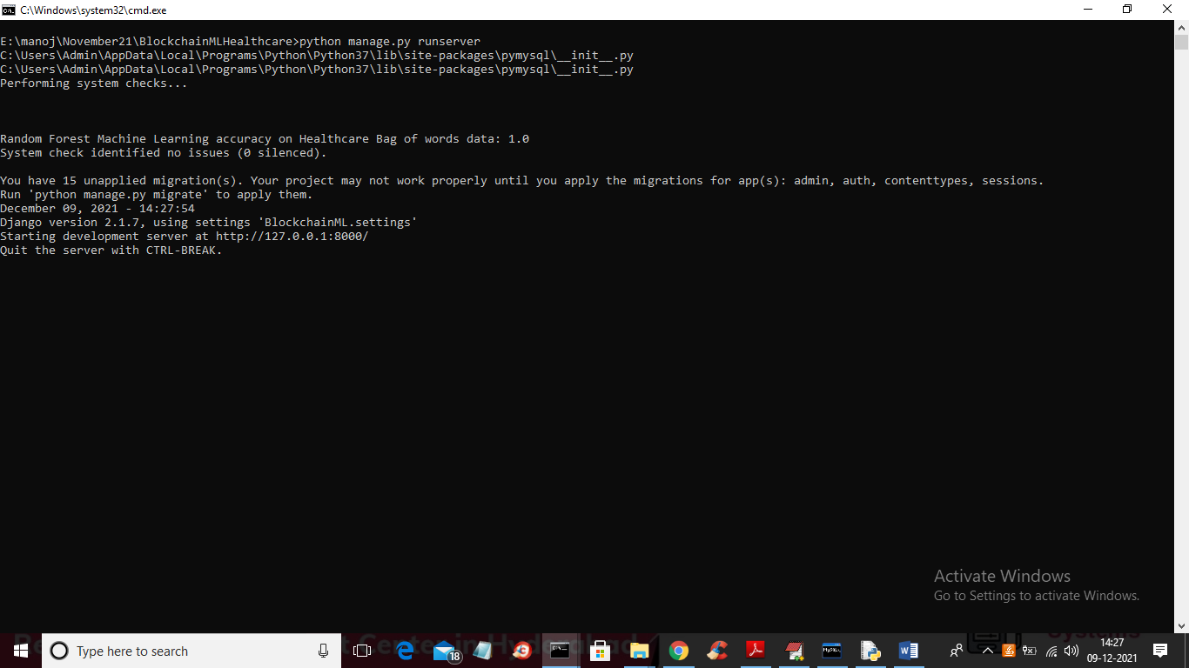

In above screen python DJANGO server started and now open browser and enter URL as <http://127.0.0.1:8000/index.html> and press enter key to get below page

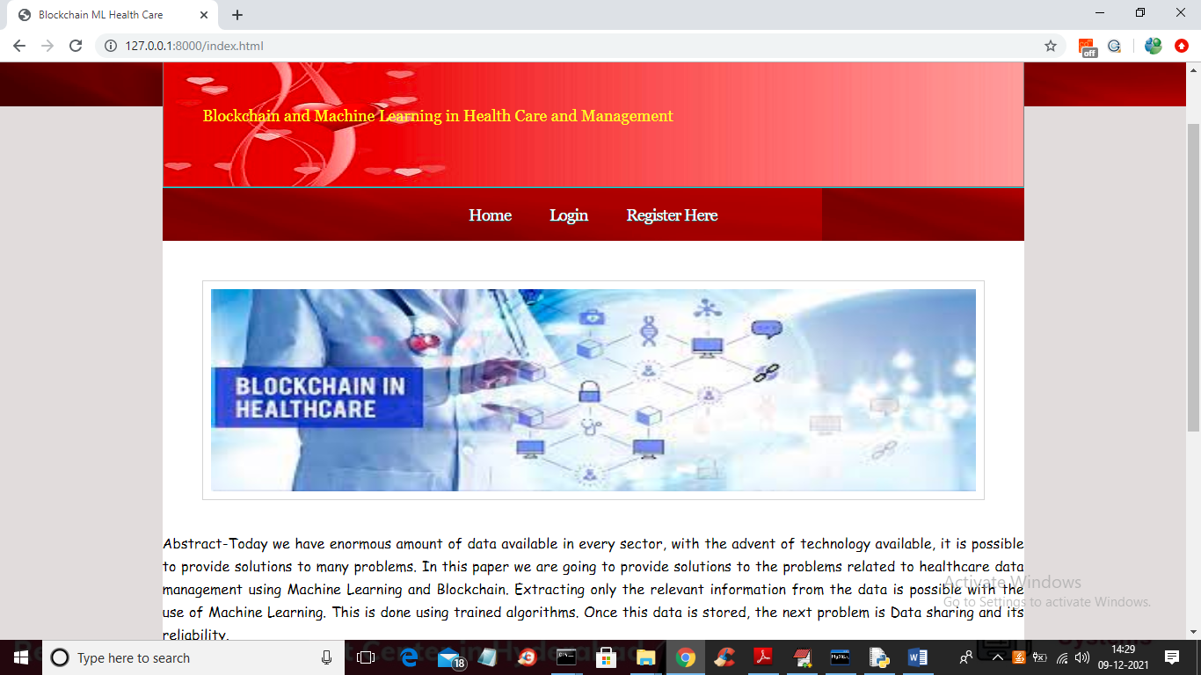

In above screen click on ‘Register Here’ link to add new doctors

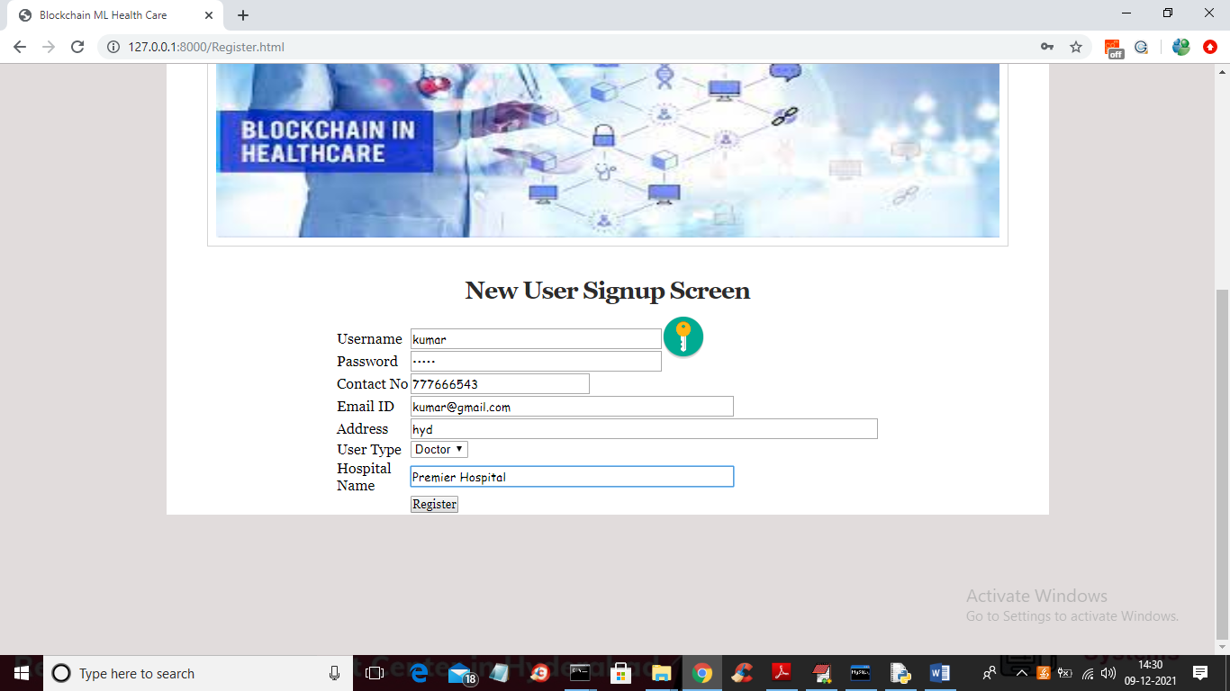

In above screen doctor is getting signup and now press ‘Register’ link to complete signup and to get below screen

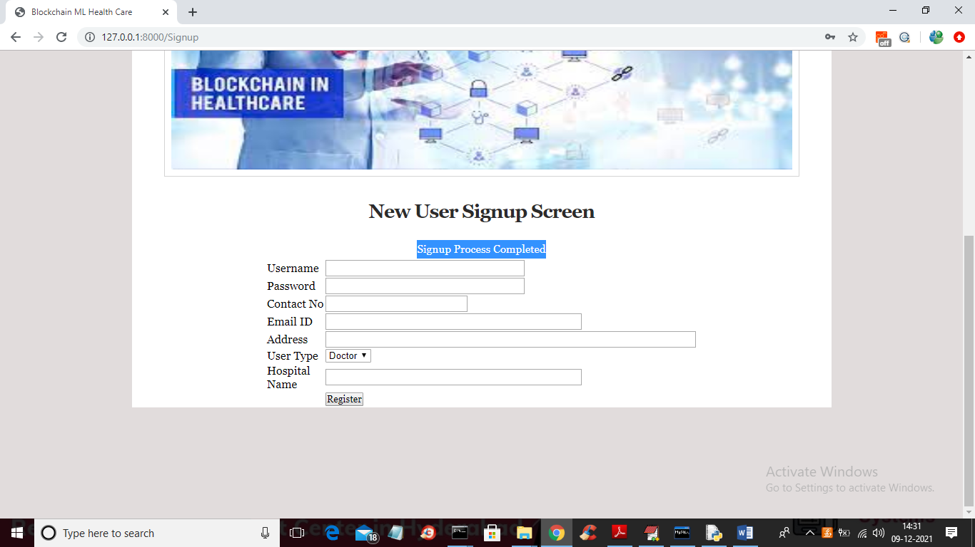

In above screen we can see ‘Signup Process Completed” and now click on ‘Login’ link to get below login screen

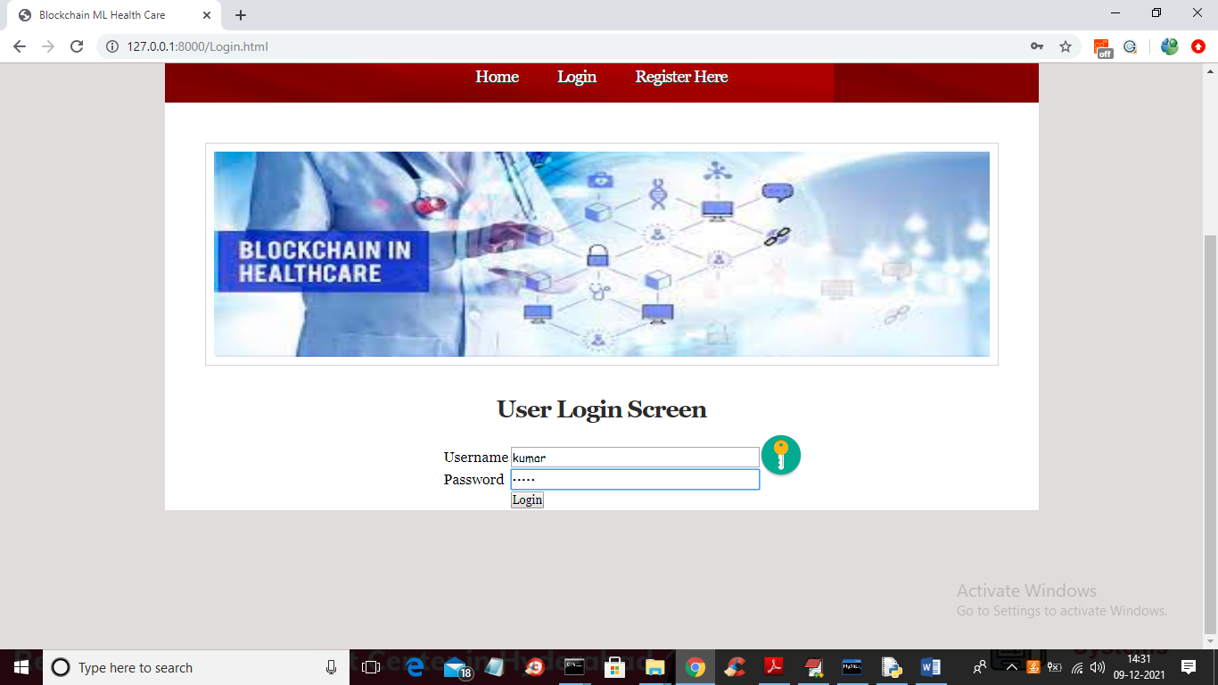

In above screen doctor is login and after login will get below screen

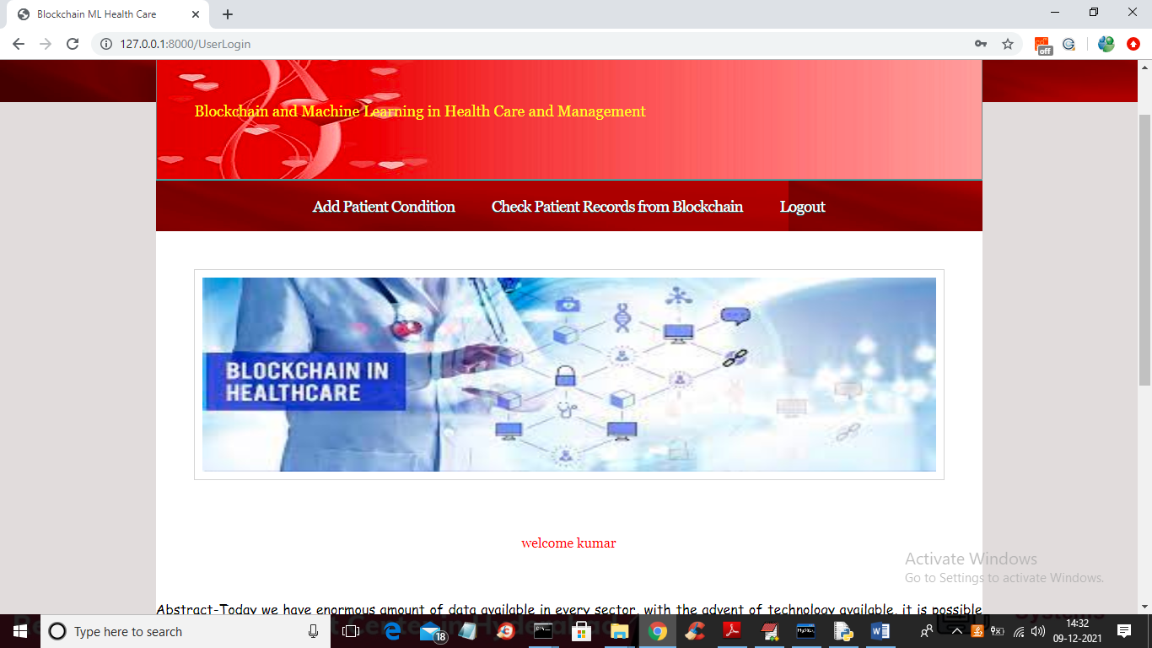

In above screen click on ‘Add Patient Condition’ link to add patient health condition

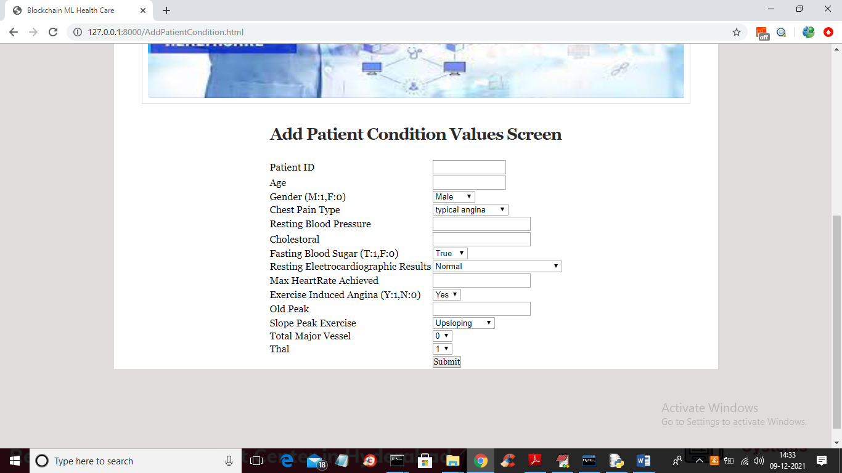

In above screen doctor will add patient details and press ‘Submit’ to save data in Blockchain

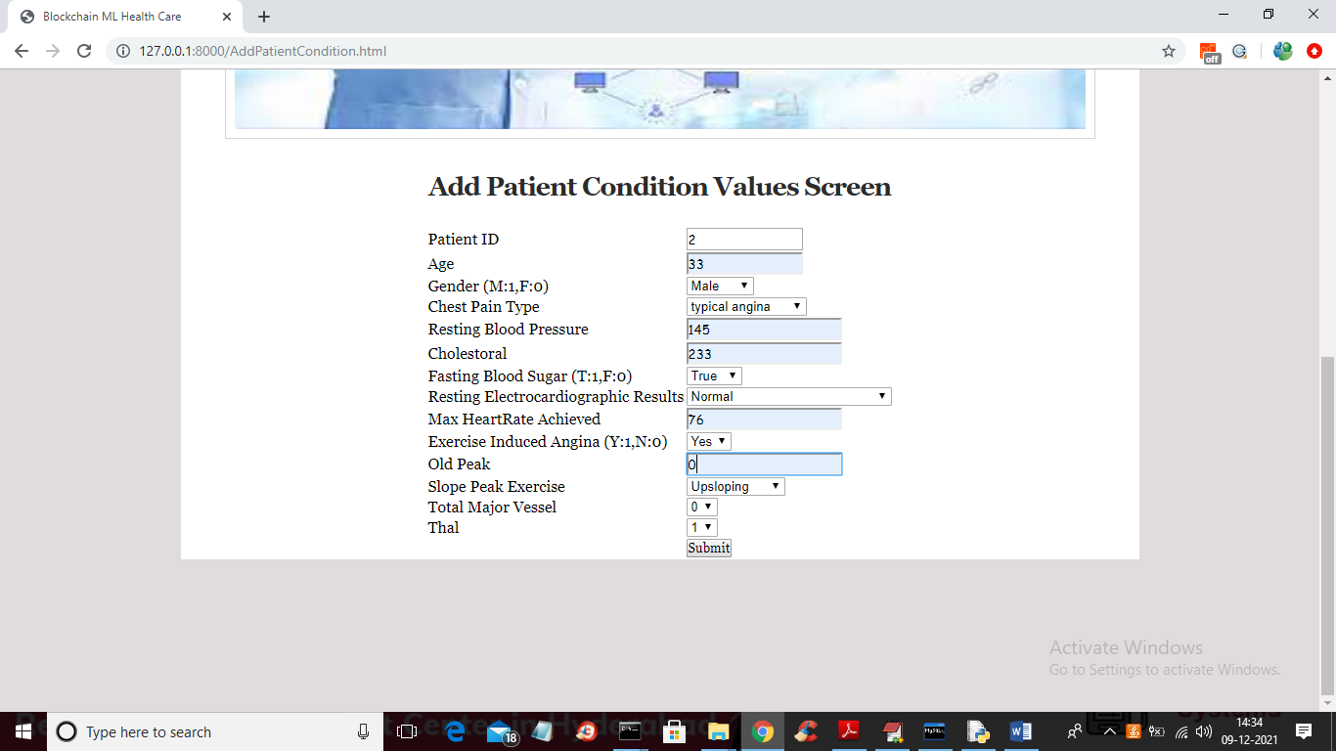

In above screen I entered patient details and then click on ‘Submit’ button to get below output and in above screen just doctor enter details but not mention whether patient condition is ‘Normal’ or ‘Abnormal’ and by using this values Machine Learning algorithm will predict condition.

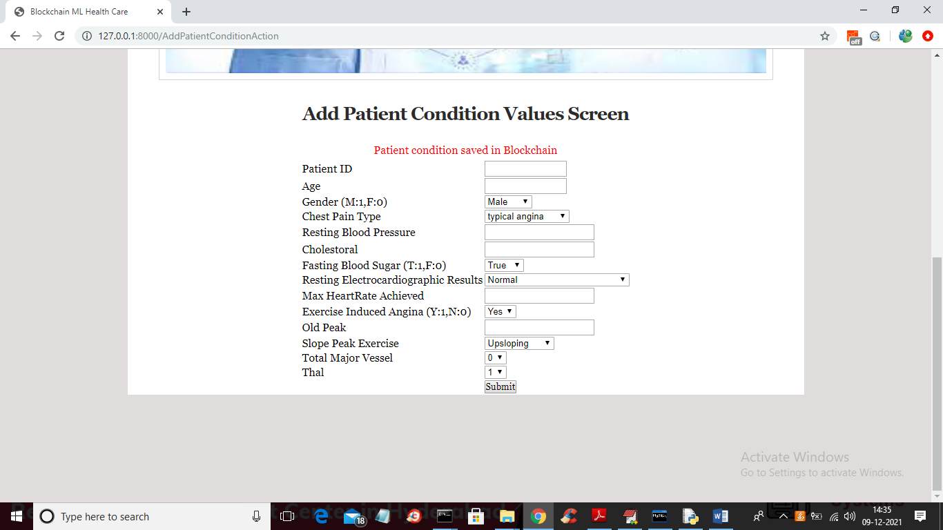

In above screen we can see all details saved in Blockchain and similarly doctors will saved all patient details. Now click on ‘Check Patient Records from Blockchain’ link to get records from Blockchain

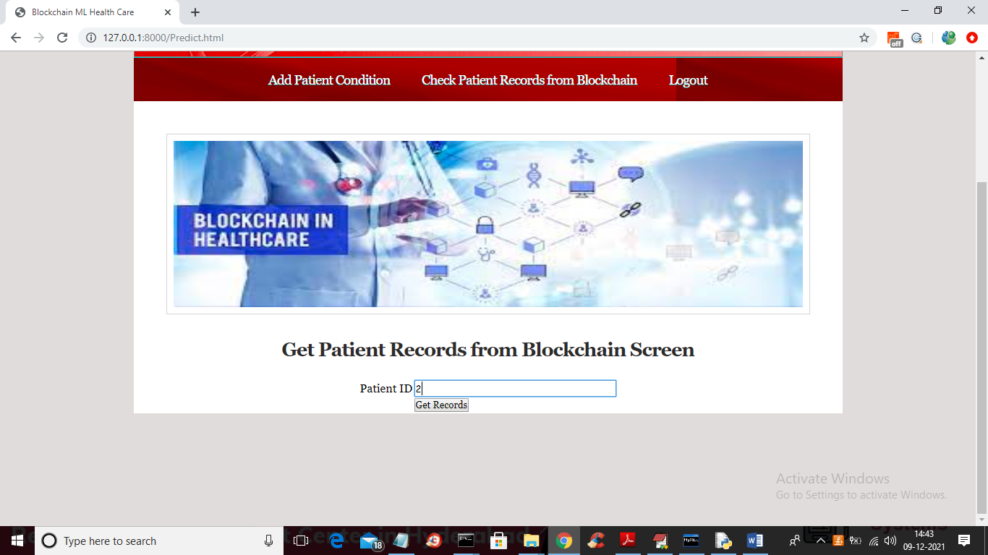

In above screen enter patient id and then click on ‘Get Records’ button to get below output and in above screen I gave patient id as 2 and below is the health records of patient id 2

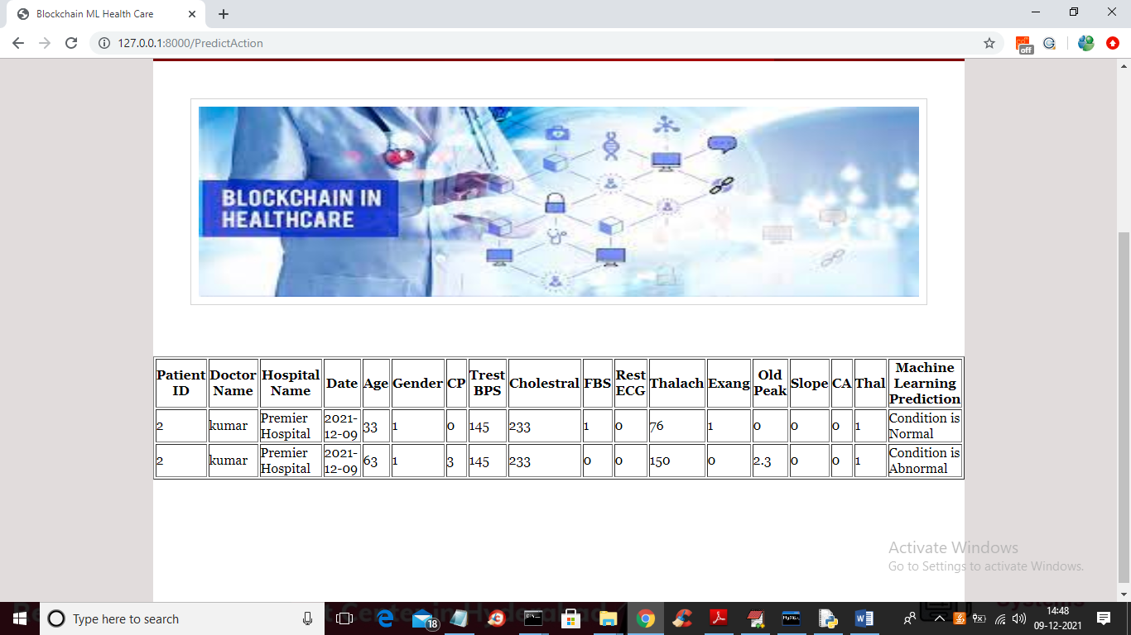

In above screen displaying details of patient id 2 and in last column Machine learning gave prediction as normal or abnormal and above is the patient heart, blood pressure and cholesterol details and by seeing this details doctors will take quick action. Patient just has to say his ID and all records will be retrieve from Blockchain with Machine Learning Prediction. Nobody can hack or alter Blockchain data so patient health records will be secured