Applications of Artificial Intelligence (AI)
Artificial Intelligence is a rapidly growing technology that is penetrating the contemporary world through solutions to numerous problems within different sectors. Taking health care, education, finance, entertainment, and agriculture as some of the sample sectors, there is significant improvement in efficiency, accuracy, and convenience from the general application of artificial intelligence. It replicates human thinking abilities and can solve problems concerning learning, reasoning, and decision-making much more proficiently than a human being.
From helping cars to drive themselves, enhancing the experience a user gets on an interface, or helping researchers in their quest for new knowledge about our universe, AI is asserting itself in the age of smart systems. Thus, it is significant to learn more and use this impactful technology correctly.
AI Applications
The following are some sectors that apply artificial intelligence.
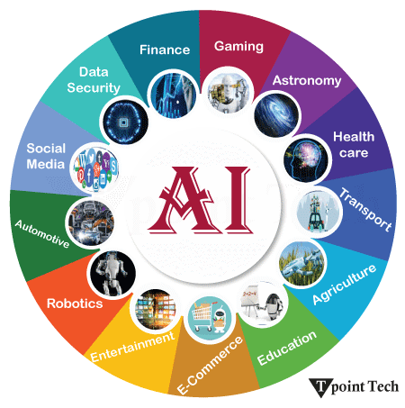
AI in Astronomy
- Automated Celestial Object Identification: Stars, Galaxies, and space phenomena Identification from telescope image data with a high level of accuracy. This speaks to the discovery of new phenomena and datasets that reduce the role of astronomers in making observations on what they find fascinating.
- Exoplanet Hunting: It uses the variation in the brightness of stars to look for drops that suggest the presence of planets orbiting the stars, assisting scientists in finding new exoplanets.
- Analyzing Space Information: AI receives large data feeds from telescopes and makes patterns or irregularities that help in discoveries, such as the confirmation of dark matter or black holes.
- Real-time Monitoring of Space Events: AI systems are used to constantly survey space and look for such events as supernovae to alert astronomers.
- Intelligent Telescope Control: AI sets telescope characteristics according to the actual climate or other conditions or depending on the type of observations that are to be conducted to optimize the images and timeliness of receiving them.
AI in Healthcare

- Medical Imaging Analysis: Diagnosing patients' condition, interpreting X-rays, MRI or CT scans to identify cancerous tissue, breakages, internal bleeding & more.
- Predictive Diagnostics: Patients' history and habits are used to anticipate diseases and conditions before occurrence, and this helps in the diagnosis of diseases such as heart ailments or cancer.
- Drug Discovery & Development: Here, the software mimics the molecular behaviors to screen and select potent drug molecules in a shorter period and with less investment than the corresponding costs involved in the conventional approach.
- Personalized Medicine: AI takes into consideration the patient's genes and medical history to ensure the best results with minimal side effects.
- Operational Efficiency in Hospitals: AI enhances the usage of resources, patient traffic, and staff timetables, as well as limits the wait time for patients.

AI in Gaming

- Smart NPC Behavior: AI makes non-player characters react and adapt dynamically, providing a challenging and immersive gaming experience.
- Procedural content generation: Another area of AI application in games is procedural content generation since it is a time-saving invention that offers a wide variety of game environments, levels, and quests for the players.
- Realistic Graphics and Physics: AI improves the graphics, which makes characters and objects look almost real, as well as making the physical aspects of the game real.

AI in Finance
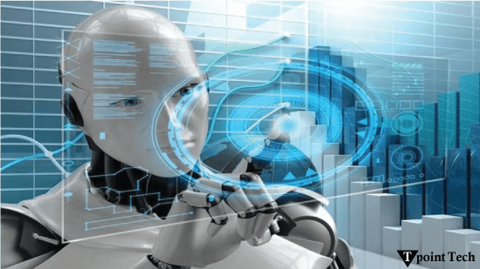
- Fraud Detection: Through machine learning, AI can analyze and quickly distinguish fraudulent transactions based on previous instances, lowering the occurrence of fraud.
- Algorithmic Trading: Accurate computer-driven buying and selling of stocks in the market with high rates of gains, which determines the best time to buy and sell depending on the current data and models.
- Credit Risk Assessment: The AI here looks at how a borrower handles their credit; this enables the lenders to make informed decisions.
AI in Data Security
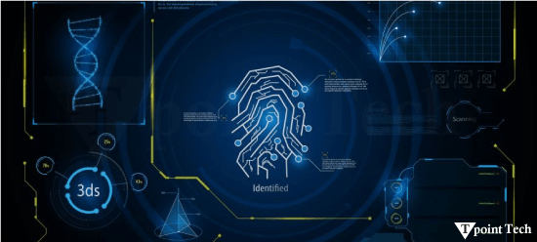
- Anomaly detection: Anomaly detection deals with mining the traffic and identifying exceptions, which may indicate potentially problematic issues such as breaches or malware.
- Risk Estimation: Based on the past records of attacks, the AI determines the possible threats in the future for which preparations can be made beforehand.
- Automated Response Systems: When an invasion is identified, it is possible for an AI to shut down the affected computers or launch a counterattack immediately.
AI in Social Media

- Content Recommendations: It follows the behavior and habits of its users and makes suggestions for posts, videos, or advertisements that entice the users.
- AI Chatbots: These bots automate customer service and avoid delays by relying on customers' messages or comments.
- Sentiment Analysis: AI derives the attitude of users on topics or products and services and comments, which helps in business decisions.
- Trend Identification: AI provides brands with details of topics to look out for concerning social media content or which content is likely to go viral.

AI in Travel & Transport
- Route Planning: AI determines effective and efficient routes across junctions and highways based on real-time occurrence and avoids unnecessary time wastages and fuel costs.
- Security Screening: Intelligent scanning tools that assist in scanning eliminate threats at airports while cutting through the time it takes for security checks.
- Virtual Travel Assistants: AI takes the form of agents that can help with bookings, provide suggestions, or answer inquiries, thus increasing comfort.
- Vehicle and Infrastructure Management: By using AI to foresee when vehicles or infrastructures need to be repaired, there is less risk of breakdowns and accidents with preserved safety.
AI in Automotive Industry
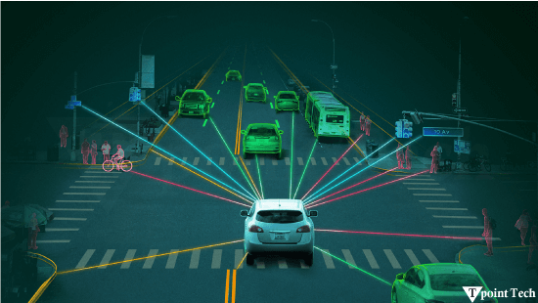
- Autonomous Vehicles: In this case, AI allows the cars to sense the environment and control them by themselves.
- Driver Assistance Systems (ADAS): Some smart features include the ability to identify lanes, maintain lane position, use adaptive cruise control, and automatically brake in case there is an obstacle.
- Manufacturing Automation: AI checks for defects on production lines, controls inventories and increases the efficiency of the manufacturing factory.
- Voice Control: AI ensures that drivers do not need to use their hands to operate the car's navigation system, make phone calls, and control the media since this can distract their attention.
AI in Robotics
- Autonomous Navigation: Robots have the ability to move around and operate and work independently, for instance, in the warehouse or disaster-affected regions.
- Object Manipulation: AI allows robots to identify, pick, and appropriately interact with various objects for applications such as logistics and production.
- Human-Robot Collaboration: AI enhances the capability of the robot to be used with ease by people with the aim of assisting humans in the completion of tasks without affecting their safety at the workplace.
AI in Entertainment
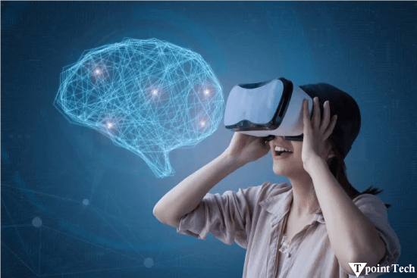
- Personalized Content: Movies, series or music suggestions depending on the user's preferences increase the level of satisfaction among the audience.
- Creative Tools: One of the most important creative use cases of AI is that AI provides the tools to support artists as co-creators in the production of pieces such as music, artwork, or videos.
- Interactive Live Shows: Through AI, real-time translations on stage shows and the overall impact that is exhibited during the show.
AI in Agriculture
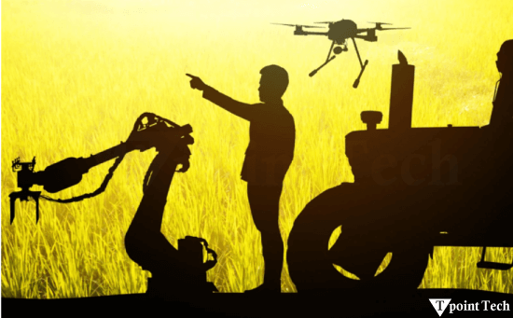
- Crop Monitoring: Drones and sensors help the AI system detect crop health, moisture, and pests to enable timely action.
- Precision Agriculture: AI knows how much water, fertilizer, or pesticide is best to apply to a certain area in order to have maximum return without wasting resources.
- Automated Equipment: In the system used for planting, applying chemicals, and even reaping, machines are driven by AI technology; thus, the cost of labor is high.
- Livestock Tracking: The AI system is used in animals to help farmers note the health or any abusive behavior associated with the stock.
AI in E-commerce
- Product Recommendations: By using product recommendations, the customer is offered products related to their interests, thus making it easy for sales to be made and the customer satisfied with the recommended products.
- Inventory Management: AI anticipates customer demand and can automatically reorder to replenish stocks or else order too many products that are not in high demand.
- Dynamic Pricing: Prices are changed periodically according to factors influencing them, such as market trends, competitor prices, and customer demand, to extract the maximum amount of money.
AI in Education
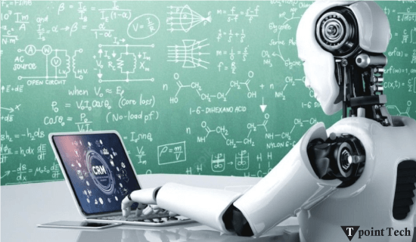
- Automated Content Generation: With the help of Artificial intelligence, teachers can easily present quizzes, notes, and lesson plans so they do not waste time on manual typing, and the quality of the content is higher.
- Virtual Tutors: It is a feature that uses artificial intelligence and is available all the time to assist the learners with questions and guidelines.
- Instant Feedback: Since it can grade assignments and tests over the shortest time possible, it eases the process of checking on student's performance.
- Personalized Learning Paths: Through the help of an Artificial Intelligence application, students are provided with materials suiting their student's abilities and difficulties.

