**Aim**:

Store the graph using adjacency matrix representation and implement Prim’s algorithm to find minimum spanning tree.

**Objectives:**

Implementing Prim’s algorithm and running it on weighted undirected graph .The algorithm is used to find the minimum spanning tree in a graph.This is a greedy algorithm traverses each edge of graph only keeping the smallest connections to each node.

**Theory:**

A minimum spanning tree (MST) or minimum weight spanning tree is a subset of the edges of a connected, edge-weighted undirected graph that connects all the vertices together, without any cycles and with the minimum possible total edge weight. That is, it is a spanning tree whose sum of edge weights is as small as possible.

 Prim’s algorithm is a Greedy algorithm. It starts with an empty spanning tree. The idea is to maintain two sets of vertices. The first set contains the vertices already included in the MST, the other set contains the vertices not yet included. At every step, it considers all the edges that connect the two sets, and picks the minimum weight edge from these edges. After picking the edge, it moves the other endpoint of the edge to the set containing MST.A group of edges that connects two set of vertices in a graph is called cut in graph theory. *So, at* every step of Prim’s algorithm, we find a cut (of two sets, one contains the vertices already included in MST and other contains rest of the verices), pick the minimum weight edge from the cut and include this vertex to MST Set (the set that contains already included vertices).

Example:

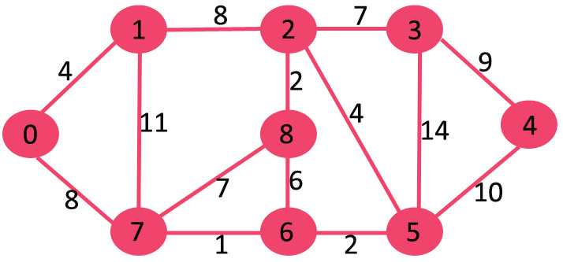

Minimum spanning tree:

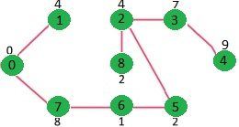

**Algorithm:**

1. Create a set mstSet that keeps track of vertices already included in MST.
2. Assign a key value to all vertices in the input graph. Initialize all key values as INFINITE. Assign key value as 0 for the first vertex so that it is picked first.
3. While mstSet doesn’t include all vertices
4. Pick a vertex *u* which is not there in mstSetand has minimum key value.
5. Include *u*to mstSet
6. Update key value of all adjacent vertices of *u*. To update the key values, iterate through all adjacent vertices. For every adjacent vertex *v*, if weight of edge u-v is less than the previous key value of *v*, update the key value as weight of u-v

**Code:**

#include<iostream>

#define INFINITY 999

#define MAX 6

using namespace std;

class tree

{

private:

int G[MAX][MAX], ST[MAX][MAX];

int v,e;

public:

tree();

void display();

void display_ST();

void MST();

};

tree::tree() //default constructor

{

int i,j;

for(i=0;i<MAX;i++)

{

for(j=0;j<MAX;j++)

{

if(i==j)

G[i][j]=0; //diagonal element zero

else

G[i][j]=INFINITY; //non connected edges

ST[i][j]=0;

}

}

}

void tree::display() //display adjacency matrix of graph

{

int i,j;

for(i=0;i<MAX;i++)

{

for(j=0;j<MAX;j++)

{

cout<<G[i][j]<<"\t";

}

cout<<"\n";

}

}

void tree::display_ST() //display adjacency matrix of spanning tree

{

int i,j;

for(i=0;i<MAX;i++)

{

for(j=0;j<MAX;j++)

{

cout<<ST[i][j]<<"\t";

}

cout<<"\n";

}

}

void tree::MST()

{

int i,j,v0,v1,wt,count;

int process[MAX]={0},via[MAX]={0},distance[MAX]={0};

int sv,mindist,u,v2,Totalcost_Graph=0, Totalcost_MST=0;

//accepting the values

cout<<"\nEnter the no. Of vertices : ";

cin>>v;

cout<<"\nEnter the no. Of edges : ";

cin>>e;

cout<<"\nEnter the "<<e<<" edges : ";

cout<<"\nSource\tDest\tWeight\n";

for(i=0;i<e;i++)

{

cin>>v0>>v2>>wt; // enter start vertex and end vertex and cost

Totalcost_Graph+=wt; //adding total cost of graph

G[v0][v2]=wt;

G[v2][v0]=wt;

}

cout<<"\n";

cout<<"\nAdjacency Matrix of graph:\n\n";

display(); //display graph

cout<<"\nPlease Enter the Starting vertex : ";

cin>>sv;

process[sv]=1; //starting vertex =1

for(i=0;i<v;i++){

distance[i]=G[sv][i]; //copying contents of original graph in dist array

via[i]=sv; //modify via array

}

count=0;

while(count<v-1) //traverse until vertex-1

{

mindist=999;

for(i=0;i<v;i++)

{

if((distance[i]<mindist)&&(process[i]!=1))

{

mindist=distance[i]; //copying distance which is satisfying the condition in mindist

v1=i;

}

}

u=via[v1];

if(u!=v1) //to avoid self loop

{

process[v1]=1;

ST[u][v1]=mindist;

ST[v1][u]=mindist;

Totalcost_MST+=mindist; //adding total cost of minimum spanning tree

for(j=0;j<v;j++)

{

if((G[v1][j]<distance[j]) && (process[j]!=1))

{

distance[j]=G[v1][j];

via[j]=v1;

}

}

count++; //incrementing count

}//while

}

cout<<"\nSpanning tree matrix is\n\n";

display_ST(); //displaying spanning tree

cout<<"\n\nThe Edges added in the minimum spanning tree";

cout<<"\n\nSource\tDest\tWeight\n";

for(i=0;i<MAX;i++)

{

for(j=0;j<MAX;j++)

{

if((j>=i)&&ST[i][j]!=0)

cout<<i<<"\t"<<j<<"\t"<<ST[i][j]<<"\n";

}

// cout<<"\n";

}

cout<<"\nTotalcost_Graph is = "<<Totalcost_Graph; //displaying

cout<<"\nTotalcost_MST is = "<<Totalcost_MST;

}

int main()

{

tree t;

t.MST();

return 0;

}

/*----------------OUTPUT----------------

Enter the no. Of vertices : 5

Enter the no. Of edges : 7

Enter the 7 edges :

Source Dest Weight

0 1 1

1 2 5

2 4 4

2 3 3

4 0 8

4 3 2

3 0 7

Adjacency Matrix of graph:

0 1 999 7 8 999

1 0 5 999 999 999

999 5 0 3 4 999

7 999 3 0 2 999

8 999 4 2 0 999

999 999 999 999 999 0

Please Enter the Starting vertex : 1

Spanning tree matrix is

0 1 0 0 0 0

1 0 5 0 0 0

0 5 0 3 0 0

0 0 3 0 2 0

0 0 0 2 0 0

0 0 0 0 0 0

The Edges added in the minimum spanning tree

Source Dest Weight

0 1 1

1 2 5

2 3 3

3 4 2

Totalcost_Graph is = 30

Totalcost_MST is = 11

*/

**Conclusion:**

|  |  |
| --- | --- |
| **Minimum edge weight data structure** | **Time complexity (total)** |
| Adjacency matrix, searching | O(|V|2) |
| Binary heap and adjacency list | O((|V|+|E|)log|V|)=O(|E|log|V|) |
| Fibonacci heap and adjacency list | O(|E|+|V|log|V|) |