ASSIGNMENT 7

AIM : Create a singly linked list for student data and perform :

i) Insertion ii) Deletion iii) Search iv) Modify

OBJECTIVE :

Objective of singly linked list is to store a reference to an object that is an element of the sequence, as well as a reference to the next node of the list. In this assignment, a student database is created using the singly linked list to insert, delete, search and modify the elements in the database.

THEORY :

Singly linked list is a basic linked list type. Singly linked list is a collection of nodes linked together in a sequential way where each node of singly linked list contains a data field and an address field which contains the reference of the next node.

Each node of a singly linked list follows a common basic structure. In a node we can store more than one data fields but we need at least single address field to store the address of next connected node.

struct node

{

int data; // Data

struct node \* next; // Address

};

To perform any operation on a linked list we must keep track/reference of the first node which may be referred by head pointer variable. In singly linked list address field of last node must contain a NULL value specifying end of the list.

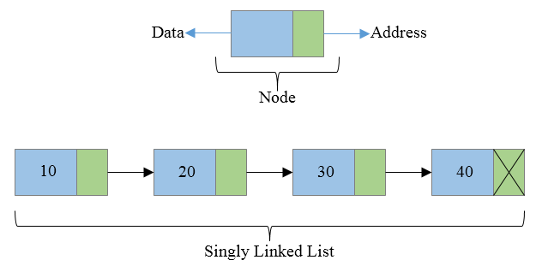

ALGORITHM : Algorithm of creation of a Linked List

CREATE---In this algorithm a Linked List of nodes is created. The list is pointed by pointer first, the last node of the list points to NULL., indicating the end of the list.

searching in sLL

1.If first=NULL then{

Print “List empty”; STOP;}

2.ptr=First; [point ptr to the 1st node]

3.while (ptr<>NULL) repeat steps 4 to 5

4.If (DATA (ptr)= ‘X’)

Then {print “item found”;

STOP

}

5.ptr=NEXT (ptr); [shift ptr to the next node]

[end of while]

6.Print “item not found”;

7.END

insertion algo    1.X=new node;

2.Read(DATA(X);

3.If (FIRST=NULL) then

{

First=X;

NEXT(X)=NULL;

}

Else

{

NEXT(X)=First;

First=X;

}

4.END

delete from linked list    1.If (DATA(list)=’VAL’)then

{

Ptr=LIST;

LIST=NEXT(list);

Delete ptr;

Stop;

}

Back=list;

Ptr=list;

2.while(ptr<>NULL) repeat step 3 to 5

3.If(DATA(ptr)=’VAL’) then

{

NEXT(back)=NEXT(ptr);

Delete ptr;

Exit;}

4.back=ptr;

5.ptr=next(ptr);

[end of while loop]

6.END

SOURCE CODE:

/\*

PROGRAM BY ANOM DEVGUN

GR: 21810017

Successfully implemented SLL and its various operations with edge cases resolved.

\*/

#include<iostream>

#include<cstdio>

#include<cstdlib>

using namespace std;

struct node

{

int data;

struct node \*next;

}\*head = NULL;

void create() //Function to create nodes at end of list

{

struct node \*nn,\*t;

nn= new node;

cout<<"Enter Data\n";

cin>>nn->data;

nn->next = NULL;

if(head == NULL)

head = nn;

else

{

t=head;

while(t->next != NULL)

t = t->next;

t->next = nn;

}

}

void beg()

{

struct node \*nn,\*t= NULL;

nn= new node;

cout<<"Enter Data\n";

cin>>nn->data;

if(head == NULL)

{

head = nn;

nn->next = NULL;

}

else{

nn->next = head;

head = nn;

}

}

void disp() //Function to display data of nodes;

{

struct node \*t;

t=head;

if(t == NULL)

{

cout<<"List is empty\n";

return;

}

while(t != NULL)

{

cout<<"Data: "<<t->data<<"\n";

t=t->next;

}

}

void sear() //Function to search data in list

{

struct node \*t;

int dat,sr=1;

t = head;

cout<<"Enter Data to be searched\n";

cin>>dat;

if(t == NULL)

{

cout<<"The list is empty.\n Now exiting to main menu.\n";

return;

}

while(t->data != dat)

{

t = t->next;

sr++;

if(t -> data != dat && t -> next == NULL)

{

cout<<"Search data not found in list.\n";

return;

}

}

cout<<dat<<" Found at node "<<sr<<"\n";

}

void del() //Function to delete data from list

{

struct node \*t,\*a;

int dat,sr=1;

t = head;

cout<<"Enter Data to be searched and deleted\n";

cin>>dat;

if(t == NULL)

{

cout<<"The list is empty.\n Now exiting to main menu.\n";

return;

}

while(t->data != dat)

{

a=t;

t = t->next;

sr++;

if(t -> data != dat && t -> next == NULL)

{

cout<<"Search data not found in list.\n";

return;

}

}

if(head->data == dat )

{

head = head->next;

}

cout<<dat<<" Found at node "<<sr<<"\n";

cout<<"Node and data deleted\n";

a->next = t->next;

delete(t);

}

void mod() //Function to modify data in list

{

struct node \*t;

int dat,sr=1;

t = head;

cout<<"Enter Data to be modified\n";

cin>>dat;

if(t == NULL)

{

cout<<"The list is empty.\n Now exiting to main menu.\n";

return;

}

while(t->data != dat)

{

t = t->next;

sr++;

if(t -> data != dat && t -> next == NULL)

{

cout<<"Search data not found in list.\n";

return;

}

}

cout<<dat<<" Found at node "<<sr<<"\n";

cout<<"Enter new data\n";

cin>>t->data;

}

int main()

{

int ch;

while(1)

{

cout<<"\n1)For Entering data(at list end)\n";

cout<<"2)For Displaying linked list data\n";

cout<<"3)for adding at beginning of list\n";

cout<<"4)To search data from list\n";

cout<<"5)To delete data from list\n";

cout<<"6)To modify data in list \n";

cout<<"7)To exit\n";

cin>>ch;

cout<<"\n";

switch(ch)

{

case 1:

create();

break;

case 2:

disp();

break;

case 3:

beg();

break;

case 4:

sear();

break;

case 5:

del();

break;

case 6:

mod();

break;

case 7:

cout<<"\nNow exiting\n";

exit(1);

break;

default:

cout<<"Invalid choice.\n";

}

}

}

Time Complexity: O(n).

CONCLUSION:

We studied the fundamentals of linked lists. Linked lists are dynamic data structures where nodes can be added, deleted or updated .It is one of most efficient data structure to implement when traversing in one direction is required.

