Data Understanding

Objective:
Explore the MNIST dataset systematically. Learn its structure, patterns and challenges.
- Part A: Load and Inspect
  - Load the MNIST Dataset
    - Questions to answer:
      - 1. Where does MNIST come from? (keras.datasets, sklearn, or direct download?)
        - A: From Kaggle in .zip
      - 2. How many total samples are there?
        - A: 60.000 training set and 10.000 test set
      - 3. What is the shape of each image? (Should be 28×28 pixels)
        - A: 28x28 (need to be checked)
      - 4. What is the pixel value range? (0–255 or 0–1?)
        - A: Need to be checked (if can’t, check the documentation, but should be observable)
      - 5. Are there 10 classes (digits 0–9)? Confirm.
        - A: Yes, 10 classes from 0-9 digits

- Part B: Class Balance
  - Examine Class Distribution
    - Classes are balanced around 6000 samples/digit from 5421 to 6742

- Part C: Visualize Sample Image
  - Visualize Sample Images
    - 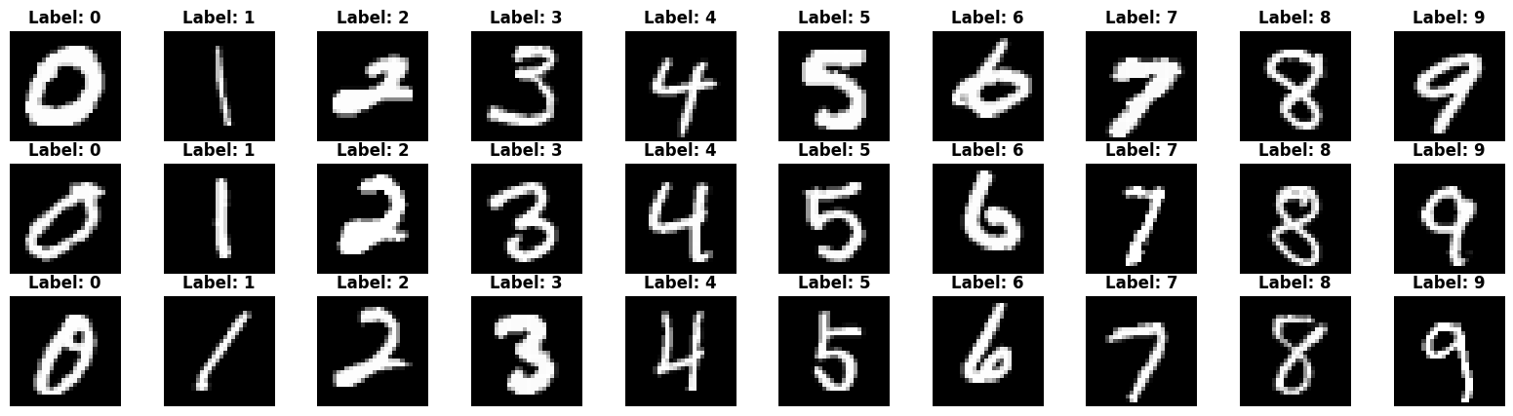

- Part D: Statistical Summary
  - Pixel Statistics
    - 28x28 pixels -> 0-255 (black to white)
- Part E: Data Quality Checks
  - Look for Issues
    - No quality problems:
      - No missing data
      - No duplicated data

- Part F: Hypotheses for Modeling
  - Form Hypotheses for Modeling
    - the 1, 9 and 0 might be the easiest to find, because 0 is easy to recognise, 1 is the darkest and easy to recognise and 9 is the brightest, it might be closer to the others.
    - 4, 5 and 3 would be misclassified easily because they are closer in look to other numbers.
    - the confusing pairs: 9-5, 4-5, 3-9 maybe. and 4-7 as well.

- Part G: Summary Statistics
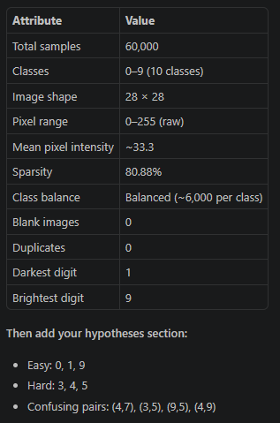
  - Create a summary table:

