

## DATA STRUCTURE AND ALGORITHM

(LAB)

**PROJECT TITLE:-**

Conversion of Digits to Words

**SUBMITTED BY:-**

Muhammad Laraib Akhter

**ID:-**

32409

**SUBMITTED TO:-**

Sir Kamal Malik

**DATE:-**

28/12/2021

**Source Code:-**

#include <iostream>

using namespace std;

string stringofones[] = { "", "one ", "two ", "three ", "four ",

"five ", "six ", "seven ", "eight ",

"nine ", "ten ", "eleven ", "twelve ",

"thirteen ", "fourteen ", "fifteen ",

"sixteen ", "seventeen ", "eighteen ",

"nineteen " };

string stringoftens[] = { "", "", "twenty ", "thirty ", "forty ",

"fifty ", "sixty ", "seventy ", "eighty ",

"ninety " };

string conversion(int Num, string s)

{

string str = "";

if (Num > 19)

str += stringoftens[Num / 10] + stringofones[Num % 10];

else

str += stringofones[Num];

if (Num)

str += s;

return str;

}

string End_Result(long Num)

{

string End;

End += conversion(((Num / 100000000000) % 100), "Kharab ");

End += conversion(((Num / 1000000000) % 100), "Arab ");

End += conversion(((Num / 10000000) % 100), "crore ");

End += conversion(((Num / 100000) % 100), "lakh ");

End += conversion(((Num / 1000) % 100), "thousand ");

End += conversion(((Num / 100) % 10), "hundred ");

if (Num > 100 && Num % 100)

End += "and ";

End += conversion((Num % 100), "");

return End;

}

int main()

{

long Num;

cout<<"Please Enter your Number: ";

cin>>Num;

cout << End_Result(Num) << endl;

return 0;

}

**OUTPUT:-**

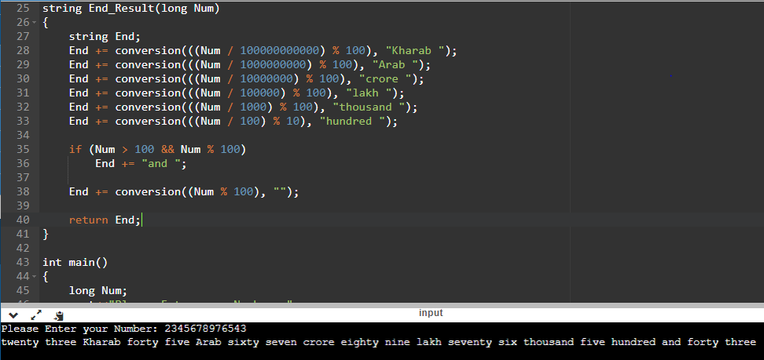

**THE END**