Employee Management System
C330L — Week 3 Course Project
Abstraction, Constructors, & Access Specifiers
Anosha Naseri | October 21, 2026

1. Project Overview
The Employee Management System is a Java console application that maintains sample employee records and calculates pay for hourly, salaried, and commission-based employees. Week 3 builds on the Week 2 implementation by making Employee an abstract superclass, adding overloaded constructors, and demonstrating appropriate access specifiers and encapsulation. Existing inheritance, Address composition, the Payable interface, polymorphism, menu interaction, and input handling are retained.

2. Updated Class Design
Class | Responsibilities and Week 3 changes
Payable (interface) | Declares calculatePay() as a public abstract contract.
Employee (abstract) | Stores employee ID, names, department, and Address in private fields; uses a protected constructor; declares abstract calculatePay().
HourlyEmployee | Extends Employee; stores private hourly rate and hours worked; implements hourly pay; adds overloaded constructor with zero hours.
SalariedEmployee | Extends Employee; stores private annual salary; computes monthly pay; adds overloaded constructor with zero salary.
CommissionEmployee | Extends Employee; stores private base salary, total sales, and commission rate; computes base plus commission; adds overloaded constructor with default zero sales/rate.
Address | Stores private address fields; supports full and shortened constructors; provides validated public setters.
App | Creates concrete employees, maintains Employee and Payable lists, and displays an eight-option console menu including Week 3 demonstrations.

3. Updated Class Relationship Diagram
The following diagram shows the class/interface relationships. The arrow labels distinguish interface implementation, inheritance, and composition.
Payable «interface» — calculatePay()
↑ implemented by
Employee «abstract» — private fields, protected constructor, abstract calculatePay()
↑ extended by
HourlyEmployee SalariedEmployee CommissionEmployee
Employee ◆──── Address (composition)
App ──── creates and manages concrete Employee and Payable references

4. Week 3 OOP Concepts
Abstraction: Employee is declared abstract and cannot be instantiated directly. It defines shared data and requires each concrete subclass to implement calculatePay(). Payable separately defines the pay-calculation contract.
Constructors: The Employee superclass has a protected parameterized constructor called with super(...). The concrete employee classes and Address offer overloaded constructors with sensible default values for missing information. The original full constructors remain available.
Access specifiers and encapsulation: Fields are private. Public getters and setters control access, and setters validate key input such as employee ID, names, compensation values, and commission rates. The protected Employee constructor supports subclass initialization without allowing general direct construction.
Polymorphism: Employee and Payable references point to objects of different employee subclasses. Calling calculatePay() uses the subclass-specific implementation at runtime.

5. User Interaction and Input Handling
The welcome screen identifies Anosha Naseri, C330L Week 3, and the assignment title. The menu offers: view all employees, view hourly, salaried, or commission employees, search by ID, demonstrate polymorphism, demonstrate Week 3 OOP concepts, and exit. The menu uses Scanner.nextLine() to accept text safely. The ID search catches NumberFormatException and reports unmatched IDs without terminating the program.

6. Test Results
Test | Observed result | Status
View all employees | Three employees displayed with details and pay. | Pass
Hourly pay | Sarah Johnson: $1,000.00. | Pass
Monthly salary | Michael Smith: $6,000.00. | Pass
Commission pay | Emily Davis: $2,500.00. | Pass
ID search (123) | No employee found with ID 123. | Pass
Polymorphism | Three correct subclass-specific pay results. | Pass
Week 3 OOP demo | Abstract class behavior, overloaded constructors, and getter/setter update displayed. | Pass
Exit | Goodbye message; program returned to command prompt. | Pass
Evidence: The screenshots below were provided from the application running in Visual Studio Code on October 21, 2026. The screenshots show the listed behavior; they do not constitute a separate automated unit-test suite.

7. Application Screenshots
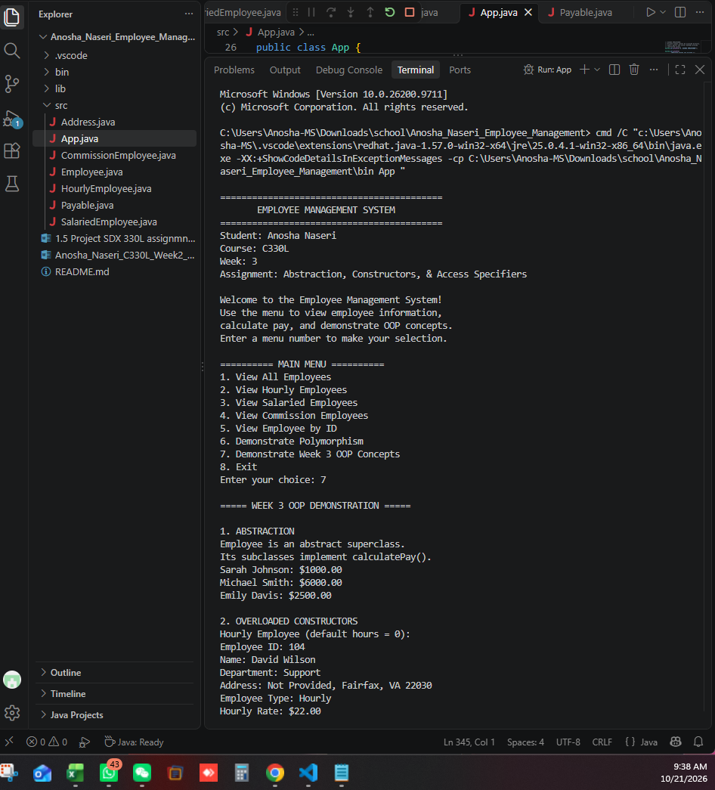
Figure 1. Week 3 welcome screen, menu, and abstraction demonstration.
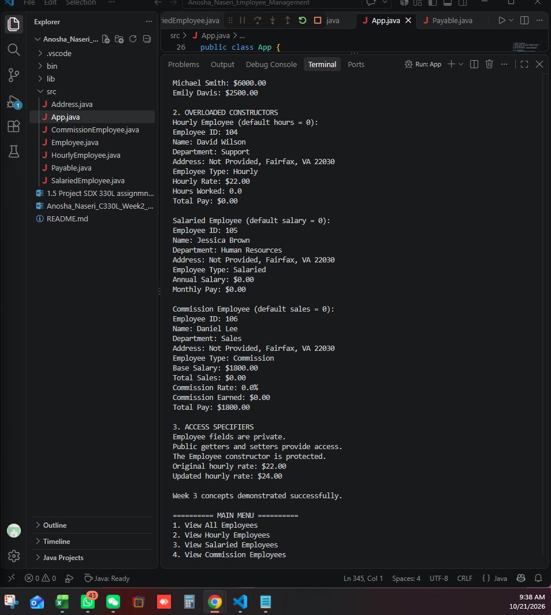
Figure 2. Overloaded constructor output and access specifier demonstration.
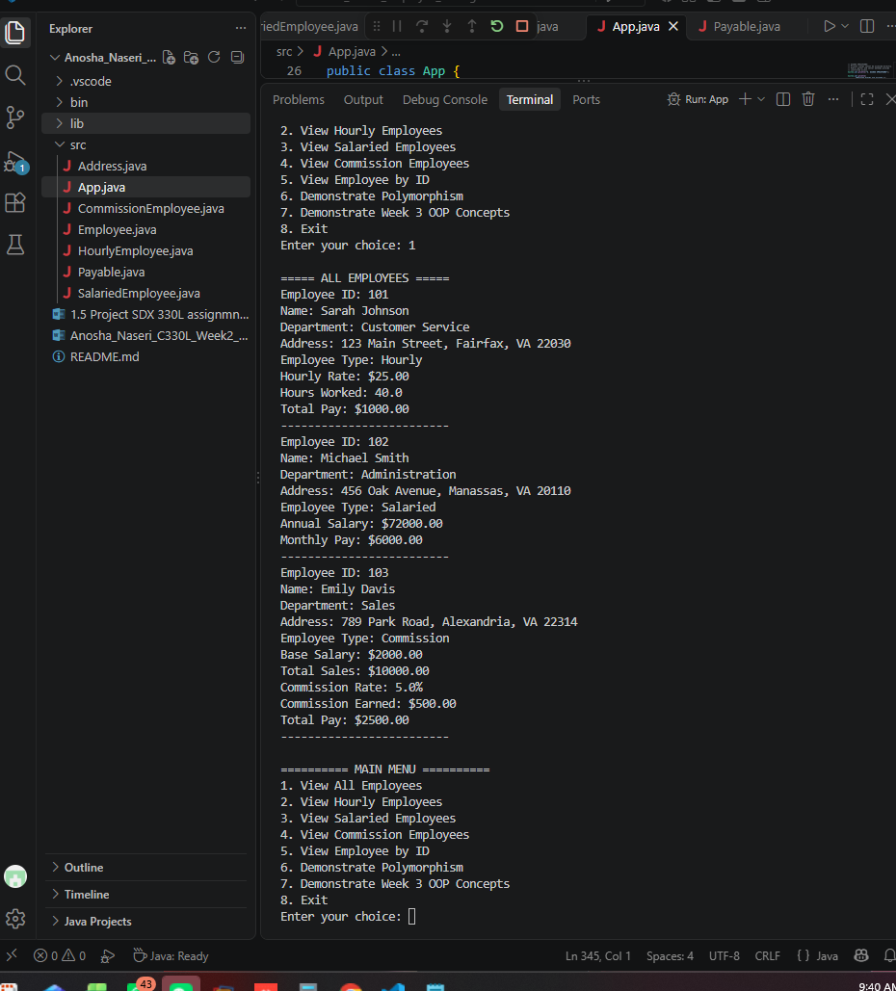
Figure 3. All employee records and pay information.
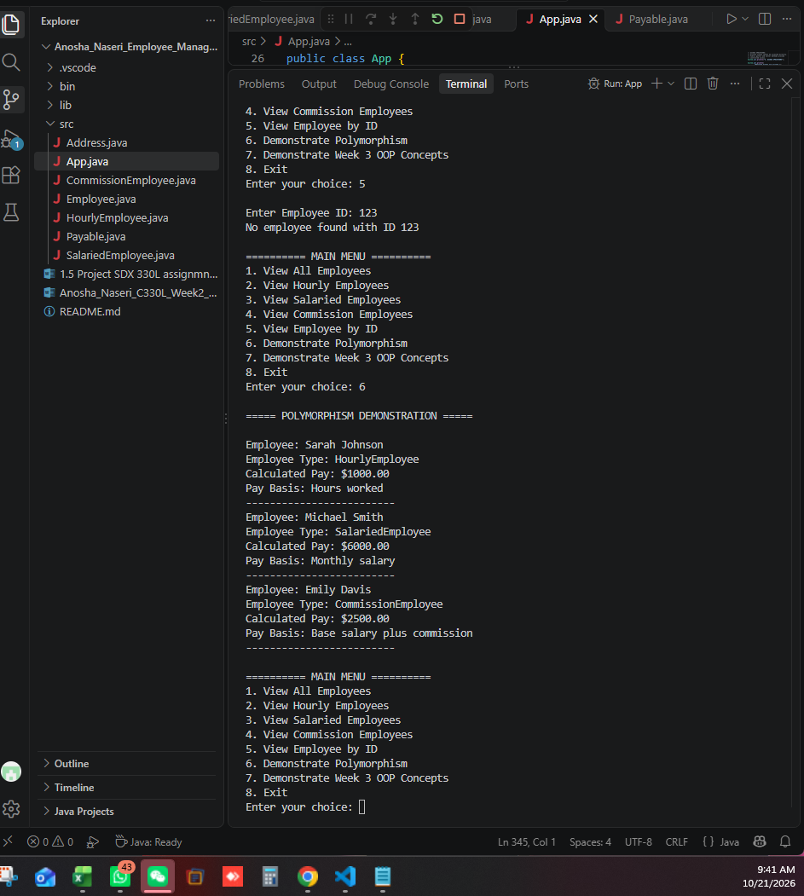
Figure 4. Unmatched employee ID and polymorphism calculations.
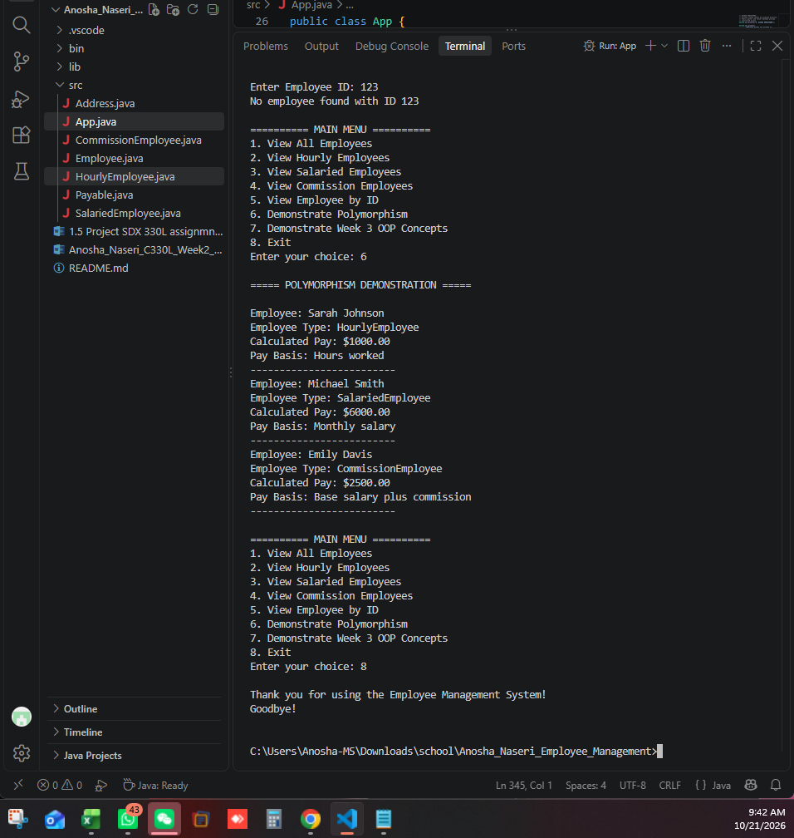
Figure 5. Exit option and successful return to the command prompt.

8. Conclusion
Week 3 extends the existing Employee Management System without removing Week 2 functionality. The application now uses an abstract Employee superclass, multiple constructors, and controlled access to private data while retaining inheritance, composition, the Payable interface, polymorphism, and console interactions. The supplied VS Code screenshots show successful execution of the demonstrated functions.

9. GitHub Submission Checklist
Commit the Week 3 Java updates to the existing course-project repository. Create and push the instructor-required tag “Phase #3” (confirm the repository platform accepts the exact tag spelling), then submit the tag URL in the Website URL field. Confirm the instructor has collaborator access. The GitHub actions are not yet completed by this document.

