Employee Management System
  - Week 1 — User Interaction Document
Student: Anosha Naseri
Course: C330L — Advanced Object-Oriented Programming Using Java Lab
Project Phase: Week 1 — User Interaction, Inheritance, and Composition

1. Project Overview
The Employee Management System is a console-based Java application designed to display and organize employee information. The Week 1 version introduces an interactive text menu, three employee types, inheritance from a shared Employee class, and composition using an Address object. The screenshots in this document show the Week 1 implementation rather than the expanded final application.

2. User Interaction Design
When the program starts, it displays the application title, a welcome message, and a numbered main menu. The user enters a menu number in the terminal, receives the requested employee information, and returns to the menu until choosing Exit.
1 — View All Employees: Displays all sample employees and their details.
2 — View Hourly Employees: Displays hourly employee records and compensation information.
3 — View Salaried Employees: Displays salaried employee records and compensation information.
4 — View Commission Employees: Displays commission-based employee records and compensation information.
5 — View Employee by ID: Prompts for an employee ID, then displays the matching employee or a not-found message.
6 — Exit: Ends the console session with a goodbye message.

3. Class Structure in Week 1
Employee holds common employee information. HourlyEmployee, SalariedEmployee, and CommissionEmployee extend Employee to represent distinct employee categories. Each employee includes an Address object, demonstrating composition. The App class displays the menu and processes the user’s choices.

4. Input and Output
Input is provided through the VS Code terminal using menu selections and an employee ID for searches. Output is displayed as readable employee details, filtered employee lists, search feedback, and a goodbye message. The application is designed to return to the menu after each action until the user exits.

5. Week 1 Screenshot Evidence
The following original screenshots document the initial console menu and the employee viewing, filtering, search, and exit functions.

Figure 1. Week 1 application startup and main menu.
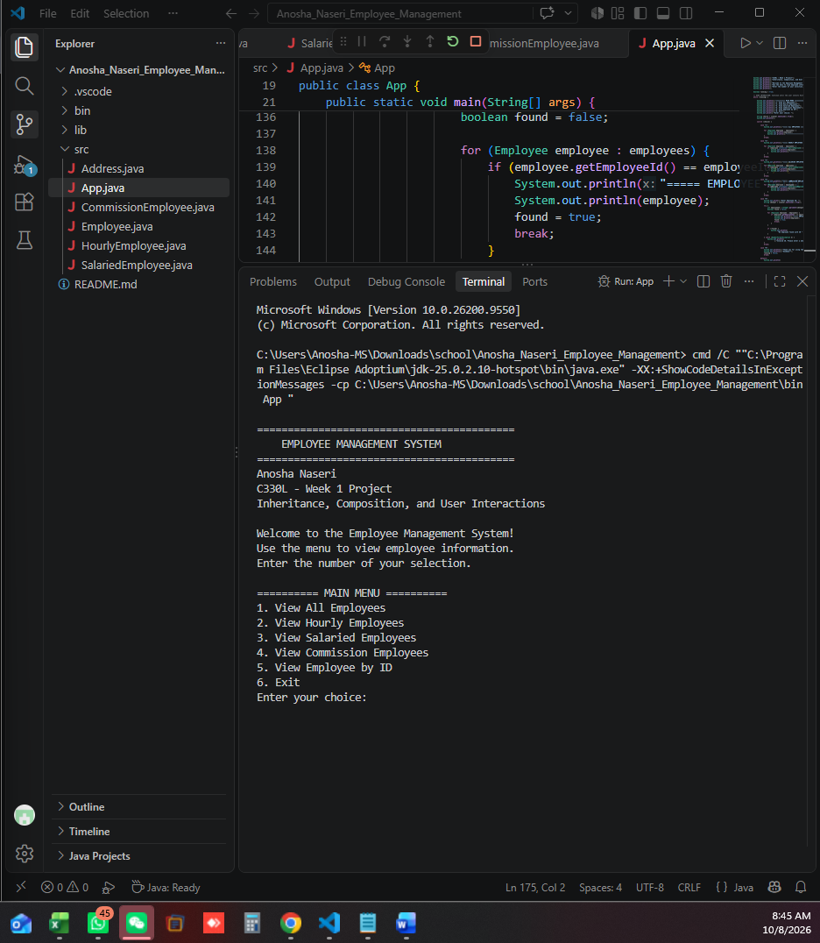

Figure 2. Viewing all employee records.
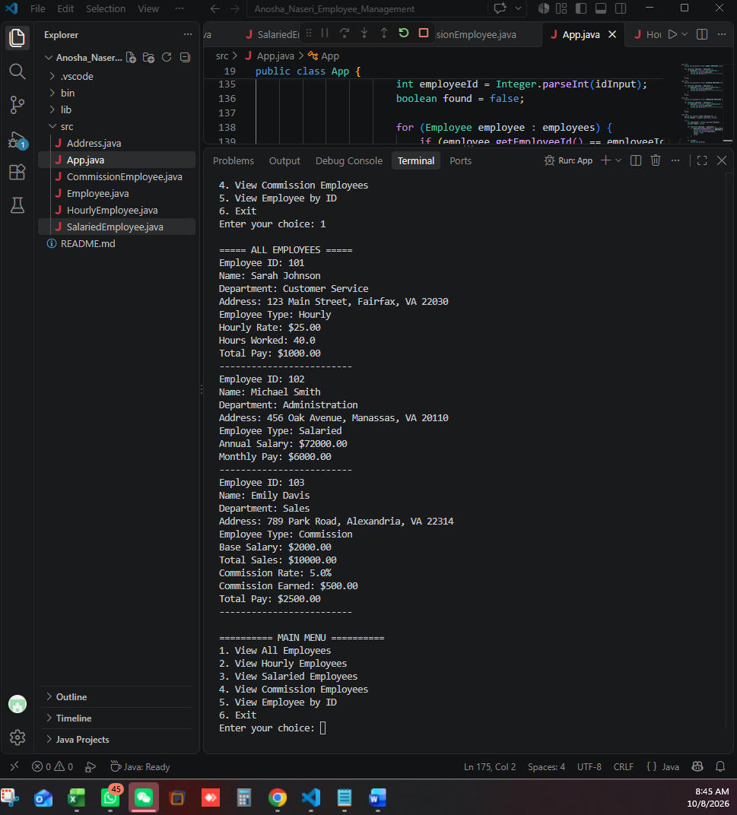

Figure 3. Filtering hourly and salaried employee records.
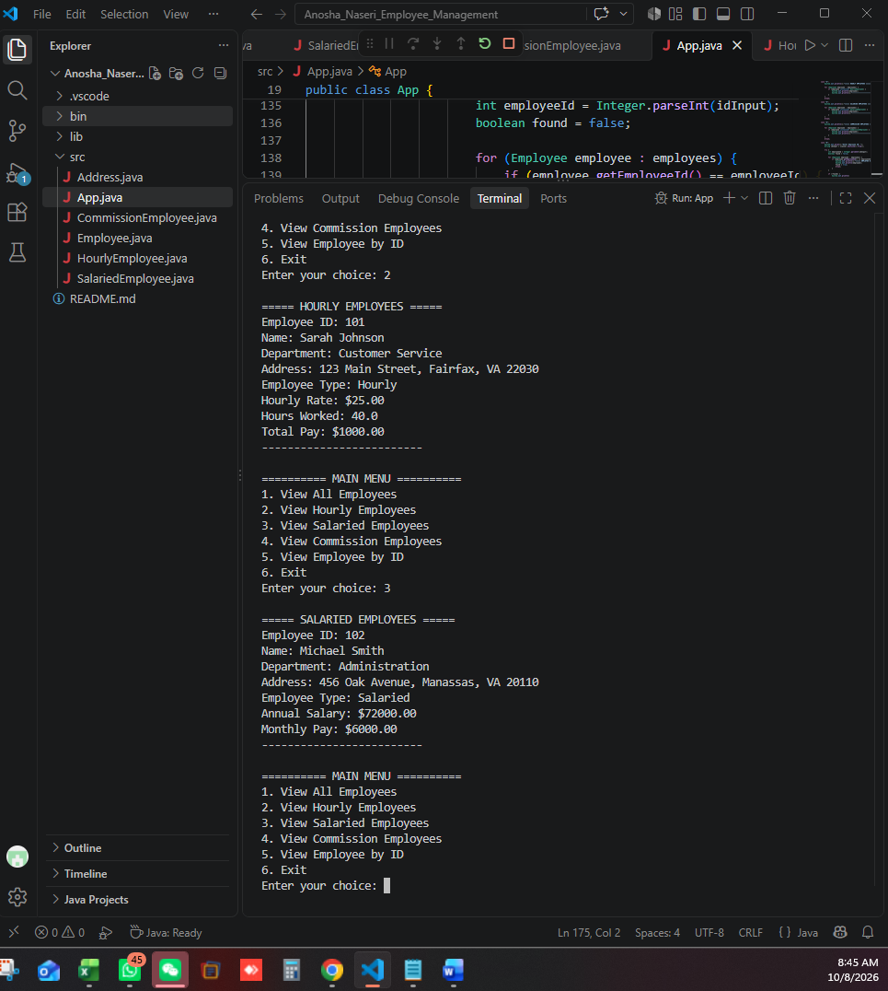

Figure 4. Commission employees, employee ID search, and exit.


