Employee Management System
C330L — Week 2 Course Project
Software Design, Interfaces, and Polymorphism
Student: Anosha Naseri
Date: October 15, 2026
Project: Anosha_Naseri_Employee_Management

1. Project Overview
The Employee Management System is a Java console application that displays employee records and calculates pay for hourly, salaried, and commission-based employees. Week 2 extends the Week 1 inheritance and composition design by introducing a Payable interface and demonstrating runtime polymorphism. The application continues to provide a menu for viewing employees and searching by employee ID.

2. Class Design and Responsibilities
Class / Interface | Purpose and key behavior
Payable (interface) | Declares double calculatePay() as the common payment behavior.
Employee (superclass) | Stores employee ID, first name, last name, department, and Address; implements Payable and supplies shared getters, setters, and display information.
HourlyEmployee | Extends Employee; stores hourly rate and hours worked; overrides calculatePay() to multiply rate by hours.
SalariedEmployee | Extends Employee; stores annual salary; calculates monthly pay as annual salary divided by 12 and overrides calculatePay().
CommissionEmployee | Extends Employee; stores base salary, sales, and commission rate; overrides calculatePay() to return base salary plus sales commission.
Address | Represents an employee address; used as an object field within Employee (composition).
App | Creates realistic sample data, runs the validated menu, and demonstrates interface-based polymorphism.

3. Inheritance, Composition, and Interface

Inheritance
HourlyEmployee, SalariedEmployee, and CommissionEmployee extend Employee. They inherit employee identity, department, address, and common methods while adding pay details specific to each employee type. This reduces duplication and keeps related responsibilities together.

Composition
Employee contains an Address instance as a private field. Address is constructed separately and passed to the Employee constructor through the subclass constructors. This allows address details to be represented by a dedicated class rather than duplicated across employee types.

Interface
The Payable interface declares calculatePay(). Employee implements Payable, and the three specialized employee classes override the method. The Employee superclass currently returns 0.0 as a default placeholder; the sample application uses the specialized subclasses for meaningful pay calculations. Making Employee abstract is reserved for a later project phase.

4. Polymorphism Design
App stores the three employee objects in an ArrayList<Payable>. During the menu option “Demonstrate Polymorphism,” each Payable reference invokes calculatePay(). Java dispatches the call to the appropriate employee subclass at runtime, even though the references share the same interface type.
Employee type | Calculation | Sample output
Hourly | 25.00 × 40 hours | $1,000.00
Salaried | 72,000.00 ÷ 12 months | $6,000.00
Commission | 2,000.00 + (10,000.00 × 0.05) | $2,500.00

5. Class Relationship Overview
Payable (interface) → implemented by Employee
Employee (superclass) → extended by HourlyEmployee, SalariedEmployee, CommissionEmployee
Employee → contains Address
App → creates and displays Employee objects; uses Payable references to calculate pay

6. Updated User Interaction Design
When launched, the program displays the Week 2 assignment title, student name, welcome message, and instructions. The console menu repeats until the user selects Exit. All menu choices are read with Scanner.nextLine(), preventing the InputMismatchException that can occur with Scanner.nextInt() when nonnumeric text is entered. The Employee ID entry is parsed inside a try/catch block, and invalid IDs or unmatched records receive clear messages.
Menu choice | Expected action
1 | Display all employees and their details.
2 | Display only hourly employees.
3 | Display only salaried employees.
4 | Display only commission employees.
5 | Look up an employee by ID; report invalid input or no match.
6 | Display interface-based polymorphic pay calculations for all three employee types.
7 | Show goodbye message and exit.
Other input | Display an invalid-selection message and return to the menu.

7. Verification and Test Results
The screenshots below were captured from the running Java application in VS Code on October 15, 2026. They show successful employee listings, the polymorphism demonstration, an unmatched employee ID, and the Exit operation. The separate nonnumeric menu-input test is not documented in the provided screenshots.
Test | Observed result
View all employees | All three sample employee records displayed.
Filter employee types | Hourly, salaried, and commission views each showed the correct employee.
Polymorphism | Calculated pay displayed as $1,000.00, $6,000.00, and $2,500.00.
Employee ID 1234 | “No employee found with ID 1234” displayed.
Exit | Goodbye message displayed and application returned to terminal.

8. Application Screenshots
Figure 1 shows the Week 2 polymorphism demonstration; Figures 2–4 document the employee records, filtered views, and exit behavior.
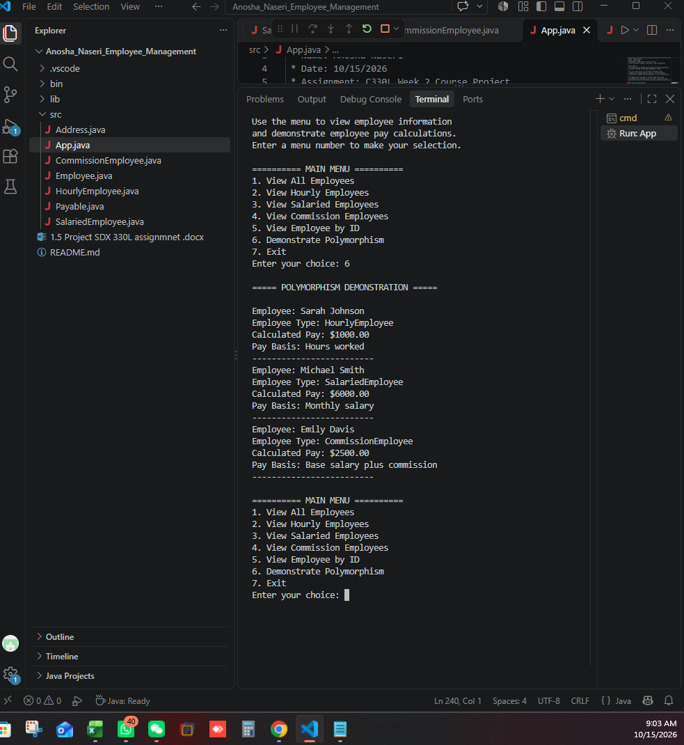
Figure 1. Polymorphism demonstration and calculated pay.

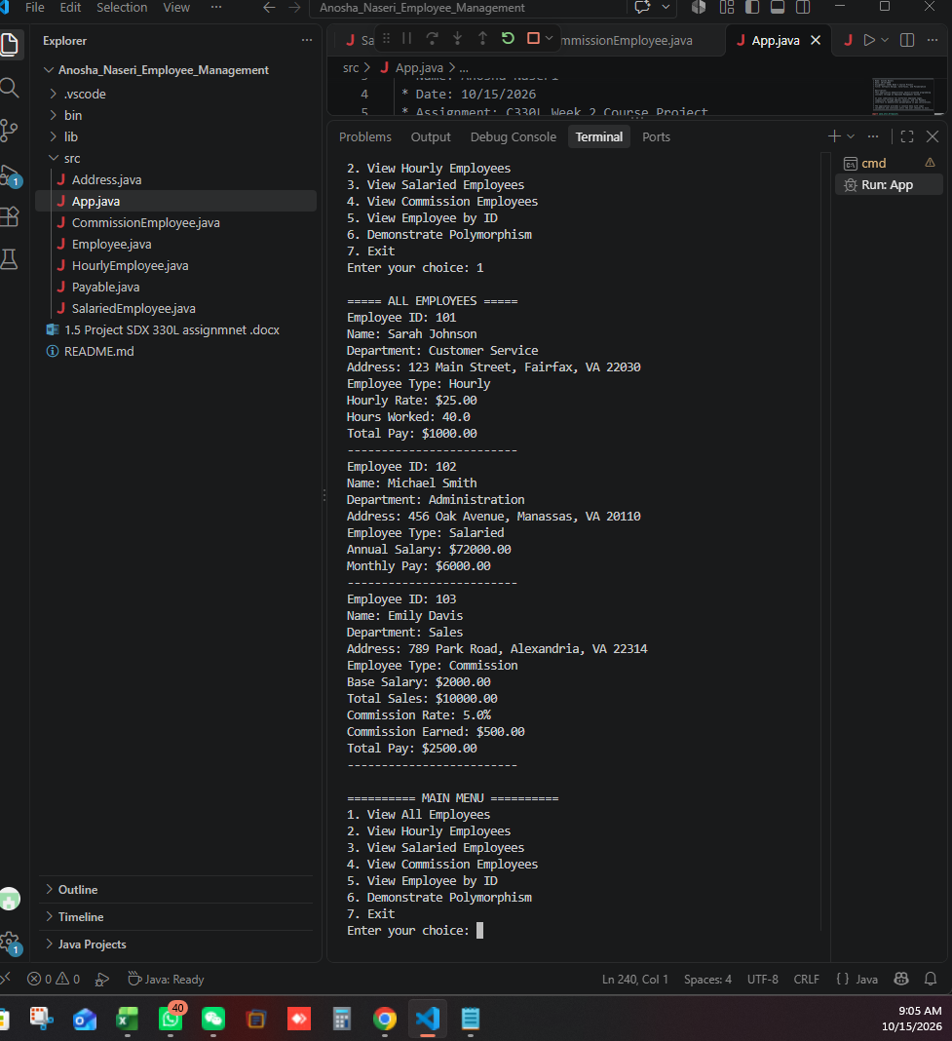
Figure 2. All employee records in the console.

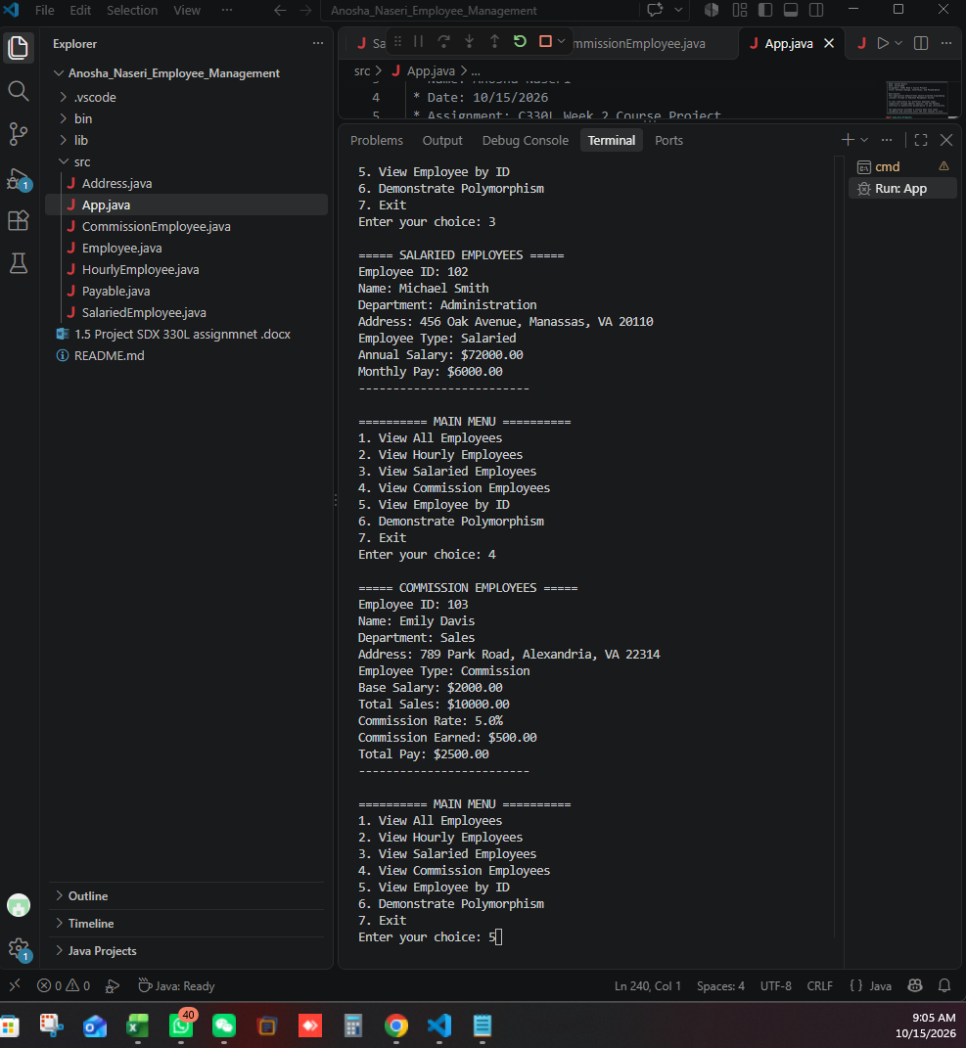
Figure 3. Salaried and commission employee filters.

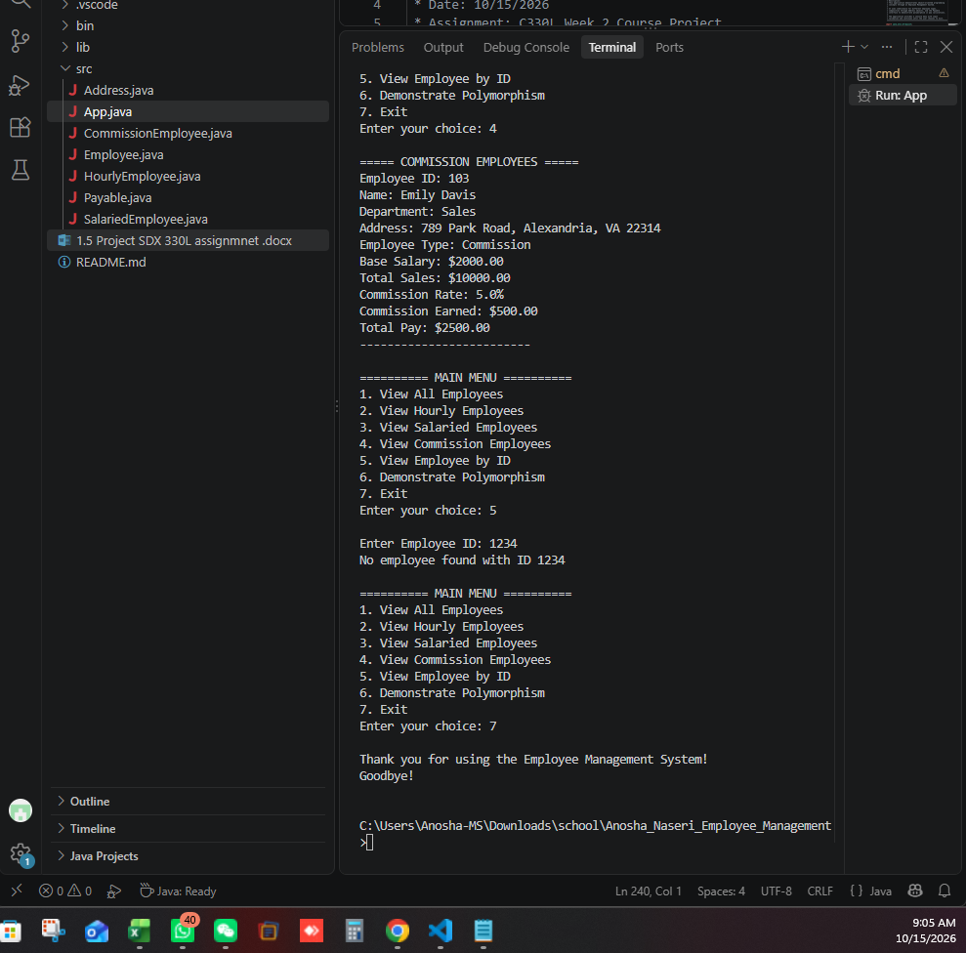
Figure 4. Employee ID lookup and successful program exit.

9. Conclusion
Week 2 extends the Employee Management System with a common Payable interface and polymorphic pay calculations without removing the existing Week 1 inheritance, composition, and menu features. The observed runs show the three employee types calculating pay correctly and the application handling a missing employee ID and a normal exit. Future phases can extend the design with abstract classes and persistent data storage.

