Чепелев В. С.
Расширения.
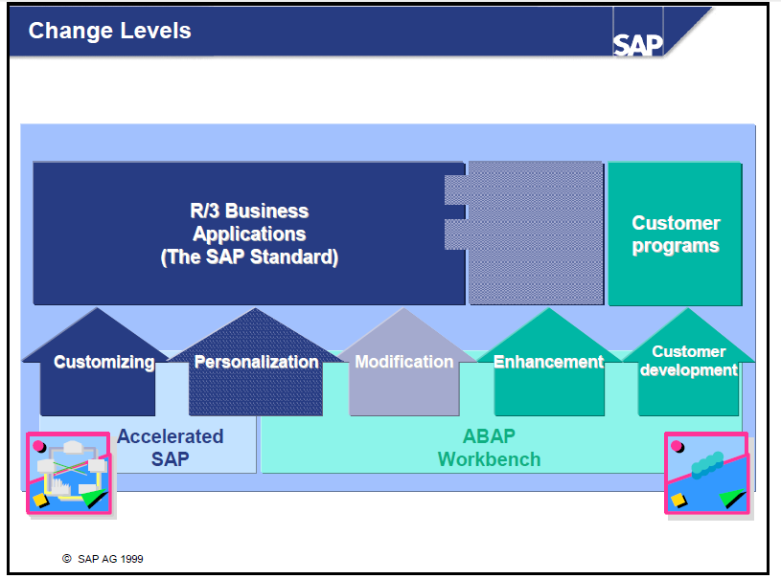
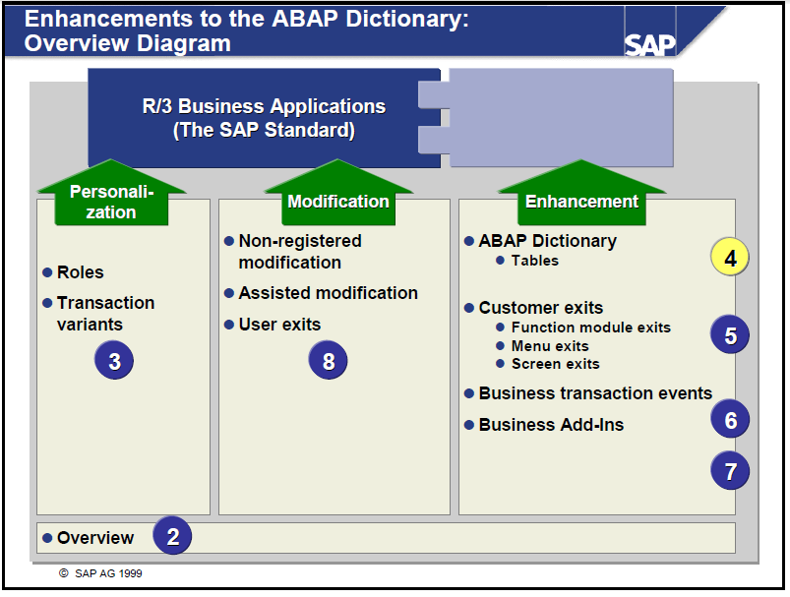

You can adjust the R/3 System to meet your needs in the following ways:
Customizing: This means setting up specific business processes and functions for your system according to an implementation guide. The need for these changes has already been foreseen by SAP and an implementation procedure has been developed.
Personalization: This means making changes to certain fields' global display attributes (setting default values or fading fields out altogether), as well as creating user-specific menu sequences.
Modifications: These are changes to SAP Repository objects made at the customer site. If SAP delivers a changed version of the object, the customer's system must be adjusted to reflect these changes. Prior to Release 4.0B these adjustments had to be made manually using upgrade utilities. From Release 4.5A, this procedure has been automated with the Modification Assistant.
Enhancements: This means creating Repository objects for individual customers that refer to objects that already exist in the SAP Repository.

Customer Developments: This means creating Repository objects unique to individual customers in a specific namespace reserved for new customer objects.

Customizing and most personalization is done using tools found in AcceleratedSAP; customer developments, enhancements, and modifications are all made using the tools available in the ABAP Workbench.

Modification – изменяет объект
Enhancement – change functionality of object
Enhancing objects instead of modifying them reduce the effort for adjustment during SP import or upgrade.

https://wiki.scn.sap.com/wiki/pages/viewpage.action?pageId=189893877
enhancements can be switched using the Switch Framework. An enhancement takes effect when the package in which the above enhancement components are defined is assigned to a switch of the Switch Framework and this switch is not deactivated.
Classic enhancement technologies such as customer exits, user exits, ABAP Dictionary appends, ABAP Dictionary includes, and classic BAdIs.
The concept of enhancement append packages is designed for the implementation of enhancements such as source code enhancements and ABAP Dictionary enhancements. Enhancement implementations are located in a separate append package that is assigned to the original package so that the package treats the content as part of the original package.
• Enhancement spots: containers for explicit enhancement options.
• Enhancement implementation elements: these contain the actual enhancement, for example, the source code to be added.
• Enhancement implementations: containers for both enhancement implementation elements of both implicit and explicit enhancement options.
The enhancement options are divided into two classes:
- Implicit enhancement options are provided by the framework and exist without any particular preparation by a developer, they do not have to belong to a container (an enhancement spot).
- Explicit enhancement options have to be inserted explicitly in the source code. They are created in an initial system and must be made known to developers in target systems by means of enhancement spots.

Enhancement Concept
enhancement options – sections or options – “hooks” (часть объектов) куда добавить расширения.

Цели Enhancement Framework:
The Enhancement Framework is about resolving an old conflict in software development: standard software solutions versus proprietary solutions. What the Enhancement Framework does is to combine the advantages of both the standard (easily maintainable) with the proprietary solutions (more flexible) while avoiding the drawbacks of both standard software (lack of flexibility) and customized software (upgrade issues).

Multiple Use Если снята и больше одного impl. => исключение CX_BADI_MULTIPLY_IMPLEMENTED
Иначе выполняются все в случайной последовательности.
Limited Filter Use ограничение с целью ускорения.
AMDP BAdI чтобы использовать в AMDP
- Filters are not supported for AMDP BAdIs.
- Fallback classes must be specified.
- BAdI interface methods must be AMDP methods. Mixing interface methods that are written in ABAP is not allowed.
- In a BAdI class, only methods for a platform can be implemented.

Contexts for BAdIs
The instance generation mode of a BAdI can be context-dependent. If you have context-dependent BAdIs, you must specify an object reference variable to a BAdI context object (an object whose class implements the tag interface IF_BADI_CONTEXT) in the GET BADI statement. As a result, within an internal session for the same BAdI context object, the same object plug-ins are always used. Such object plug-ins are singletons as far as their BAdI implementation class and a BAdI context object are concerned. Using a context-dependent BAdI is linked to a program is illustrated in the example below.
Example
By using the predefined global class cl_badi_report_context you can easily couple BAdI implementations to an (executable) program (or more generally, to a compilation unit). This class implements the interface if_badi_context, has a public attribute repid, and a public static method get_instance, which creates an object and sets the attribute.
By calling the method cl_badi_report_context=>get_instance, you can create unique instances as far as the attribute, which can serve as BAdI context object is concerned.
Suppose the BAdI badi_ctx_badi is context-dependent and has no filters. The code fragment below shows how to use the cl_badi_report_context:
DATA: bd TYPE REF TO badi_ctx_badi,
ctx TYPE REF TO cl_badi_report_context.

ctx = cl_badi_report=>get_instance( repid = sy-repid ).
GET BADI bd CONTEXT ctx.
The reference variable ctx references an instance that is unique for the current program name. In this context a BAdI object is requested. If the same code fragment is executed in other programs in the same internal session, different instances of the BAdI implementation classes are always associated with the BAdI object.
The class cl_badi_report_context allows you to bind object plug-ins to compilation units. The methods of these object plug-ins can be called anywhere in the internal session by using the combinations of GET BADI and CALL BADI shown above. The state is kept in this connection, which means that the same instances are always called for the same compilation units.

Ошибка:
The specified type cannot be converted into the target variable.
- Проблема активации

Context-Dependent BAdI (def)
If the radio butoon is set, the system returns, at runtime, an internal mode for the same instance of a context class, the same instance of the implementing class.
https://help.sap.com/viewer/46a2cfc13d25463b8b9a3d2a3c3ba0d9/7.5.9/en-US/949cdc40132a8531e10000000a1550b0.html
https://help.sap.com/saphelp_nw74/helpdata/en/44/f6d0c6a4bb0484e10000000a155369/frameset.htm
https://wiki.scn.sap.com/wiki/display/ABAP/Concepts+and+Working+with+BADI#ConceptsandWorkingwithBADI-BADIDefinition
https://wiki.scn.sap.com/wiki/display/ABAP/The+new+Enhancement+Framework+and+the+new+kernel-based+BAdI
https://wiki.scn.sap.com/wiki/display/ABAP/Enhancements+and+Modifications+-+BADI%2C+Enhancement+Framework%2C+User+Exits%2C+BTE

Migrating BAdIs
Automatic (Partial) Migration
- Call the classical BAdI Builder (transaction SE18).
- Enter the name of the BAdI you want to migrate.
- Choose Utilities → Migrate Classic BAdI.
- Create for an enhancement spot with the same name as the classic BAdI.
It is also possible to use another name or to choose an existing enhancement spot.
- In the enhancement spot, create one new BAdI which has the same name as the classic BAdI.
- The new BAdI should be defined with a context-dependent instance generation mode.
The properties of the classic BAdI (such as multiple use, texts) and the screen and menu enhancements (such as function code enhancements) are copied one to one.
The tag interface IF_BADI_INTERFACE is included in the BAdI interface of the classic BAdI.
- If you define a filter for the classic BAdI, copy the components of the related filter structure to the new BAdI as separate filters. Use the name of the component is used as a name of the new filter; its type is always c.
- Copy all existing implementations of the classical BAdI to new BAdI implementations. Create the new BAdI methods within the existing BAdI implementation classes.
- Analogous to the migration of the filter definition, the structure of the filter condition of a classic BAdI implementation should also be dissembled into individual filter conditions.
- Transport the change into a follow-up system:
  - Call transaction SPAU if there is a BAdI implementation for the migrated BAdI.
In this case, a message with identifier 6 will appear in the input log of the transport request.
  - Choose the traffic light in front of the BAdI implementation.
  - Enter an enhancement implementation.
Complete Migration
After finishing the (partial) migration, you may to proceed with the optional full migration to profit from all of the advantages of the new BAdIs.
Caution
To perform this procedure you need expert knowledge of the application. The effort may vary from several minutes up to several days per BAdI
- Delete the classic BAdI. (Answer the question: Shall the migrated BAdI be deleted, too? with No.
- Change the new BAdI according to your needs.
In most cases you do not need the context, so change the instantiation mode accordingly.
- Find all calls of the classic BAdI by GET_INSTANCE and reprogram the BAdI call using the new commands GET BADI and CALL BADI
- To improve the performance you can change the context settings for BAdIs called more than once in one program.

https://help.sap.com/saphelp_nw74/helpdata/en/44/f6d0c6a4bb0484e10000000a155369/frameset.htm

- Терминалогия Enhancement Framework
Explicit Явные расширения:
Секция (ENHANCEMENT-SECTION) -
Опция
Point (ENHANCEMENT-POINT) –

Implicit неявные:
Point или Опция (без не секций) – позиция в объекте репозитория, которая может быть Явно объявлена или Неявно доступна.

-Source Code enhancements
-Function Group enhancements
-Enhancements to global classes and interfaces
optional parameters to existing methods
methods
events and event handlers
references to interfaces
types*
exits to existing methods
–Pre-Exit –Called at the beginning of a method
–Post-Exit –Called at the End of a method
–Overwrite-Exit –Replaces the original method
–access to private and protected attributes of the original class*
-BAdIs
-WebDynpro enhancements

- Конкретизация
Enhancment option Static or Dynamic управляются Switch Framework Tcode SFW2
Enhancement Implementation и Enhancment Spot конкретизируется по Enhancem. Technique и объекту репозитория

0) РАСШИРЕНИЕ ТАБЛИЦ
Append Structures Структуры-дополнения Append View
Goto->Append Structure
Customizing includes
Например таблица PROJ CI_PROJ
Предоставляется SAP начинается с CI_ Может включаться сразу в несколько таблиц. Не требует Adjustment of Database Structures. Se11->Utilities->DatabaseUlity [juːˈtɪlɪtɪ]
Index Extension для таблиц
Index->Create Extension Index

1) USER EXIT устарел
USER EXIT поставлялись SAP и использовались для заданий места, точки для выполнения Модификации. Раньше это была модификации, сейчас рекомендуется Source Enhancement с BADI.
Используется только в SD модуле.
Package VMOD

PERFORM USEREXIT

FORM USEREXIT_
ENDFORM
User exits & customer exists
USEREXIT_FIELD_MODIFICATION
Used to modify screen attributes.

USEREXIT_SAVE_DOCUMENT
Helps in performing operations when the user hits Save.

USEREXIT_SAVE_DOCUMENT_PREPARE
Very useful to check input fields, put any value in the field or show a popup to users and to confirm the document.

USEREXIT_MOVE_FIELD_TO_VBAK
Used when user header changes are moved to header work area.

USEREXIT_MOVE_FIELD_TO_VBAP
Used when user item changes are moved to SAP item work area.

Обратный поиск по двойному клику на название формы.
2) CUSTOMER EXIT +стабильный интерфайс, гарантированный в вышестоящих версиях SAP устарел
Технически это модификация.
User Exit -> Customer Exit + menu/screen exits + стабильный интерфейс
SMOD – обзор Доступных Enhancement
CMOD – Enhancement Projects устарел, использровать Enhancement Framework.

- Function module exits
CALL CUSTOMER-FUNCTION '910'
Название функционального модуля:
FUNCTION EXIT_<program name>_<3 digit suffix>
INCLUDE ZXC1AU27 . – реализуется пользователем
ENDFUNCTION.
Обратный поиск невозможен.
- menu exits Замена не известна, видимо сап планирует перевести их всех на BADI menu exit в будущем.
Позволяет добавить пункты выпадающего меню. Технически это модификация.
Необходима активация в CMOD.
- sreen exits Замена не известна.
Выводить дополнительные поля на экран, разработчики SAP зарезервировали зону экрана:
В dynpro flow logic:
CALL CUSTOMER-SUBSCREEN CUSTSCR3 INCLUDING 'SAPLXCAT' '3000'."XQP
Например CATS0012 программа SAPLCATS экран 2002 2003 2500
Необходима активация в CMOD.

Набор из customer exit

Находить:
  - Se81 -> select module -> Edit-SelectSubtree
Information system – Enhancements
  - Se84
Общие:
  - ТРАССИРОВКА: ST05 Buffer Trace Activate Trace Deactivate Trace Display Tree
  - ОТЛАДКА: System->Utilities->Debuging->F9 CALL CUSTOMER-FUNCTION
  - Поиска Ctr+F на программе

https://wiki.scn.sap.com/wiki/pages/viewpage.action?pageId=189893877
3) Business Transaction Events BTE(FI) только program exit:
Customer Exit -> BTE(FI) +дополнения могут выполняться и существовать параллельно.
-menu/screen exit
Основная транзакция FIBF.

There are two types of interface available in the General Ledger Accounting (FI-GL), Accounts Receivable and Accounts Payable (FI-AR/FI-AP), and Sales and Distribution (SD) components for this:
Publish & Subscribe interfaces
Реализации ничего не возвращают, но запускаются параллельно
Process interfaces
Управляют процессом SAP, возвращают данные в SAP но может выполняться только одна реализация
PERFORM OPEN_FI_PERFORM_<event number>* or OUTBOUND_CALL_*
("Service function module") определяет активную реализацию, можно реализовать фильтр.

Обратный поиск невозможен.

Исползование:
1) ищем OPEN_FI_PERFORM (OUTBOUND_CALL не видел)
FIBF->Environment->
For Publish and Subscribe Interfaces, Environment Info system (P/S)
For Process Interfaces : Infosystem(Processes)
Attirbute type A Искать по event number в Process Interface
2) Simple function module –это шаблон, его нужно скопировать с приставкой Z и активировать
3) Зарегистровать как Customer или Partner продукт: FIBF->Settings->Products->Process(customer)
Создать строку ‘ZANY’ и активировать
4) Зарегистрировать событие: FIBF->Settings->Process Modules->.. of customer
Добавить строку с номером процесса Zфункционального номера и ZANY продуктом
https://wiki.scn.sap.com/wiki/display/ABAP/BTE+-+Business+Transaction+Event
https://wiki.scn.sap.com/wiki/display/ABAP/Business+Transaction+Events+-+Process+Interface+-+Event+00001030+-+customer+implementation+for+printing+dunning+notice
https://blogs.sap.com/2013/11/27/white-paper-on-business-transaction-events-bte/

4) Classic BADI – Business Add-Ins
Определение: BAdI объектно-ориентированная технология расширения, петля(hook) к добавляемому объекту.
Add-in – существительное (дослово) «добавить-в», близкое к plug-in.
+OO
+дополнительный уровень между определением и реализацией
+улучшенные возможности администрирования
Classic BAdIs не используют Enhancement Spot. Показываю как создается.
SE18 Definition
SE19 Implementation
Interface IF_EX_
Generated hiden class with bridging method CL_EX_
Implementation CL_IM_
data r_exit type ref to if_ex_businessaddin.
call method cl_exithandler=>get_instance #стандартный класс создающий adapter class instance
changing
instance = r_exit.
call method r_exit->method # вызов bridging method
exporting
flt_val = ‘RU’.
Если ошибка Raise non-class-based exception. FLT_VAL – filter value параметр во всех методах реализаций Filter-dependent BAdI. Обычно это отрасль или страна
СД
Определение GET_INSTANCE:
class-methods GET_INSTANCE
importing
value(EXIT_NAME) type EXIT_DEF optional
value(NULL_INSTANCE_ACCEPTED) type SEEX_BOOLEAN
BAdI выбирается по EXIT_NAME строке или по типу интерфейса.

Multiple-Use BAdI: в случайной последовательности
Методы не должны иметь “returning”or “exporting” parameters

Обратный поиск невозможен, в основном вызов происходит динамически по EXIT_NAME, но даже если статически по интерфейсу, найти все равно почему-то не удается.
Можно использовать глобальный поиск строк RS_ABAP_SOURCE_SCAN, который сможет найти EXIT_NAME присвоенные явно.

Обратный поиск возможен только через отладчик или RS_ABAP_SOURCE_SCAN.

Найти:
  - По классу SE24 – CL_EXITHANDLER=>get_instance ставится точка прерывания. В Exit_name – имя бади.
  - По пакету System-Status SE84
  - SE81 см. Customer Exit
  - ST05 trace
http://abap-blog.ru/enhancements/programmy-avtomaticheskogo-poiska-rasshirenij/
BC427 BC425
https://help.sap.com/viewer/2b28ffa716c24348903f8ffbfeb81df8/7.5.9/en-US/eb3e7cf7940e11d295df0000e82de14a.html
4) Kernel-based BADI
+значительная оптимизация производительности (40-600 раз быстрее).
+улучшения: фильтрации, callback class, simple class ( значении фильтрующиего параметра задаётся при GET BADI)
Как находить явные enhancement options
+интеграция с новым Enhancement Framework
+более четкое разграничение статического и динамического вызова.
С версии SAP NetWeaver 7.0 (2004s), SAP ERP Central Component (ECC) 6.0, Oct-2005
То же что и Classic, но класс адаптера теперь BAdI-Handle создается на уровне ядра.
Вместо интерфейса теперь используется непосредственно BAdI имя или тип общего абстрактного класса CL_BADI_BASE (с передачей TYPE).

Пример: транзакция MIGO отладчик по CALL BADI

Фильтрация:
- Switch Framework – switched on
- Constant Filter values – match flt_val
- Active flag – for implementation

Выбор BAdI реализации во время выполнения:
    - Активные не-default(normal) реализации
    - Если нет => активные default(standard) implementations
    - Если нет => fallback class.

Выбор Instance Creation Mode (действует в течении internal session):
Context Dependent(not context-free) - один BAdI вызывается несколько раз и имеет instance методы.
Instance Reuse – статические методы одного бади вызываются несколько раз
Newly created – используется только один раз.

Наименования произвольные, рекомендации:
Enhancement spot ES_
BADI Name BADI_
BADI Definition BADI_ бизкое к BADI Name
Interface INIF_BADI_
Enh. Impl. BADI_*_IM_
BAdI Impl. BADI_
Implementation Class CL_IM_ или BADI_*_CL
В создаваемый Implementation Class автоматически включается IF_BADI_INTERFACE - Tag Interface без методов и атрибутов, использующийся для изменения способа его обработки ABAP компилятором.

BAdI menu exits
  - В GUI Status должно иметься Function Code с + , например: +3X1.
  - В PAI модуле экрана должен быть вызов CALL BADI.
BAdI screen exits
  - В программе должен существовать вызов GET-BADI

Находить: аналогично Classic BADI, кроме отладчика.
Where-used, почему-то, не работает.

5) WebDynpro enhancement.
- Enhancement of Component
  - Creating New view
  - Creating New window
  - Creating New Controller
  - Creating New Application
- Enhancement of Window
  - Enhancing Embed views / Adding new views
  - Enhancing navigation link / Adding New links
- Enhancement of View
  - Enhancing UI elements / Adding New UI elements
  - Enhancing Plugs / Adding New Plugs
- Enhancement of Controller
  - Enhancing standard methods & Actions / Adding New methods & Actions
  - Enhancing standard Context / Adding New Context
  - Enhancing standard Attributes / Adding New Attributes
- Deleting the Enhancement Implementation

https://blogs.sap.com/2015/04/14/enhancements-in-web-dynpro-abap-part-i/
https://blogs.sap.com/2015/04/14/enhancements-in-web-dynpro-abap-part-ii/

5) Substitution FI Замещения (Customization)
GGB0 and OB28---------> Validation.
GGB1 and OBBH--------->Substitution.
Validations are used to help insure data integrity when entering actual transactions online or in batch.
Substitutions are used to derive or correct values being passed via integration or entered into the FI / CO modules.

https://wiki.scn.sap.com/wiki/display/ERPFI/Validation+and+Substitution
https://blogs.sap.com/2014/06/06/create-fi-substitutions-using-ggb1-substitution-maintenance/
https://sapland.ru/articles/stats/Rabota_s_zamescheniyami_FI.html

Рассказывать расслаблено.

