**Dictionary:**

We are familiar with python lists or as other programming languages prefer the term array. We know that lists or arrays are containers with holds multiple values and those values are accessed using index numbers. Python has got another type of container which is called dictionary. The dictionary is a container which holds elements in key:value pair. For lists we can only access the elements using integer index numbers. But for dictionary we can access its elements using string keys and also numbers. The syntax for a python dictionary is:



Here doing Dict[key] will provide us the value. Now let us observe a practical example of a python dictionary:

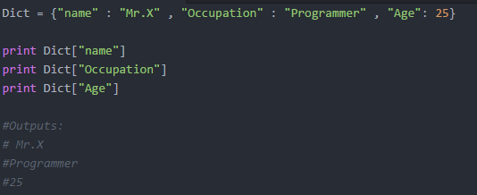

We are able to access the dictionary elements using the key. This key can also be an integer. For example:

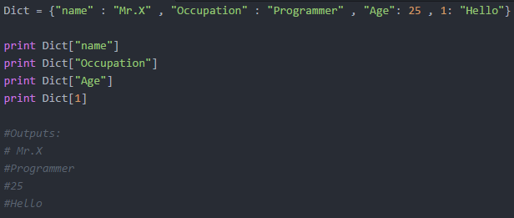

Even providing a float number as a key wouldn’t be a problem. Following are some examples of playing (accessing or modifying) dictionary with its functions:

