**POLYMORPHISM:**

The word “Poly” means “many” and the word “morph” means “forms” in Greek. So the word “Polymorphism” becomes “Many Forms”. In programming polymorphism indicates “same action different reaction”. Polymorphism is one of the vital characteristics of Object-Oriented Programming. As python is an object-oriented language, so we will now observe polymorphism in python.

Suppose we have two classes named Cat & Dog. Now polymorphism with these two classes would look like,

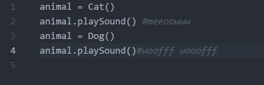

Here both the objects have a common method playSound() ,here we can see same action(animal.playSound()) & different reaction(meeooww , woofff wooofff) which is polymorphism. So now lets arrange the required classes to perform this polymorphism:

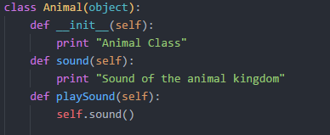

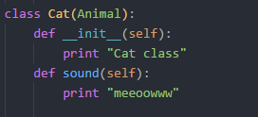 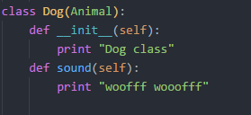

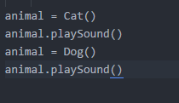

**Output:**

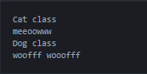

Here, both the classes Cat & Dog inherits the Animal class thus getting all of its properties. Then both the classes overrides the function sound() in their own way. So whenever the inherited method playSound() is called for individual objects the self.sound() is called for each instances & the output is different as they are overridden differently. This is Polymorphism.