A

PROJECT REPORT

ON

**“HomeCare.In”**

Towards partial fulfilment of the requirement in

**4th Semester BCA (2022)**

**Submitted by:**

210510110099 Hemang Nilesh Thakkar

210510110059 Vraj Nikunj Thakkar

210510110077 Janki VijayBharti Goswami

**Submitted To:-**



**Parul Institute of Computer Application,**

**Parul University.**

Under the guidance of

Assistant Professor **Prof. Bharti Vani**

**Acknowledgement**

*The success and final outcome of this project required a lot of guidance and assistance from many people and we are extremely privileged to have got this all along the completion of our project. All that we have done is only due to such supervision and assistance and we would not forget to thank them.*

*We respect and thank Dr Priya Swaminarayan, Dean, FITCS for providing us an opportunity to do the project work in BCA and giving us all support and guidance, which made us complete the project duly. We are extremely thankful to Mam for providing her support and guidance, although she had busy schedule managing the academic affairs.*

*We would not forget to remember Prof. Hina Chokshi, HOD, BCA department for her encouragement and more over for her timely support and guidance till the completion of our project work.*

*We owe our deep gratitude to our project guide _Bharti Vani_, who took keen interest on our project work and guided us all along, till the completion of our project work by providing all the necessary information for developing a good system.*

*We are thankful to and fortunate enough to get constant encouragement, support and guidance from our Parents, all Teaching staffs of BCA Department which helped us in successfully completing our project work. Also, we would like to extend our sincere esteems to all staff in laboratory for their timely support.*

***JANKI VIJAYBHARTI GOSWAMI***

***HEMANG NILESH THAKKAR***

***VRAJ NIKUNJ THAKKAR***



**PARUL INSTITUTE OF COMPUTER APPLICATION**

**CERTIFICATE**

This is to certify that ***HEMANG, VRAJ, JANKI*** the student(s) of Parul Institute of Computer Application, has/have satisfactorily completed the project entitled “***_HOMECARE.IN*** *”* as a part of course curriculum in BCA / IMCA semester-V for the academic year 2021-2022 under guidance of  **Prof. Bharti Vani  *.***

Enrollment Number: 210510110099

Enrollment Number: 210510110059

Enrollment Number: 210510110077

|  |  |  |
| --- | --- | --- |
| **Quality of work** | **Grade** | **Sign of Internal guide** |
| **Poor / Average / Good /**  **Excellent** | **B /B+ / A / A+** |  |

Date of submission:

HOD, Principal,

**Prof. Hina Chokshi** **Dr Priya Swaminarayan**

**INDEX**

|  |  |
| --- | --- |
| **Content** | **Page No.** |
| 1. Research | 01 |
| 1. Feasibility Studies | 02 |
| * 1. Technical Feasibility | 02 |
| * 1. Economic Feasibility | 02 |
| * 1. Operational Feasibility | 03 |
| 1. System Requirement Specification | 04 |
| * 1. Introduction to SRS | 04 |
| * 1. Abstract | 07 |
| * 1. System Users | 07 |
| * 1. Modules | 07 |
| * 1. Modules Description | 07 |
| * 1. Hardware / Software Requirement | 07 |
| * 1. Flow Chart | 07 |
| * 1. TimeLine Chart | 08 |
| 1. Technology Description | 09 |
| * 1. Features and Limitations of New System | 10 |
| 1. Data Flow Diagram | 10 |
| * 1. Context Level DFD’s | 11 |
| * 1. Level 1 DFD’s | 11 |
| * 1. Level 2 DFD’s | 13 |
| * 1. Level 3 DFD’s | 13 |
| 1. Use Case Diagram | 15 |
| 1. Class Diagram | 17 |
| 1. Activity Diagram | 18 |
| * 1. Description of Activity Diagram | 18 |
| 1. E-R Diagram | 20 |
| * 1. E-R Diagram Description | 20 |
| 1. Data Dictionary | 21 |
| * 1. Description of Data Dictionary | 21 |
| 1. Form Design (Screenshots Phase 1, 2, 3, 4 and Validation’s Screenshots) | 24 |
| 1. What is Testing? | 26 |
| * 1. Importance and Types of Testing | 27 |
| 1. Future Enhancement | 28 |
| 1. References and Bibliography | 29 |

1. **Research**
   1. **What is research?**

It refers to the process of gathering information and data relevant to a particular project, with the goal of producing comprehensive and accurate project documentation. The research process can include a variety of activities such as conducting surveys, reviewing existing literature and data, conducting interviews, and analysing results. The objective of the research is to provide a solid foundation for the project, which will inform decisions and guide the development and implementation of the project. The results of the research can be used to create project plans, budgets, schedules, and other important project documents. Effective project documentation helps ensure that the project is completed on time, within budget, and to the satisfaction of stakeholders.

* 1. **Types of Research Methodology**

Methodology, on the other hand, refers to the specific methods and techniques used to conduct the research. It is the plan or strategy used to conduct the research that defines the process, it also helps to provide a structured approach to carry out the research. It outlines the steps that will be taken in order to collect and analyze data, as well as the methods that will be used to ensure the quality and validity of the data.

**Types-**

Quantitative

Qualitative

Mixed Method

Experimental

Non-Experimental

Descriptive

Correlational

Survey

Case Study

Action Research

1. **Feasibility Studies**

**What is Feasibility?**

Feasibility refers to the practicality or likelihood of an idea or proposal being successful and achievable, often based on an evaluation of its resources, costs, and risks. Feasibility studies are used in many fields, including business, engineering, and public policy, to determine whether a proposed project or idea is viable.

The goal of a feasibility study is to provide a comprehensive analysis of the strengths and weaknesses of the proposal and to identify any potential problems or obstacles that need to be addressed before proceeding with implementation. The study considers the technical, financial, and economic feasibility of the proposal, as well as its alignment with organizational goals and objectives.

* 1. **Technical Feasibility**

Technical feasibility is a subcategory of feasibility that specifically refers to the evaluation of a proposal's technical requirements and the resources available to meet those requirements. Technical feasibility assesses whether the required technology, equipment, and infrastructure are available and can be effectively utilized to successfully implement the proposal.

* 1. **Economic Feasibility**

Economic feasibility is another subcategory of feasibility that evaluates the financial aspects of a proposal, including costs, benefits, and risks. The goal of economic feasibility is to determine whether the proposal is economically viable and whether the benefits of the proposal justify the costs of implementation.

* 1. **Operational Feasibility**

Operational feasibility is another subcategory of feasibility that evaluates the practical and operational aspects of a proposal. The goal of operational feasibility is to determine whether the proposal can be successfully integrated into the organization's existing operations and processes, and whether the organization has the necessary resources and capabilities to implement and sustain the proposal.

* 1. **Importance of Feasibility Studies**

Feasibility studies are important because they provide a comprehensive analysis of the viability of a proposal and help organizations make informed decisions about the allocation of resources. Feasibility studies play a critical role in the planning and implementation of new projects, initiatives, and programs. They provide organizations with a comprehensive analysis of the viability of a proposal, including technical, financial, and operational feasibility. This allows organizations to make informed decisions about the allocation of resources, reduce the risks associated with implementation, improve planning, increase stakeholder support, and improve project management. Feasibility studies help organizations avoid costly mistakes, secure funding and support, and ensure that resources are allocated effectively. In short, conducting a feasibility study is a crucial step in ensuring the success of a project, initiative or program.

* 1. **Feasibility Study of our Proposed System**
     1. **Technical Feasibility**:

This is very important aspect to be considered while developing a project. We decided the technology based on minimum possible cost factor.

All hardware and software cost has to be borne by the organization

Overall we have estimated that the benefits the organization is going to receive from the proposed system will surely will surely overcome the initial costs and the later on running cost for system.

* + 1. **Economical Feasibility:**

This included the study of function, performance and constraints that may affect the ability to achieve an acceptable to be provided in the system, as described in the System Requirement Specification (SRS), and checked if everything was possible using different type of frontend and backend platforms.

* 1. **Operational Feasibility:**

No doubt the proposed system is fully GUI based is very user friendly and all inputs to be taken all self-explanatory even to a Layman. Besides, a proper training has been conducted to let know the essence of the system to the users so that feel comfortable with new system. As far our study is concerned the clients are comfortable and happy as the system has the system has cut doown their loads and doing.

1. **System Requirement Specification**
   1. **Introduction To SRS**

SRS stands for Software Requirements Specification, which is a document that outlines the requirements and objectives of a software project. It includes details on the software's functionality, performance, design, and user interfaces. SRS serves as a blueprint for the development process and helps ensure that everyone involved in the project has a clear understanding of the software's requirements.

**What is SRS?**

SRS stands for Software Requirements Specification. It is a document that outlines the requirements and objectives of a software project. The SRS describes what a software system should do and how it should perform, and serves as a blueprint for the development process. The SRS typically includes information about the software's functionality, performance, constraints, and design requirements, as well as user and system interfaces. It is an essential tool for effective communication between stakeholders, including developers, users, and customers, and helps ensure that the final product meets the needs and expectations of the stakeholders. The SRS is often updated and refined as the project progresses.

**Need of SRS**

The need for a Software Requirements Specification (SRS) in a project is to provide a clear and comprehensive documentation of the project's objectives and requirements. It serves as a blueprint for the development process, facilitates better communication among stakeholders, reduces risk and improves project management, and enhances the final product quality and customer satisfaction. The SRS helps ensure that everyone involved in the project is on the same page, and that the final product meets the needs and expectations of the stakeholders.

* 1. **Abstract**

Home Care Services is a web application that will allow its users to hire staff for home. The staff will be available for services such as child care (babysitter), maid, and kitchen care (cook). Homecare. In System project is a web application which is developed in PHP platform. Homecare. In System is a open source.This project has 3 roles as admi – client and service provider. The client should be able to hire a service provider through this web application.

The application will get the client’s requirements in the form of a questionnaire and depending on the answers by the client; the application will show the closest matching service providers to the client. The client will be able to send an offer to the service provider of his/her choice.

* 1. **System Users**

**Client:**

In this website, the user have to register/login to the website to enable the services.

Ones the register is done then the user can book maids or security from the website.

With this, the billing and payment method will be go with ease.

The client will not have to maintain all the bills and billing of all services will be done under one roof.

**Admin:**

The admin will be keep records of the registered clients.

Will receive payments from the clients.

* 1. **Modules**

Registration

Security

Maid

Cleaner

Payment

Feedback

* 1. **Modules Description**

**Admin:** The admin will track record of the clients and payments

**Registration:** User have to register to the website to enable the company services.

**Security:** The security guard will be provided by this website**.**

**Maid:** The maid will be provided by the company.

**Cleaner:** The company will also be providing one time cleaner to the clients.

**Payment:** The payment will be done either offline or online

* 1. **Hardware Requirements**

|  |  |
| --- | --- |
| **Name of Components** | **Specification** |
| Processor | Windows 10 I 7 gen 10 |
| RAM | 8gb 512gb rom |
| Hard Disk |  |

**3.6. Software Requirements**

|  |  |
| --- | --- |
| **Name of Components** | **Specification** |
| Operating System | Windows 10 |
| Software development Kit | Firefox limited addition |
| Tools & languages | Php , chrome , xampp |

* 1. **Flow Chart**

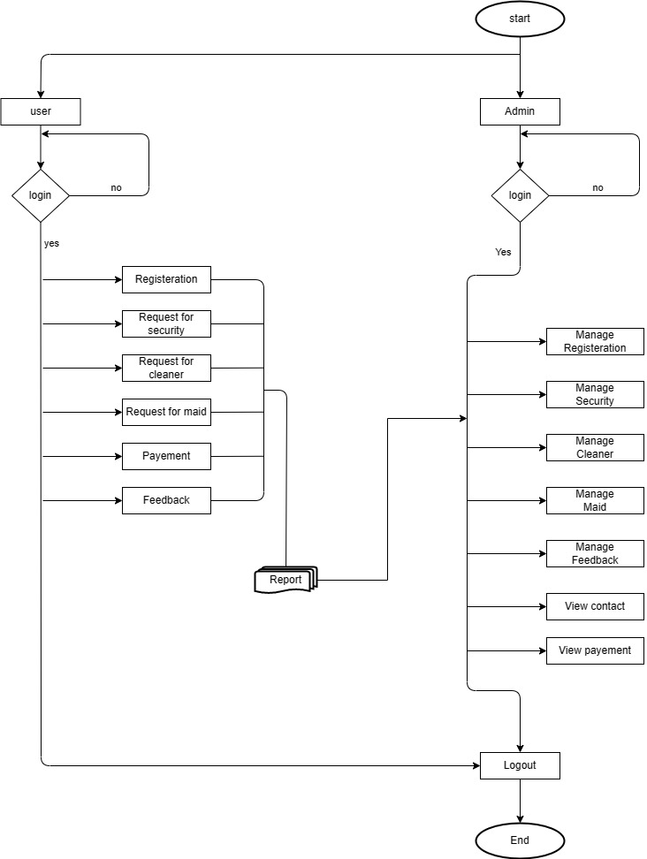

**Fig. a Flowchart**

* 1. **Time Line Chart**

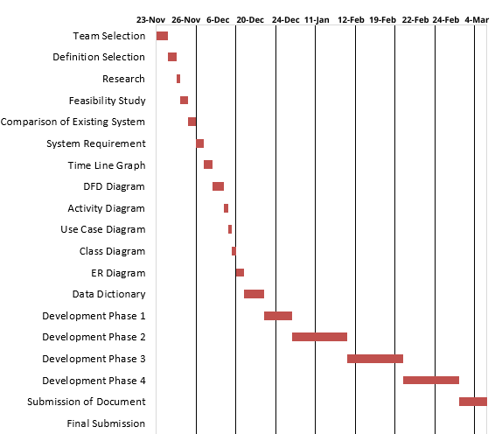

Figure 3.7.1. Time Line Chart

1. **Technology Description**
   1. **Features and Limitations of New System**

|  |  |
| --- | --- |
| **Existing System** | **New System** |
| All the services are done via different apps | Services will be done under one application |
| There will be no cleaner for vehicles only residential will be provided . | We will be also providing the one time service facility to all the residential clients |

1. **Data Flow Diagram**
   1. **Context Level DFD’s**

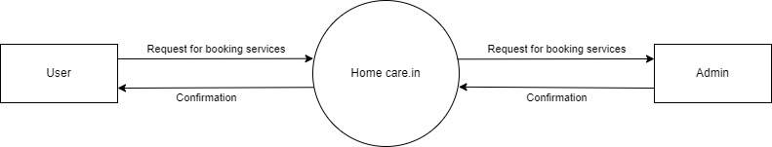

Figure 5.1.1. Context Level DFD: 0 Level

* 1. **Level 1 DFD’s: Admin side**

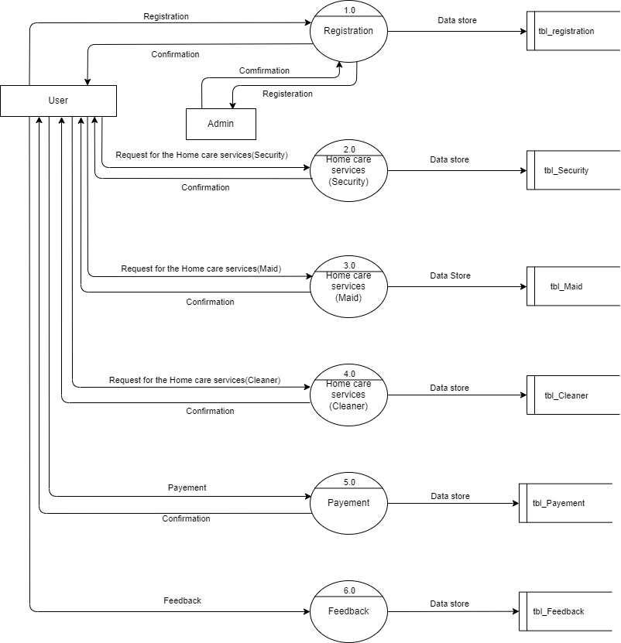

Fig. a Level 1 DFD diagram for Admin

**User side 1 st level dfd**



Fig. a Level 1 DFD diagram for user

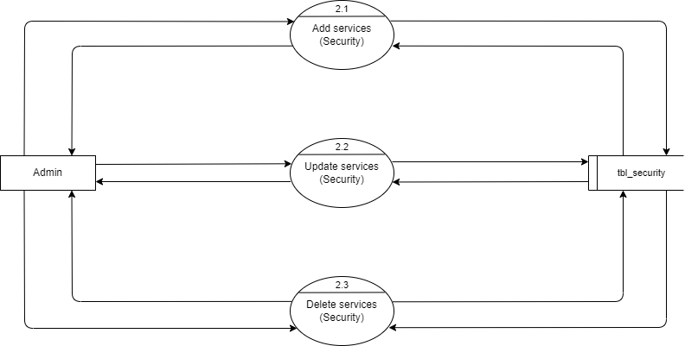

Fig. a Levrll 2 DFD diagram for Admin

**User side 2nd level dfd :**

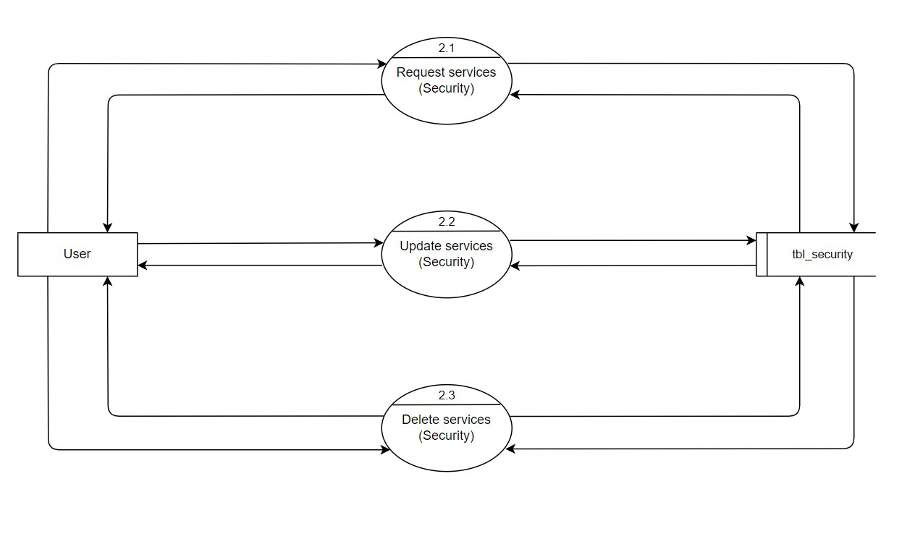

**Fig. a Level 2 DFD**

**6 . Use Case Diagram**

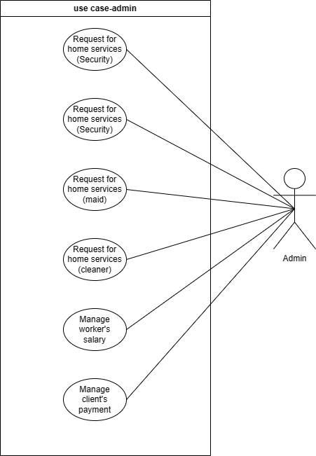

**Fig. a Use case Diagram**

**6 User-**

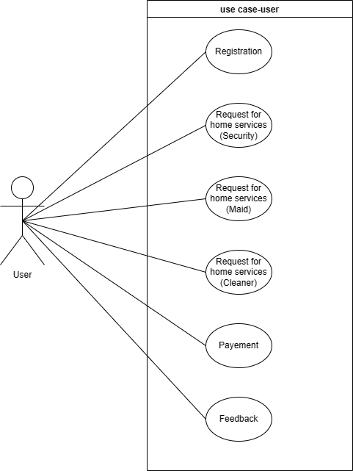

**Fig a. Usecase diagram for user**

**7.Class Diagram**

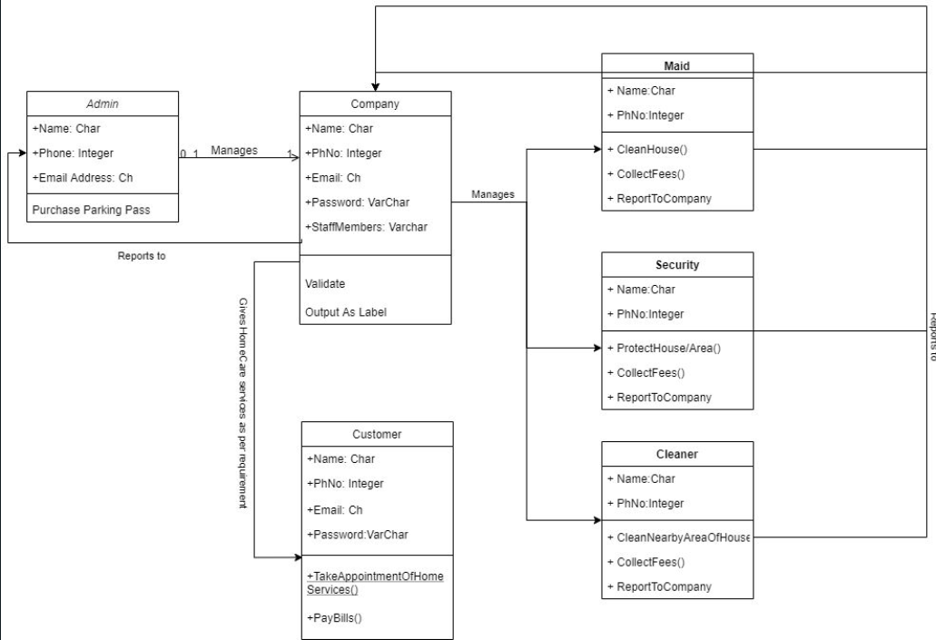

**8. Activity Diagram**

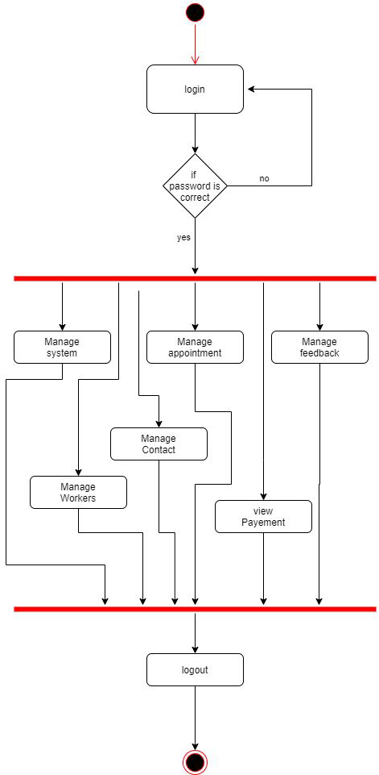

Fig. a Activity diagram for Admin

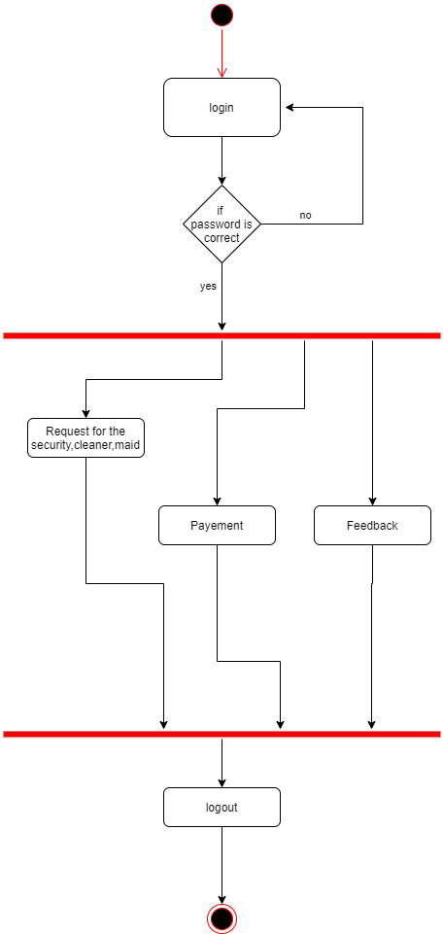

**Fig. a Activity diagram for Admin**

1. **E-R Diagram**

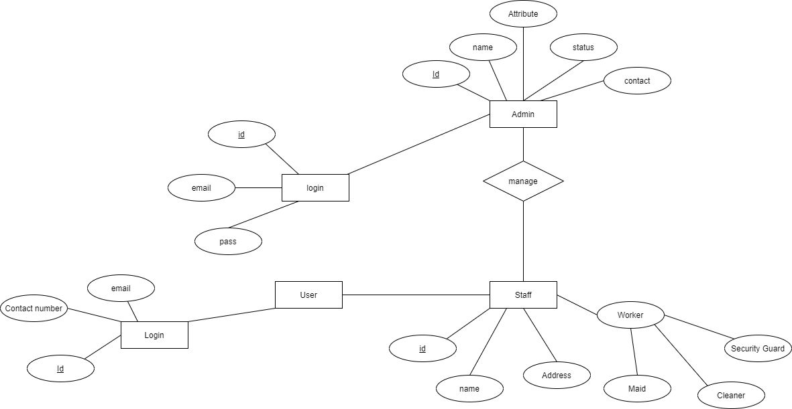

Fig. a ER diagram

1. **Data Dictionary**
2. **Table Name: adminlogin**

**Table Description: details for admin .**

|  |  |  |  |  |  |  |
| --- | --- | --- | --- | --- | --- | --- |
| **Sr. No** | **Field Name** | **Datatype** | **Size** | **Description** | **Constraint** | **Example** |
| 01 | Name | varchar | 30 | Name store | - | Admin |
| 02 | Email | Varchar | 30 | Email id store | - | [admin@gmail.com](mailto:admin@gmail.com) |
| 03 | Password | Varchar | 30 | Password store | - | Admin@123 |

**Table Name : cleaner**

|  |  |  |  |  |  |  |
| --- | --- | --- | --- | --- | --- | --- |
| **Sr. No** | **Field Name** | **Datatype** | **Size** | **Description** | **Constraint** | **Example** |
| 01 | Email | Varchar | 50 | Stored email | PRIMARYkey | [abc@gmail.com](mailto:abc@gmail.com) |
| 02 | Floor | Int | 5 | Stored floor | - | Floor 1 2 3 |
| 03 | Room | Int | 5 | Stored room | - | Room no 1 |
| 04 | Bedroom | Int | 5 | Stored bed room | - | Bedroom 6 |
| 05 | Kitchen | Int | 5 | Stored kitachen | - | Kitchen 3 |
| 06 | Hall | Int | 5 | Stored hall | - | Hall 4 |
| 07 | Extraroom | Int | 5 | Stored extraroom | - | Extraroom 6 |
| 08 | Bathroom | int | 5 | Stored bath room | - | Bathroom 7 |

**Table Name : Contactpage**

|  |  |  |  |  |  |  |
| --- | --- | --- | --- | --- | --- | --- |
| **Sr. No** | **Field Name** | **Datatype** | **Size** | **Description** | **Constraint** | **Example** |
| 01 | Name | Varchar | 30 |  | - | Janki |
| 02 | Email | Varchar | 70 |  | - | abc@123.com |
| 03 | Mobile | Bigint | 15 |  | - | 7486896866 |
| 04 | issue | varchar | 150 |  | - | I have this problem . |

**Table Name : login**

|  |  |  |  |  |  |  |
| --- | --- | --- | --- | --- | --- | --- |
| **Sr. No** | **Field Name** | **Datatype** | **Size** | **Description** | **Constraint** | **Example** |
| 01 | Name | Varchar | 50 |  | - |  |
| 02 | Mobile | Bigint | 15 |  | - |  |
| 03 | Mail | Varchar | 80 |  | Primary key |  |
| 04 | Password | Varchar | 30 |  | - |  |

**Table Name : security**

|  |  |  |  |  |  |  |
| --- | --- | --- | --- | --- | --- | --- |
| **Sr. No** | **Field Name** | **Datatype** | **Size** | **Description** | **Constraint** | **Example** |
| 01 | Email | Varchar | 50 | Stored email | PRIMARYkey | [abc@gmail.com](mailto:abc@gmail.com) |
| 02 | Housetype | Int | 30 | Stored housetype | - | Floor 1 2 3 |
| 03 | Contact | Int | 12 | Stored contact | - | Room no 1 |
| 04 | Shift | Int | 50 | Stored shift | - | Bedroom 6 |
| 05 | Startdate | Date | - | Stored date | - | 04/4/2023 |
| 06 | Enddate | Date | - | Stored date | - | 4/4/2023 |

**Table Name : maid**

|  |  |  |  |  |  |  |
| --- | --- | --- | --- | --- | --- | --- |
| **Sr. No** | **Field Name** | **Datatype** | **Size** | **Description** | **Constraint** | **Example** |
| 01 | Email | Varchar | 50 | Stored email | PRIMARYkey | [abc@gmail.com](mailto:abc@gmail.com) |
| 02 | Service | Varchar | 25 | Stored services details | - |  |
| 03 | Floor | Int | 11 | Stored floor | - |  |
| 04 | Rooms | Int | 11 | Stored room | - | room 6 |
| 05 | Bedroom | Int | 11 | Stored bedroom | - | Bedroom 9 |
| 06 | Kitchen | Int | 11 | Stored kitachen | - | Kitchen 3 |
| 06 | Hall | Int | 5 | Stored hall | - | Hall 4 |
| 07 | Extraroom | Int | 5 | Stored extraroom | - | Extraroom 6 |
| 08 | Time | Varchar | 20 | Stored time | - | 9:00pm |
| 08 | Bathroom | int | 5 | Stored bath room | - | Bathroom 7 |

1. **Form Design (Screenshots Phase 1 ,2,3,4 & validation’s screenshots)**
   1. **Development Phase -1**

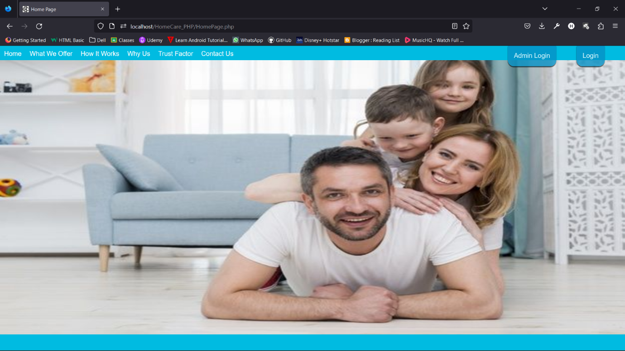

* 1. **Development Phase -2**

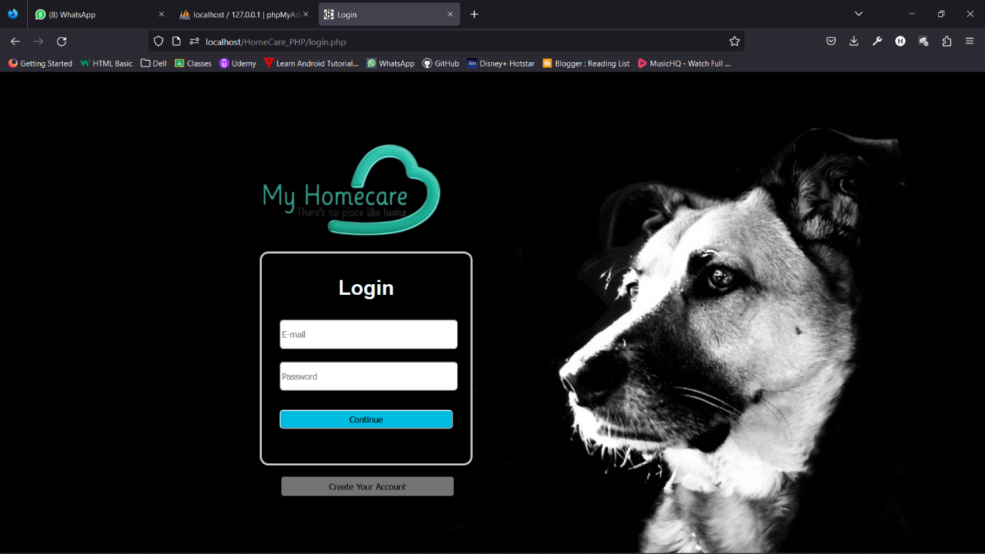

* 1. **Development Phase -3**

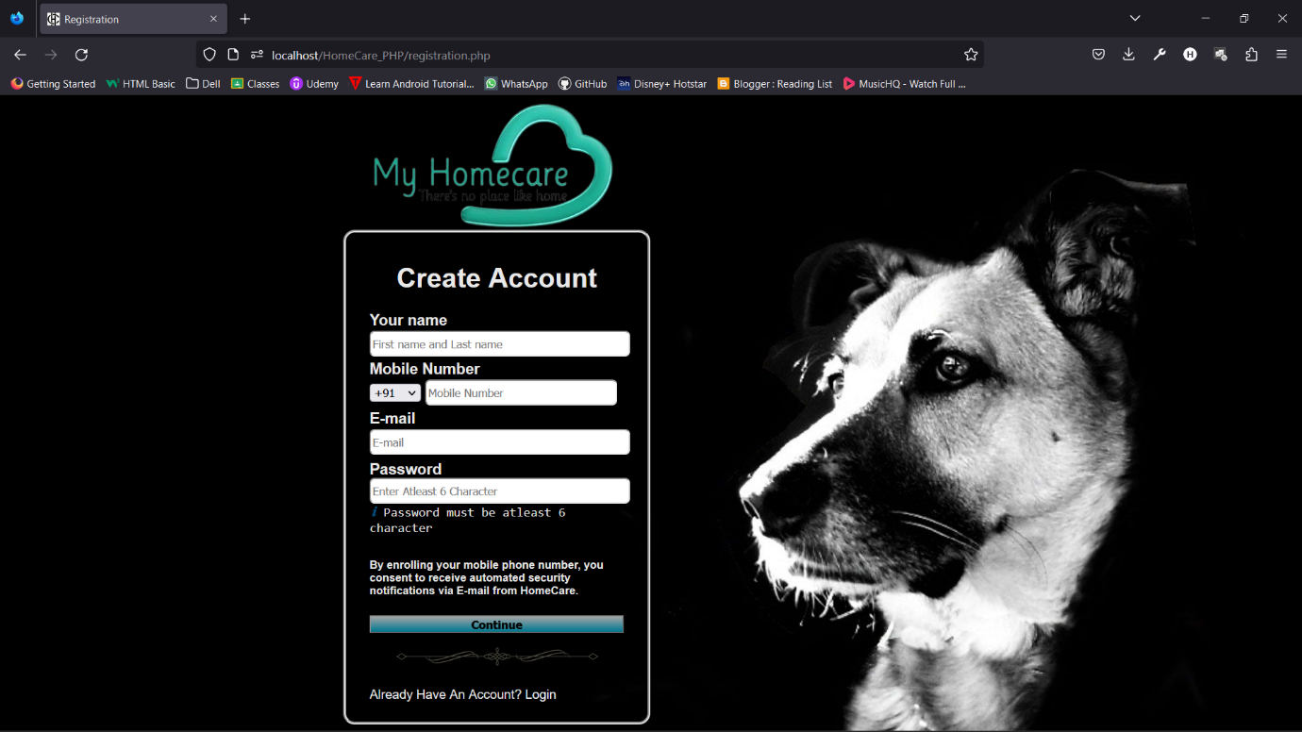

* 1. **Development Phase -4**

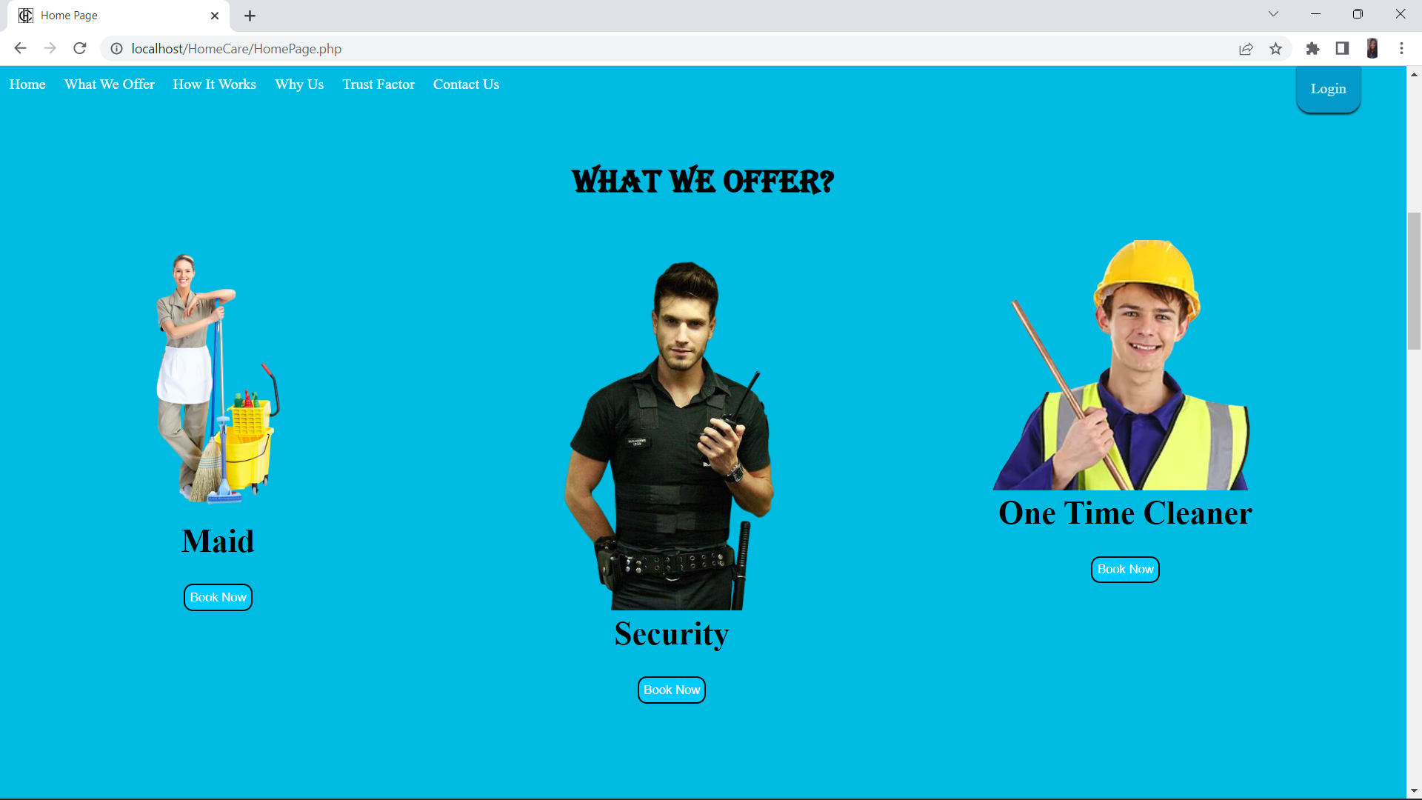

**12. What is testing?**

Software Testing is a method to check whether the actual software product matches expected requirements and to ensure that software product is Defect free. It involves execution of software/system components using manual or automated tools to evaluate one or more properties of interest. The purpose of software testing is to identify errors, gaps or missing requirements in contrast to actual requirements.

Some prefer saying Software testing as a White Box and Black Box Testing. In simple terms, Software Testing means the Verification of Application Under Test (AUT). This tutorial introduces testing software to the audience and justifies its importance.

**12.1. Importance and types of testing**

Software Testing is Important because if there are any bugs or errors in the software, it can be identified early and can be solved before delivery of the software product. Properly tested software product ensures reliability, security and high performance which further results in time saving, cost effectiveness and customer satisfaction.

Testing is important because software bugs could be expensive or even dangerous.

**Types of Software Testing**

Typically Testing is classified into three categories.

* Functional Testing
* Non-Functional Testing or Performance Testing
* Maintenance (Regression and Maintenance)

Functional Testing

* Unit Testing
* Integration Testing
* Smoke
* UAT (User Acceptance Testing)
* Localization
* Globalization
* Interoperability

Non-Functional Testing

* Performance
* Endurance
* Load
* Volume
* Scalability
* Usability

Maintenance

* + Regression
  + Maintenance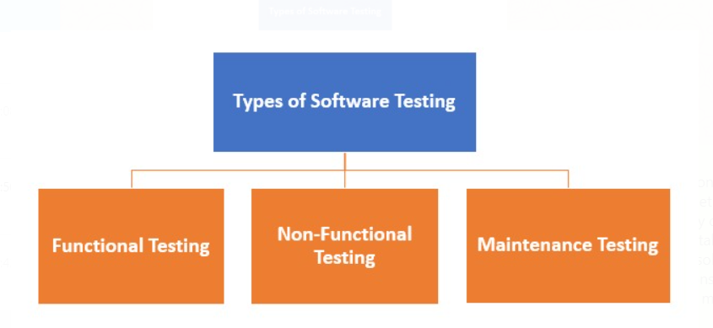

**13. Future Enhancement**

In future, we will be also providing the commercial services for one time cleaner.

Maids and peon will be also provided to the commercial.

If the demands rises them we will also provide the cleaner for the vehicles

**14.References & Bibliography**

PHP manual - The PHP manual is a comprehensive resource for learning PHP and provides information on the syntax and usage of various functions and classes. It can be found at <https://www.php.net/manual/en/>

Online tutorials - There are many online tutorials available that teach PHP from the basics to more advanced topics. Some popular websites include Codecademy, Udemy, and Coursera.

Stack Overflow - Stack Overflow is a Q&A site for programming questions and can be a great resource for finding answers to specific questions related to HomeCare.IN SYSTEM in PHP language.

GitHub - GitHub is a platform for hosting open-source projects and can be a great place to find code examples and projects related to HomeCare.IN SYSTEM in PHP language.

PHP developers' forums - There are several forums where PHP developers can ask questions, share code, and collaborate with others on projects. Some popular forums include php.net, dev.to, and Code Project.

**w3school -** <https://www.w3schools.com/php/>

**javaTpoint -** <https://www.javatpoint.com/>