NAME – AMAN ANAND TIWARI

COURSE – BCA

SESSION – 2022 – 25

# ASSIGNMENT – Practical Assignment on

# 18 NOV 2022 (conditional statements)

DATE OF ASSIGNMENT – 10 NOV 2022

DATE OF SUBMISSION – 10 NOV 2022

/* 1. Write a C program to check whether a number is negative, positive or zero.*/

#include <stdio.h>

int main(void)

{

    float n;

    printf("enter number \n");

    scanf("%f",&n);

    if(n>0)

        printf("input is positive \n");

    else if(n<0)

        printf("input is negative \n");

    else

        printf("input is zero \n");

return 0;

}

Output –

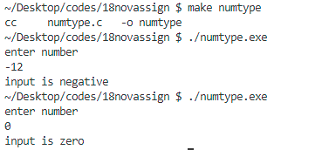

__________________________________________________________

/* 2. Write a C program to check whether a number is divisible by 5 and 11 or not.*/

#include <stdio.h>

int main(void)

{

    int n;

    printf("enter number \n");

    scanf("%d",&n);

    if((n%5==0)&&(n%11==0))   //% operator can take only integer operand

        printf("%d is divisible by 5 and 11 both \n",n);

    else

        printf("%d is not divisible by both 5 and 11 \n",n);

    return 0;

}

Output –

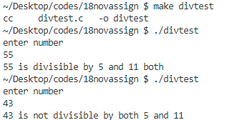

____________________________________________________________

/* 3. Write a C program to check whether a year is leap year or not.*/

#include <stdio.h>

int main(void)

{

    int n;

    printf("enter year \n");

    scanf("%d",&n);

    if(((n%4==0)&&(n%100 != 0)) || (n%400 ==0))

        printf("%d is leap year \n",n);

    else

        printf("%d is not leap \n",n);

    return 0;

}

Output –

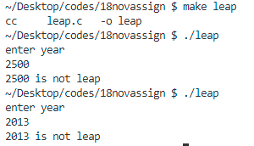

_________________________________________________________

/* 4. Write a C program to check whether a character is alphabet or not.*/

#include <stdio.h>

int main(void)

{

    char c;

    printf("enter character \n");

    scanf("%c",&c);

    if(((c>='a')&&(c<='z')) || ((c>='A')&&(c<='Z')))

        printf("character entered is alphabetical \n");

    else

        printf("character is not alphabetical \n");

return 0;

}

Output –

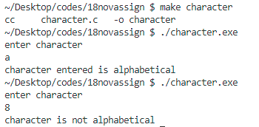

/* 5. Write a C program to input any alphabet and check whether it is vowel or consonant. */

#include <stdio.h>

#include <stdlib.h>

#include <ctype.h>   //for using toupper() function

int main(void){

    char a;

    //ensuring only alphabetical character is entered

    do

    {

        printf("enter alphabetical character \n");

        scanf("%c",&a);

        a = toupper(a);

    }

    while((a<'A'|| a>'Z'));

    /*toupper() function return uppercase if char is lowercase

    uppercase characters remain unchanged */

    a = toupper(a);

    if(a =='A' || a=='E' || a=='I' || a=='O' || a=='U')

        printf("entered character is a vowel \n");

    else

        printf("entered character is consonant \n");

    return 0;

}

Output –

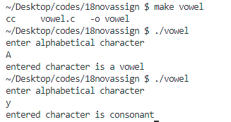

/* 6. Write a C program to input any character and check whether it is alphabet, digit

        or special character. */

#include <stdio.h>

int main(void)

{

    char c;

    printf("enter character \n");

    scanf("%c",&c);

    if(((c>='a')&&(c<='z')) || ((c>='A')&&(c<='Z')))

        printf("character entered is alphabetical \n");

    else if((c>='0')&&(c<='9'))

        printf("character entered is digit \n");

    else

        printf("character is special character \n");

    return 0;

}

Output –

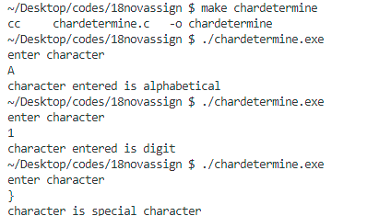

____________________________________________________________

/* 7. Write a C program to check whether a character is uppercase or lowercase alphabet. */

#include <stdio.h>

int main(void)

{

    char c;

    printf("enter character \n");

    scanf("%c",&c);

    if(c>='a' && c<='z')

        printf("character is lowercase alphabet \n");

    else if(c>='A' && c<='Z')

        printf("character is uppercase alphabet \n");

    else

        printf("character is not alphabetical \n");

    return 0;

}

Output –

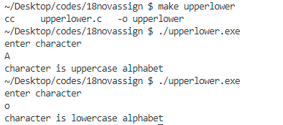

____________________________________________________________

/* 8. Write a C program to input week number and print week day.*/

#include <stdio.h>

int main(void)

{

    int a;

    printf("enter week number(1 to 7) \n");

    scanf("%d",&a);

    if(a == 1)

        printf("sunday \n");

    else if(a == 2)

        printf("monday \n");

    else if(a == 3)

        printf("tuesday \n");

    else if(a == 4)

        printf("wednesday \n");

    else if(a == 5)

        printf("thursday \n");

    else if(a == 6)

        printf("friday \n");

    else if(a == 7)

        printf("saturday \n");

    else

        printf("invalid week number \n");

return 0;

}

Output –

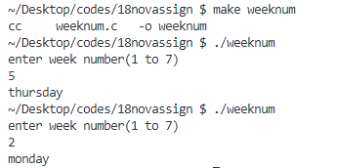

____________________________________________________________

/* 9. Write a C program to input month number and print number of days in that month.*/

#include <stdio.h>

int main(void)

{

    int i;

    printf("enter month - number \n");

    scanf("%d",&i);

    if(i==1||i==3||i==7||i==8||i==10||i==12)

        printf("31 days \n");

    else if(i==2)

        printf("27 or 28 days(for leap year) \n");

    else if(i==4||i==6||i==9||i==11)

        printf("30 days \n");

    else

        printf("invalid month number \n");

    return 0;

}

Output –

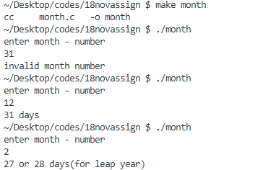

/* 10. Write a C program to input angles of a triangle and

 check whether triangle is valid or not.*/

#include <stdio.h>

int main(void)

{

    float a1,a2,a3;

    printf("enter angles of triangle \n");

    scanf("%f %f %f",&a1,&a2,&a3);

    if((a1>0 && a2>0 && a3>0) && (a1+a2+a3 == 180))

    {

        printf("angles entered corresponds to a valid triangle \n");

    }

    else

        printf("angles entered is not valid for existance of triangle \n");

    return 0;

}

Output –

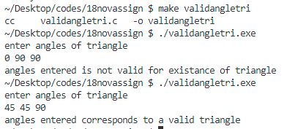

____________________________________________________________

/* 11. Write a C program to input all sides of a triangle and check whether

 triangle is valid or not.*/

#include <stdio.h>

int main(void)

{

    float a,b,c;

    printf("enter sides of the triangle \n");

    scanf("%f %f %f",&a,&b,&c);

    if(a+b>c && b+c>a && c+a>b)

        printf("sides are valid and corresponds to triangle \n");

    else

        printf("entered sides doesn't corresponds to triangle \n");

    return 0;

}

Output –

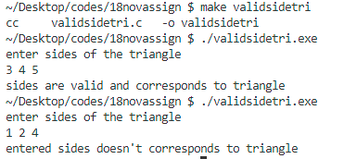

____________________________________________________________

/* 12. Write a C program to check whether the triangle is equilateral, isosceles

    or scalene triangle.*/

#include <stdio.h>

int main(void)

{

    float a,b,c;

    printf("enter the sides of the triangle \n");

    scanf("%f %f %f",&a,&b,&c);

    //check if sides are valid for a triangle - sum of any two must be greater then third

    if((a+b>c) && (b+c>a) && (c+a>b))

    {

        if((a==b) && (b==c))

            printf("triangle is equilateral \n");

        else if((a==b) || (b==c) || (c==a))

            printf("triangle is isosceles \n");

        else

            printf("triangle is scelene \n");

    }

    else

        printf("wrong input for sides of triangle\n");

    return 0;

}

Output –

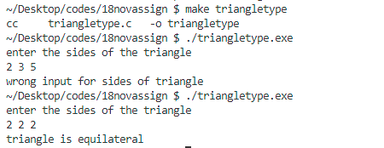

____________________________________________________________

/* 13. Write a C program to input marks of five subjects Physics,

 Chemistry, Biology, Mathematics and

Computer.

Calculate percentage and grade according to following:

Percentage >= 90% : Grade A

Percentage >= 80% : Grade B

Percentage >= 70% : Grade C

Percentage >= 60% : Grade D

Percentage >= 40% : Grade E

Percentage < 40% : Grade F */

#include <stdio.h>

int main(void)

{

    float a,b,c,d,e,percent;

    percent =0;

    printf("input marks for sunbjects \n");

    printf("Physics :");

    scanf("%f",&a);

    printf("chemistry :");

    scanf("%f",&b);

    printf("biology :");

    scanf("%f",&c);

    printf("mathematics :");

    scanf("%f",&d);

    printf("computer :");

    scanf("%f",&e);

    percent = ((a+b+c+d+e)/500)*100;

    if(percent >= 90)

        printf("percentage = %.3f ->> Grade A \n",percent);

    else if(percent >= 80)

        printf("percentage = %.3f ->> Grade B \n",percent);

    else if(percent >= 70)

        printf("percentage = %.3f ->> Grade C \n",percent);

    else if(percent >= 60)

        printf("percentage = %.3f ->> Grade D \n",percent);

    else if(percent >= 40)

        printf("percentage = %.3f ->> Grade E \n",percent);

    else if(percent < 40)

        printf("percentage = %.3f ->> Grade F \n",percent);

    return 0;

}

Output –

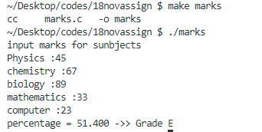

____________________________________________________________

/* 14. Write a C program to input basic salary of an employee and

calculate its Gross salary according to

following:

Basic Salary <= 10000 : HRA = 20%, DA = 80%

Basic Salary <= 20000 : HRA = 25%, DA = 90%

Basic Salary > 20000 : HRA = 30%, DA = 95% */

#include <stdio.h>

int main(void)

{

    float salary,hra,da;

    hra = 0;

    da = 0;

    printf("enter Basic salary \n");

    scanf("%f",&salary);

    if(salary<=10000)

    {

        hra = (salary*20)/100;

        da = (salary*80)/100;

    }

    else if(salary<=20000)

    {

        hra = (salary*25)/100;

        da = (salary*90)/100;

    }

    else if(salary>20000)

    {

        hra = (salary*30)/100;

        da = (salary*95)/100;

    }

    //net salary calculation

    salary = salary + hra + da;

    printf("gross salary(basic salary+da+hra) = %.3f \n",salary);

    return 0;

}

Output –



