NAME – AMAN ANAND TIWARI

COURSE – BCA

SESSION – 2022 – 25

ASSIGNMENT – FIBONACCI SERIES (ASSIGNMENT FOR CET1 )

DATE OF ASSIGNMENT – 10 NOV 2022

DATE OF SUBMISSION – 10 NOV 2022

/\* 1. Write a program to print Fibonacci numbers from 1 to n.\*/

#include <stdio.h>

int main(void)

{

    int n,sum;

    sum =0;

    printf("enter upto value for fibonacci series \n");

    scanf("%d",&n);

    int a=0,b=1;

    printf(" %d ",a);

    sum = a+b;

    while(sum < n)

    {

        printf("%d ",sum);

        sum = a+b;

        a = b;

        b = sum;

    }

printf("\n");

    return 0;

}

Output –

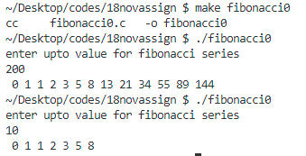

/\* 2. Write a program to print all Fibonacci numbers upto nth term.\*/

#include <stdio.h>

int main(void)

{

    int n,sum;

    printf("enter n for number of terms required in series \n");

    scanf("%d",&n);

    int a,b,i;

    a=0,b=1;

    printf("%d ",a);

    sum = a+b;

    for(i=2; i<=n; i++)

    {

        printf("%d ",sum);

        sum = a+b;

        a=b;

        b=sum;

    }

    printf("\n");

return 0;

}

Output –



