NAME – AMAN ANAND TIWARI

COURSE – BCA

SESSION – 2022 – 25

Assignment – programming for problem solving ( 28 Oct 2022)

DATE OF ASSIGNMENT – 21 OCT 2022

DATE OF SUBMISSION – 21 OCT 2022

/\*  5. Write a C program to find the Area of the Triangle by Entering Height, and Base. \*/

#include <stdio.h>

int main (void)

{

    float height , base , area;

    //taking input no negatives allowed as length is always +ve

    do

    {

        printf ("enter the height and base (both positive) \n");

        scanf ("%f %f", &height , &base);

    }

    while ((height <= 0) || (base <= 0));

    //calculation

    area = (float) 1/2 \* base \* height ;

    //output

    printf("area of triangle = %.4f \n", area);

    return 0;

}

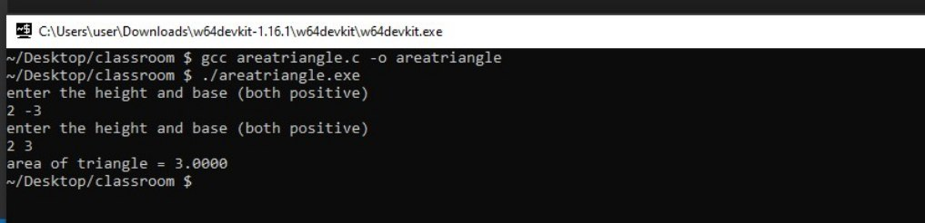

/\*  6. Write a C program to perform Celsius to Fahrenheit Temperature Conversion.  \*/

#include <stdio.h>

int main(void)

{

    float cel , fah ;

    printf ("enter temperature (in Celcius)  ");

    scanf ("%f",&cel);

    //conversion

    fah = (float) (9 \* cel + 160)/5 ;

    //output result

    printf("%.4f in Celcius = %.4f Fahrenheit \n", cel , fah);

    return 0;

}

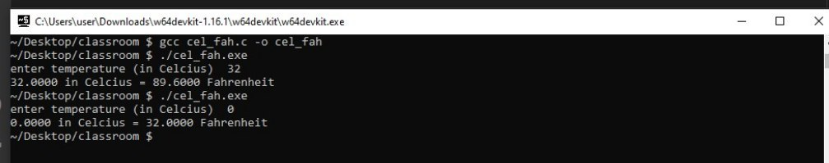

/\* 7. Write a C program to perform Fahrenheit to Celsius Temperature Conversion. \*/

#include <stdio.h>

int main(void)

{

    float cel , fah ;

    printf ("enter temperature (in Fahrenheit)  ");

    scanf ("%f",&fah);

    //conversion

    cel = (float)(5 \* fah - 160) / 9;

    //output result

    printf("%.4f in Fahrenheit = %.4f Celcius \n", fah , cel);

    return 0;

}

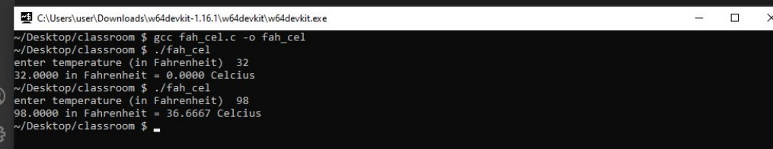

/\*  8. Enter Marks of Five Subjects and Calculate Total, Average, Percentage using C

programing. \*/

#include <stdio.h>

int main(void)

{

    float m1 ,m2, m3, m4, m5, total = 0, avg = 0 ,percentage = 0;

    //taking input for marks

    printf("enter marks for 5 subjects \n");

    printf("subject 1 = "); scanf ("%f",&m1);

    printf("subject 2 = "); scanf ("%f",&m2);

    printf("subject 3 = "); scanf ("%f",&m3);

    printf("subject 4 = "); scanf ("%f",&m4);

    printf("subject 5 = "); scanf ("%f",&m5);

    //calulations

    total = m1 + m2 + m3 + m4 + m5;

    avg = (float) total/5;

    percentage = (float) (total\*100)/500;

    //output

    printf("total marks = %.2f \n avg marks = %.2f \n",total,avg);

    printf("percentage = %.2f%% \n",percentage);

    return 0;

}

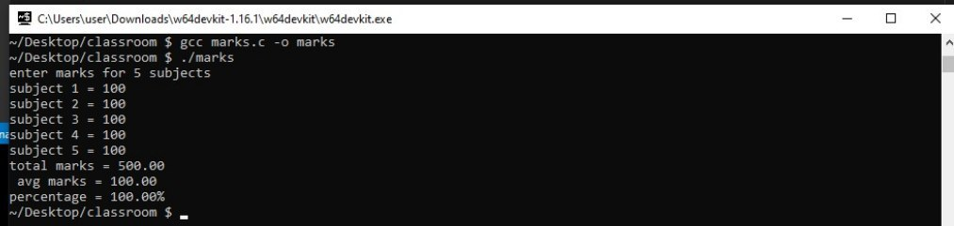

/\* 9. Write a C program to convert Centimetre into Meter and Kilometre \*/

#include <stdio.h>

int main (void)

{

    float cm , m=0 ,km=0 ;

    //taking input no negative value

    do

    {

        printf ("enter the length (in centimeter)   ");

        scanf ("%f",&cm);

    }

    while (cm < 0);

    //calculation

    m = (float) cm /100;

    km = (float) cm / 100000;

    //printing result

    printf(" cm = %f \n m = %f \n km = %f \n",cm ,m ,km);

    return 0;

}

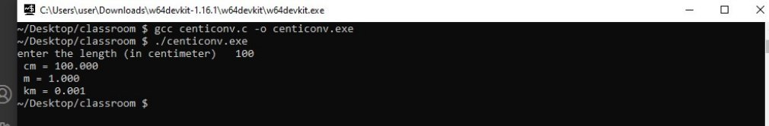

/\* 10. Write a C program to Calculate Simple Interest | Principle, Rate of interest &

Time \*/

#include <stdio.h>

int main(void)

{

    float p,r,t,si;

    //taking input principle and rate

    printf("enter Principle , Rate of interest(per year) \n");

    scanf ("%f %f",&p , &r);

    //time input no negative values allowed

    do

    {

        printf("enter time period (in years) =  ");

        scanf ("%f",&t);

    }

    while (t<0);

    //simple interest calculation

    si = (float) (p \* r \* t)/100;

    //output

    printf("simple interest = %.4f \n",si);

    return 0;

}

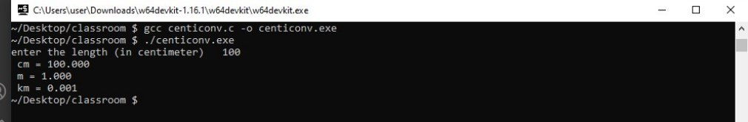

/\*wap to check whether a triangle is isosceles ,equilateral or scalene\*/

#include <stdio.h>

int main(void)

{

    float a,b,c;

    printf("enter the sides of the triangle \n");

    scanf("%f %f %f",&a,&b,&c);

    //check if sides are valid for a triangle - sum of any two must be greater then third

    if((a+b>c) && (b+c>a) && (c+a>b))

    {

        if((a==b) && (b==c))

            printf("triangle is equilateral \n");

        else if((a==b) || (b==c) || (c==a))

            printf("triangle is isosceles \n");

        else

            printf("triangle is scelene \n");

    }

    else

        printf("wrong input for sides of triangle\n");

    return 0;

}

Output -

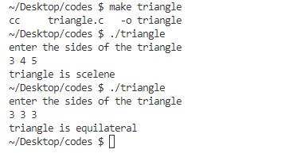

/\*wap to check whether a number is two digit or not\*/

#include <stdio.h>

int main(void)

{

    int i;

    printf("enter number \n");

    scanf("%d",&i);

    if(i>=10 && i<=99)

    {

        printf("number is 2 digit \n");

    }

    else

        printf("number is not of 2 digit \n");

return 0;

}

Output –

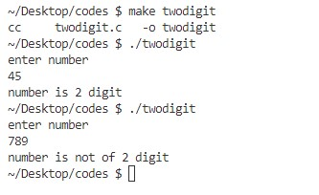

/\*wap to find greatest amaong 3 numbers using nested if-else\*/

#include <stdio.h>

int main(void)

{

    float a,b,c;

    printf("enter three numbers \n");

    scanf("%f %f %f",&a,&b,&c);

    //required comparisons

    if(a>b)

    {

        if(a>c)

            printf("%f is greatest \n",a);

        else

            printf("%f is greatest \n",c);

    }

    else

    {

        if(b>c)

            printf("%f is greatest \n",b);

        else

            printf("%f is greatest \n",c);

    }

return 0;

}

OUT PUT –

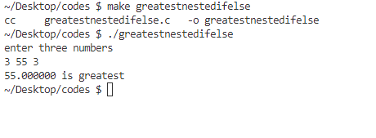

/\*wap to print number of days using switch statement\*/

#include <stdio.h>

int main(void)

{

    int i;

    printf("enter nth day of week \n");

    scanf("%d",&i);

    //using switch to print day

    switch (i)

    {

        case 1 :

            {

                printf("sunday \n");

                break;

            }

        case 2 :

            {

                printf("monday \n");

                break;

            }

        case 3 :

            {

                printf("tuesday \n");

                break;

            }

        case 4 :

            {

                printf("wednesday \n");

                break;

            }

        case 5 :

            {

                printf("thrusday \n");

                break;

            }

        case 6 :

            {

                printf("friday \n");

                break;

            }

        case 7 :

            {

                printf("satuday \n");

                break;

            }

        default :

                printf("not valid day number \n");

    }

    return 0;

}

Output

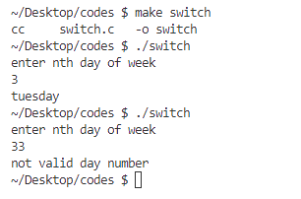

/\*wap to print days of week\*/

#include <stdio.h>

int main(void)

{

    int i;

    printf("enter the nth day \n");

    scanf("%d",&i);

    //printing day according to user input

    if(i==1)

        printf("sunday \n");

    else if(i == 2)

        printf("monday \n");

    else if(i == 3)

        printf("tuesday \n");

    else if(i == 4)

        printf("wednesday \n");

    else if(i == 5)

        printf("thrusday \n");

    else if(i == 6)

        printf("friday \n");

    else if(i == 7)

        printf("saturday \n");

    else

        printf("wrong input for 'day number'\n");

return 0;

}

Output

