NAME – AMAN ANAND TIWARI

COURSE – BCA

SESSION – 2022 – 25

# Assignment – Practical Assignment: 04.11.2022(if else and switch)

DATE OF ASSIGNMENT – 4 Nov 2022

DATE OF SUBMISSION – 4 Nov 2022

/* 1 .wap to check whether a number is two digit or not*/

#include <stdio.h>

int main(void)

{

    int i;

    printf("enter number \n");

    scanf("%d",&i);

    if(i>=10 && i<=99)

    {

        printf("number is 2 digit \n");

    }

    else

        printf("number is not of 2 digit \n");

return 0;

}

Output –

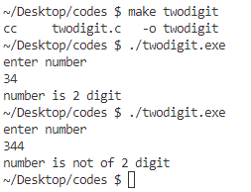

/* 2. Write a program in C to find the greater number between two numbers. */

#include <stdio.h>

int main(void)

{

    int a,b;

    printf("enter numbers to be compared \n");

    scanf("%d %d",&a,&b);

    if(a>b)

        printf("%d is greater than %d\n",a,b);

    else if(a<b)

        printf("%d is greater than %d \n",b,a);

    else

        printf("both numbers are equal \n");

    return 0;

}

Output

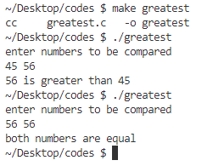

/* 3. Write a program in C to check whether a triangle is equilateral, isosceles or scalene. */

#include <stdio.h>

int main(void)

{

    float a,b,c;

    printf("enter the sides of the triangle \n");

    scanf("%f %f %f",&a,&b,&c);

    //check if sides are valid for a triangle - sum of any two must be greater then third

    if((a+b>c) && (b+c>a) && (c+a>b))

    {

        if((a==b) && (b==c))

            printf("triangle is equilateral \n");

        else if((a==b) || (b==c) || (c==a))

            printf("triangle is isosceles \n");

        else

            printf("triangle is scelene \n");

    }

    else

        printf("wrong input for sides of triangle\n");

    return 0;

}

Output –

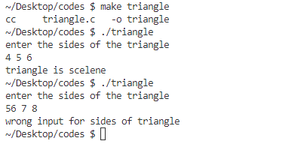

/* 4. Write a program in C to print the names of the day of a week using switch case. */

#include <stdio.h>

int main(void)

{

    int i;

    printf("enter nth day of week \n");

    scanf("%d",&i);

    //using switch to print day

    switch (i)

    {

        case 1 :

            {

                printf("sunday \n");

                break;

            }

        case 2 :

            {

                printf("monday \n");

                break;

            }

        case 3 :

            {

                printf("tuesday \n");

                break;

            }

        case 4 :

            {

                printf("wednesday \n");

                break;

            }

        case 5 :

            {

                printf("thrusday \n");

                break;

            }

        case 6 :

            {

                printf("friday \n");

                break;

            }

        case 7 :

            {

                printf("satuday \n");

                break;

            }

        default :

                printf("not valid day number \n");

    }

    return 0;

}

Output –

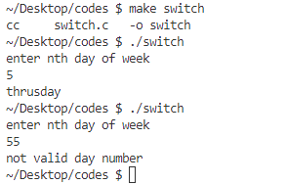

/*5. Write a program in C to find the greatest number among three numbers using nested if else.*/

#include <stdio.h>

int main(void)

{

    float a,b,c;

    printf("enter three numbers \n");

    scanf("%f %f %f",&a,&b,&c);

    //required comparisons

    if(a>=b)

    {

        if(a>c)

            printf("%f is greatest \n",a);

        else if(a==c)  //for the case when all inputs are equal

            printf("all values are equal \n");

        else

            printf("%f is greatest \n",c);

    }

    else

    {

        if(b>c)

            printf("%f is greatest \n",b);

        else

            printf("%f is greatest \n",c);

    }

return 0;

}

Output –

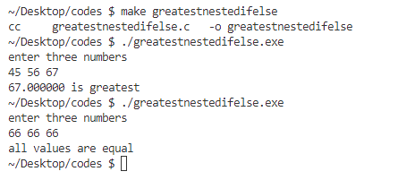

/* 6. Write a program in C to check whether an input is vowel or consonant */

#include <stdio.h>

#include <stdlib.h>

#include <ctype.h>   //for using toupper() function

int main(void){

    char a;

    //ensuring input is only alphabetical character

    do

    {

        printf("enter alphabetical character \n");

        scanf("%c",&a);

        a = toupper(a);

    }

    while((a<'A'|| a>'Z'));

    /*toupper() function return uppercase if char is lowercase

    uppercase characters remain unchanged */

    a = toupper(a);

    if(a =='A' || a=='E' || a=='I' || a=='O' || a=='U')

        printf("entered character is a vowel \n");

    else

        printf("entered character is consonant \n");

    return 0;

}

Output –

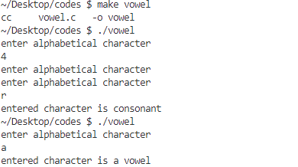

/*7. Write a program in C to perform the addition of time. */

#include <stdio.h>

#include <stdlib.h>

int main(void){

    //taking time input

    int h1,h2,m1,m2,s1,s2,h,m,s;

    h=0; m=0; s=0;

    printf("enter time1 \n");

    scanf("%d %d %d",&h1,&m1,&s1);

    printf("enter time2 \n");

    scanf("%d %d %d",&h2,&m2,&s2);

    //time addition

    s = s1 + s2;

    if(s>=60)

    {

        m = s/60;

        s = s%60;

    }

    m = m+ m1+m2;

    printf("minute intermediate = %d \n",m);

    if(m>=60)

    {

        h = m/60;

        m = m%60;

        printf("%d is hour \n",h);

    }

    h = h+h1+h2;

    //printing final results

    printf("   t1 = %d hh %d mm %d ss \n",h1,m1,s1);

    printf(" + t2 = %d hh %d mm %d ss \n",h2,m2,s2);

    printf("--------------------------- \n");

    printf("total = %d hh %d mm %d ss \n",h,m,s);

    return 0;

}

Output –

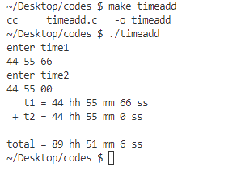

/*8. Write a program in C to print the range of an input.*/

#include <stdio.h>

int main(void){

    int a;

    printf("enter number \n");

    scanf("%d",&a);

    switch(a)

    {

        case 1 ... 10 :{

            printf("input ranges from 1 to 10 \n");

            break;

        }

        case 11 ... 20 :{

            printf("input ranges from 11 to 20 \n");

            break;

        }

        case 21 ... 30 :{

            printf("input ranges from 21 to 30 \n");

            break;

        }

        case 31 ... 40 :{

            printf("input ranges from 31 to 40 \n");

            break;

        }

        case 41 ... 50 :{

            printf("input ranges from 41 to 50 \n");

            break;

        }

        case 51 ... 60 :{

            printf("input ranges from 51 to 60 \n");

            break;

        }

        case 61 ... 70 :{

            printf("input ranges from 61 to 70 \n");

            break;

        }

        case 71 ... 80 :{

            printf("input ranges from 71 to 80 \n");

            break;

        }

        case 81 ... 90 :{

            printf("input ranges from 81 to 90 \n");

            break;

        }

        case 91 ... 100 :{

            printf("input ranges from 91 to 100 \n");

            break;

        }

        default :{

            printf("you are only allowed to give input in the range 1 - 100 \n");

        }

    }

    return 0;

}

Output –



