PMEGP e-Tracking Monitoring Module for Bank User
This module is meant for the use of only Bank Head office/Zone/Regional Branch for monitoring purpose
Step1:- Website address: www.kviconline.gov.in/pmegp

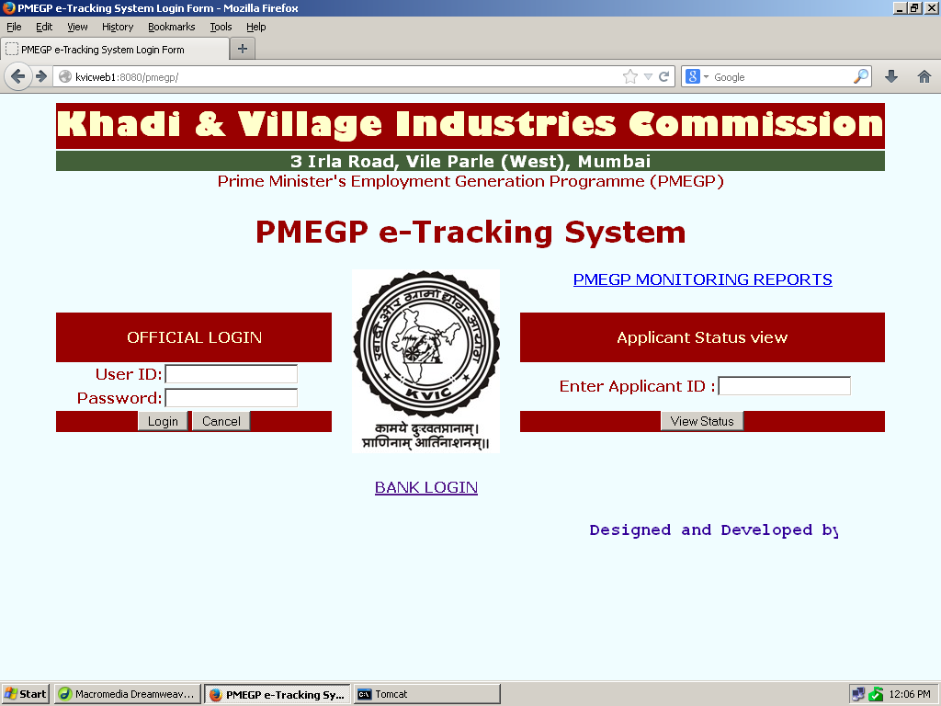
Click on Bank login link

Following screen will appear

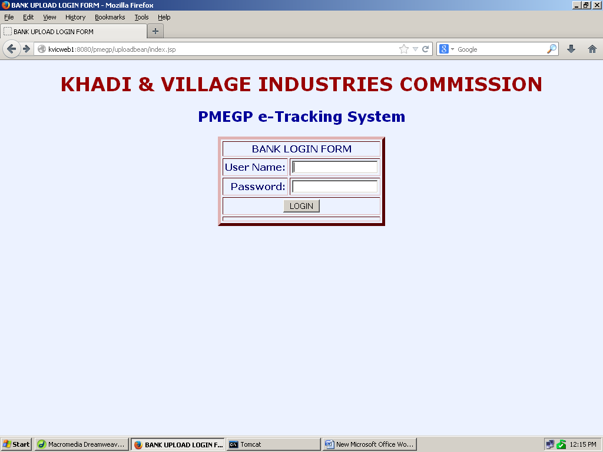
Enter first 4 characters of bank IFSC code as User Name
Enter first 4 characters of bank IFSC code as Password
After entering User Name and Password click on Login Button, the following screen will appear.

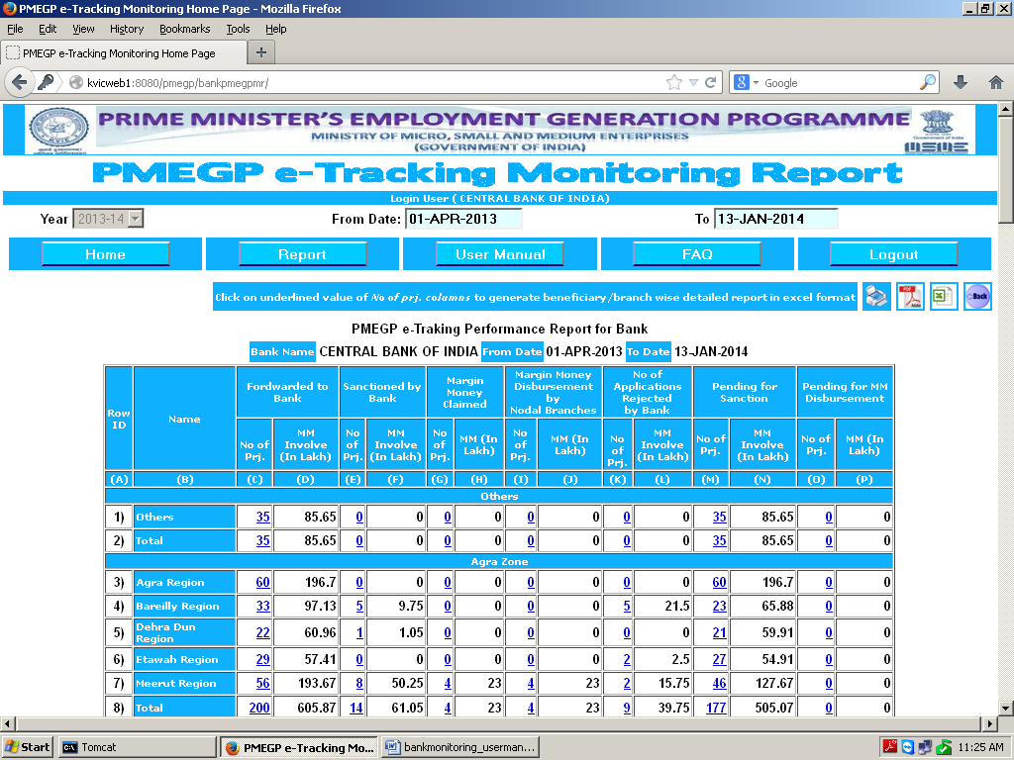
Click on Report button to view Bank zone / Region / State wise Performance of your bank as shown below

Home – To Return the Home Page
User Manual – To download the User Manual in pdf format
FAQ - Frequently Asked Questions and Answers
Logout - To close the Programme and return to log-in Page

Click on No of Proj. link of any row to get the beneficiary / branch wise details in excel format related to the particular zone or region

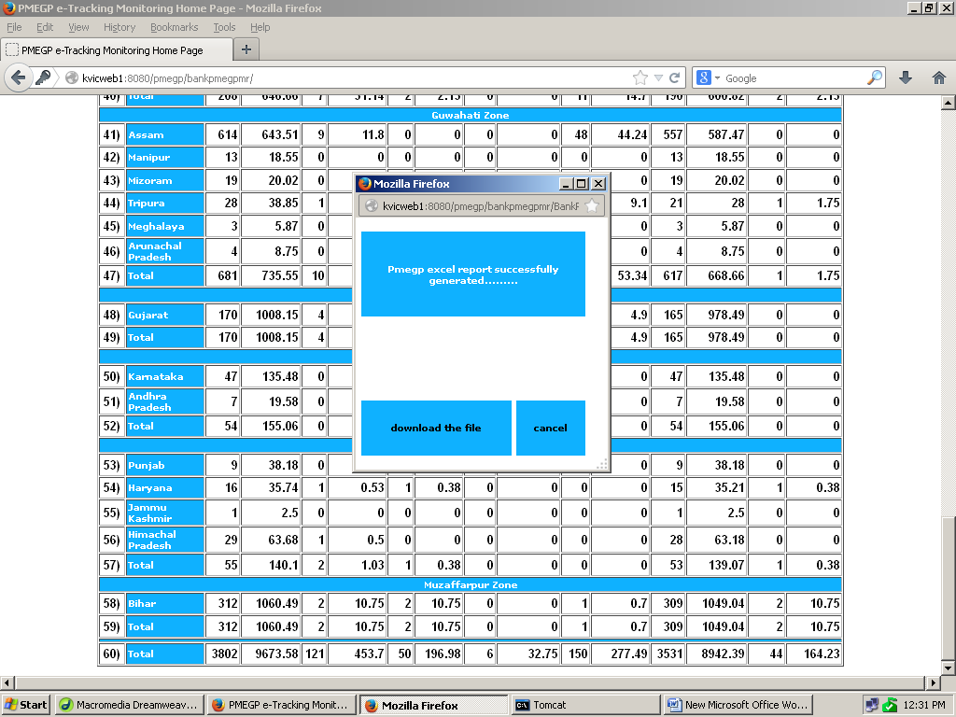
Click on download the file link to download the beneficiary wise detailed excel file

By default the report will display in state-wise order. In case Zone-wise /Region wise reports are required, a list of branch IFSC code along with branch name, Zone/ Region in excel format may be sent to this office by e-mail.

****

