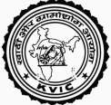 | Prime Minister Employment Generation Programme (PMEGP)  Khadi and Village Industries Commission  Ministry of Micro, Small and Medium Enterprises, Govt. of India  3 Irla Road, Vile Parle West, Mumbai-400056, Maharashtra | 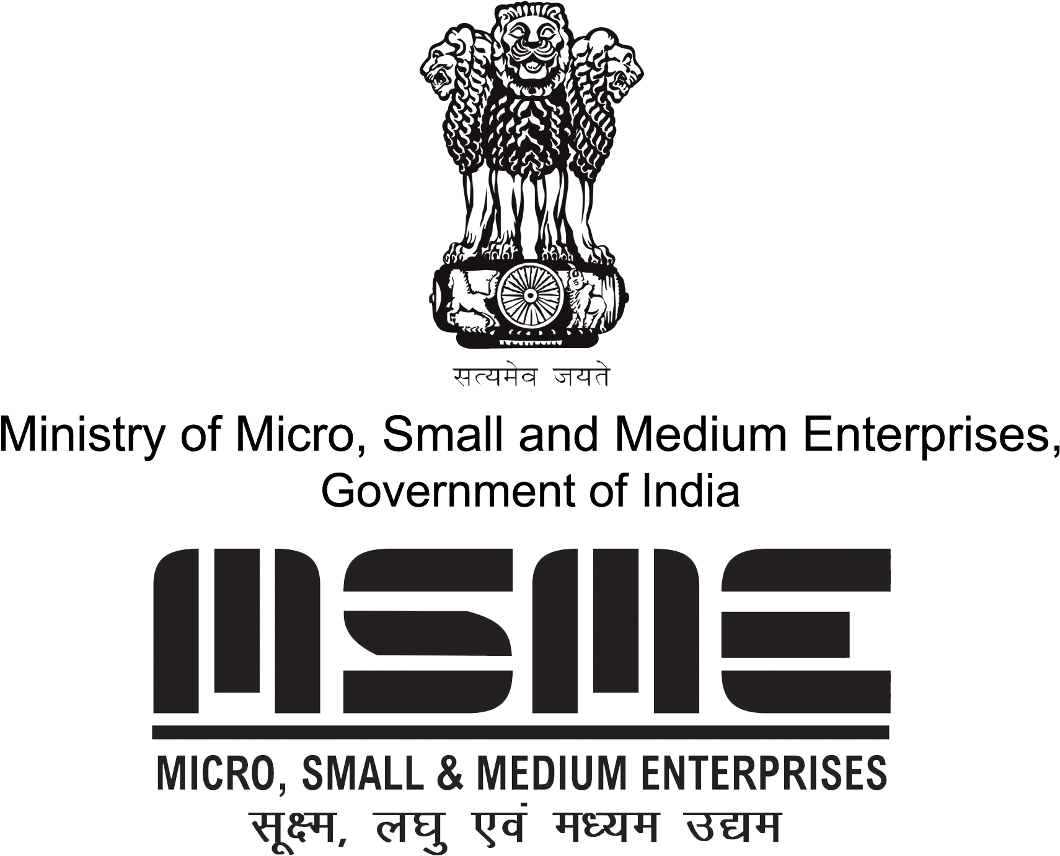
 | pmegpeportal.kvic@gov.in / pmegp.kvic@gov.in

MARGIN MONEY REMITENCE / REFUND e-CHALLAN

KVIC A/c Detail for Refund |  | Transaction Status
Account Name | KVIC PMEGP MM Refund A/c |   Scan QR code to check status
Refund Amount | 112.00  (Rupees one hundred twelve Only)
Account Number  ( Applicable for this Challan only) | 14147821083
IFSC Code | UTIB000PAYU
Details of PMEGP Beneficiary
Challan Creation Date | 21-10-2021
PMEGP Beneficiary Name | Sameer
PMEGP Applicant ID
Financing Bank Name
Branch Name (IFS Code)
Financing Branch Remarks
Terms & Conditions
- This challan is valid for 07 days from the date of generation, subject to merchant’s acceptance.
- The Beneficiary Bank Account Number generated is applicable for this challan only. For branch induced NEFT/RTGS, only Person to Person mode (R41) to be used. Any other mode of transfer may be treated as invalid.
- The exact amount (upto 2nd decimal) appearing in this challan should be transferred to the beneficiary bank account. Bank charges (if any) to be paid separately to the bank.
- Do not make multiple payments against this challan by splitting the amount into more than one NEFT/RTGS transactions.

Challan Payment Process
To pay for you challan:-
Fund Transfer by Financing Bank Branch

- Financing Branch should transfer fund by NEFT/RTGS in R41 Mode ( Person to Person) as per the KVIC fund transfer details mentioned above
- Collect the Acknowledgement receipt and send to KVIC email pmegpeportal.kvic@gov.in and pmegp.kvic@gov.in
To know the Fund Transfer status
Scan the QR on challan using any QR code scanner app.

Buy online Khadi and Village Industries products through online portal https://www.khadiindia.gov.in and support Rural Artisans / PMEGP entrepreneurs

