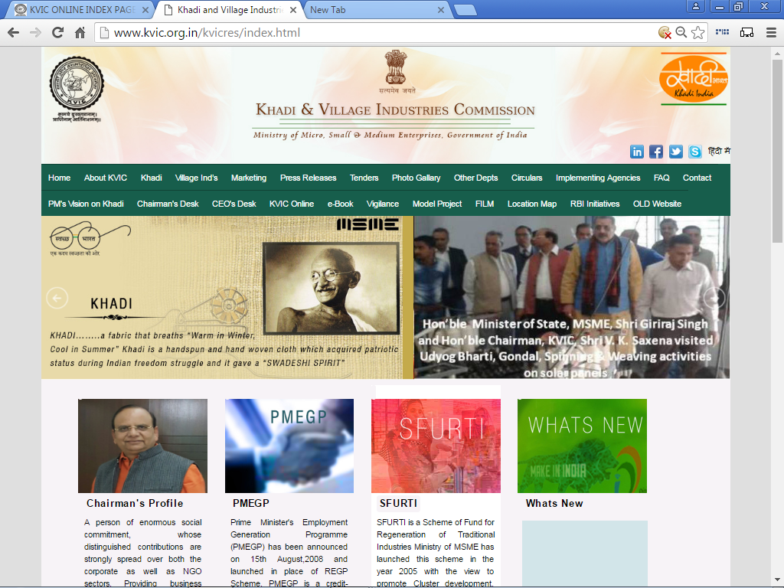

“USER MANUAL”
for
PMEGP e-PORTAL
for
DLTFC Convenor
Under
PMEGP SCHEME

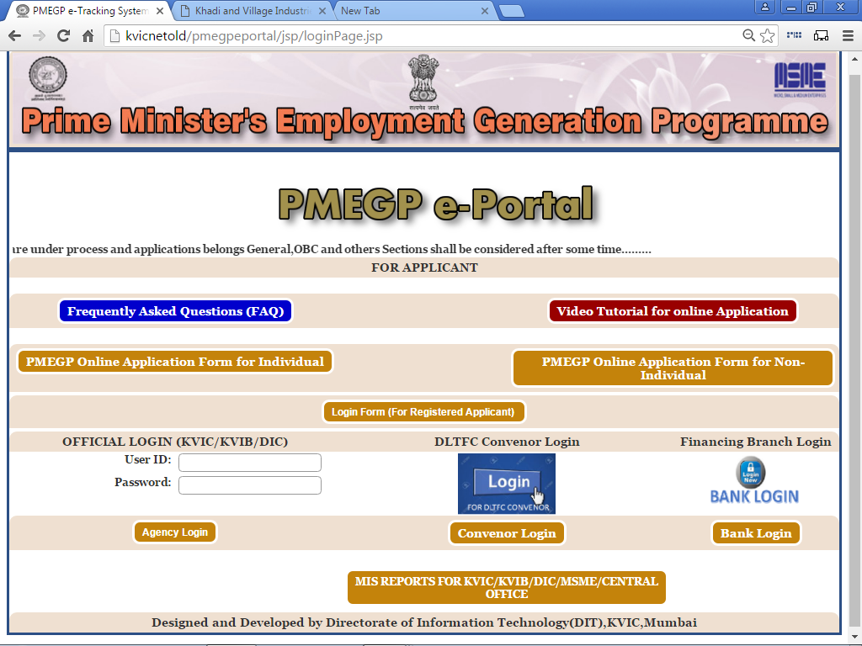
Please visit Khadi & Village Industries Commission Official Website i.e. www.kvic.org.in and Click on “KVIC Online” Button as shown below:-
STEP No:- 1 (A)

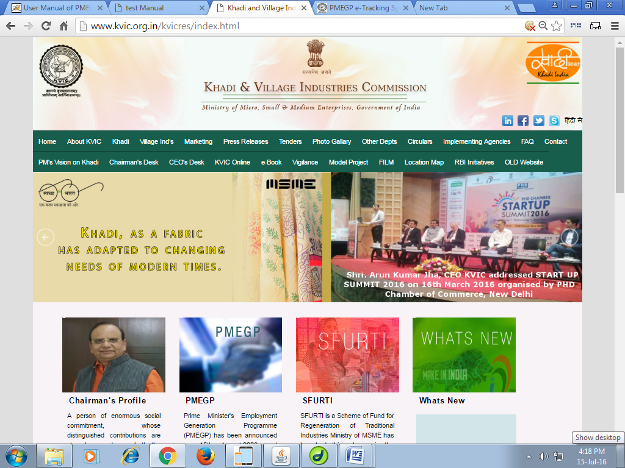
Click here

STEP No:- 1 (B)

After Entering into next webpage, please click on “PMEGP e-Portal” Link as shown below:-

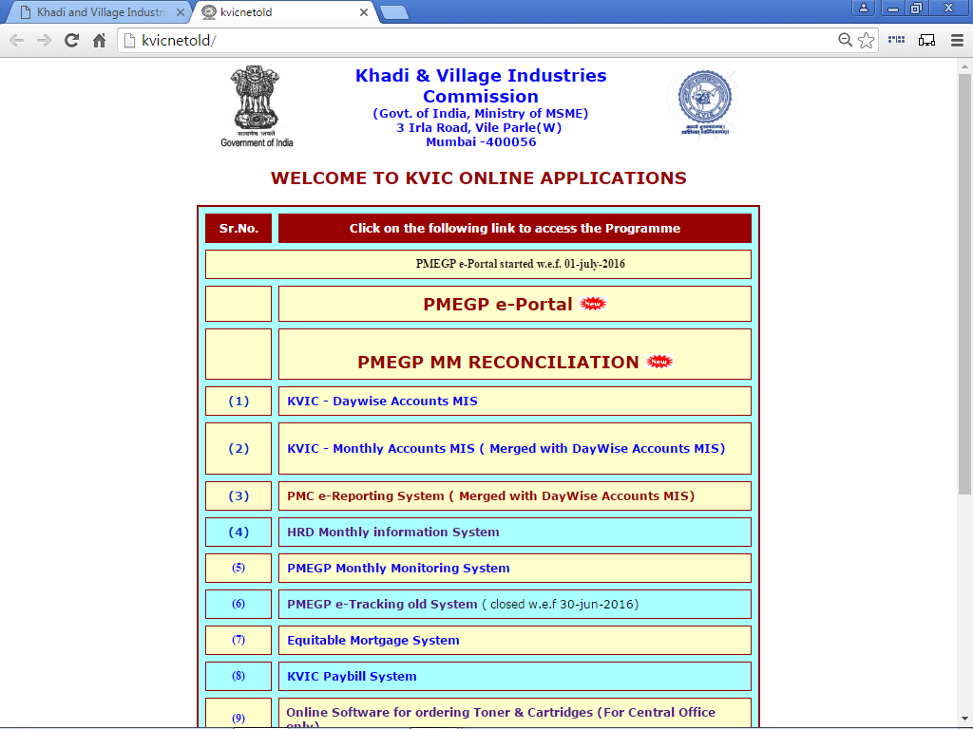

Click here

After Entering in PMEGP e-Portal, please click on “DLTFC Convenor Login” for Open Login Page, Link as shown below:-
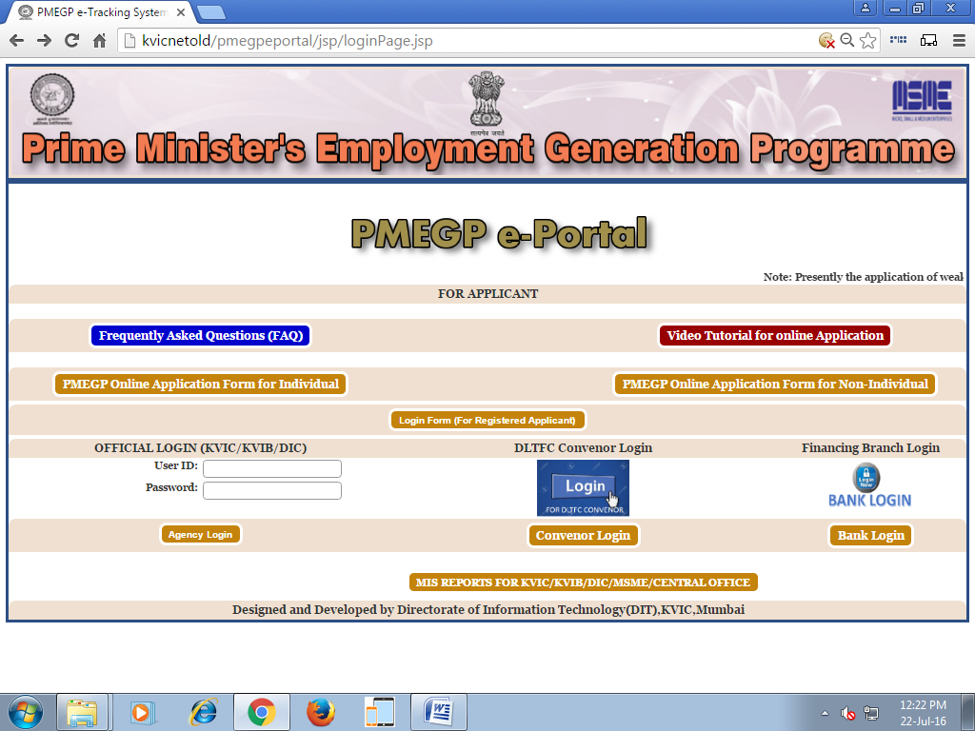
STEP No:- 2 (A)

Enter Password
Enter User ID
to Return Home Page
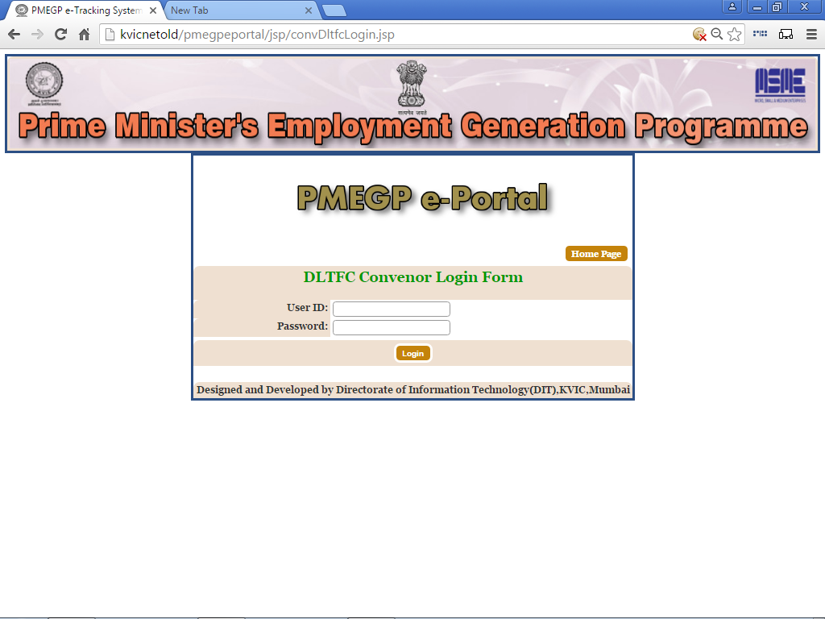

Click here

STEP No:- 2 (B)

After click on “DLTFC Convenor Login”, Login Page shown below:-

After Login “DLTFC Convenor Login”, DLTFC Convenor Home Page shown below:-
STEP No:- 3 (A)

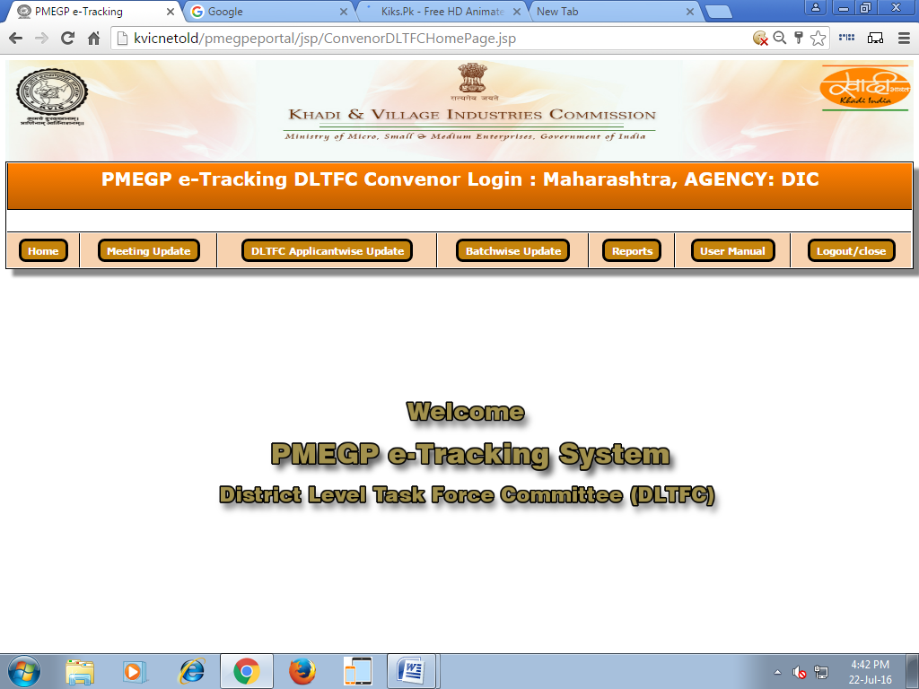
Home - To Return the Home Page
Meeting Update - To Update the Meeting Date and Place etc.
DLTFC Applicantwise Update - Update DLTFC Status Rejected / Approved
Report - To View Full Report
User Manual - To download the User Manual in PDF format
Logout - To close the Program and return to log-in Page

After Click on 'Add Meeting', You can Add your Data in Meeting Form, Page as shown below:-
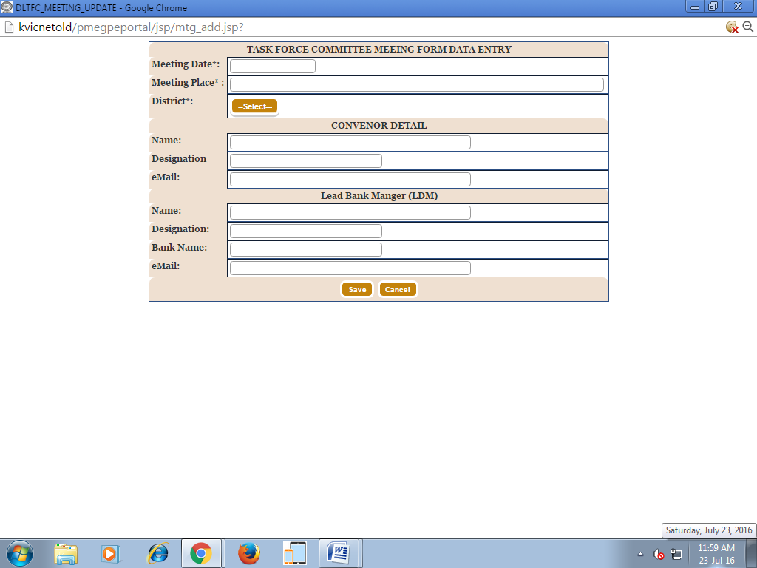
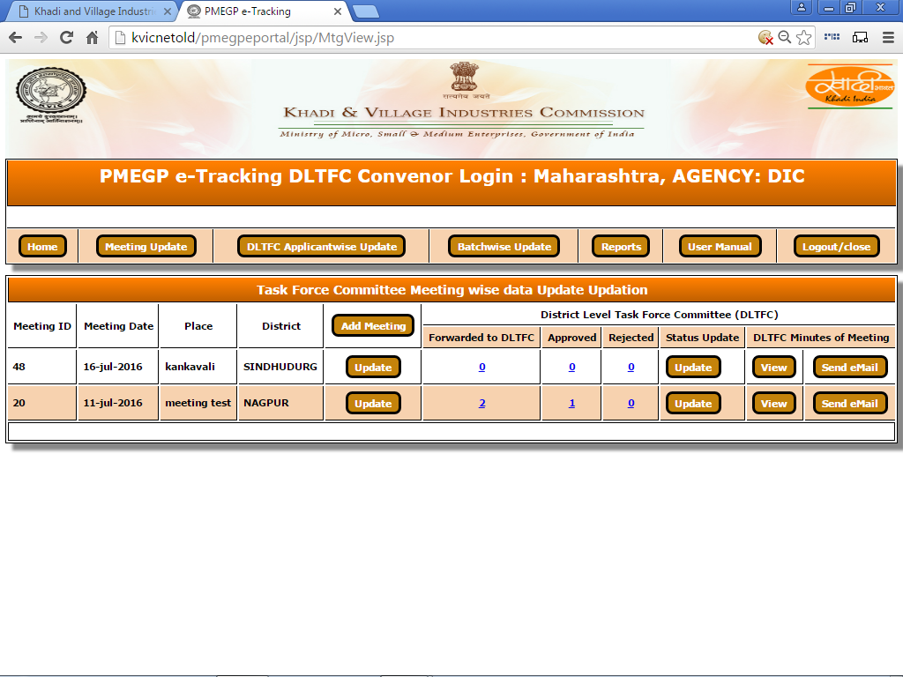
STEP No:- 3 (B)i

After Entering 'Meeting Update' Page as shown below:-

STEP No:- 3 (B)ii

After Click on 'Update' 
You can Update your Data in Meeting Form, Page as shown below:-
If any Correction, Edit here and Save
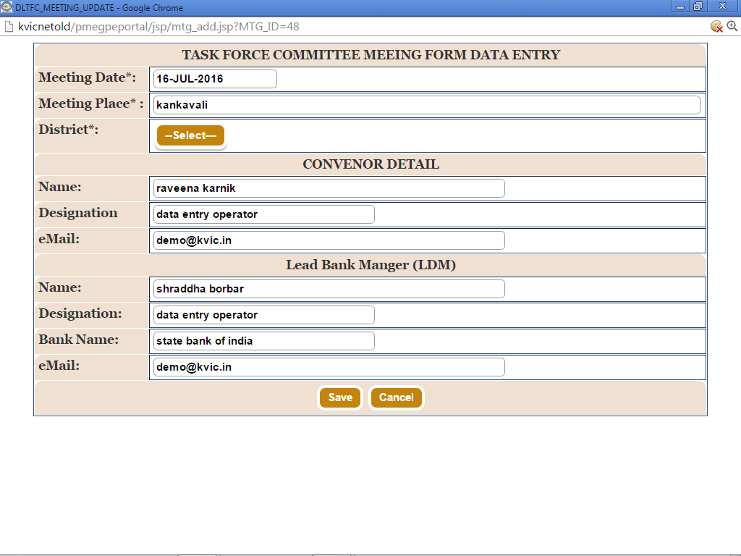
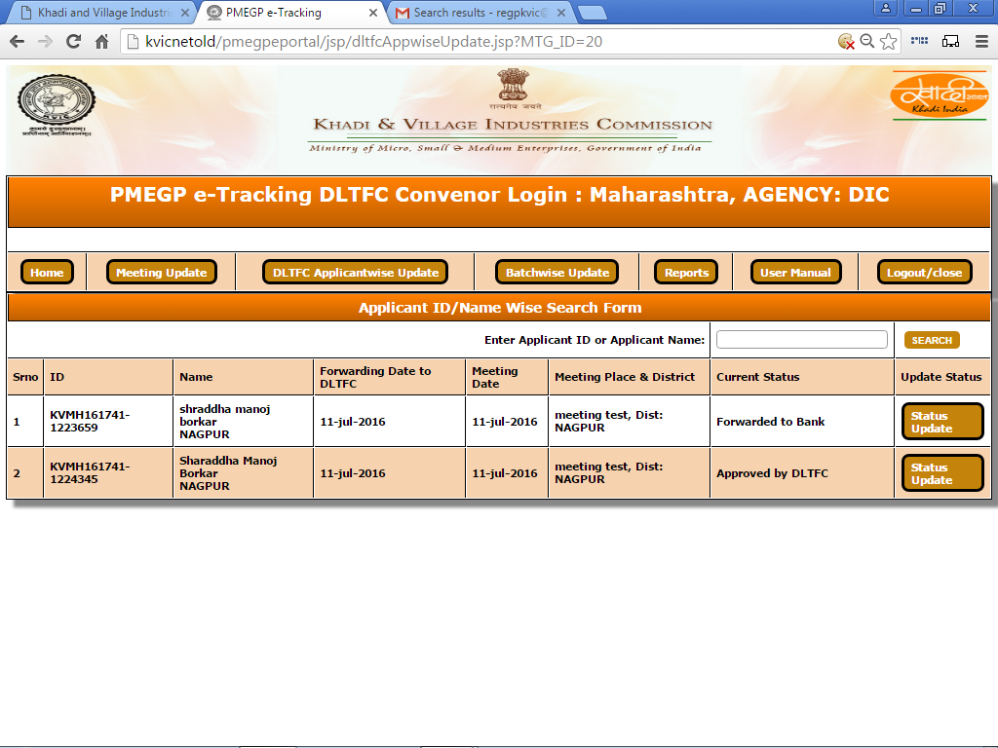
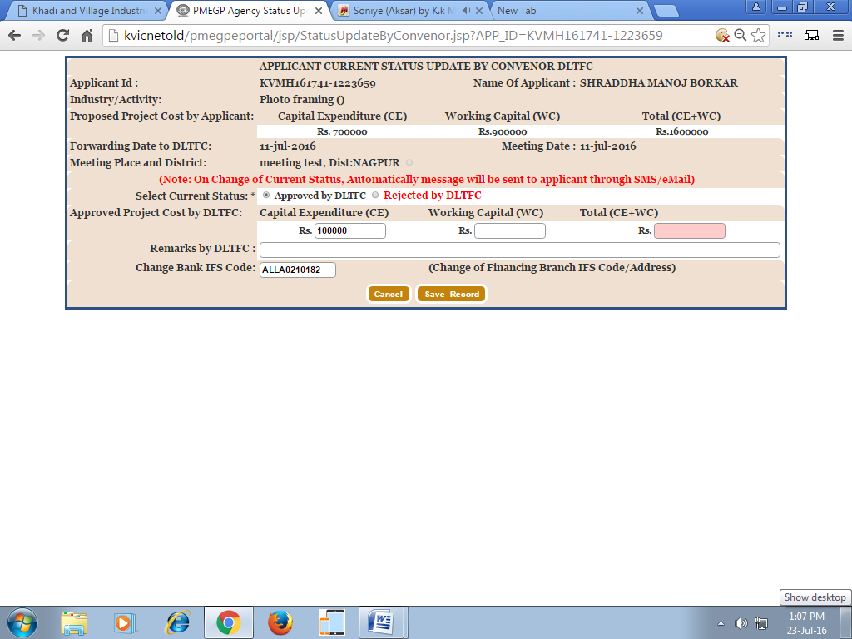
After Click on 'Status Update' 
Page as shown below:-
STEP No:- 3 (B)iii

Click on 'Status Update'
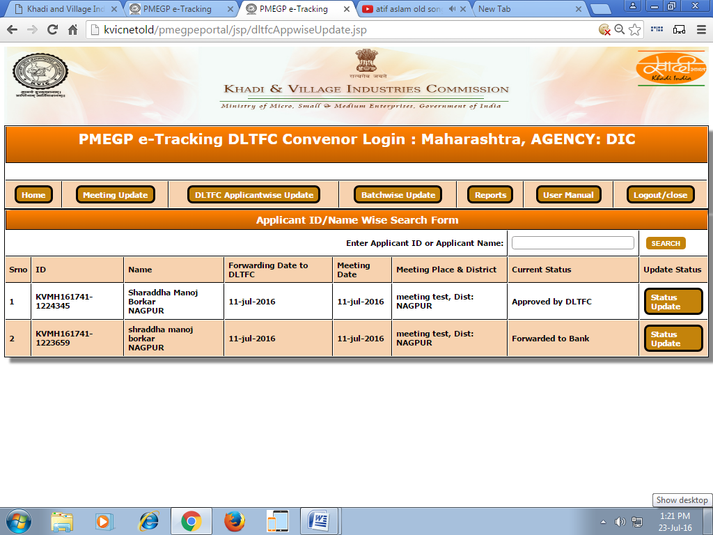
STEP No:- 4 (A)i

After Entering 'DLTFC Applicantwise Update' Page as shown below:-

STEP No:- 4 (A)ii

After Entering 'Status Update', Page as shown below:-

On This Page, You can Update you Status
