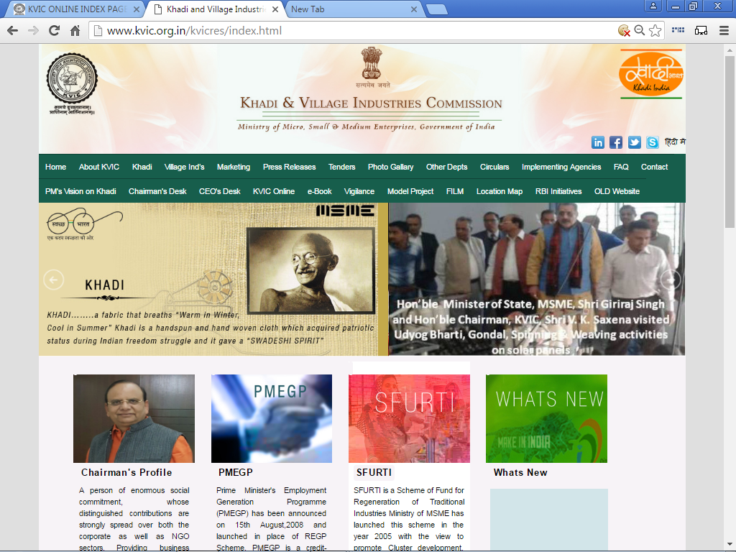

“USER MANUAL”
for
PMEGP e-PORTAL
for
FINANCING BRANCH
Under
PMEGP SCHEME
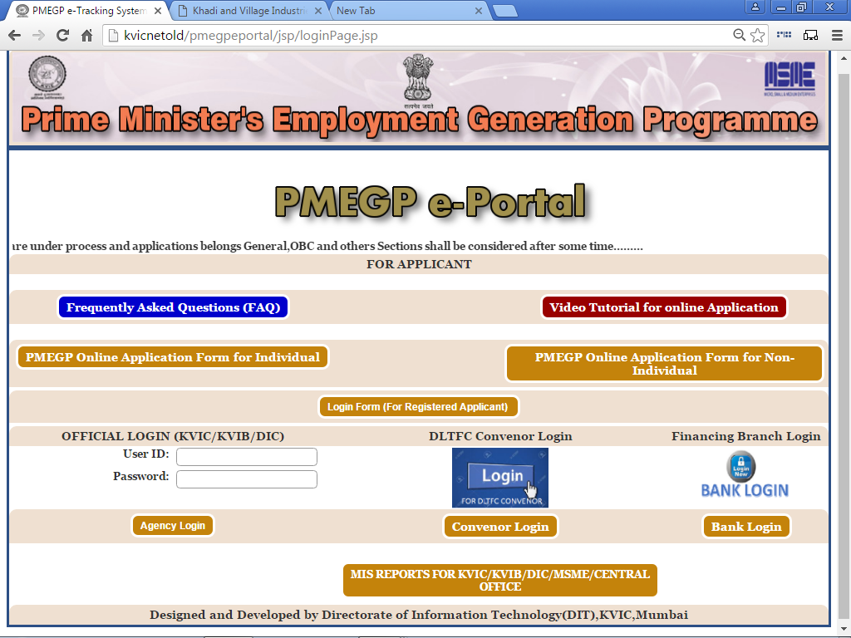
STEP No:- 1 (A)

Please visit Khadi & Village Industries Commission Official Website i.e. www.kvic.org.in and Click on “KVIC Online” Button as shown below:-

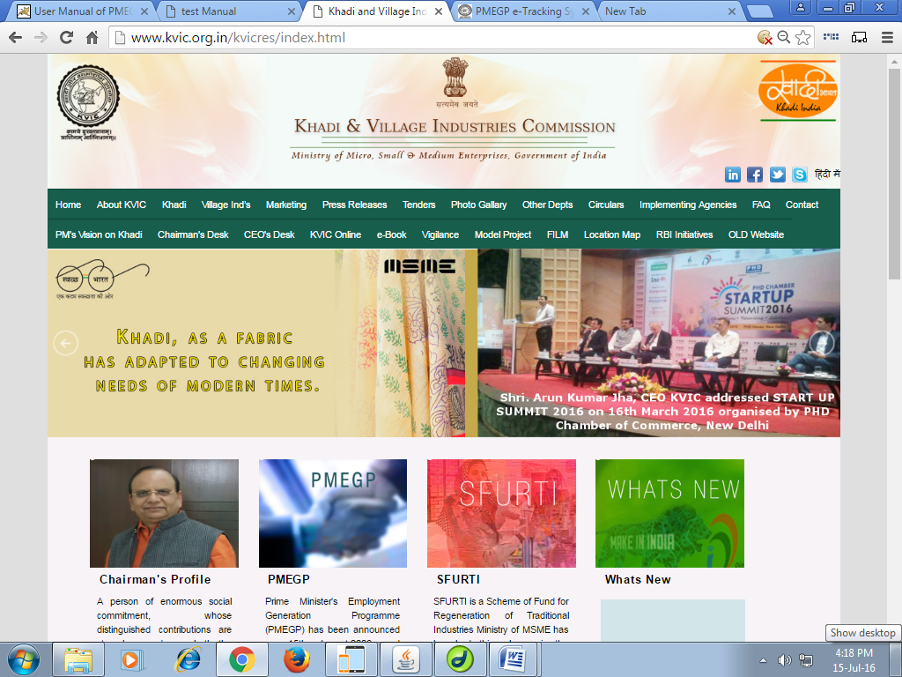
Click here

STEP No:- 1 (B)

After Entering into next webpage, please click on “PMEGP e-Portal” Link as shown below:-

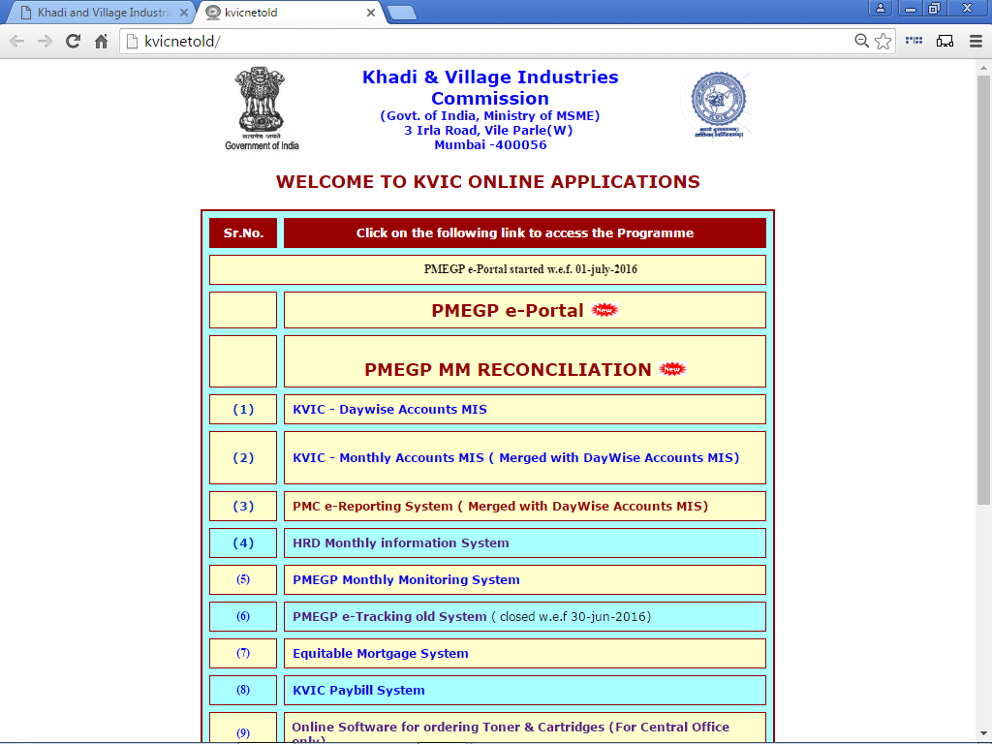

Click here

After click on “Bank Login”, Login Page shown below:-
STEP No:- 2 (B)

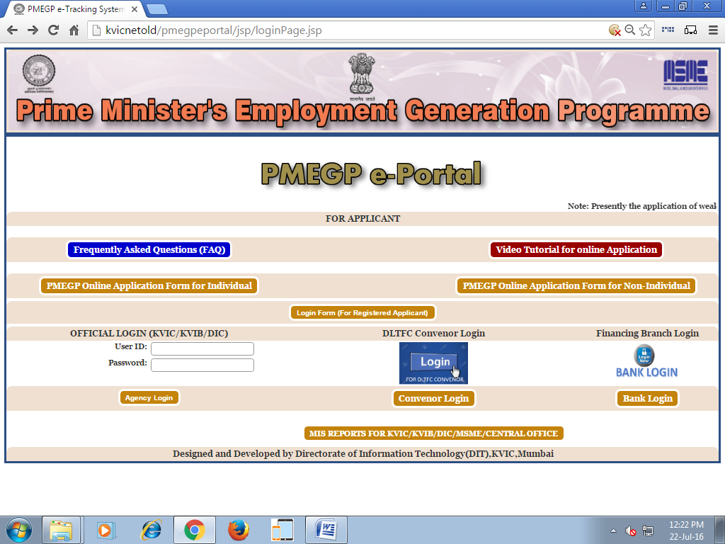
After Entering in PMEGP e-Portal, please click on “Bank Login” for Open Login Page, Link as shown below:-
STEP No:- 2 (A)

Enter User Name
Enter Password
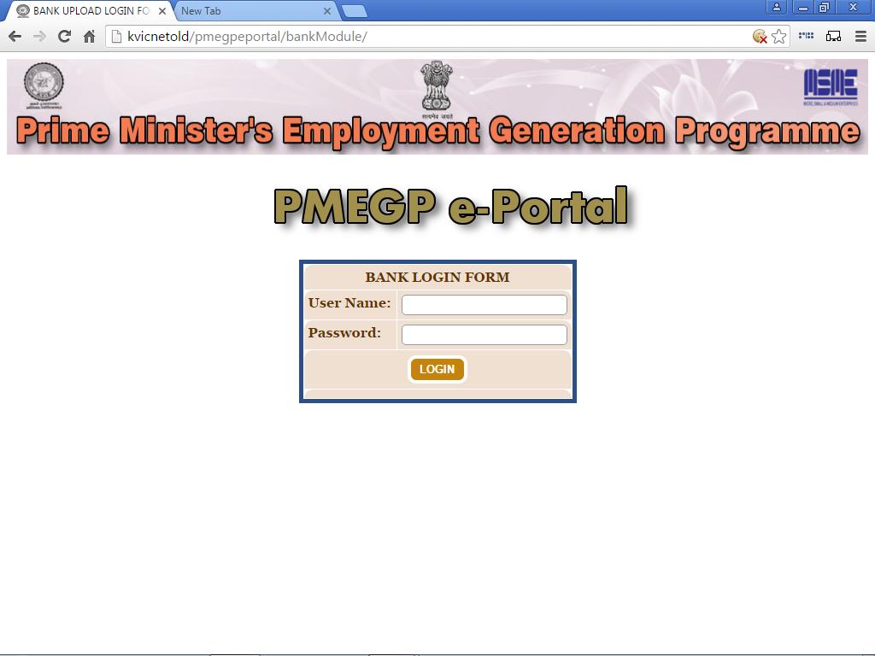
Click here

STEP No:- 3 (A)

After Login, Home Page shown below:-

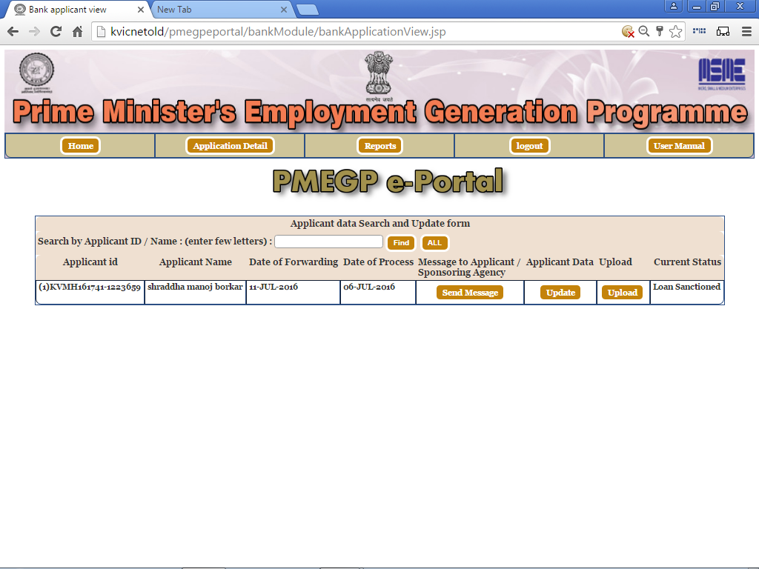

Home - To Return the Home Page
Application Detail - To Update PMEGP Applicant Data
Report - To View Full Report
Logout - To close the Program and return to log-in Page
User Manual - To download the User Manual in PDF format

STEP No:- 3 (B)

After Login, Application Data Search And Update Form is by default Home Page,
Page as shown below:-


Find - Search Applicant
All - To View all Applicant list
Send Message - To Send Email / SMS to applicant
Update - Update Bank details of Application
Upload - To Upload any additional documents

STEP No:- 3 (C)

If You have to Update Your Data, Click below:-


Click here
After Entering in 'Update', Page as shown below:-
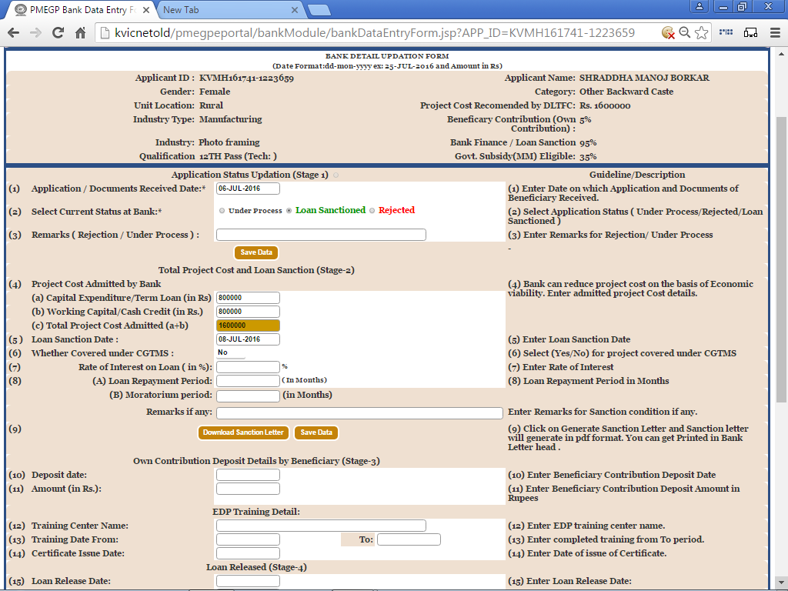
After Complete, Click On 'Save' Button for Save all Data 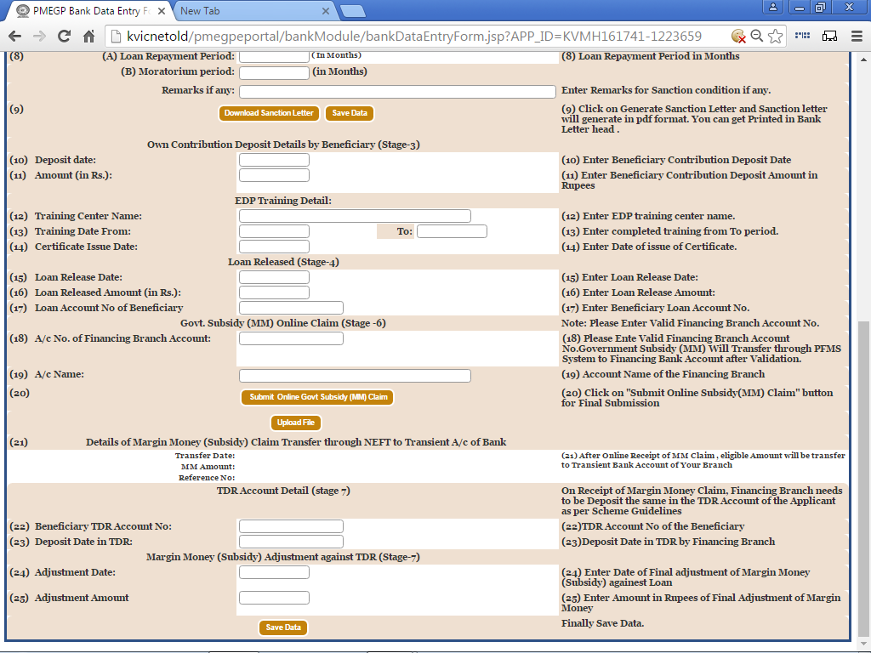

Click here

