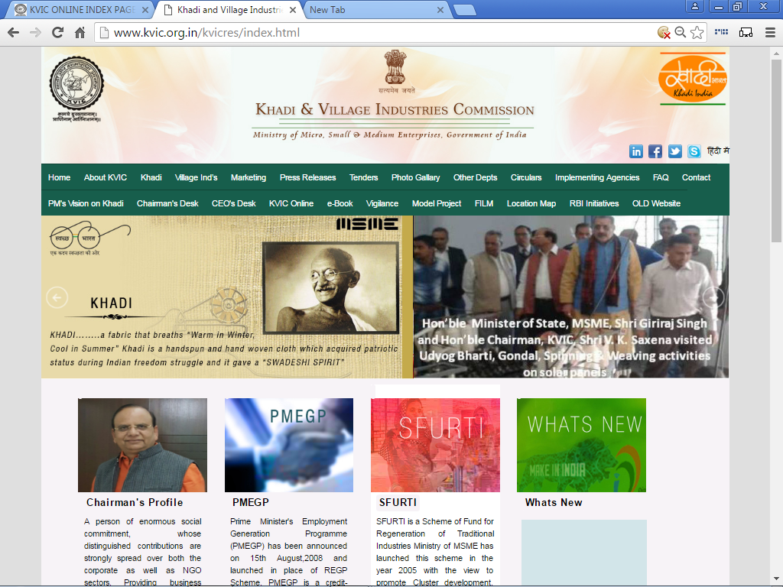

“USER MANUAL”
for
PMEGP e-PORTAL
for
MIS REPORT
Under
PMEGP SCHEME

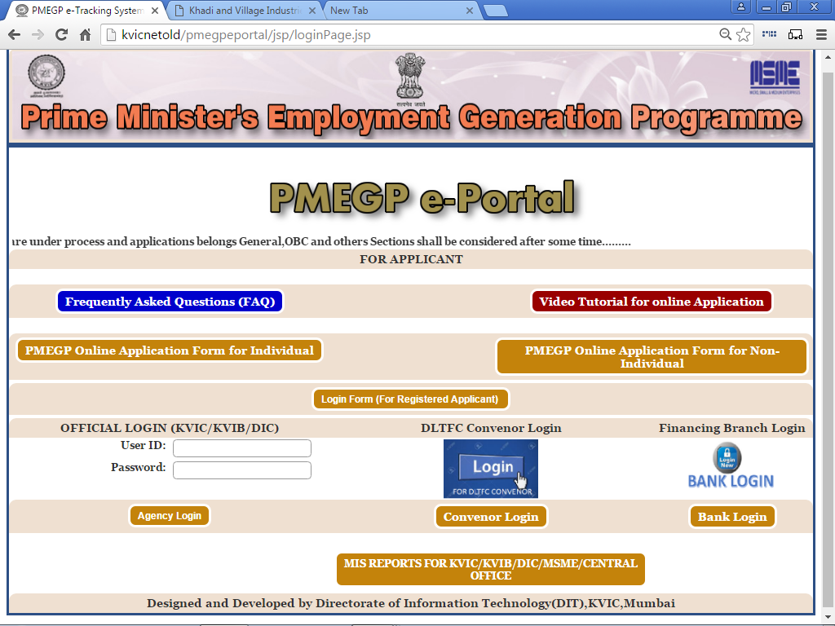
STEP No:- 1 (A)

Please visit Khadi & Village Industries Commission Official Website i.e. www.kvic.org.in and Click on “KVIC Online” Button as shown below:-

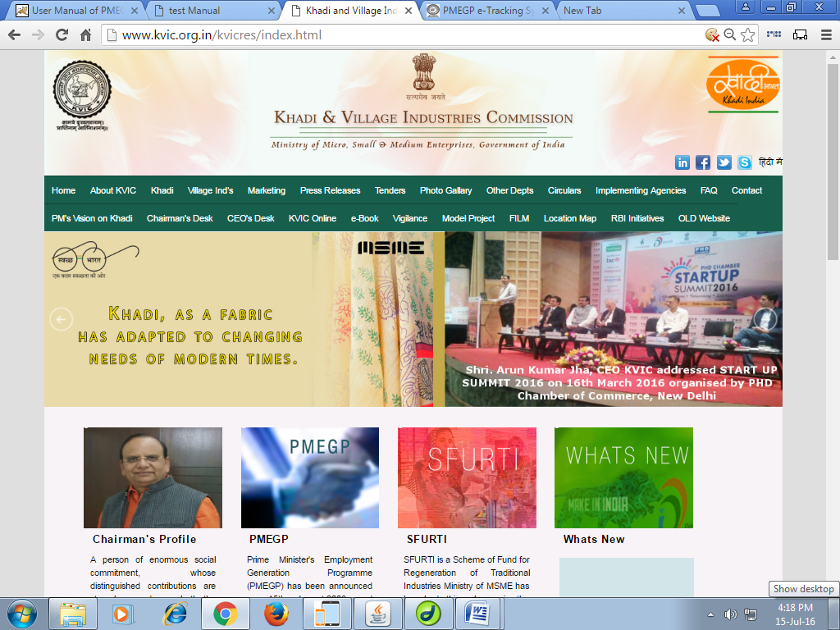
Click here

STEP No:- 1 (B)

After Entering into next webpage, please click on “PMEGP e-Portal MIS Report” Link as shown below:-

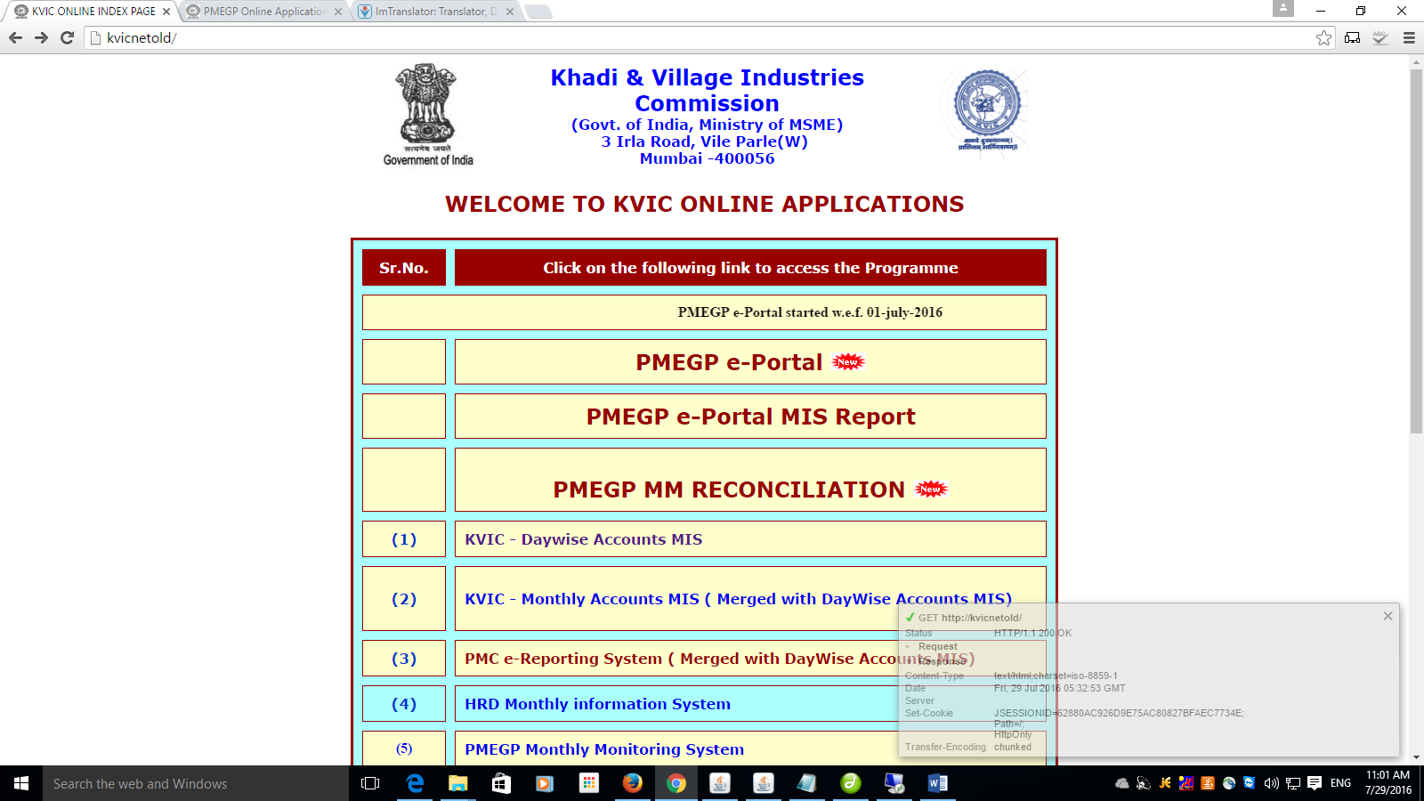

Click here

STEP No:- 2 (A)


Click here

Now Enter your User Name and Password, Login Form as shown below:-

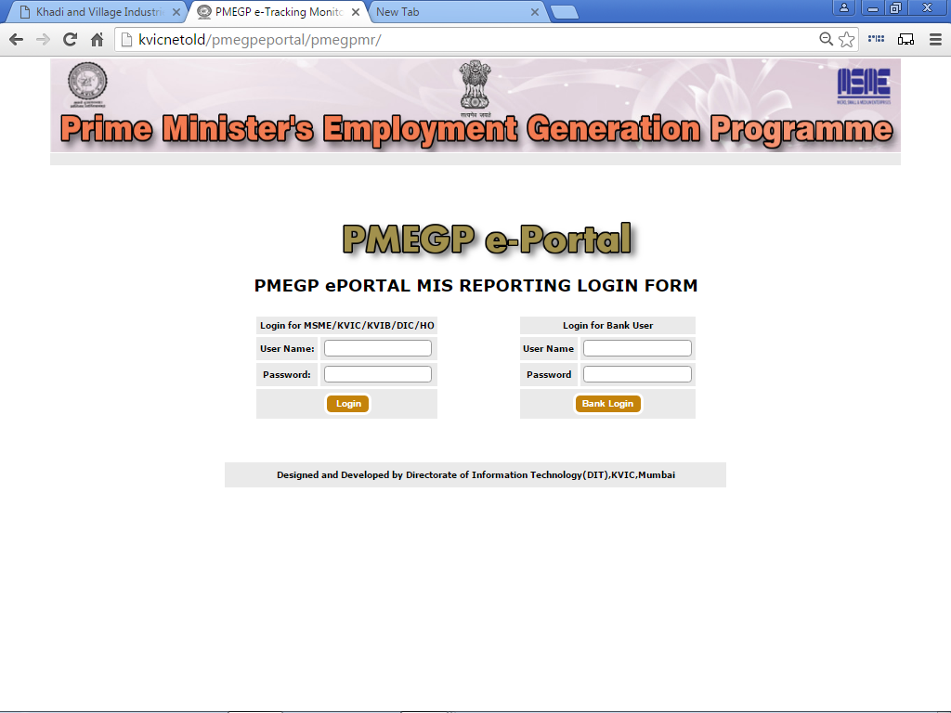
Enter User Name

Enter Password

STEP No:- 3 (A)

After Login, Home Page as shown below:-

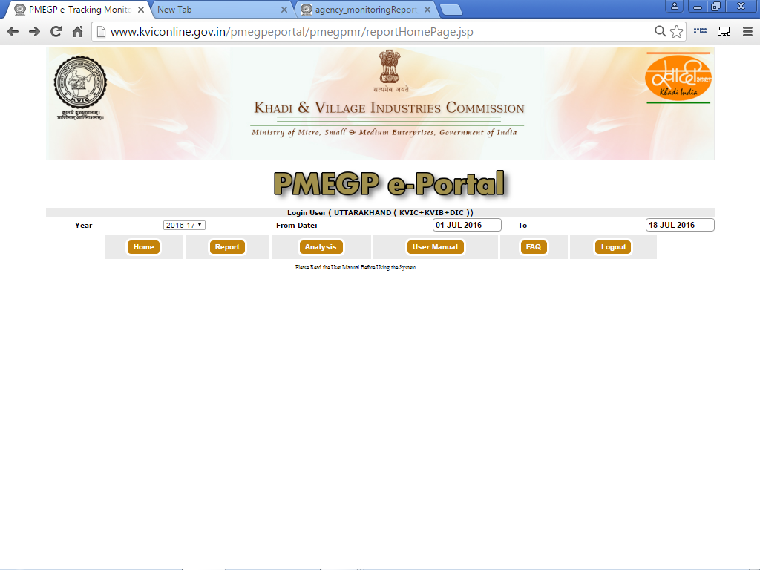
Home – To Return the Home Page
Report – To Generate Periodical Progress Report
Analytical – To Generate Analytical Reports Based on various criteria
User Manual – To download the User Manual in PDF format
FAQ – Frequently Asked Questions and Answers
Logout – To close the Program and return to log-in Page

STEP No:- 3 (B)

After Entering 'REPORT', Page as shown below:-

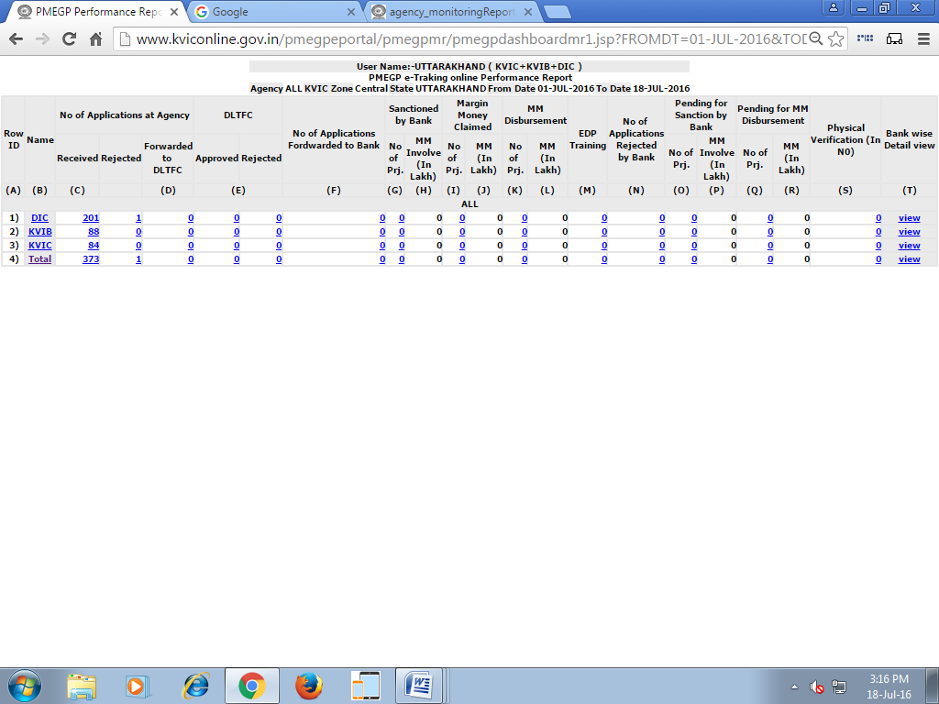

Click here to get Beneficiary wise Detailed report in excel sheet related to this particular value

Click here to View the Bank wise Detailed Reports related to the row
Click here to get summarised report pertaining to next level relevant to the User

STEP No:- 3 (C)

After Click on 'KVIC, KVIB or DIC', The Page as shown below:-

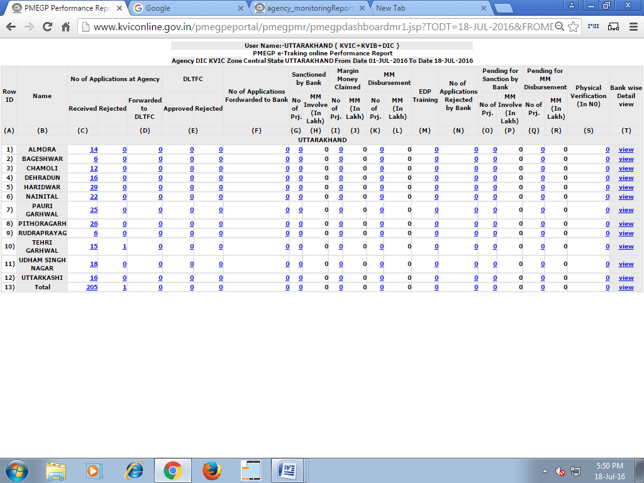

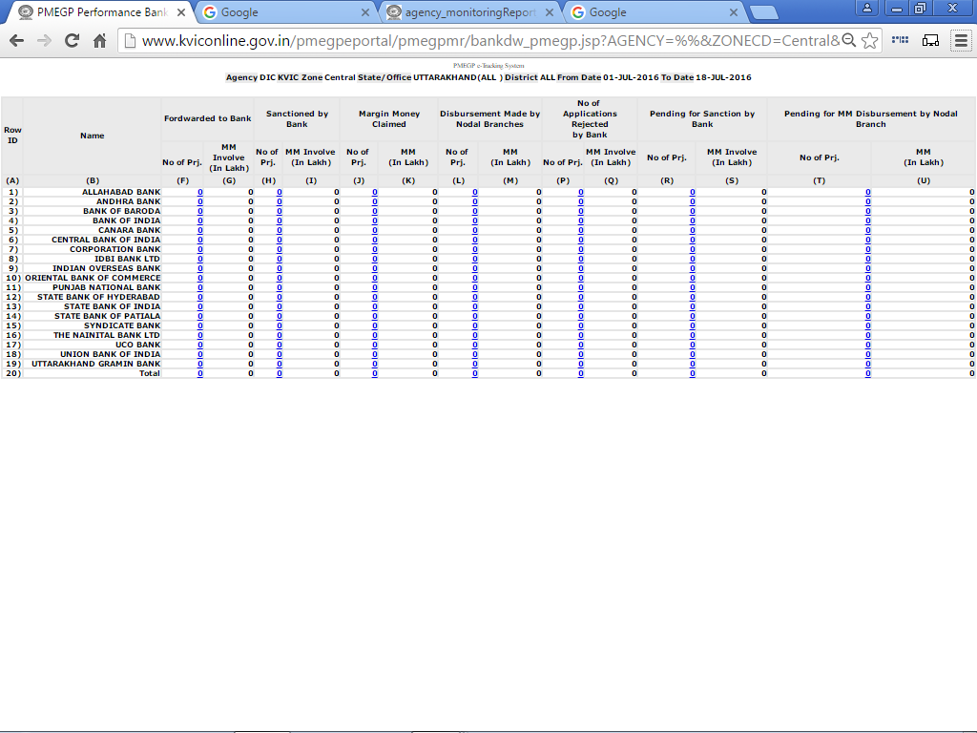

After Click on 'VIEW', The Page as shown below:-
STEP No:- 3 (D)

STEP No:- 3 (E)

After Click on

The Page as shown below:-

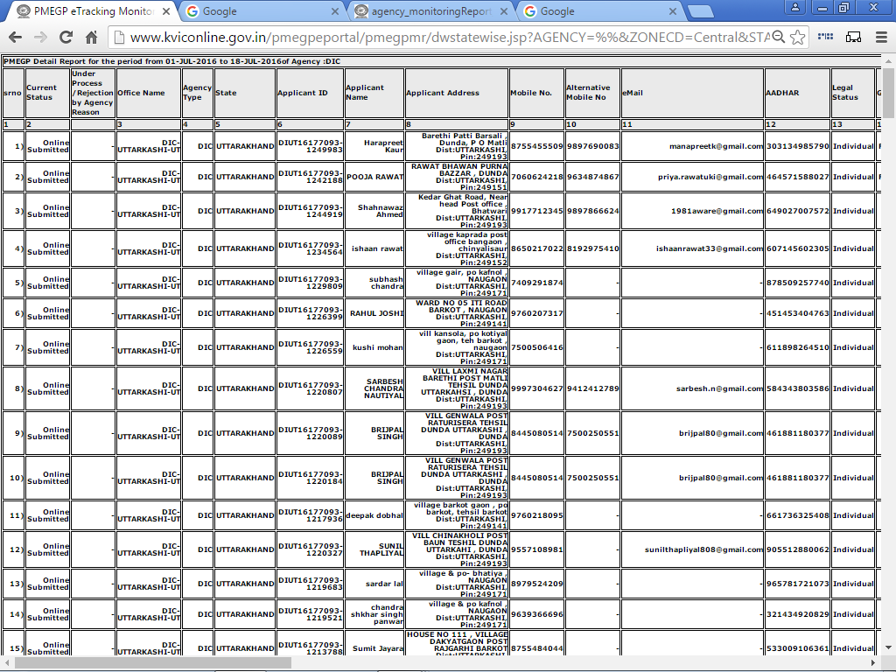

STEP No:- 4 (A)

After Click on 'ANALYSIS' button, The Page as shown:-
below:-

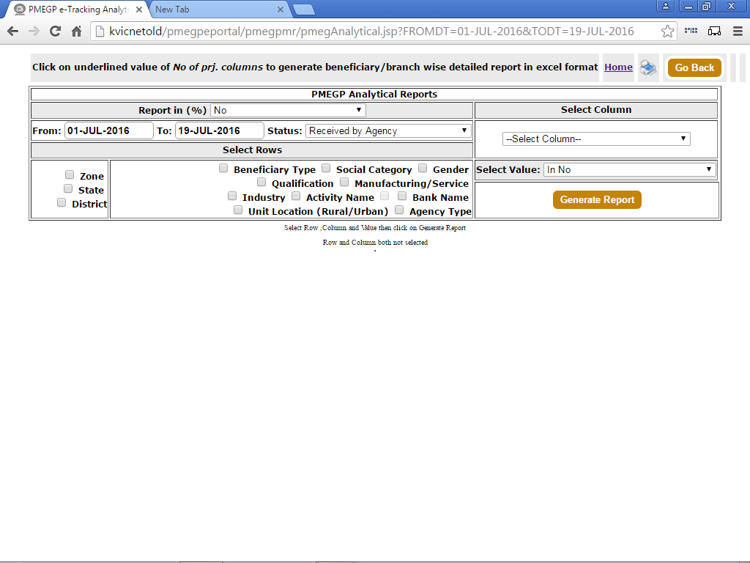

Select Column Value from the list
Select appropriate value from the list
Click here to Select the Row value

After selecting the three values click on Generate Report Button

