User Manual Geotag Physical Verification Nodal Officer
Geotag Physical Verification units will be available to District Nodal Officer after QC of 3rd party Physical Verification Team on the basis of online Geotagged report concern Agency can Margin Money adjustment / callback of Margin Money letter from PMEGP Portal .
System Validation Report also included in PMEGP Portal so that it will help of Agency for decision.
Provisions Available
- Unit photo/video
- System generated report inbuilt in Physical Verification Report.
- Margin Money adjustment letter generation in the prescribed format.
- Maker and Checker concept is available.

Step-1
Click on Agency Login.
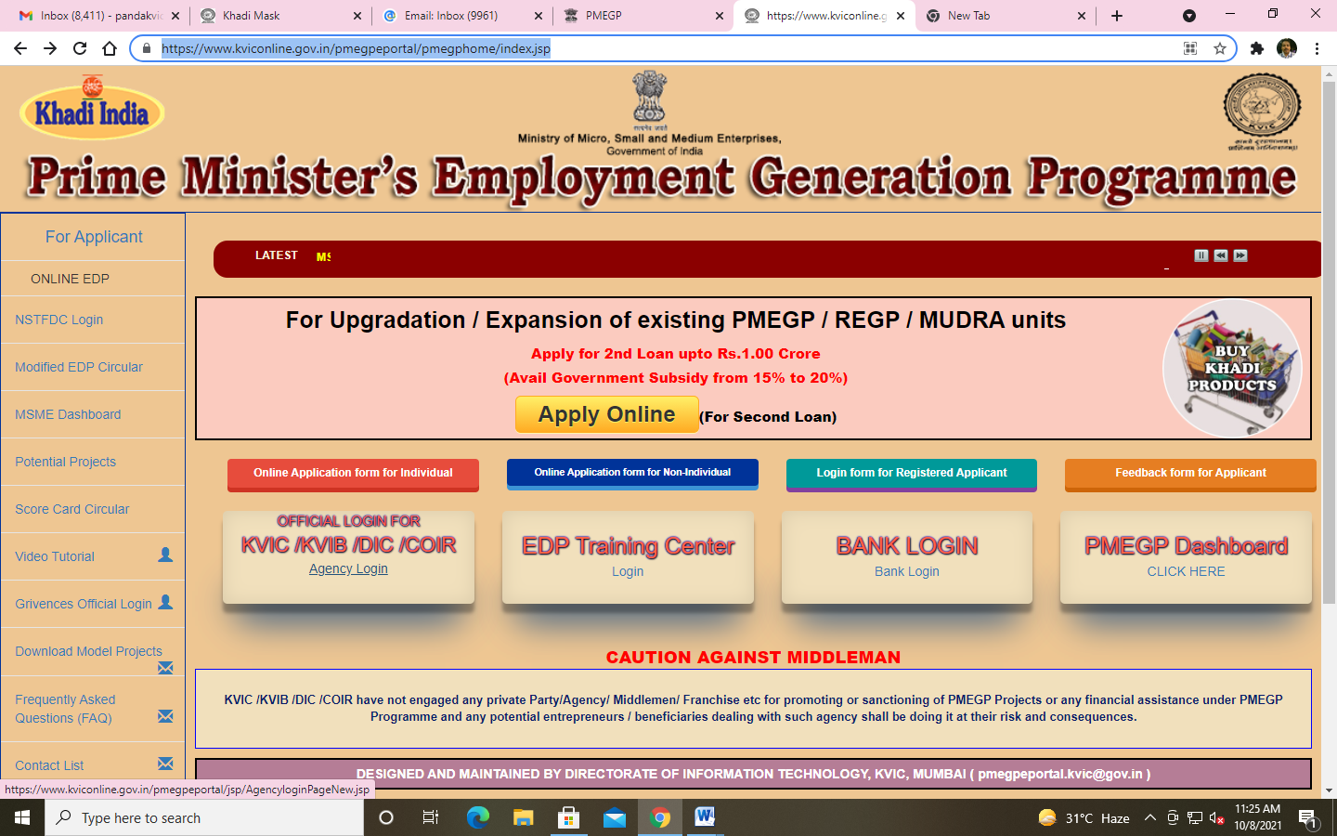
Click on Agency login

Step-2
After clicking on Agency login enter existing credential then click on agency login.
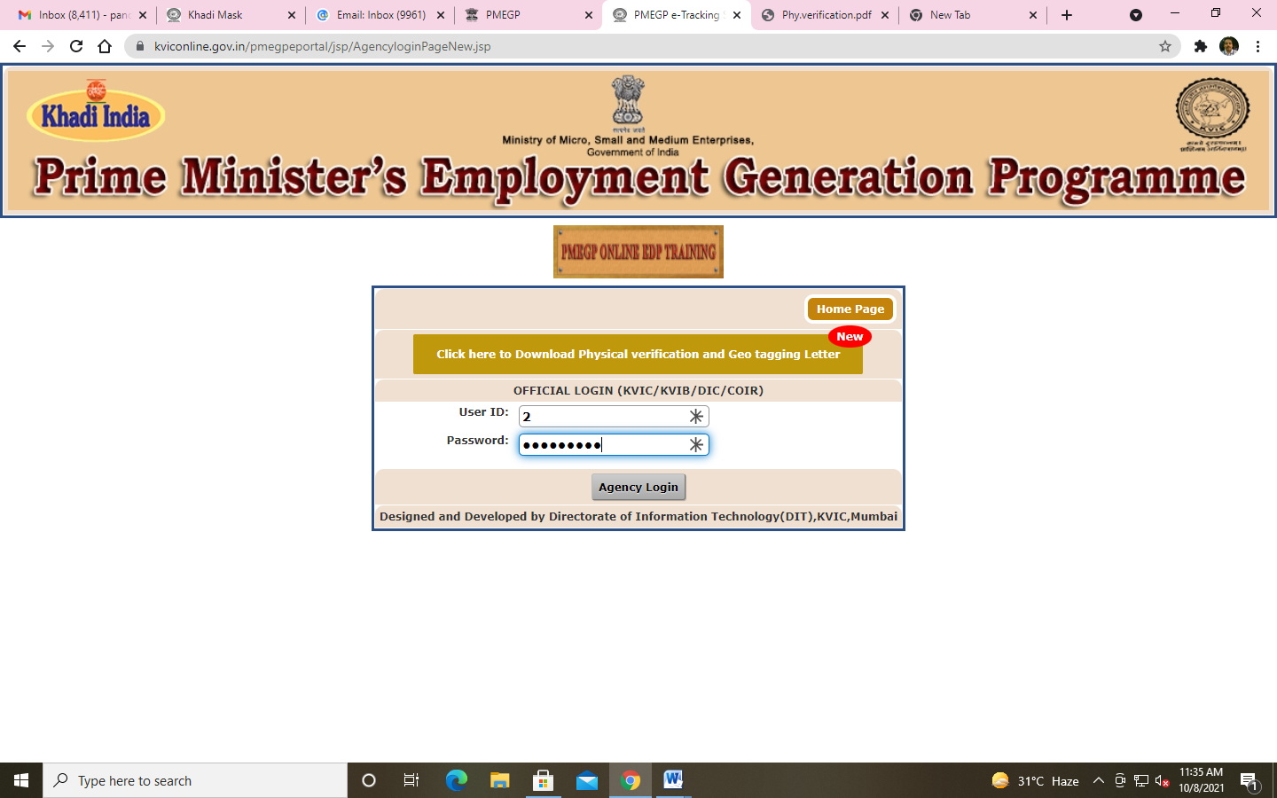
Click on Agency Login
Step- 3
After successfully login Click on Physical Verification.

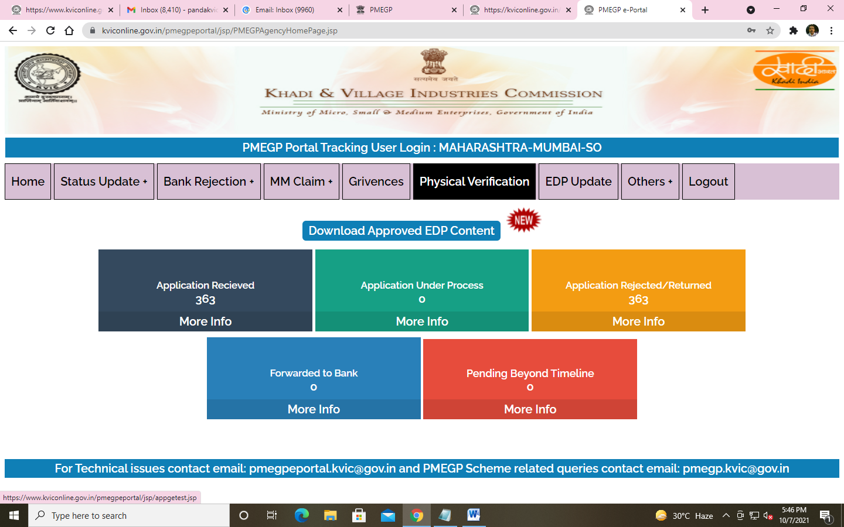
Click on Physical Verification
Step - 4
Once you click on Physical Verification you will see the Geotagging System Update.

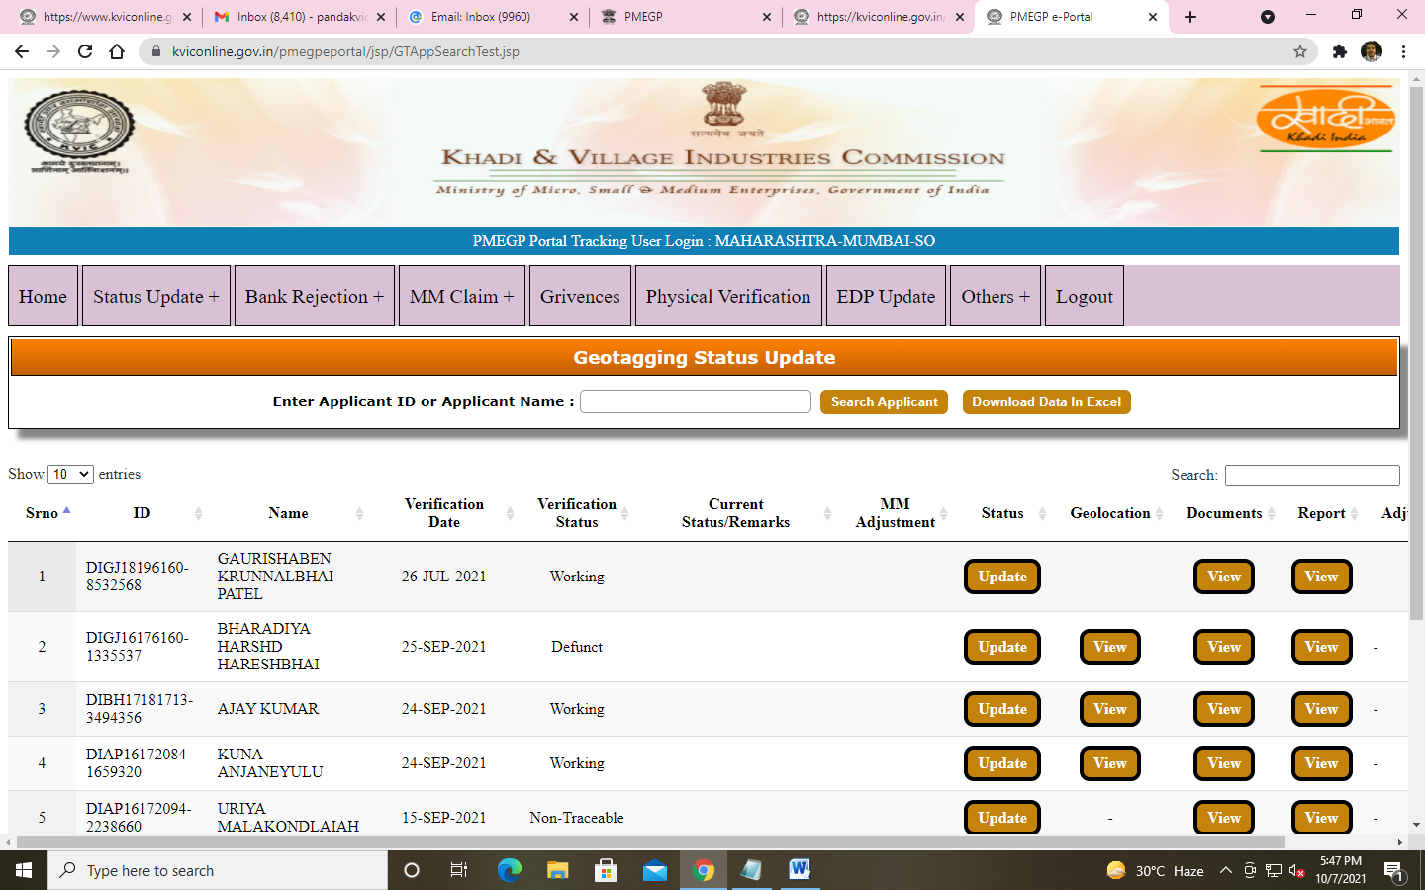
Buttons: -
Update
Update button > To Process Margin Money Claim. After through Verification reports/documents.

Note:
Before process the claim please verify Geolocation unit photo/video and most important Physical Verification report of 3rd party agency with system verification report.

