gdd

Contents

Intro 2

Character Bios 3

Familiar 3

Shop keeper 3

Witch friend 3

Rough Plot 4

Gameplay Description 5

Altar making 5

Shopping 5

Stuff collection 5

Artistic Style Outline 6

Systematic Breakdown of Components 7

Asset Breakdown 8

Art Assets 8

UI 8

Objects 8

Environments 8

Living things 8

Text Assets 8

Sound Assets 8

Suggested Game Flow Diagram 9

Suggested Project Timeline 10

Additional Ideas and Possibilities 11

# Intro

You are a witch. Unfortunately, you lack most of everything that would let you practice your craft. Fortunately, you have a Familiar, who will gladly help you by going on adventures to collect things in order to help you.

# Character Bios

## Familiar

## Shop keeper

## Witch friend

# Rough Plot

4-6 paragraphs. With as little backstory as possible, describe the game from start to finish. Include a rough breakdown of what is cutscene, what is gameplay, etc. With each part of the plot, it should be obvious how it will be presented in the game itself.

# Gameplay Description

## Altar making

In the first game mode, you can make your own altar. In a point-and-click fashion, you can choose your altar shape (type of table, if there is a window, …), and then you have access to your full inventory to place on it as you see fit.

## Shopping

In order to fill your altar, you will need things. You can get them at an occult shop, and you can buy them in exchange for gold or trading. You can also buy stuff to upgrade your familiar.

## Stuff collection

You can send your familiar to collect stuff. This mode will be like a “runner”, where you will go forward until you cannot anymore. You will meet enemies which you will have to beat by using spells. These spells can be chosen by drawing a pattern, much like phone lock screens. They can be offensive, defensive (healing), and buffs.

# Artistic Style Outline

The style will be simple 3D, but still more complex than very low poly.

UI should be minimalistic and witchy themed. There can be a slight change in style between altar making and stuff collecting, but the styles should stay similar enough.

# Systematic Breakdown of Components

A rough outline of what systems will be required (for example, ones that will show up on most lists: 2D and/or 3D renderer, state machine, save/load system, UI system, collision system, particle system, etc). Include special features that, while they may not have their own system, will still need to be accounted for when creating systems (ie. day/night cycles, sound affecting gameplay, etc). If you will be using an API/SDK for a system, note it down - you'll still have to do some work learning/integrating the foreign system.

* 3D rendering
* Single save
* UI
* 3D point and click object placing
* Inventory, money and shop management
* Pattern drawing
* Spell system
* Enemy management
* Level creation

## Unity scenes

* Main scene : with the altar
* Shop
* Level

## Data model

* Player
  + Name [string]
  + Money [num]
  + Appearance [object]
  + Familiar [Familiar]
  + AltarInventory [List<AltarItem>]
  + FamiliarInventory [List<Equipment>]
  + SpellInventory [List<Spell>]
* Familiar
  + Name [string]
  + Stats [Stats]
  + Equipment [List<Equipment>]
  + AvailableSpells [List<Spell>]
* Stats
  + Level [num]
  + Experience [num]
  + AvailableSlots [List<SpellSlot>]

# Asset Breakdown

## Art Assets

### UI

* Lmao

### Objects

* All the freaking altar stuff
* Familiar equipment

### Environments

* Level backgrounds
* Level assets

### Living things

* Familiar
* Shopkeeper
* Enemies
* Bosses?

## Text Assets

* Menu stuff
* Tutorial
* Shopkeeper dialog
* Boss dialogs?

## Sound Assets

Lol, as if I had any possibility of thinking about sound design (TODO)

# Suggested Game Flow Diagram

The intent of this section is to lay out, step by step, what the player experiences from as soon as they turn on the game until the end. While this can be generic and use a lot of loops (ie. Start Game -> Cutscene -> Tutorial -> loop(Cutscene -> Level -> Results Screen) -> End), it's probably a good idea to attempt to envisage how your game might be able to break up the monotony that is evident in that design.

The great thing about this section is it gets you really thinking about what your game is and how it is presented, as opposed to the amalgam of disjointed ideas in your head. The deeper you get into this Game Flow Diagram, the more confident you will be about what your game is precisely made up of, and what the experience of playing it will be.

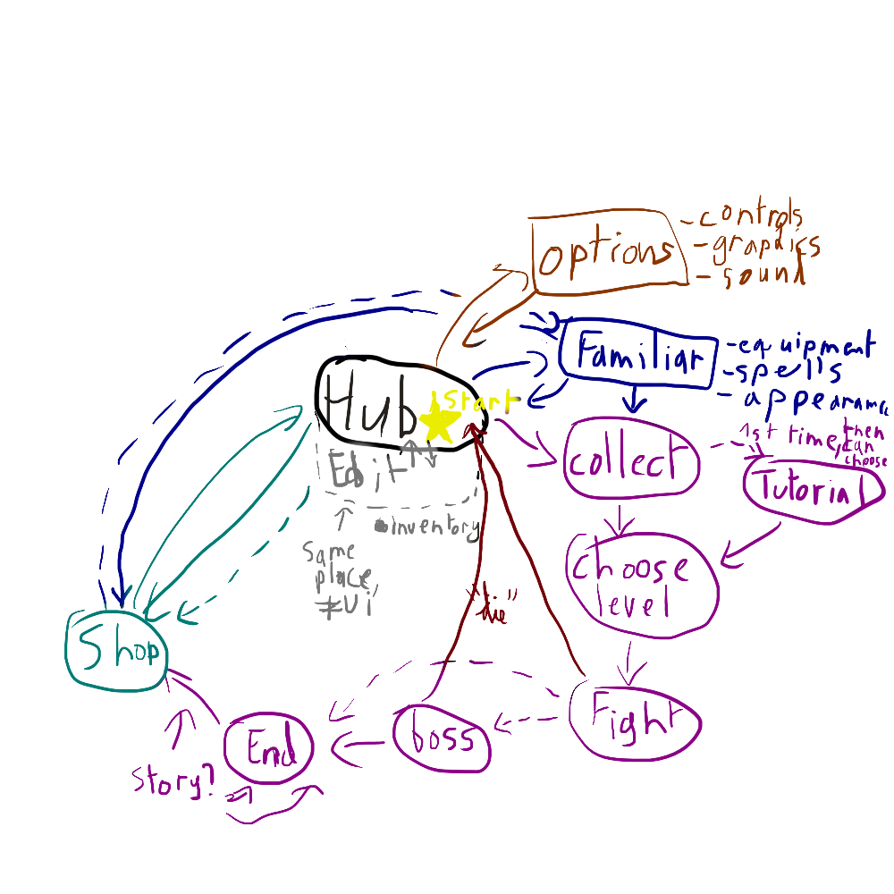

# Suggested Project Timeline

Here's where we get to the part where hearts break and tempers are lost - laying out a rough schedule for the game's development that utilizes the breakdowns that were made earlier in the document. Schedule aggressively, but be realistic - you're probably not going to get all of your menus in and working in a day. You don't have to be specific about where and when - the most important information to end up with here is the number of work hours per team member required, and exactly who will be responsible for what.

# Additional Ideas and Possibilities

This final section is a bit of an amalgam of everything that didn't fit in the sections before hand. It's an appendix of all of the things that you didn't think were necessarily core to the game, but you'd like to consider along the way. It's also for alternate possibilities - for instance, if you had two main characters in mind, put the better one in the main document, and then the alternate here. Finally, if you have any ideas that you're not sure about, but would like to prototype, then this is the place for that stuff as well.