**Users stories**

|  |  |  |  |
| --- | --- | --- | --- |
| **Story ID** | 01a | **Story Name** | **Course grade** |
| **Description** | * As a user, * I hope that when I check my grades, I can see not only GPA and rankings, but also specific scores for each semester and each course, * so that I can be better aware of my strengths and weaknesses and make progress. | | |
| **Priority** | M | **Iteration(Sprint)** | 1 |
| **Acceptance Criteria** | 1. Ensure that user and staff identity choices are clear and Ensure that degree grade, total grades, grades for each semester, and scores for individual courses can be viewed separately. 2. Ensure that the query function works properly and the page classification is clear. 3. Users can see whether they have a first-class bachelor's degree, a second-class bachelor's degree or something else. | | |
| **Date** | Date started: 2022/3/21 Date finished:2022/3/24 | | |

|  |  |  |  |
| --- | --- | --- | --- |
| **Story ID** | 02a | **Story Name** | **Personal**  **Cultivate**  **Program** |
| **Description** | * As a user, * I want to get relevant courses, resources and activities recommended based on my personal interests and learning history, * which can help me discover new learning opportunities. | | |
| **Priority** | S | **Iteration(Sprint)** | 1 |
| **Acceptance Criteria** | 1. The learning programs that users get on this page should be personal and selective. 2. Users can view all the courses, resources, and activities provided, and there should be a short introduction to tell the user what these resources are about. 3. Users can set their own filtering criteria, such as subject category, discipline difficulty, etc., to filter the courses, resources and activities they want. | | |
| **Date** | Date started: 2022/3/24 Date finished:2022/3/28 | | |

|  |  |  |  |
| --- | --- | --- | --- |
| **Story ID** | 02b | **Story Name** | **Study**  **Arrangement** |
| **Description** | * As a user, * I want to use this module to list the tasks, readings and assignments I need to complete, as well as key dates and deadlines, and set reminders. * In this way, I can plan my study arrangement. | | |
| **Priority** | M | **Iteration(Sprint)** | 2 |
| **Acceptance Criteria** | 1. Ensure that users can edit in place to list the tasks and dates they   want to record.   1. Ensure that the user can set the reminder and that the reminder   appears in the correct preset way at the correct preset time.   1. The page should be clear for users to get the information they want   quickly. | | |
| **Date** | Date started: 2022/4/2 Date finished:2022/4/4 | | |

|  |  |  |  |
| --- | --- | --- | --- |
| **Story ID** | 03a | **Story Name** | **Course Selection** |
| **Description** | * As a user, * I want to be able to select my optional courses, * so that I could take enough credits for my course. | | |
| **Priority** | W | **Iteration(Sprint)** | 4 |
| **Acceptance Criteria** | 1. Ensure that the system is able to provide students with the appropriate options based on their personal information  2. Ensure that course titles and credits are displayed correctly  3. Courses with conflicting times and full capacity should be blocked from choosing  4. Ensure that selections can be changed within a specified time frame | | |
| **Date** | Date started: 2023/5/24 Date finished:2023/5/27 | | |

|  |  |  |  |
| --- | --- | --- | --- |
| **Story ID** | 03b | **Story Name** | **Course Schedule Search** |
| **Description** | * As a user, * I want to be able to view my course schedule, * so that I can know the schedule of the course. | | |
| **Priority** | M | **Iteration(Sprint)** | 1 |
| **Acceptance Criteria** | 1. Ensure the course schedule is up to date with the latest results 2. Ensure the schedule can be displayed by date 3. Option to view the timetable for different weeks | | |
| **Date** | Date started: 2023/3/21 Date finished:2023/3/23 | | |

|  |  |  |  |
| --- | --- | --- | --- |
| **Story ID** | 04a | **Story Name** | **Assessment of Teaching** |
| **Description** | * As a user, * I want to be able to grade and give feedback to my teachers, * so that I can express my needs to the teacher. | | |
| **Priority** | C | **Iteration(Sprint)** | 4 |
| **Acceptance Criteria** | 1. Make sure the course schedule is up to date with the latest results 2. Ensure that students can only give their assessment to their own teachers 3. Ensuring the anonymity of the assessment process 4. The results of the students' evaluations are public | | |
| **Date** | Date started: 2023/5/5 Date finished:2023/5/12 | | |

|  |  |  |  |
| --- | --- | --- | --- |
| **Story ID** | 04b | **Story Name** | **Student Forum** |
| **Description** | * As a user, * I want to be able to interact with my fellow students and teachers, * so that I can get more information about course study. | | |
| **Priority** | W | **Iteration(Sprint)** | 4 |
| **Acceptance Criteria** | 1. Ensure that students can initiate queries with teachers 2. Ensure timely notification of replies | | |
| **Date** | Date started: 2023/5/1 Date finished:2023/5/2 | | |

|  |  |  |  |
| --- | --- | --- | --- |
| **Story ID** | 05a | **Story Name** | **Personal centre** |
| **Description** | * As a user, * I would like to have the ability to look up all my accolades, such as the positions I have held at school, the awards I have received and my thesis portfolio, and to export these, * so that I can use them directly when I need them later. | | |
| **Priority** | M | **Iteration(Sprint)** | 1 |
| **Acceptance Criteria** | 1. Ensure that the search function works properly and that page categories are clear and error-free. 2. Ensure that personal information is not retained after account cancellation | | |
| **Date** | Date started: 2022/3/24 Date finished:2022/4/11 | | |

|  |  |  |  |
| --- | --- | --- | --- |
| **Story ID** | 06a | **Story Name** | **Notification** |
| **Description** | * As a user, * I would like to be kept informed of study-related information, such as meetings, seminars, etc.so that I am following. * So that I can broaden my horizons and improve my academic performance. | | |
| **Priority** | C | **Iteration(Sprint)** | 2 |
| **Acceptance Criteria** | 1. Ensure that the correct and relevant information is pushed in a timely manner 2. Ensure that event start reminders can be set | | |
| **Date** | Date started: 2022/3/28 Date finished:2022/4/11 | | |

**Overall concept map**

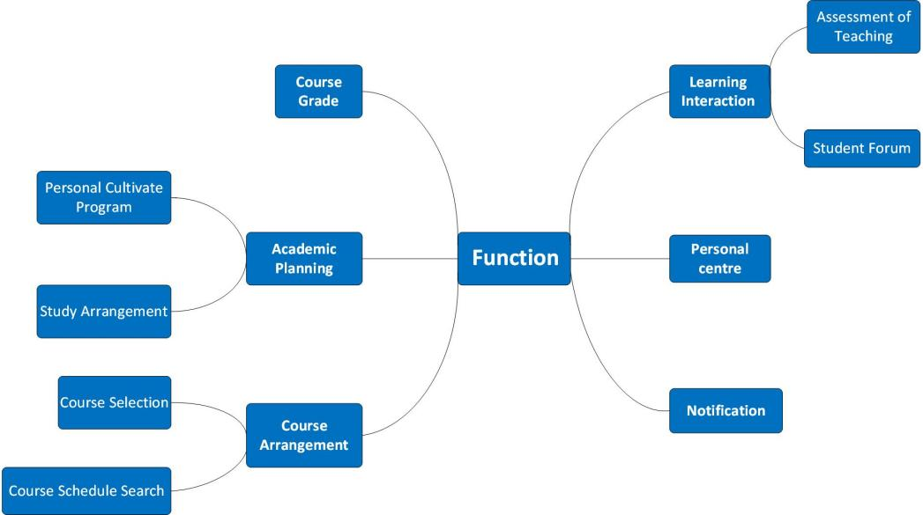

**Prototype**

