**Retail Industry**

**Software Requirements Document**

**V 1.0**

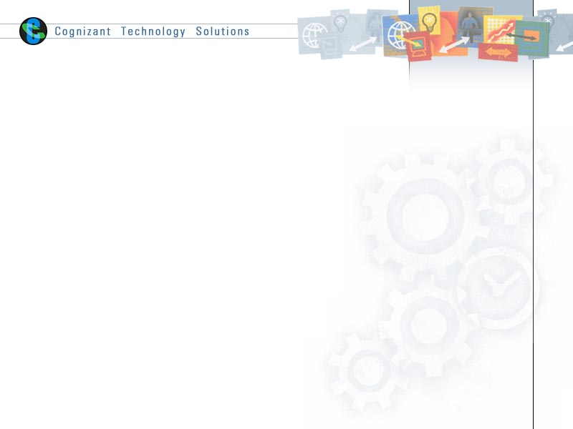

|  |  |  |  |
| --- | --- | --- | --- |
|  | **Prepared By** | **Reviewed by** | **Approved By** |
| **Name** |  |  |  |
| **Role** |  |  |  |
| **Signature** |  |  |  |
| **Date** |  |  |  |

Contents

1 Introduction 3

1.1 About this document 3

1.1.1 Purpose & Scope of the document 3

1.1.2 Intended Audience 3

1.2 About the Software System 3

1.2.1 Scope of the system 3

1.2.2 Exclusions 4

1.2.3 System Perspective 4

1.2.4 Architecture diagram 4

1.2.5 Impact of the System 4

2 System Requirements 5

2.1 Functional Requirements 5

2.1.1 Sales 5

2.1.2 Customer Module 5

2.1.3 Branch 6

3 Annexure 6

4 Terms and conditions 6

5 Change Log 7

# Introduction

## About this document

### Purpose & Scope of the document

The purpose of the software requirements document is to show the usage of the ETL processes in building a Data warehouse specific to business requirements. The ETL tool being used here would be Informatica.

### Intended Audience

Project Team

## About the Software System

The following section will cover aspects related to

We define the scope and objectives, and relate them to the requirements of Retail Industry. This is a good test case to see how a Data Warehouse can be built.

The following are the modules in this proposed system

1. Sales
2. Customer
3. Branch

### Scope of the system

The scope of the system is explained through its modules as follows

* **Sales** – This module is to display and sale of new or used goods to consumers for personal or household consumption. [The retail trade division](http://www.statista.com/topics/1308/trade-in-the-us/) includes motor vehicle retail, fuel retailing, food retailing, and other forms of store-based retail. Dimension invoice fact is to produce the sales revenue details.
* **Customer** –This module is to find the loyal customers of the retail industry. Based on the sales which are given by the customers from the specific locations. Dimension Customer Master which has the product history is to find the customer loyalty. Customer will be a type 2 dimension
* **Branch**– This module is to find the branch which is giving high profitable revenue in the retail industry. Dimension Branch Master which has the zip code to find branch region. This will be a type 1 dimension

### Exclusions

1. The system will operate only on the modules discussed above and will not include any additional functionality.

### System Perspective

The system is a data warehouse developed to manage the activities like finding the yearly sales revenue, sales customer and sales region.

### Architecture diagram

#### Logical Architecture:

The Logical Architecture defines the Processes (the activities and functions) that are required to provide the required [User Services](http://www.iteris.com/itsarch/html/user/userserv.htm). Many different [Processes](http://www.iteris.com/itsarch/html/pspec/pspecs.htm) must work together and share information to provide a User Service. The Processes can be implemented via software, hardware, or firmware. The Logical Architecture is independent of technologies and implementations.

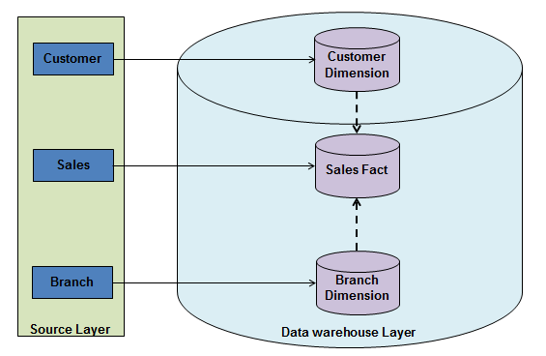

### Impact of the System

The data warehousing system is being developed to enhance the decision support and generating customized reports for Retail Industry.

# System Requirements

## Functional Requirements

### Sales

|  |  |
| --- | --- |
| DW – Sales  Req-1.3.1 |  |
| Functional Requirements | 1. Build a data warehouse which helps in Decision Support to forecast and value their products. 2. This module is to display and sale of new or used goods to consumers for personal or household consumption. [The retail trade division](http://www.statista.com/topics/1308/trade-in-the-us/) includes motor vehicle retail, fuel retailing, food retailing, and other forms of store-based retail. 3. Dimension invoice fact is to produce the sales revenue details. |

### Customer Module

|  |  |
| --- | --- |
| DW –Customer  Req-1.3.2 |  |
| Functional Requirements | 1. Centralized Data access is required for generating various reports like wholesale, retail and export sales. 2. To find the most loyal customers. Based on the sales given by the customer. 3. Customer Master which has the details of customer product history. |

### Branch

|  |  |
| --- | --- |
| DW –Branch  Req-1.3.3 |  |
| **Functional Requirements** | 1. This module will be retrieving the data into the data warehouse on a yearly basis and to produce the report of the branch which is giving high profit. 2. Dimensions item master is producing the item details and the invoice fact is to produce the selling price of the items. |

# Annexure



# Terms and conditions

GenCs shall be solely responsible for all its acts and omissions under this program. GenCs will comply at all times with all applicable laws. GenCs shall not use Cognizant’s name, logo and trademark in any promotional materials or other communications with third parties without the prior written consent of Cognizant. Any materials used by GenCs in relation to program will not infringe the copyrights, trademarks, patents, trade secrets or other intellectual property rights, privacy or similar rights of any person or entity. GenCs agrees not to post, draw, make, display any content that is threatening, libelous, obscene, defamatory, abusive, pornographic, or advocates/encourages any conduct that could constitute a criminal offence or give rise to any civil liability. Cognizant its associates’ personal details including but not limited to name, address, contact number shall not be shared or forwarded to any third party, without prior written consent of Cognizant, its associates. All intellectual property provided by Cognizant as part of program shall be owned exclusively by Cognizant. Intern shall indemnify, defend and indemnify Cognizant its associates, officers, directors from and against any claims, demands, loss, damage, liability, causes of action, judgments, or costs and expenses of every nature (including attorney’s fees and expenses) incurred by Cognizant based on any claim that any breach of terms and conditions of this program.

# Change Log

Please note that this table needs to be maintained even if a Configuration Management tool is used.

|  |  |  |  |  |
| --- | --- | --- | --- | --- |
| Version Number | Changes made | | | |
| V1.0 |  | | | |
| V1.1 | *<If the change details are not explicitly documented in the table below, reference should be provided here>* | | | |
| Page no | Changed by | Effective date | Changes effected |
|  |  |  |  |
|  |  |  |  |
|  |  |  |  |
|  |  |  |  |
| V1.2 | *<If the change details are not explicitly documented in the table below, reference should be provided here>* | | | |
| Page no | Changed by | Effective date | Changes effected |
|  |  |  |  |
|  |  |  |  |
|  |  |  |  |