Introduction:

Linear search is a very basic and simple search algorithm. In Linear search, we search an element or value in a given array by traversing the array from the starting, till the desired element or value is found.

 The time complexity of Linear search algorithm is **O(n)**, we will analysis the same and see why it is **O(n)** after implementing it.

#include <stdio.h>

#include <stdlib.h>

int main()

{

freopen("Output.text","w",stdout);

long int i=0;

int long Arr[10000];

for(i=0;i<=10000;i++)

{

printf("%d ", i);

}

return 0;

}

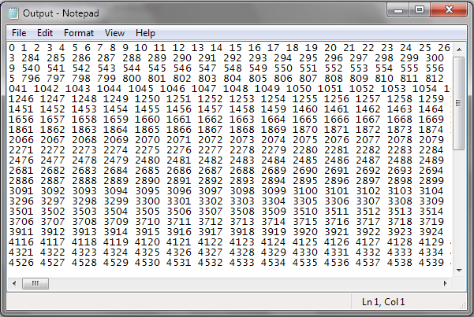

#include <stdio.h>

#include <stdlib.h>

int main()

{

//freopen("Abc.txt","w",stdout);

freopen("Output.text","r",stdin);

long int i=0;

long long arr[100001];

for(i=0;i<=10000;i++)

{

int tm;

scanf("%lld ",&arr[i]);

// printf("%d ",rand());

}

long int src=101;

for(i=0;i<=10000;i++)

{

if(arr[i]==src)

{

printf("Found");

return 0;

}

}

printf("Not Found");

return 0; }

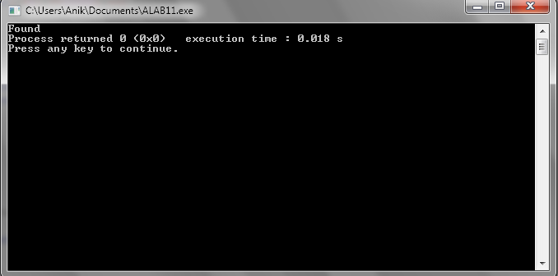

Conclusion:

We know Linear search is so damn simple to implement, but it is not used practically because binary search is a lot faster than linear search.