# Labsheet -4

The Class(Program.cs) with Driver Code is used to execute the rest of the questions.

Below is the driver code:

using System;

namespace Lab4

{

class Program

{

static void Main(string[] args)

{

//This is the driver program to execute all the programs

//switch case will be used for question-numbered Access

Console.WriteLine("Question 1\nQuestion 2\nQuestion 3\nQuestion 4\nQuestion 5");

int choice = Convert.ToInt32(Console.ReadLine());

switch (choice)

{

case 1:

Quadratic quadratic = new Quadratic();

Console.WriteLine("Enter The Equation In the form ax^2+bx+c");

double []a = new double[3];

for (int i=0;i<a.Length;i++)

{

a[i] = Convert.ToInt32(Console.ReadLine());

}

quadratic.setVal(a[0],a[1],a[2]);

quadratic.pos_root_of_quadratic();

quadratic.neg_root_of_quadratic();

Console.WriteLine("The Root of ({0})x^2+({1})x+{2} is {3} and {4}",quadratic.sq_r(),quadratic.s_r(),quadratic.z_r(),quadratic.neg_root_of_quadratic(),quadratic.pos_root_of_quadratic());

break;

case 2:

Student student = new Student();

student.Age = 27;

student.Name = "Tyler Durden";

student.Code = 111;

Console.WriteLine("Hello Mr. {0},You are {1} years old and Your code is {2}, right ?",student.Name,student.Age,student.Code);

break;

case 3:

Students students = new Students("Dwanye Johnson", "Princton", "therock@gmail.com",3339996666);

Console.Write(students.return_info());

Students students1 = new Students("Jason Stanthom", "Automobile Engg", "Fluid Mechanics", "Yale University", "jasonstanthom@gmail.com", 998900100);

Console.Write(students1.return_info());

break;

case 4:

Electricity electricity = new Electricity();

Console.WriteLine("Enter The Customer name !");

String consumer_name = Console.ReadLine();

electricity.setConsumer(consumer_name);

Console.WriteLine("Enter The Electricity Usage in Units.");

double units = Convert.ToDouble(Console.ReadLine());

electricity.set_Usage(units);

electricity.showBill();

break;

case 5:

Voting voting = new Voting();

voting.count_votes();

voting.ShowResults();

break;

default:

Console.WriteLine("Invalid Question Entered !");

break;

}

}

}

}

1) Write a Program in C# to find the roots of Quadratic Equation.

using System;

using System.Collections.Generic;

using System.Text;

namespace Lab4

{

class Quadratic

{

private double sqaure_power, single_power, zero_power;

//The Eqn is (Some Number)x^2+(Some Number)x^1+(Some Number)x^0

public Quadratic()

{

sqaure_power = 0;

single_power = 0;

zero_power = 0;

}

public void setVal(double sq,double nq,double zq)

{

sqaure_power = sq;

single_power = nq;

zero_power = zq;

}

public double z_r()

{

return zero_power;

}

public double sq_r()

{

return sqaure_power;

}

public double s_r()

{

return single_power;

}

public double neg_root_of_quadratic()

{

double root;

root = (-single_power + Math.Sqrt((Math.Pow(single_power, 2) -( 4 * sqaure_power * zero_power)))) / (2 * sqaure_power);

return root;

}

public double pos_root_of_quadratic()

{

double root;

root = (-single_power - Math.Sqrt((Math.Pow(single_power, 2) - (4 * sqaure_power * zero_power))))/(2 * sqaure_power);

return root;

}

}

}

Output:

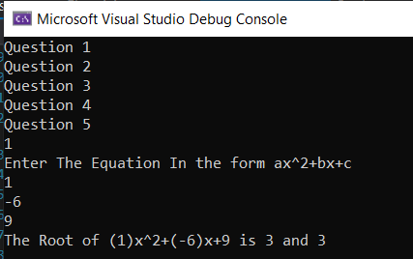

2) Create a class student with private attribute code, name, age. Create corresponding properties for the attributes and test the class in main function.

using System;

using System.Collections.Generic;

using System.Text;

namespace Lab4

{

class Student

{

private int code;

private String name;

private int age;

public int Code

{

get

{

return code;

}

set

{

code = value;

}

}

public String Name

{

get

{

return name;

}

set

{

name = value;

}

}

public int Age

{

get

{

return age;

}

set

{

age = value;

}

}

}

}

Output:

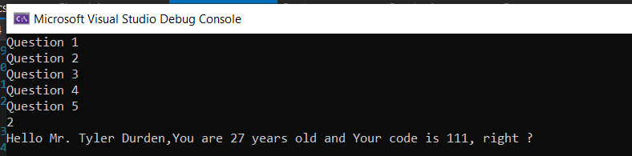

3) Define a class Student, which contains the following information about students: full name, course, subject, university, e-mail and phone number.

- Declare several constructors for the class Student, which have different lists of parameters (for complete information about a student or part of it). Data, which has no initial value to be initialized with null. Use nullable types for all non-mandatory data.\

- Add a method in the class Student, which displays complete information about the student.

- Test the class

using System;

using System.Collections.Generic;

using System.Text;

namespace Lab4

{

class Students

{

private String full_name, course, subject, university, email;

private long ? phone=null;

public Students()

{

full_name = null;

course = null;

subject = null;

university= null;

email = null;

phone = null;

}

public Students(String f_name,String course_con,String subject_con,String uni,String em,long phone_num)

{

full_name = f_name;

course = course_con;

subject = subject_con;

university = uni;

email = em;

phone = phone_num;

}

public Students(String f_name, String uni, String em, long phone_num)

{

full_name = f_name;

university = uni;

email = em;

phone = phone_num;

}

public Students(String f_name, String uni, String em)

{

full_name = f_name;

university = uni;

email = em;

}

public Students(String f_name, String uni, String university_con, String em, long phone_number)

{

full_name = f_name;

university = university_con;

email = em;

phone = phone_number;

}

public String return_info()

{

return full_name+"\n"+course+"\n" + subject+ "\n" + university + "\n" + email + "\n" + phone+"\n" ;

}

}

}

Output:

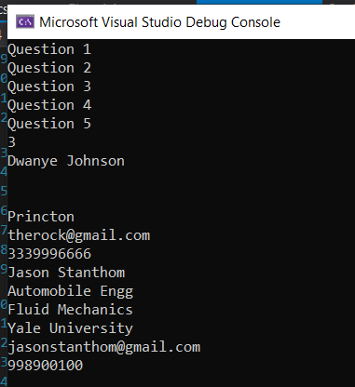

4) An electricity board charges the following rates to domestic users to discourage large consumption of energy:

For the first 100 units -60P per unit

For next 200 units -80P per unit

Beyond 300 units -90P per unit

All users are charged a minimum of Rs.50.00. if the total amount is more than Rs.300.00 than an additional surcharge of 15% is added.

Write a C# program to read the names of users and number of units consumed and print out the charges with names

using System;

using System.Collections.Generic;

using System.Text;

namespace Lab4

{

class Electricity

{

private String name_of_consumer;

private double net_usage,rate;

public void setConsumer(String name)

{

name_of_consumer = name;

}

public void set_Usage(double usage)

{

net_usage = usage;

if (net_usage <= 100)

{

rate = (60.00*net_usage)/100.00;

}

else if (net_usage > 100 && net_usage <= 300)

{

rate = ((100.00*60.00) + ((net_usage - 100) * 80.00) )/ 100.00;

}

else if (net_usage > 300)

{

rate = ((60.00*100.00) + (200.00 * 80.00) + ((net_usage - 300)*90.00))/100.00;

}

}

public void showBill()

{

if (rate > 300.00)

{

rate += (0.15 * rate);

Console.WriteLine("Consumer Name:{0}\nUsage:{1}\nNet Amount(With Surcharge):Rs {2}", name_of_consumer, net_usage, rate);

}

else if(rate<50)

{

rate = 50.00;

Console.WriteLine("Consumer Name:{0}\nUsage:{1}\nNet Amount(No Surcharge):Rs {2}", name_of_consumer, net_usage, rate);

}

else

{

Console.WriteLine("Consumer Name:{0}\nUsage:{1}\nNet Amount(No Surcharge):Rs {2}", name_of_consumer, net_usage, rate);

}

}

}

}

Output:

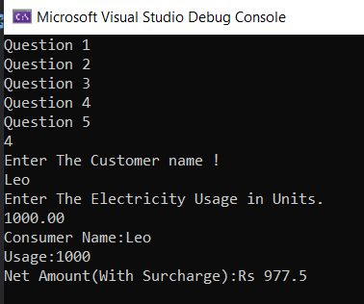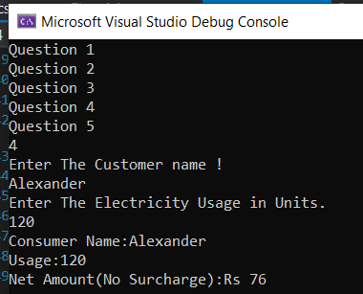

5) An election is contested by five candidates. The candidates are numbered 1 to 5 and a voting is done by marking the candidate number in a ballot paper. Write a C# program to read the ballot and count the votes cast for each candidate using an array variable count. In case, a number read is outside the range 1 to 5 the ballot should be considered as a ‘spoilt ballot’, and the program should also count the number of spoilt ballots.

using Microsoft.VisualBasic;

using System;

using System.Collections;

using System.Collections.Generic;

using System.Linq;

namespace Lab4

{

class Voting

{

int[] count;

int one, two, three, four, five, spoilt;

public Voting()

{

count = new int[] {11,2,1,3,12,4,5,6,2,1,6,2,4,4,5,6,5,5121,2,2,2};

one = 0;

two = 0;

three = 0;

four = 0;

five = 0;

spoilt = 0;

}

public void count_votes()

{

for (int i = 0; i < count.Length; i++)

{

switch (count[i])

{

case 1:

one++;

break;

case 2:

two++;

break;

case 3:

three++;

break;

case 4:

four++;

break;

case 5:

five++;

break;

default:

spoilt++;

break;

}

}

}

public void ShowResults()

{

int[] votes = new int[5];

votes[0] = one;

votes[1] = two;

votes[2] = three;

votes[3] = four;

votes[4] = five;

int max = votes[0];

int pos = 1;

for (int i = 1; i < 5; i++)

{

if (max < votes[i])

{

max = votes[i];

pos = i+1 ;

}

}

if (Check_duplicates(votes,max))

{

Console.WriteLine("No Clear Winner !");

showVoting();

}

else

{

Console.WriteLine("Candidate {0} Won The Election,With {1} Votes.", pos, max);

showVoting();

}

}

private void showVoting()

{

Console.WriteLine("*****Votes Gained By Each Candidate ******");

Console.WriteLine("Canidate One:{0}\nCanidate Two:{1}\nCanidate Three:{2}\nCanidate Four:{3}\nCanidate Five:{4}\nSpoilt Votes:{5}",one,two,three,four,five,spoilt);

}

//Using Arrays and checking the duplicates.

private static bool Check_duplicates(int[] arr,int max_value)

{

bool found = false;

int count = 0;

foreach (int i in arr)

{

if (i == max_value) { count++; }

}

if (count > 1)

found = true;

return found;

}

}

}

Output:

