🌐
ATTACK
DHCP SPOOFING
Rogue DHCP Server Detection Using Wireshark

┃ YOUNESS BOUSSEDARI
Technicien en Cyber Sécurité — Test d'Intrusion, SOC Analyste
October 2026

TABLE OF CONTENTS
01 | Introduction

02 | Lab Environment

03 | Understanding the DHCP Protocol

04 | Lab Preparation

05 | Initial DHCP Traffic Analysis

06 | Rogue DHCP Simulation

07 | Client Selection and DHCP Response Analysis

08 | Wireshark Detection Techniques

09 | Security Impact

10 | Limitations

11 | Mitigation

12 | Conclusion

01 Introduction
The objective of this lab was to understand how a Rogue DHCP Server can affect clients on a local network, how to simulate this behavior in an isolated virtual environment, and how to detect unauthorized DHCP responses using Wireshark.
A Rogue DHCP Server is an unauthorized DHCP server that responds to DHCP clients and may provide incorrect or malicious network configuration, including an IP address, default gateway, or DNS server.
In a real enterprise network, this behavior can lead to network disruption, traffic redirection, or potentially enable further attacks if additional security weaknesses exist.

02 Lab Environment
The lab was built using VirtualBox with an isolated Internal Network named DHCP_LAB.

Virtual Machines
Machine | Role | IP Address
Windows Server | Legitimate DHCP Server | 192.168.11.1
Kali Linux | Rogue DHCP Simulation | 192.168.11.201
Windows 10 | DHCP Client | 192.168.11.200 → 192.168.11.228

The subnet mask was 255.255.255.0, corresponding to the network 192.168.11.0/24.
The legitimate Windows Server DHCP scope was configured to allocate addresses from 192.168.11.200 to 192.168.11.250.
On Kali Linux, dnsmasq version 2.93 was used to simulate a second DHCP server with a test address pool from 192.168.11.220 to 192.168.11.230.
⚠ IMPORTANT
The two DHCP address pools overlapped. This was intentional for the lab, to demonstrate the risks of competing DHCP servers.

03 Understanding the DHCP Protocol
DHCP automatically provides network configuration to clients. Its standard address-allocation process is known as DORA:
1. Discover: The client broadcasts a message to find available DHCP servers.
2. Offer: A DHCP server proposes an IP address and configuration.
3. Request: The client requests the offered configuration.
4. ACK: The selected server confirms the lease.

DHCP messages are commonly exchanged over UDP ports 68 (client) and 67 (server).
🔑 ملاحظة مهمة — Option 54
An important DHCP field is Option 54 — DHCP Server Identifier. It identifies the DHCP server associated with an offer or response and helps analysts distinguish between legitimate and unexpected DHCP servers.

04 Lab Preparation

Step 1 — Configure the Legitimate DHCP Server
Windows Server was configured with the static IP address 192.168.11.1/24.
The DHCP Server role was installed, a scope was created for 192.168.11.200–192.168.11.250, and the scope was activated.
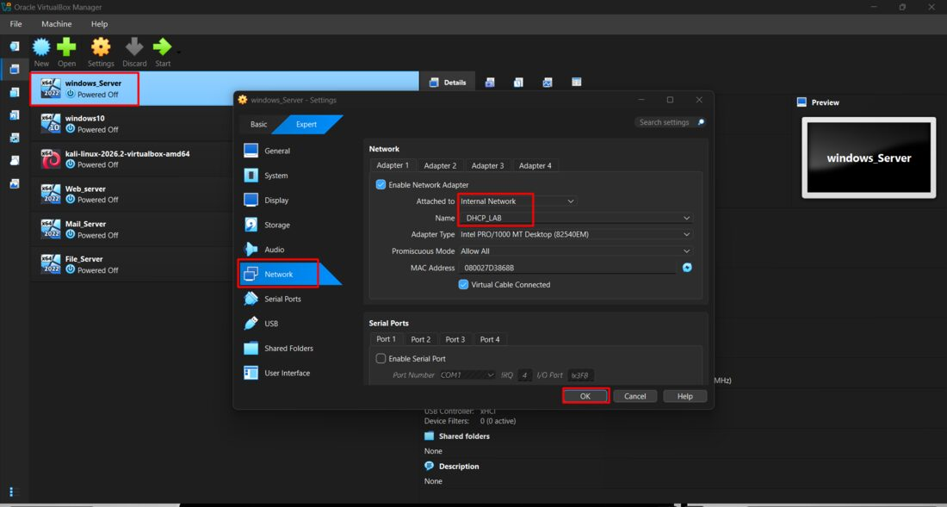
Figure 1 — VirtualBox: windows_Server network adapter attached to the Internal Network "DHCP_LAB".
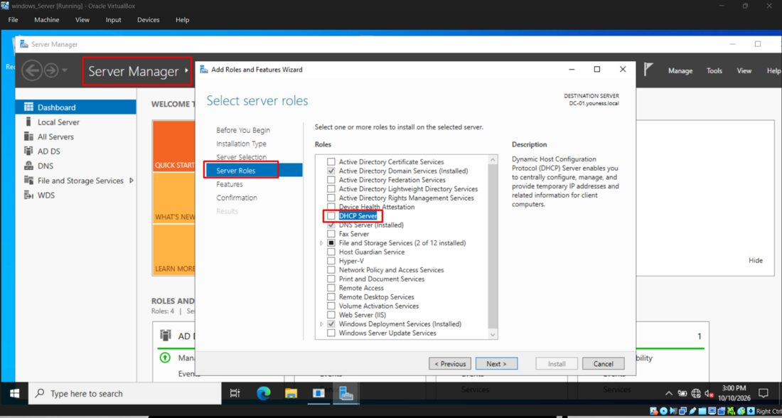
Figure 2 — Server Manager: selecting the DHCP Server role for installation.
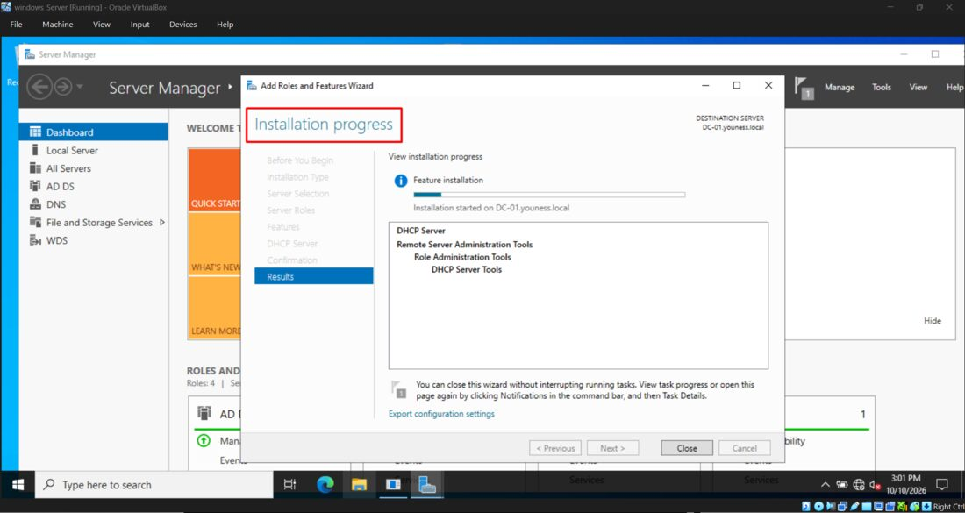
Figure 3 — Installation progress: DHCP Server role installed successfully.
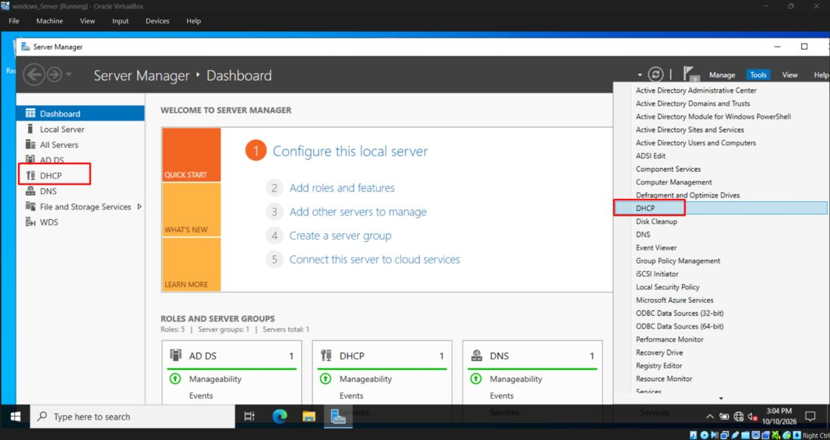
Figure 4 — Server Manager Tools menu: opening the DHCP management console.
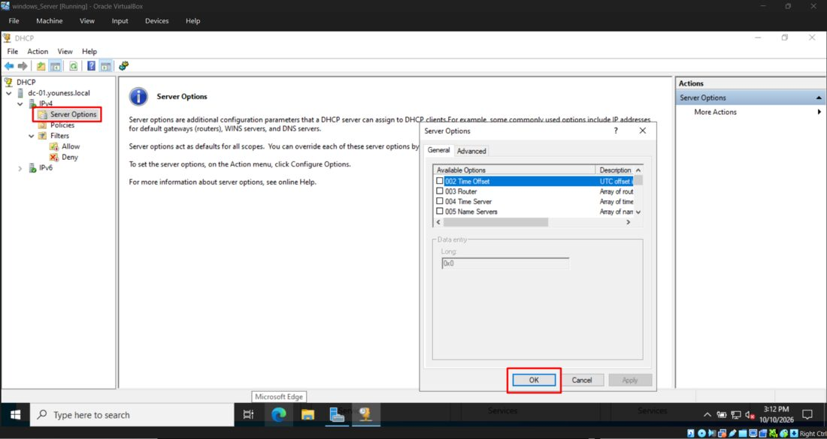
Figure 5 — DHCP console: Server Options view.
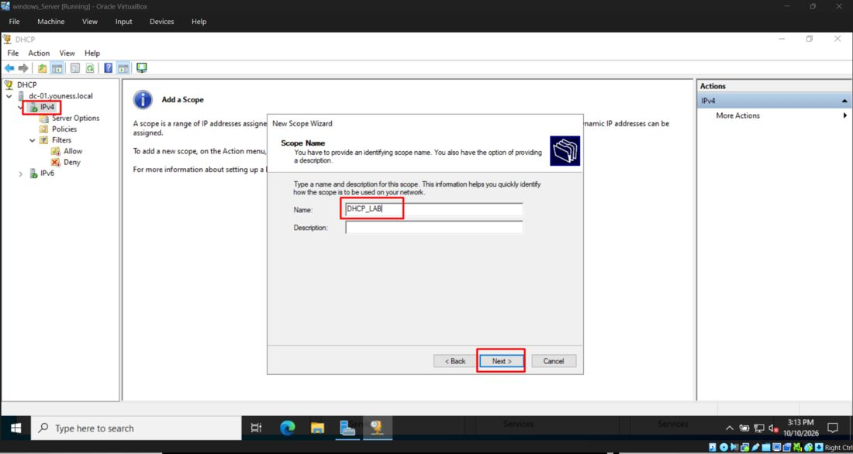
Figure 6 — New Scope Wizard: naming the scope "DHCP_LAB".
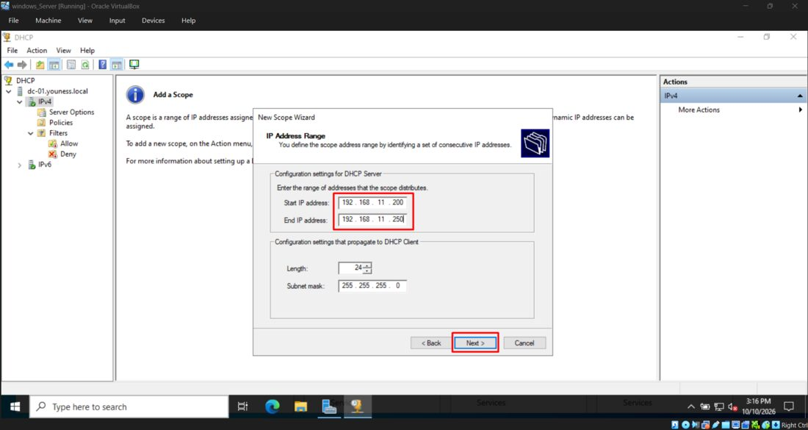
Figure 7 — New Scope Wizard: IP address range 192.168.11.200 – 192.168.11.250, mask 255.255.255.0.
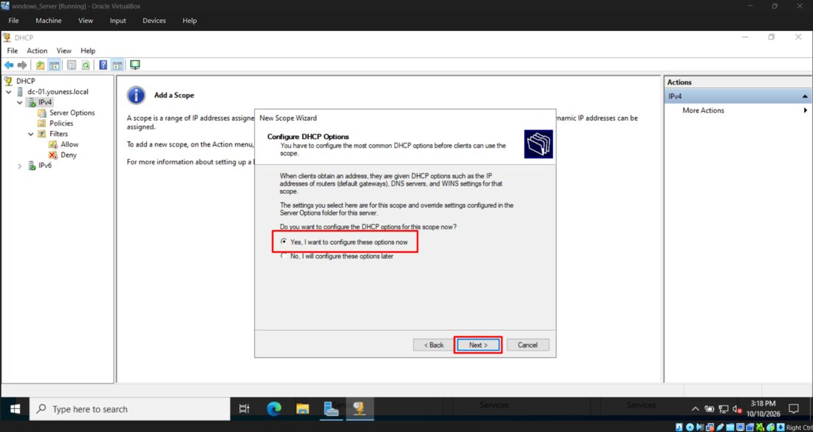
Figure 8 — New Scope Wizard: choosing to configure DHCP options immediately.
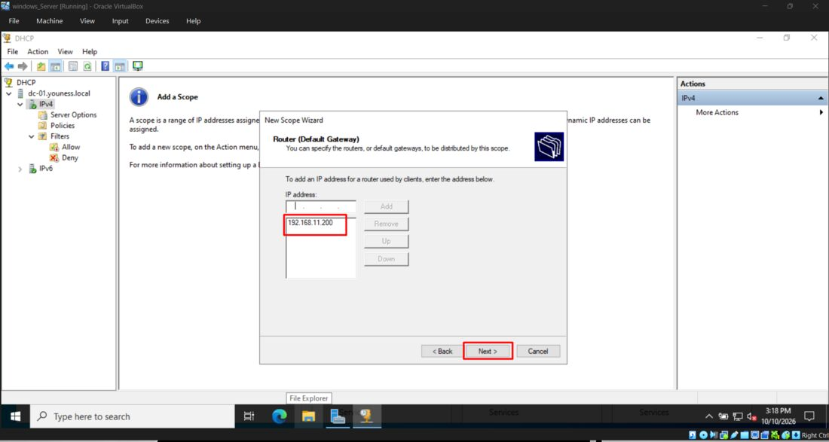
Figure 9 — New Scope Wizard: Router (Default Gateway) configuration.
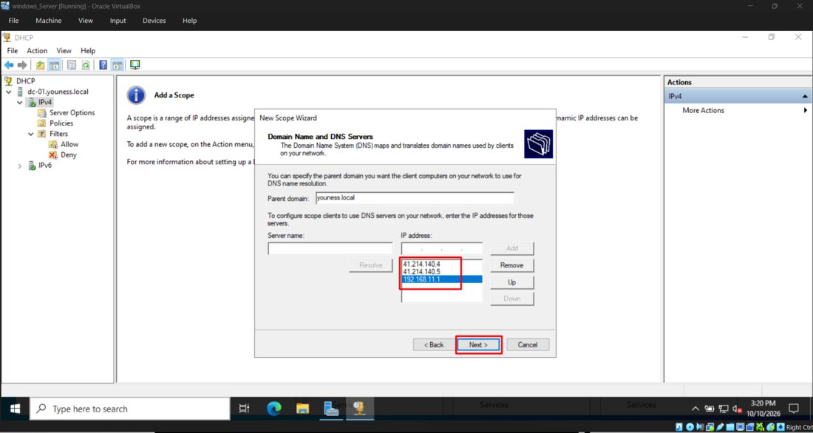
Figure 10 — New Scope Wizard: parent domain "youness.local" and DNS server addresses.

Step 2 — Configure the Client
Windows 10 was configured to obtain its IP address automatically through DHCP. Initially, it received 192.168.11.200 from the legitimate DHCP server at 192.168.11.1.
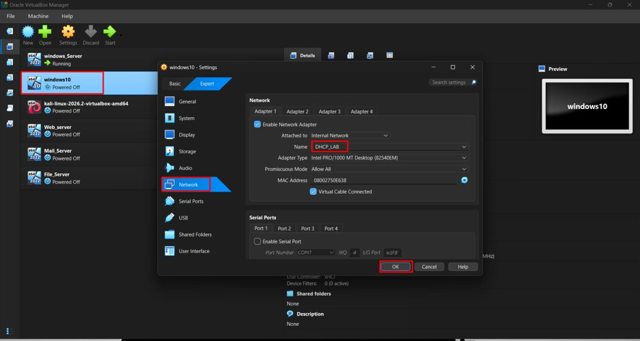
Figure 11 — VirtualBox: windows10 network adapter attached to the Internal Network "DHCP_LAB".
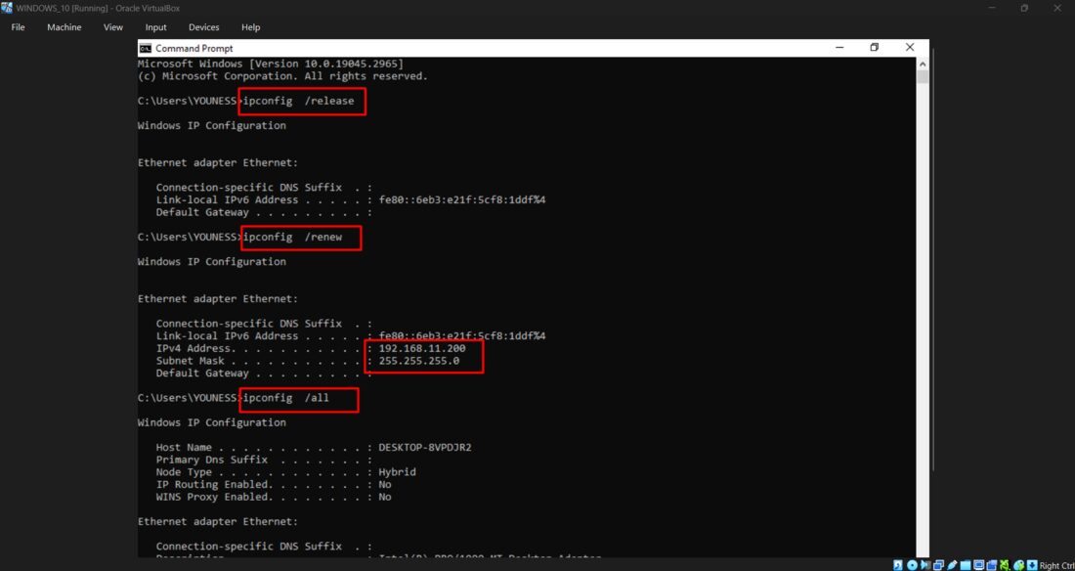
Figure 12 — Windows 10 Command Prompt: ipconfig /release, /renew and /all showing the leased address 192.168.11.200.
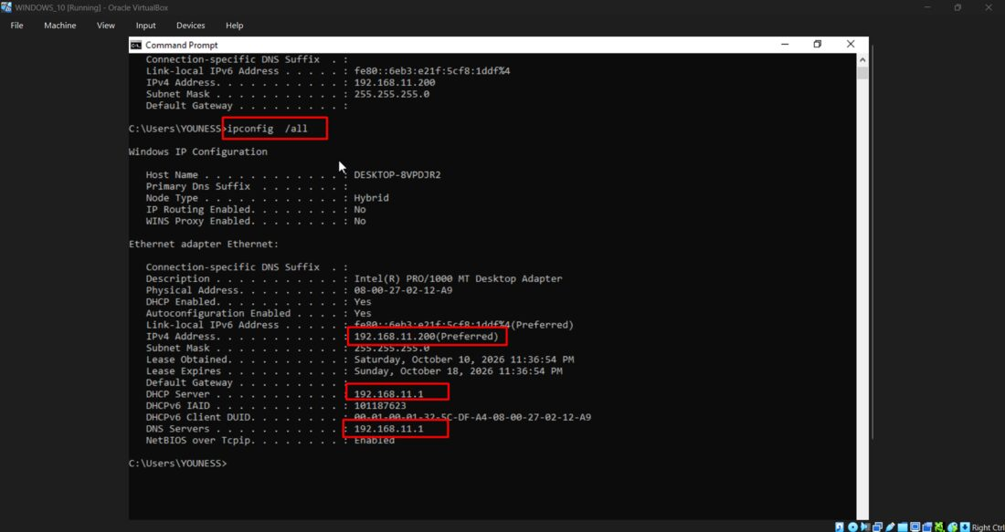
Figure 13 — ipconfig /all (continued): Default Gateway and DHCP Server both 192.168.11.1.
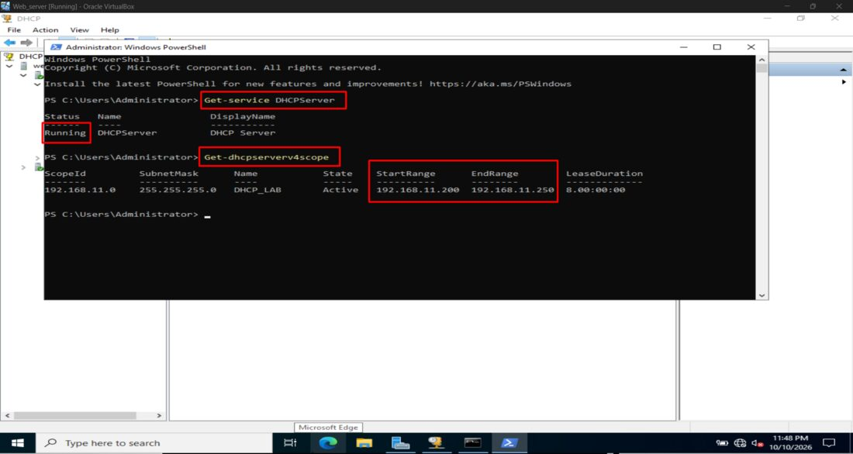
Figure 14 — PowerShell on the DHCP server: Get-Service DHCPServer (Running) and Get-DhcpServerv4Scope confirming the active scope DHCP_LAB.

Step 3 — Configure Kali Linux
Kali Linux was connected to the same VirtualBox Internal Network, DHCP_LAB, with the static address 192.168.11.201/24 on interface eth0. Wireshark was installed to capture and inspect DHCP traffic.
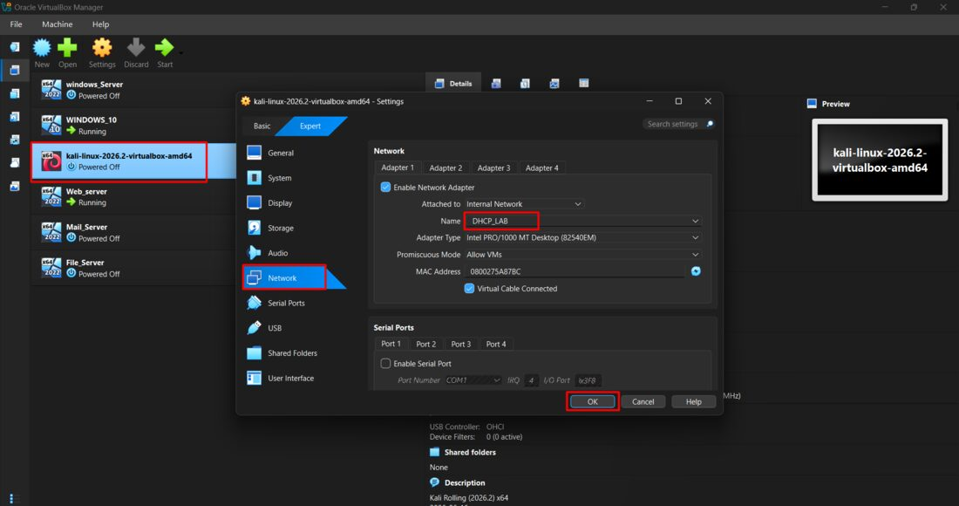
Figure 15 — VirtualBox: kali-linux network adapter attached to the Internal Network "DHCP_LAB" (Promiscuous Mode: Allow VMs).
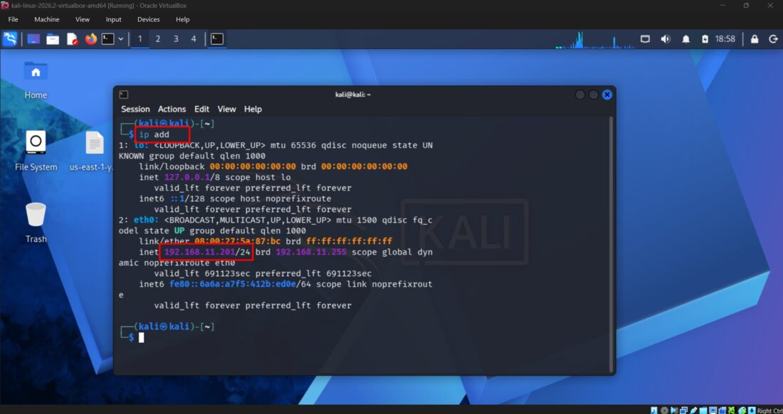
Figure 16 — Kali terminal: ip add confirming eth0 holds 192.168.11.201/24.
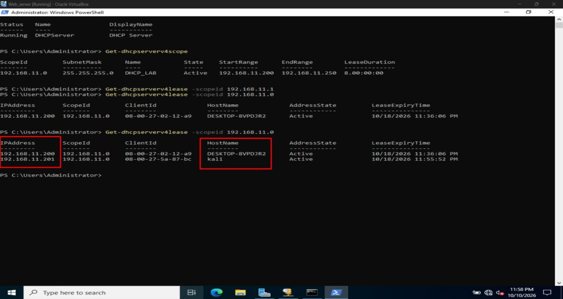
Figure 17 — PowerShell: Get-DhcpServerv4Lease showing both active leases — 192.168.11.200 (DESKTOP-8VPDJR2) and 192.168.11.201 (kali).
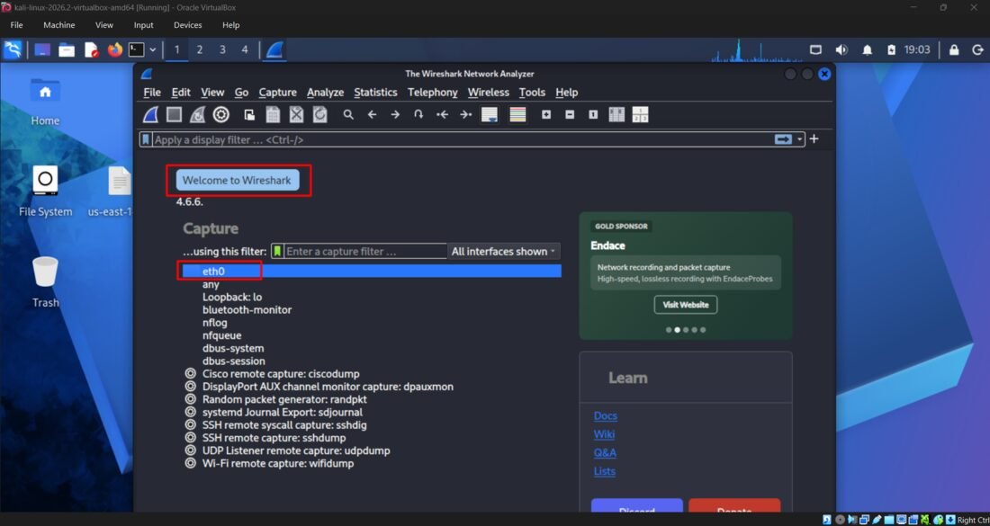
Figure 18 — Wireshark launched on Kali, interface eth0 selected for capture.
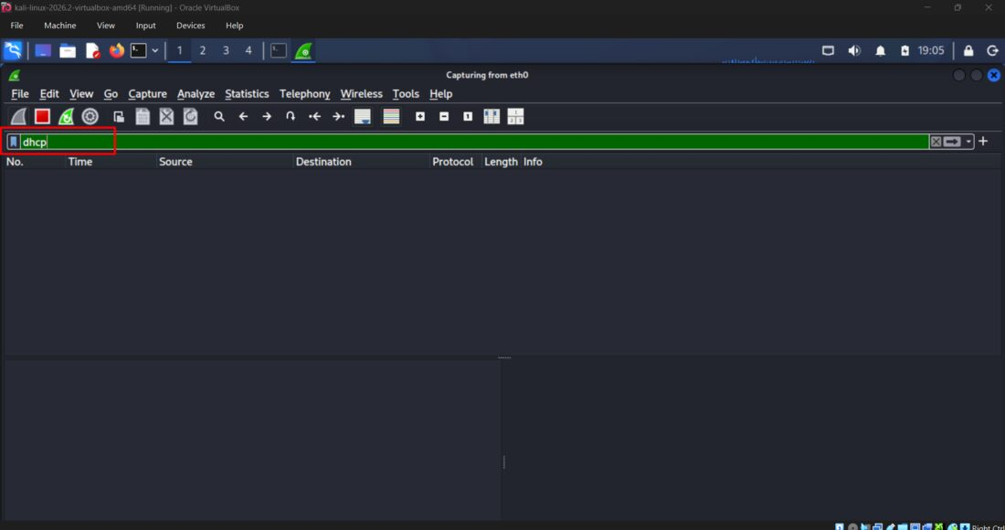
Figure 19 — Wireshark capturing live on eth0 with the display filter "dhcp" applied.
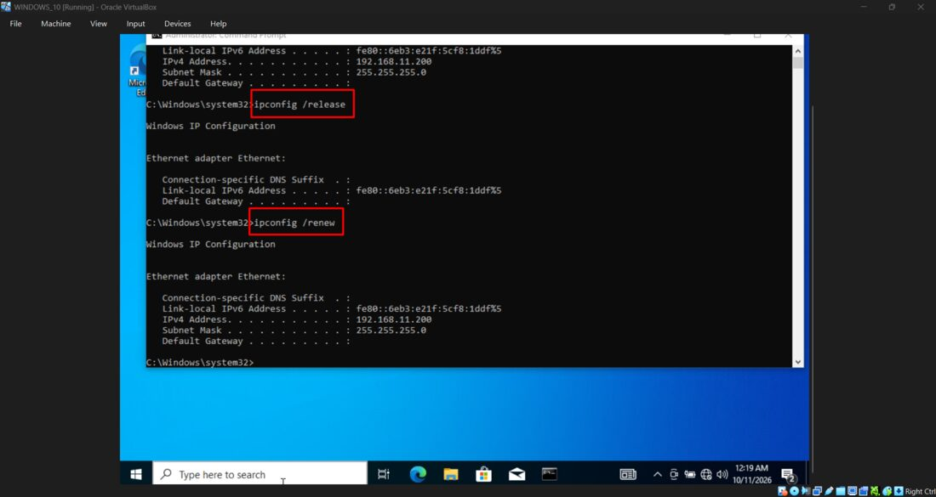
Figure 20 — Windows 10 Command Prompt: ipconfig /release and /renew, re-confirming the baseline lease 192.168.11.200 before the rogue test.

05 Initial DHCP Traffic Analysis
The first Wireshark captures showed the normal DHCP process between Windows 10 and the legitimate Windows Server.
The legitimate server offered 192.168.11.200, and its DHCP Server Identifier was 192.168.11.1.
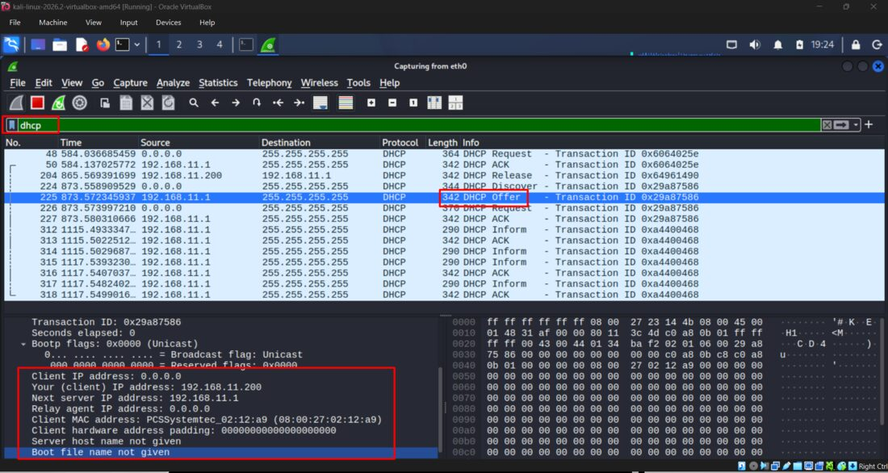
Figure 21 — Wireshark: baseline DHCP exchange (Discover / Offer / Request / ACK) with the legitimate server 192.168.11.1.
✔ BASELINE
At this stage, the observed DHCP behavior was normal and did not, by itself, indicate a Rogue DHCP attack.

06 Rogue DHCP Simulation

Step 4 — Configure the Second DHCP Server
The dnsmasq service was configured with a dedicated configuration file at /tmp/rogue-dhcp.conf. The configuration bound the service to eth0, disabled its DNS service, and defined a test DHCP range of 192.168.11.220–192.168.11.230.
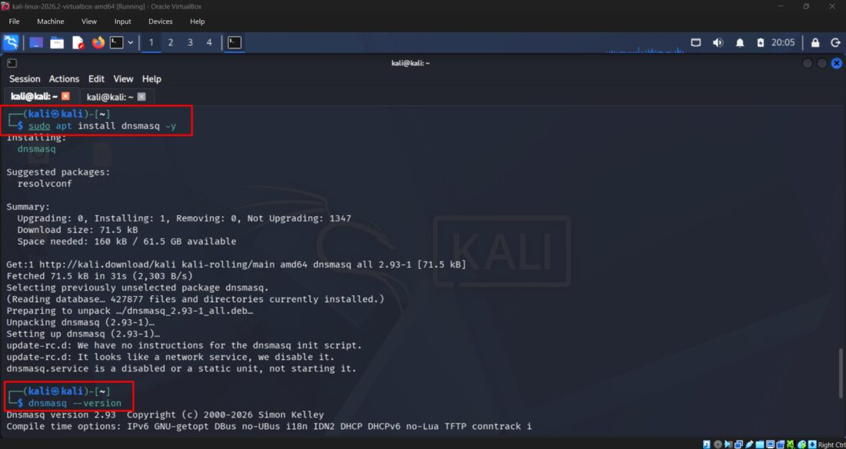
Figure 22 — Installing dnsmasq on Kali and confirming version 2.93.
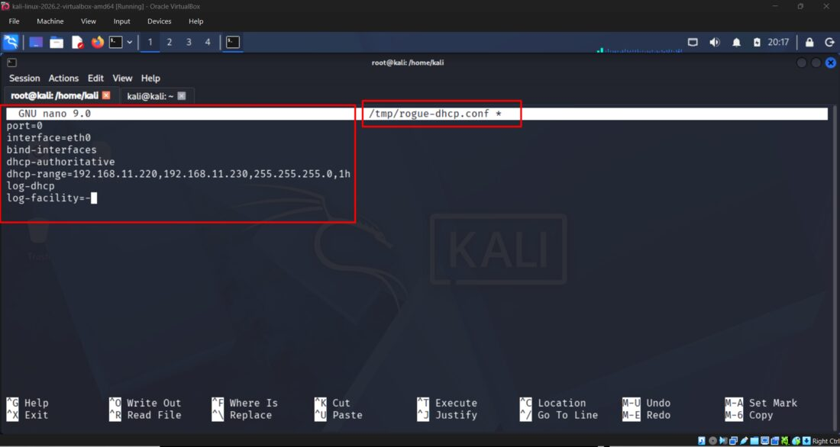
Figure 23 — /tmp/rogue-dhcp.conf: interface eth0, dhcp-authoritative, range 192.168.11.220–192.168.11.230, 1h lease.
# /tmp/rogue-dhcp.conf
port=0
interface=eth0
bind-interfaces
dhcp-authoritative
dhcp-range=192.168.11.220,192.168.11.230,255.255.255.0,1h
log-dhcp
log-facility=-

The configuration syntax was validated successfully using dnsmasq --test.
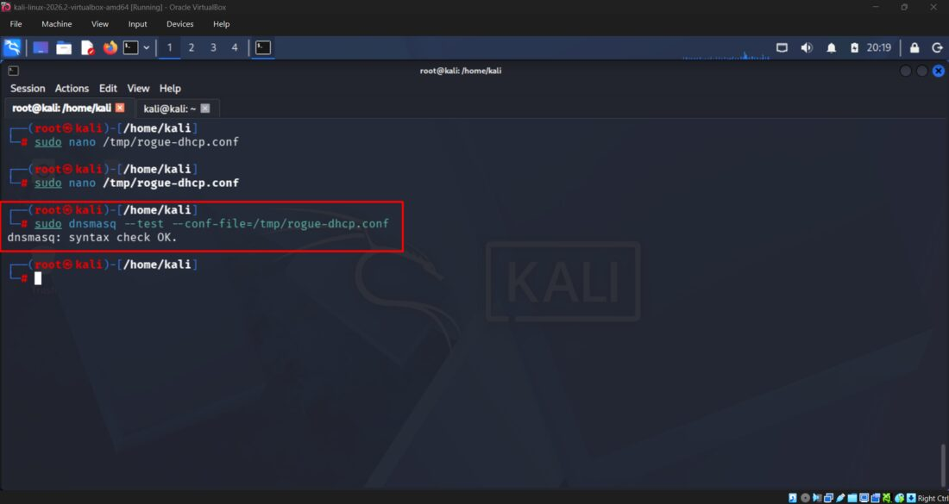
Figure 24 — dnsmasq --test --conf-file=/tmp/rogue-dhcp.conf → "syntax check OK".
After starting the configured dnsmasq service on Kali, the second DHCP server began responding to client DHCP traffic. The logs identified Kali as the server using the address 192.168.11.201.
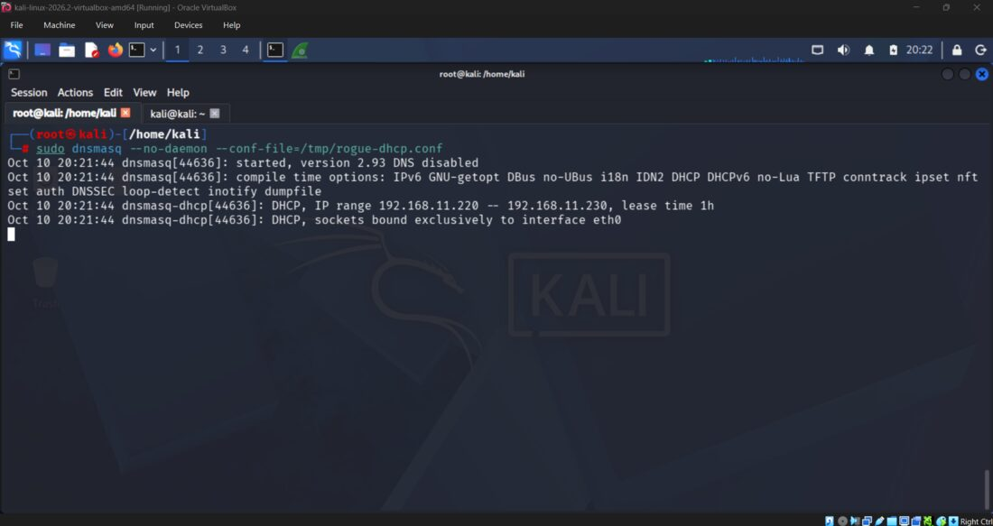
Figure 25 — dnsmasq --no-daemon: service started, DHCP range 192.168.11.220–192.168.11.230, bound exclusively to eth0.
Wireshark confirmed the presence of DHCP Offers associated with both server addresses — the legitimate server (192.168.11.1) and the rogue DHCP simulation (192.168.11.201) — demonstrating that two DHCP servers could respond within the same broadcast domain.

07 Client Selection and DHCP Response Analysis
During the initial competition, Windows 10 continued using the legitimate lease, 192.168.11.200. The packet captures showed a DHCP Request identifying the legitimate server at 192.168.11.1, followed by a DHCP ACK from that server. Kali also generated DHCP NAK messages when it received requests associated with another server's identifier.
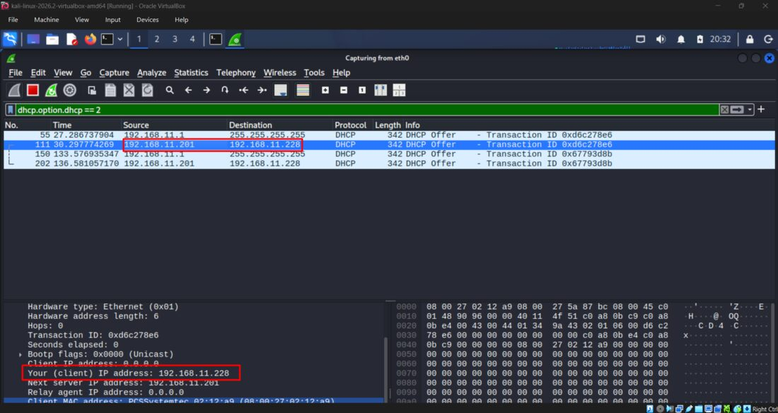
Figure 26 — Wireshark (dhcp.option.dhcp == 2): DHCP Offer from the rogue server 192.168.11.201 to the client, proposing 192.168.11.228.
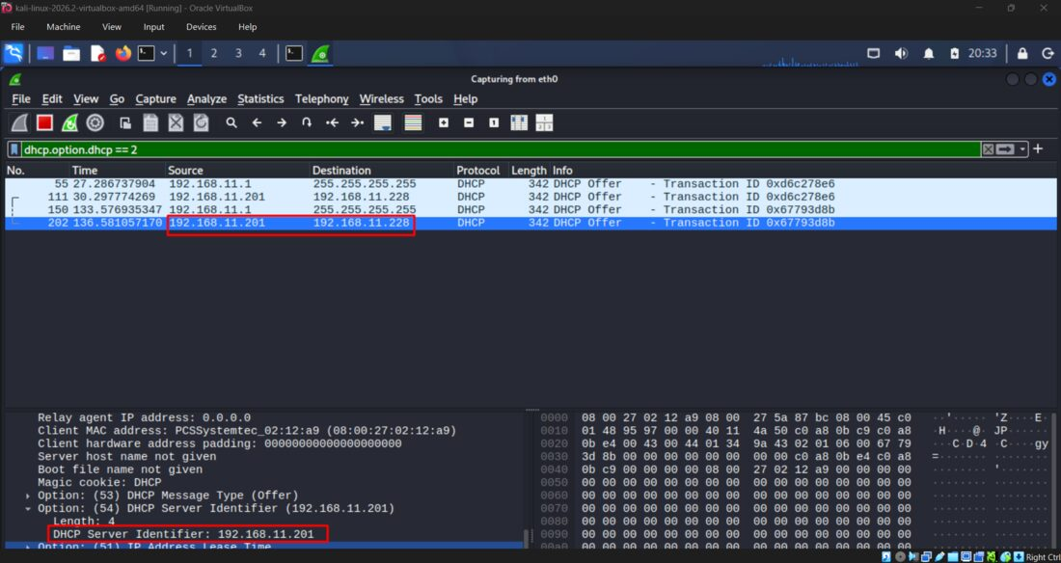
Figure 27 — Wireshark: Option 54 — DHCP Server Identifier confirmed as 192.168.11.201 inside the rogue Offer.
Later, during a subsequent test, Windows 10 obtained the address 192.168.11.228 from Kali. The client configuration showed:
- IPv4 address: 192.168.11.228
- DHCP Server: 192.168.11.201
- Default Gateway: 192.168.11.201
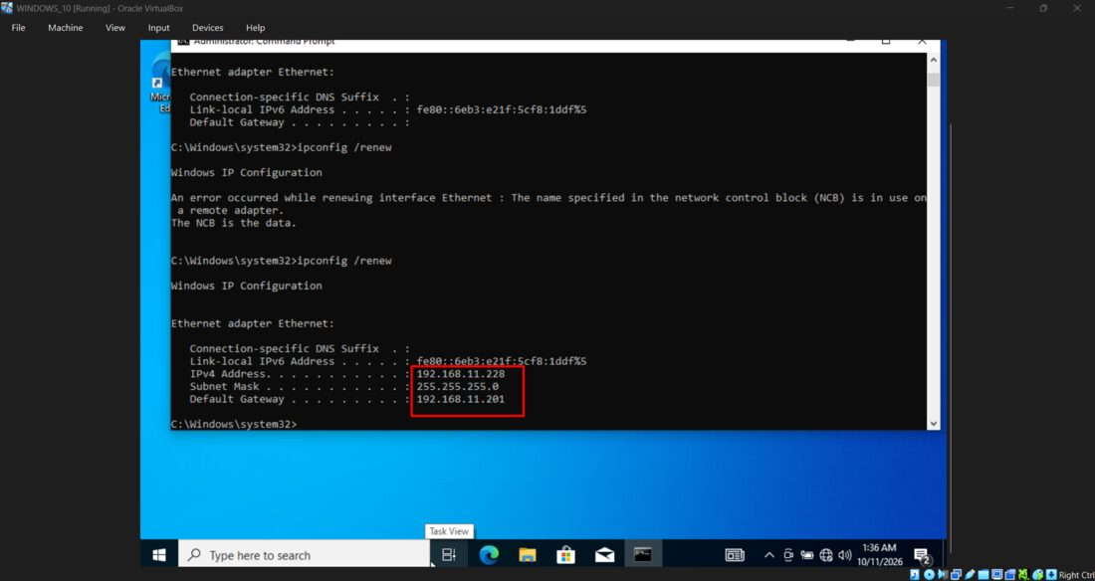
Figure 28 — Windows 10 Command Prompt: ipconfig /renew now returns IPv4 192.168.11.228 with Default Gateway 192.168.11.201 (Kali).
A DHCP ACK from Kali was captured in Wireshark, confirming that Kali had acknowledged the lease.
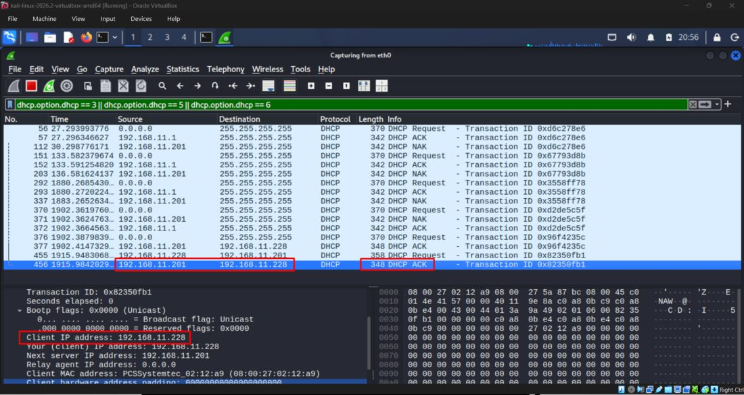
Figure 29 — Wireshark: final DHCP ACK (Transaction ID 0x82350fb1) from 192.168.11.201 to 192.168.11.228, closing the rogue lease.
🚨 RESULT
The experiment demonstrated that a client can accept a lease from an unauthorized DHCP server. The client's choice is not guaranteed to favor the legitimate server; it can depend on timing and client behavior.

08 Wireshark Detection Techniques
Wireshark was used to identify DHCP messages and inspect their contents. The following display filter was used to display DHCP Offer messages:
# Show DHCP Offer messages
dhcp.option.dhcp == 2

# Older protocol field name (alternative)
bootp.option.dhcp == 2

For DHCP Request, ACK, and NAK messages, the following filter was used:
# Show Request / ACK / NAK messages
dhcp.option.dhcp == 3 || dhcp.option.dhcp == 5 || dhcp.option.dhcp == 6

The analyst inspected:
- DHCP message type
- Source IP address
- Client MAC address
- Offered IP address
- Transaction ID
- Option 54 — DHCP Server Identifier

The most important detection indicator was the presence of DHCP responses from an unexpected server address, 192.168.11.201, alongside responses from the legitimate server, 192.168.11.1.
ℹ NOTE
In a production environment, an unexpected DHCP server should be investigated rather than automatically classified as malicious based only on its IP address.

09 Security Impact
A Rogue DHCP Server may provide incorrect network configuration to clients. Potential impacts include:

Incorrect IP Configuration
Clients may receive addresses that conflict with existing assignments or are unsuitable for the intended network.

Malicious Default Gateway
An unauthorized server may advertise itself as the default gateway. If it is configured to forward traffic, traffic destined for external networks may be redirected through it.

Malicious DNS Configuration
An unauthorized DHCP server may advertise an untrusted DNS server, potentially causing clients to receive incorrect DNS responses.

Network Disruption
Incorrect gateway, DNS, or IP configuration may prevent clients from reaching internal resources or external services.

Potential Traffic Interception
If traffic is successfully redirected through an attacker-controlled device, additional weaknesses may permit traffic observation or manipulation. DHCP alone does not decrypt HTTPS or automatically reveal passwords.
⚠ SCOPE OF THIS LAB
In this lab, the changed default gateway was observed, but successful forwarding or interception of client traffic was not verified.

10 Limitations
The lab demonstrated competing DHCP responses and the assignment of a lease from the simulated Rogue DHCP server. However, it did not complete the following tests:
- Successful routing of the client's external traffic through Kali.
- Verification of traffic interception or manipulation.
- Implementation and validation of DHCP Snooping on a compatible switch.
- Full testing of DNS redirection.
⚠ IMPORTANT
These are separate tests and should not be reported as completed.

11 Mitigation
In enterprise networks, a key mitigation is DHCP Snooping, where supported by the network switch. A typical deployment involves:
1. Enabling DHCP Snooping on the relevant VLANs.
2. Marking ports connected to authorized DHCP servers as trusted.
3. Leaving client-facing ports untrusted.
4. Verifying that unauthorized DHCP server responses are blocked.
5. Monitoring DHCP logs and investigating unexpected servers.

Other useful controls include switch port security, network segmentation, DHCP server monitoring, and alerting on unexpected DHCP Server Identifiers.
ℹ NOTE
DHCP Snooping must be configured on compatible network infrastructure; it is not enabled simply by changing a Windows Server or Kali Linux setting.

12 Conclusion
This lab provided practical experience with DHCP behavior, Rogue DHCP simulation, packet capture, and protocol analysis.
The main result was the successful observation of two DHCP servers responding on the same isolated network and the subsequent assignment of a lease from Kali Linux to Windows 10.
Wireshark and DHCP Option 54 were useful for identifying the responding servers and distinguishing legitimate DHCP activity from unexpected responses.
The experiment also demonstrated why DHCP security matters: clients generally rely on network configuration received through DHCP, so unauthorized responses can affect connectivity and potentially create opportunities for further attacks.
➡ NEXT STEP
The next stage is to study and validate network-level protections, particularly DHCP Snooping, in a lab environment that supports the feature.

