Web Mining – Lab 8
Implementation of Decision Trees
By Abhijeet Ambadekar (16BCE1156)

Problem Statement:
To implement a decision tree classifier on categorical data.

Porgram Code:

import numpy as np
import pandas as pd

from pprint import pprint
from math import log

class DecisionTree():
def __init__(self):
self.tree = {}

def calc_entropy(self, target_vals):
entropy = 0.0
tot_size = target_vals.shape[0]
target_value_counts = target_vals.value_counts()
for val in target_vals.unique():
size = target_value_counts[val]
entropy -= log(size/tot_size) * size/tot_size

return entropy

def fit(self, data, target):
self.data = data
self.target = target
outcom_counts = self.data.loc[:, self.target].unique().shape[0]

def generate_subtree_tree(self, data = pd.DataFrame([]), parent=-1, tree = {}, parentval = None):
if data.empty:
data = self.data

entropy = {}
infoGains = {}

if tree.keys():
nodenumber = max(tree.keys()) + 1
else:
nodenumber = 0

for col in data.columns:
# If column is target, the computed entropy is the entropy is the current dataset
if col == self.target:
entropy[col] = self.calc_entropy(data.loc[:, col])
# Else each column has different values having different target values, for which entropies are computed indivisually
# And their weighted sum in computed
else:
tot_size = data.shape[0]
entropy[col] = 0.0
for val in data.loc[:, col].unique():
subset_data = data.loc[(data[col] == val), self.target]
size = subset_data.shape[0]
entropy[col] += self.calc_entropy(subset_data) * size / tot_size

for col in data.columns:
if col == self.target:
continue
infoGains[col] = entropy[self.target] - entropy[col]

# pprint(infoGains)
# Based on the maximum InfoGain the dataset is split on the basis of that column
# And the function is performed on indivisual subsets recursively
maxkey = max(infoGains, key = lambda key: infoGains[key])
# print(maxkey)

if infoGains[maxkey] == 0:
tree[nodenumber] = (parent, data.iloc[0,:][self.target], True, parentval)
return tree

else:
# if parent == -1:
tree[nodenumber] = (parent, maxkey, False, parentval)
# else:
# tree[nodenumber] = (parent, maxkey, False, )

for curr_val in data.loc[:, maxkey].unique():
subset_data = data.loc[(data[maxkey] == curr_val), :]
tree = self.generate_subtree_tree(subset_data, nodenumber, tree, curr_val)

if parent == -1:
self.tree = tree
else:
return tree

def print_tree(self):
pprint(self.tree)
print()

def show_tree(self, pnode = 0, level = 0):
if self.tree[pnode][3] == None:
strdata = str(pnode) + " split at " + str(self.tree[pnode][1])
else:
if not self.tree[pnode][2]:
strdata = str(pnode) + " parent value = " + str(self.tree[pnode][3]) + " split at " + str(self.tree[pnode][1])
else:
strdata = str(pnode) + " parent value = " + str(self.tree[pnode][3]) + " results at target: " + str(self.tree[pnode][1])
print(" " * 2 * level, '-' * (level), strdata, sep='')
for node in [k for k in self.tree if self.tree[k][0] == pnode]:
self.show_tree(node, level+1)

# datamat = [
# ["val1", "val3", "val5", "no"],
# ["val1", "val4", "val5", "yes"],
# ["val2", "val3", "val5", "yes"],
# ["val2", "val4", "val6", "no"],
# ]
# datacols = ["param1", "param2", "param3", "target"]

# data = pd.DataFrame(datamat)
# data.columns = datacols

data = pd.read_csv("data.csv")
target = data.columns[-1]

dcc = DecisionTree()
dcc.fit(data, target)
dcc.generate_subtree_tree()
dcc.print_tree()
dcc.show_tree()
Data.csv used:
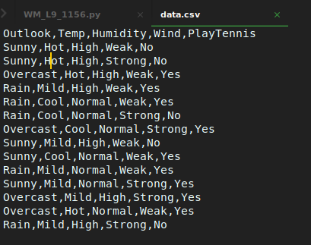

Outlook:
