Web Mining – CSE 3024
Sessionization using Python
By Abhijeet Ambadekar (16BCE1156)

Q1. Following is a set of web usage logs from an organization. Assume the following rules.
- The time heuristic h1 for a session duration = 30 minutes.
- The time heuristic h2 for the average duration for the user visit of a page = 1 minute.
- Include a page in a session if the page that refers is in that session.
- During a session, the IP address, browser and OS is the same.
You need to printout a table containing session number, IP address, session start time and
session end time.

Q2. Use the same program to find do sessionization of a log file that is downloaded from web
that is uploaded into moodle today and give it in same format as Q1.
Program Code:
import pandas as pd
import datetime

pd.set_option('display.max_columns', None)

class Sessionizer():
def __init__(self, h1, h2):
self.h1 = h1
self.h2 = h2
self.session_table = pd.DataFrame(columns = ["session_no", 'session_ip', 'session_start_time', 'session_end_time'])
self.session_table.set_index("session_no")

def load(self, data, datecol=None):
if datecol:
self.datecol = datecol
self.data = data

def parse(self, datecol=None, datetime_format=None):
# if not (datecol and datetime_format):
# datecol = self.datecol
self.data[datecol] = [datetime.datetime.strptime(dt, datetime_format) for dt in self.data[datecol]]

def sessionize(self):
data_ip = self.data.groupby('ip')
sno = 1
for ip in data_ip.groups.keys():
data_ip_time = data_ip.get_group(ip).groupby(['ip', pd.Grouper(key=self.datecol, freq= str(self.h1)+"Min")])
for key in data_ip_time.groups.keys():
try:
values = data_ip_time.get_group(key)
time_min = values[self.datecol].min()
time_max = values[self.datecol].max()
temp = {'session_no':sno, 'session_ip':key[0], "session_start_time":time_min, "session_end_time":time_max}
self.session_table = self.session_table.append(pd.DataFrame(temp.copy(), index=[0]), ignore_index = True, sort=False)
sno += 1
except KeyError as e:
print(e)

def print_details(self):
print("The session table is made as follows: ")
print(self.session_table)

data = pd.read_csv("data.csv")
datecol = "timestamp"
datetime_format = "%d/%b/%Y:%H:%M:%S"

ss = Sessionizer(30, 1)
ss.load(data, datecol)
ss.parse(datecol, datetime_format)
ss.sessionize()
ss.print_details()
Output:
Q1.
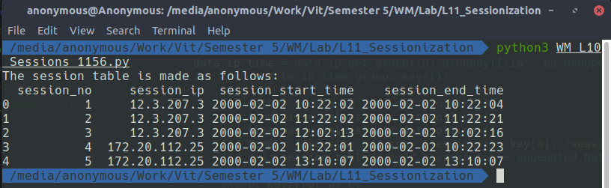

Q2.
<<Insert output after receiving the moodle log file >>

