Web Mining(CSE3024) – Lab 10
Naive Bayes Clustering
By Abhijeet Ambadekar (16BCE1156)

Problem Statement:
Part A-
Build a Naïve Bayes Classifier using this data.
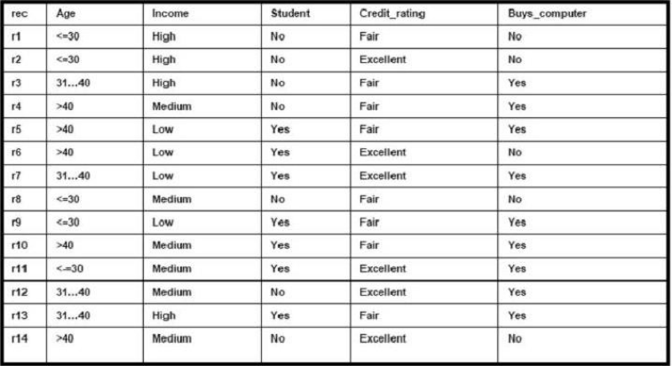
Predict whether the following user will buy a computer?
X= ( age <=30, income = medium, student = yes, credit_rating = fair)

Part B -
The following gives a Term frequency of some of the documents for the given keywords and the last column gives the category of the document
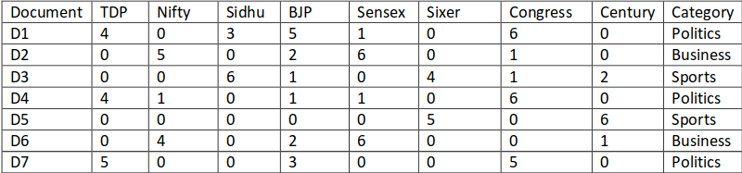
Predict which Category the following document will fall into
Program Code:

import pandas as pd
# import math
from operator import itemgetter
from pprint import pprint

def preprocess_data(data, return_thresholds=False):
columns = data.columns
thresholds = []
for column in columns[:-1]:
min_val = 0
max_val = data.loc[:, column].max()
threshold = (max_val + min_val)/2
thresholds.append(threshold)
data.loc[(data[column] <= threshold), column] = 0
data.loc[(data[column] > threshold), column] = 1
thresholds = pd.DataFrame({'column': columns[:-1], 'threshold': thresholds}).set_index(keys = ['column'])
# print(thresholds.head(len(columns[:-1])))
# print('\n')
if return_thresholds:
return data, thresholds
else:
return data

class NBClassifier():
def __init__(self):
pass

def load_data(self, train_data, target=None):
self.train_data = train_data
if target:
self.target = self.train_data.columns[-1]
else:
self.target = target

self.outcomes = self.train_data[self.target].unique()

self.outcomeProb = {}
total_count = self.train_data.shape[0]
for outcome in self.outcomes:
count = self.train_data.loc[(self.train_data[self.target] == outcome)].shape[0]
self.outcomeProb[outcome] = count/total_count

self.probTable = pd.DataFrame(columns = ['key'].append(self.outcomes))
for column in train_data.columns[:-1]:
for entry in train_data[column].unique():
temp = {}
temp['key'] = column + '_' + str(entry)
for outcome in self.outcomes:
temp[outcome] = self.calcProb(column, entry, outcome)
self.probTable = self.probTable.append(pd.DataFrame(temp.copy(), index = [0]), ignore_index = True)
self.probTable = self.probTable.set_index('key')

print("\nThe probabilites for each entry for each column is calculated as follows: ")
pprint(self.probTable)

def calcProb(self, column, entry, outcome):
tot_count = self.train_data.loc[self.train_data[self.target] == outcome].shape[0]
count = self.train_data.loc[(self.train_data[column] == entry) & (self.train_data[self.target] == outcome)].shape[0]
return count/tot_count

def predict(self, test_data):
labels = []
for _, test_instance in test_data.iterrows():
results = {}
for outcome in self.outcomes:
results[outcome] = 1
for key in test_instance.keys():
results[outcome] *= self.probTable.loc[key + '_' + str(test_instance.loc[key]), outcome]
results[outcome] *= self.outcomeProb[outcome]
labels.append(max(results.items(), key=itemgetter(1))[0])
return list(enumerate(labels))

print("Lab Question Part - A --------------------------------------------------\n")

train_data = pd.read_csv("train_A.csv")
print("\nThe training data looks like :")
pprint(train_data)

target = "Buys_computer"

test_data = pd.read_csv("test_A.csv")
print("\nThe testing data looks like :")
pprint(test_data)

nbc = NBClassifier()
nbc.load_data(train_data, target)
print("\nThe output for the test instances are: \n")
for outcome in nbc.predict(test_data):
print(outcome[0], ": ", outcome[1])

print("\nLab Question Part - B --------------------------------------------------\n")

train_data = pd.read_csv("train_B.csv")
train_data, threasholds = preprocess_data(train_data, return_thresholds=True)
print("\nThe training data after preprocessing looks like :")
pprint(train_data)

target = "Category"

test_data = pd.read_csv("test_B.csv")
test_data = preprocess_data(test_data)
print("\nThe testing data after preprocessing looks like :")
pprint(test_data)

nbc2 = NBClassifier()
nbc2.load_data(train_data, target)
print("\nThe output for the test instances are: \n")
for outcome in nbc2.predict(test_data):
print(outcome[0], ": ", outcome[1])

Output:
Part A -
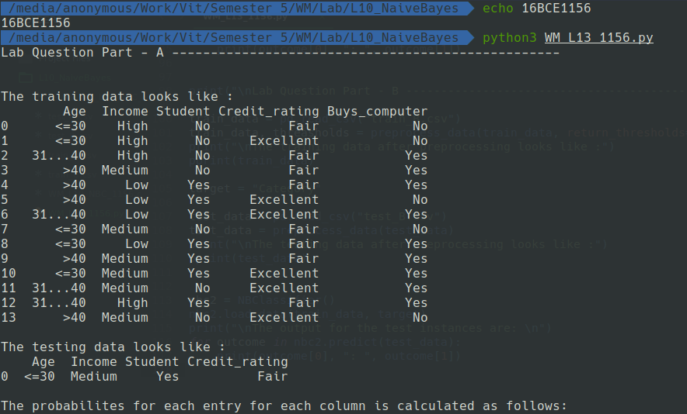
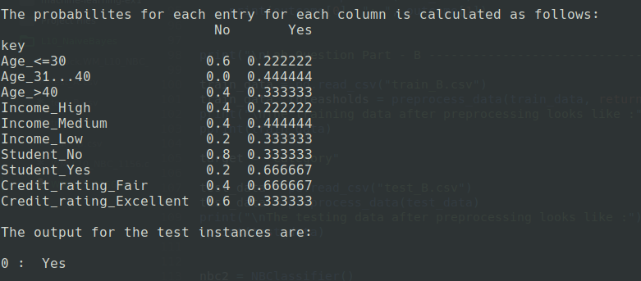

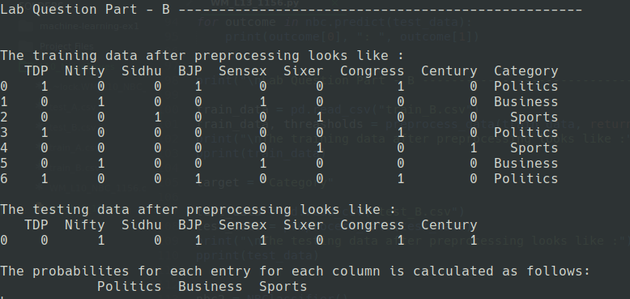
Part B -
