Web Mining – Lab 1

Understanding Requests and Re Modules
By Abhijeet Ambadekar (16BCE1156)

The aim of this experiment is to have a general overlook on the python requests module and create a
program that find out the urls of all the webpages and images that can be accessed from a given
input url.

Program Code:
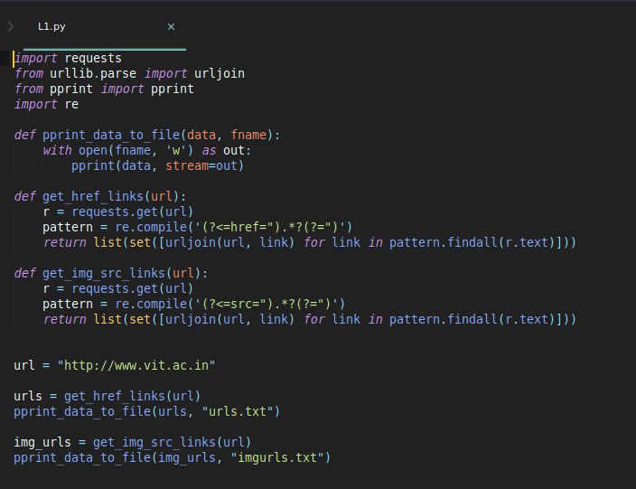

Output (urls.txt):
['http://www.vit.ac.in/files/admissions/viteee/VITEEE2018_Physics.pdf',
'http://vtop2.vit.ac.in:8080/VITEEE/',
'http://www.vit.ac.in/iprcell',
'http://www.vit.ac.in/',
'http://www.vit.ac.in/campus/ncc',
'http://www.vit.ac.in/about/infrastructure',
'http://www.vit.ac.in/files/VITEEE2017STATUS/Phase2-Day5_19-May-2017.pdf',
'http://www.vit.ac.in/files/B_Tech_Part-Time-Notification-2017.jpg',
'http://www.vit.ac.in#counselling1',
'http://intranet.vit.ac.in/',
'http://www.vit.ac.in/admissions/research',
'http://www.vit.ac.in/academics/centers',
'http://www.vit.ac.in/css/hover-min.css',
'http://intranet.vit.ac.in',
'http://www.vit.ac.in/research/sponsoredResearch',
'http://vtop3.vit.ac.in:8080/VITEEERESULTS/',
'http://www.vit.ac.in/academics/itp',
'http://vitbhopal.ac.in/',
'http://www.vit.ac.in/about/community',
'http://admission.vit.ac.in/Results/2017/ARC_Results2017/index.asp',
'http://vtop7.vit.ac.in:8080/paymentfreshers/',
'https://webmail.vit.ac.in',
'http://info.vit.ac.in/phddec2017/index.asp',
'http://www.vit.ac.in/{{ breadcrumb.path }}',
'http://vit.ac.in/files/viteee2017/Hotels_VLR.pdf',
'http://www.vit.ac.in/files/admissions/PhysicalFitness_Certificate.pdf',
'http://www.vitaa.org/',
'http://www.vit.ac.in/files/admissions/viteee/VITEEE2018_Mathematics.pdf',
'http://www.vit.ac.in/redressal',
'http://vtop2.vit.ac.in:8080/UGFOREIGN/',
'https://vtop9.vit.ac.in/vtop/login/freshers',
'http://www.mhrdnats.gov.in/',
'http://www.vit.ac.in/campus/startups',
'http://www.vit.ac.in/campus/hostels',
'http://www.vit.ac.in/placement/consortium',
'http://careers.vit.ac.in/',
'http://www.vit.ac.in/about/leadership',
'http://www.vit.ac.in/icc',
'http://www.vit.ac.in/placement/dreamoffers',
'https://peopleorbit.vit.ac.in/',
'http://www.vit.ac.in/events/eventView/Two Day Workshop on Raspberry Pi '
'Programming for Beginners 2018',
'http://www.vit.ac.in/files/SBST_Freshers_App.rar',
'http://vtop2.vit.ac.in:8080/UGNRI/',
'http://www.vit.ac.in/files/FormatGuidelines.doc',
'http://www.vit.ac.in/campus/fests',
'http://www.vit.ac.in/events',
'http://www.vit.ac.in/files/admissions/Affidavit_Student.pdf',
'http://www.vit.ac.in/research/academic',
'http://www.vit.ac.in/about/mhrd',
'http://www.vit.ac.in/ap/careers',
'http://www.vit.ac.in/campus/sports',
'http://www.vit.ac.in/btechadmissions/viteee2018',
'http://www.vit.ac.in/placement',
'http://www.vit.ac.in/images/favicon.ico',
'http://www.vit.ac.in/files/admissions/viteee/VITEEE2018_Chemistry.pdf',
'http://www.vit.ac.in/about/raac',
'http://www.vit.ac.in/campus/studentchapters/creationLabs',
'http://www.vit.ac.in/files/ug-2018/index.html',
'http://www.vit.ac.in/campus',
'http://www.vit.ac.in/files/hostels/HostelAdmission_InformationSheet.pdf',
'http://academics2.vit.ac.in/onlinewithdraw/',
'http://www.vit.ac.in/academics/internationalRelations',
'https://webmail.vit.ac.in/',
'https://mail.google.com/',
'http://www.vit.ac.in/events/eventView/One Day Workshop on Modelling and '
'simulation of electric motors using ANSYS - MAXWELL for beginners',
'http://www.vit.ac.in/files/wifiservices.pdf',
'http://www.vit.ac.in/academics/ffcs',
'http://www.vit.ac.in/admissions',
'https://plus.google.com/107959047122513483934',
'http://www.vit.ac.in/events/eventView/VIT Summer School ',
'http://www.vit.ac.in/files/admissions/viteee/VITEEE2018_English.pdf',
'http://www.vit.ac.in/css/materialize.min.css',
'http://www.vit.ac.in#counselling',
'http://www.vit.ac.in/files/admissions/Hostel_Affidavit_Ladies_2018.pdf',
'http://www.vit.ac.in/about',
'http://www.vit.ac.in/admissions/pg',
'http://www.vit.ac.in/academics/certificates',
'http://www.vit.ac.in/academics/schools',
'http://www.vit.ac.in/about/administrativeOffices',
'https://vtopbeta.vit.ac.in/studentprofile/',
'http://info.vit.ac.in/guesthouse',
'http://www.vit.ac.in/ap',
'http://www.vit.ac.in/files/admissions/viteee/VITEEE2018_Biology.pdf',
'http://www.vit.ac.in/css/style.css',
'http://www.vit.ac.in/placement/pat',
'http://www.vit.ac.in/admissions/eligibility',
'http://www.vit.ac.in/campus/otheramenities',
'https://fonts.googleapis.com/icon?family=Material+Icons',
'http://www.vit.ac.in',
'http://www.vit.ac.in/admissions/international',
'http://www.vit.ac.in/admissions/testcities',
'http://www.vit.ac.in/campus/studentchapters',
'http://www.vit.ac.in/academics',
'http://www.vit.ac.in/contactus',
'http://www.vit.ac.in/ '
'http:/www.vit.ac.in/files/admissions/Affidavit_Parent.pdf',
'http://www.vit.ac.in/files/admissions/Hostel_Affidavit_Mens_2018.pdf',
'http://chennai.vit.ac.in/',
'http://www.vit.ac.in/files/VITEEE2017STATUS/Phase2-Day1_15-May-2017.pdf',
'http://www.vit.ac.in/campus/studentclubs',
'http://www.vit.ac.in/admissions/postoffices',
'http://www.vit.ac.in/academics/transcripts',
'http://www.vittbi.com/tedp_food.pdf',
'http://vit-otbs-lb.centralindia.cloudapp.azure.com/vitotbs/',
'http://www.vit.ac.in/research',
'http://www.vit.ac.in/placement/advancedTraining',
'https://academics.vit.ac.in/faculty/fac_login.asp',
'http://www.vit.ac.in/css/angular-csp.css',
'http://gmail.vit.ac.in',
'http://www.vit.ac.in/about/news',
'http://www.vit.ac.in/academics/iqac',
'http://www.vit.ac.in/vitunplugged',
'http://www.vit.ac.in/btechadmissions/viteee2017',
'http://www.vit.ac.in/about/sustainability',
'http://www.vit.ac.in/admissions/ug',
'http://careers.vit.ac.in/careers/',
'http://www.vit.ac.in/campus/sae',
'http://www.vit.ac.in/css/home.css',
'http://www.vit.ac.in/research/centers',
'http://www.vit.ac.in/admissions/procedure',
'https://vtopbeta.vit.ac.in/vtop/',
'http://www.vit.ac.in/academics/library',
'http://www.vit.ac.in/admissions/feeStructure',
'http://www.vit.ac.in/academics/coe',
'http://www.vit.ac.in/PGAdmissions2018',
'http://www.vit.ac.in/campus/healthservices',
'http://info.vit.ac.in/map/']
Output (imgurls.txt)
['http://www.vit.ac.in/js/angular.js',
'http://www.vit.ac.in/js/angular-sanitize.js',
'http://www.vit.ac.in/js/google-map-api.js',
'http://www.googletagmanager.com/ns.html?id=GTM-WMCMXM',
'http://www.vit.ac.in/js/jquery-2.1.3.min.js',
'http://www.vit.ac.in/js/script.js',
'http://www.vit.ac.in/undefined',
'http://www.vit.ac.in/js/angular-route.js',
'http://www.vit.ac.in/js/one-angular.js',
'http://www.vit.ac.in/images/logo.png',
'http://www.vit.ac.in/js/ocLazyLoad.min.js',
'http://www.vit.ac.in/js/ngMap.min.js',
'http://www.vit.ac.in/js/init.js',
'http://www.vit.ac.in/images/ripple.svg',
'http://www.vit.ac.in/js/route-styles.js',
'http://www.vit.ac.in/images/logo1.png',
'http://www.vit.ac.in/js/materialize.js',
'http://code.tidio.co/iuj4oxikuxxrmxjhavcs6yd6us8ijebu.js',
'http://platform-api.sharethis.com/js/sharethis.js#property=5ae3047f6a9348001198603e&product=sticky-share-buttons']

