Web Mining – Lab 2

Generating a Mini-Crawler
By Abhijeet Ambadekar (16BCE1156)

The aim of this experiment is to use the python requests and BeautifulSoup modules to create a
mini crawler that can crawl over a given seed url to generate a page table containg the list of all the
urls that can be accessed from the seed url and recursively to those urls and similarly a reverse page
table to backtrack this data.

Program Code:

import requests
from bs4 import BeautifulSoup
from pprint import pprint

try:
# Python 3
from urllib.parse import urlparse, urljoin
except ImportError:
from urlparse import urljoin, urlparse

def pprint_data_to_file(data, fname):
with open(fname, 'w') as out:
pprint(data, stream=out)

class Crawler(object):
def __init__(self):
self.pagetable = {}

def get_seed(self):
self.seed_url = input("Enter the seed URL: ").strip()
# self.seed_url = "http://www.vit.ac.in"
self.hostname = urlparse(self.seed_url).hostname
self.frontier = [self.seed_url]
self.rev_pagetable = {}

def seed_test(self, url):
return True if self.hostname in url else False

def get_all_urls(self, url):
try:
page = requests.get(url)
except Exception as e:
try:
print("Failed to reached {}".format(url))
except UnicodeEncodeError:
print("Failed to reached and cant show the URL")
return None

soup = BeautifulSoup(page.text, 'html.parser')

urls = []
for link in soup.find_all('a', href=True):
if link.get('href') in [None, "#", ""]:
continue
urls.append(urljoin(self.seed_url, link.get('href')))

return list(set(urls))

def crawl(self):
for curr_url in self.frontier:

urls = self.get_all_urls(curr_url)
if not urls:
continue

oldFronLen = len(self.frontier)

for url in urls:
if curr_url in self.pagetable:
self.pagetable[curr_url].append(url)
else:
self.pagetable[curr_url] = [url]

if url not in self.frontier and self.seed_test(url):
self.frontier.append(url)

if len(self.frontier) > oldFronLen:
try:
print("Added {} links in the frontier for the link: {}".format(len(self.frontier)-oldFronLen, curr_url))
except UnicodeEncodeError:
print("Added {} links in the frontier for the link: NOT ABLE TO PRINT".format(len(self.frontier)-oldFronLen))

def rev_table_gen(self):
for url in self.pagetable:
for target in self.pagetable[url]:
if target in self.rev_pagetable:
if url in self.rev_pagetable[target]:
continue
else:
self.rev_pagetable[target].append(url)
else:
self.rev_pagetable[target] = [url]

vitc = Crawler()
vitc.get_seed()
vitc.crawl()

pprint_data_to_file(vitc.pagetable, "pagetable.txt")
pprint_data_to_file(vitc.rev_pagetable, "rev_pagetable.txt")
pprint_data_to_file(vitc.frontier, "frontier.txt")

Output:
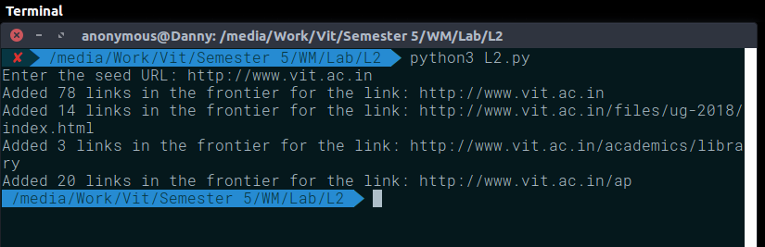
Output (pagetable.txt) (A file of 10000 lines, hence discrete output):
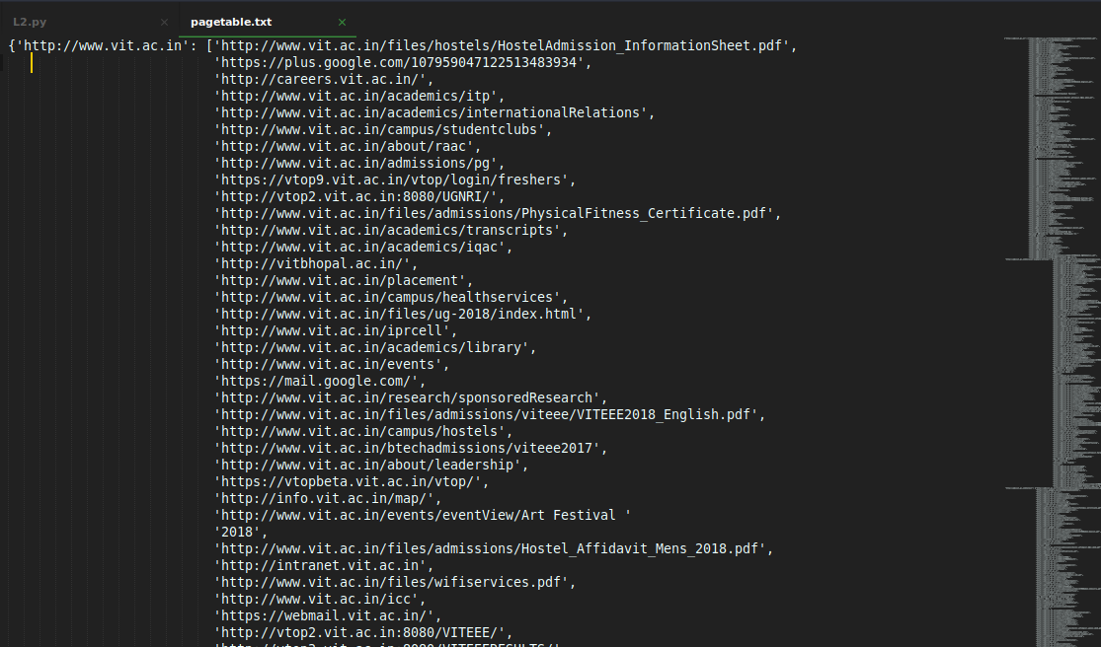
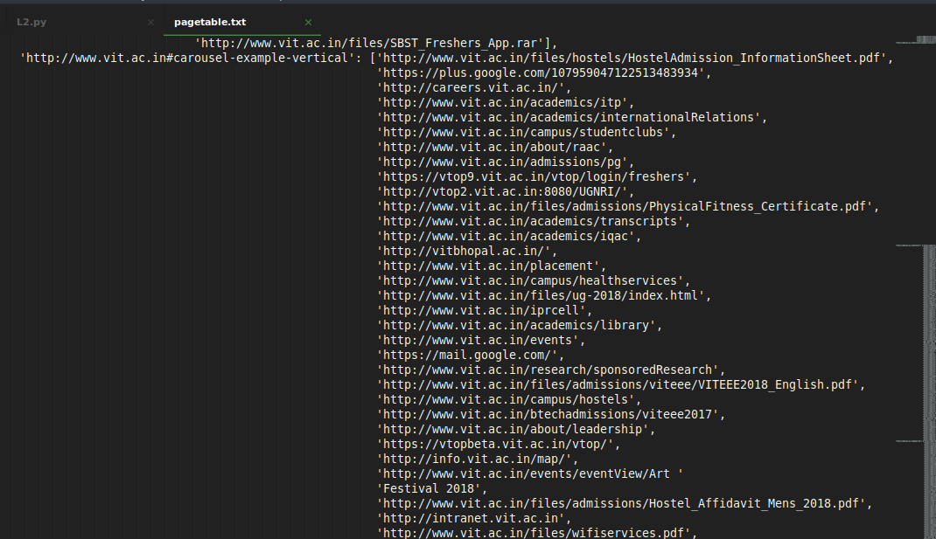
Output (rev_pagetable.txt):
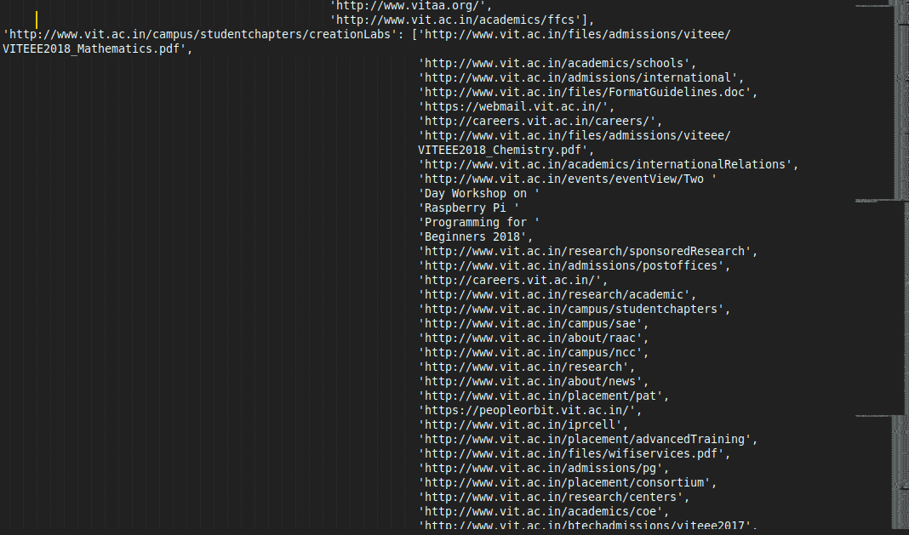
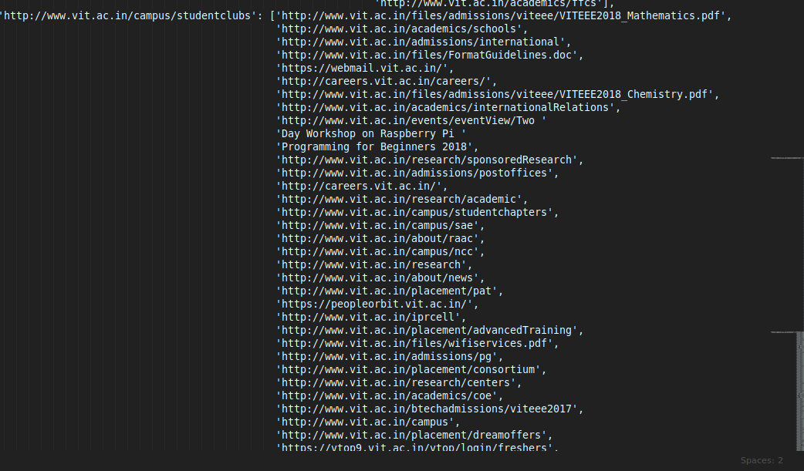
Output (frontier.txt):
['http://www.vit.ac.in',
'http://www.vit.ac.in/files/admissions/viteee/VITEEE2018_Mathematics.pdf',
'http://www.vit.ac.in/academics/schools',
'http://www.vit.ac.in/admissions/international',
'http://www.vit.ac.in/files/FormatGuidelines.doc',
'http://www.vit.ac.in/files/admissions/viteee/VITEEE2018_Chemistry.pdf',
'http://www.vit.ac.in/academics/internationalRelations',
'http://www.vit.ac.in/events/eventView/Two Day Workshop on Raspberry Pi '
'Programming for Beginners 2018',
'http://www.vit.ac.in/research/sponsoredResearch',
'http://www.vit.ac.in/admissions/postoffices',
'http://www.vit.ac.in/research/academic',
'http://www.vit.ac.in/campus/studentchapters',
'http://www.vit.ac.in/campus/sae',
'http://www.vit.ac.in/about/raac',
'http://www.vit.ac.in/campus/ncc',
'http://www.vit.ac.in/research',
'http://www.vit.ac.in/about/news',
'http://www.vit.ac.in/placement/pat',
'http://www.vit.ac.in/iprcell',
'http://www.vit.ac.in/placement/advancedTraining',
'http://www.vit.ac.in/files/wifiservices.pdf',
'http://www.vit.ac.in/admissions/pg',
'http://www.vit.ac.in/placement/consortium',
'http://www.vit.ac.in/research/centers',
'http://www.vit.ac.in/academics/coe',
'http://www.vit.ac.in/btechadmissions/viteee2017',
'http://www.vit.ac.in/campus',
'http://www.vit.ac.in/placement/dreamoffers',
'http://www.vit.ac.in/academics/centers',
'http://www.vit.ac.in/academics/iqac',
'http://www.vit.ac.in/about/mhrd',
'http://www.vit.ac.in/contactus',
'http://www.vit.ac.in/events/eventView/One Day Workshop on Modelling and '
'simulation of electric motors using ANSYS - MAXWELL for beginners',
'http://www.vit.ac.in/academics',
'http://www.vit.ac.in/campus/studentclubs',
'http://www.vit.ac.in/academics/certificates',
'http://www.vit.ac.in/ap',
'http://www.vit.ac.in/events',
'http://www.vit.ac.in/admissions/ug',
'http://www.vit.ac.in/admissions',
'http://www.vit.ac.in/campus/startups',
'http://www.vit.ac.in/ '
'http:/www.vit.ac.in/files/admissions/Affidavit_Parent.pdf',
'http://www.vit.ac.in/files/admissions/viteee/VITEEE2018_English.pdf',
'http://www.vit.ac.in/files/SBST_Freshers_App.rar',
'http://www.vit.ac.in/icc',
'http://www.vit.ac.in/academics/itp',
'http://www.vit.ac.in/about/community',
'http://www.vit.ac.in/campus/hostels',
'http://www.vit.ac.in/files/PGAdmissions2018/index.html',
'http://www.vit.ac.in/redressal',
'http://www.vit.ac.in/academics/library',
'http://www.vit.ac.in/files/admissions/viteee/VITEEE2018_Biology.pdf',
'http://www.vit.ac.in/events/eventView/VIT Summer School ',
'http://www.vit.ac.in/files/ug-2018/index.html',
'http://www.vit.ac.in/',
'http://www.vit.ac.in/about/administrativeOffices',
'http://www.vit.ac.in/campus/studentchapters/creationLabs',
'http://www.vit.ac.in/files/hostels/HostelAdmission_InformationSheet.pdf',
'http://www.vit.ac.in/about',
'http://www.vit.ac.in/admissions/research',
'http://www.vit.ac.in/campus/fests',
'http://www.vit.ac.in/files/admissions/PhysicalFitness_Certificate.pdf',
'http://www.vit.ac.in/placement',
'http://www.vit.ac.in/files/admissions/viteee/VITEEE2018_Physics.pdf',
'http://www.vit.ac.in/vitunplugged',
'http://www.vit.ac.in/files/admissions/Hostel_Affidavit_Ladies_2018.pdf',
'http://www.vit.ac.in/campus/otheramenities',
'http://www.vit.ac.in/about/sustainability',
'http://www.vit.ac.in/about/infrastructure',
'http://www.vit.ac.in/files/admissions/Hostel_Affidavit_Mens_2018.pdf',
'http://www.vit.ac.in/about/leadership',
'http://www.vit.ac.in/ap/careers',
'http://www.vit.ac.in/files/admissions/Affidavit_Student.pdf',
'http://www.vit.ac.in/academics/transcripts',
'http://www.vit.ac.in/campus/healthservices',
'http://www.vit.ac.in/campus/sports',
'http://www.vit.ac.in/admissions/testcities',
'http://www.vit.ac.in/academics/ffcs',
'http://www.vit.ac.in/in-focuslist',
'http://www.vit.ac.in/campus-life/sports/',
'http://www.vit.ac.in/eventslist?status=publish',
'http://www.vit.ac.in/programmes-offered',
'http://www.vit.ac.in/facilitieslist/',
'http://www.vit.ac.in/visual-media/',
'http://www.vit.ac.in/campus-life/clubs-chapters/',
'http://www.vit.ac.in/announcementlist',
'http://www.vit.ac.in#carousel-example-vertical',
'http://www.vit.ac.in/vit-ap-advantage/#vitutp',
'http://www.vit.ac.in/vit-ap-advantage/#vitco-op',
'http://www.vit.ac.in/vit-ap-advantage/#vitsp',
'http://www.vit.ac.in/facilitieslist',
'http://www.vit.ac.in/vit-ap-advantage/#vitqf',
'http://www.vit.ac.in/international-collaborations/',
'http://www.vit.ac.in/leadership/',
'http://www.vit.ac.in/vit-ap-advantage/#vitms',
'http://www.vit.ac.in/academics/engineering-clinics/',
'http://www.vit.ac.in/eventslist?status=future',
'http://www.vit.ac.in/newslist',
'http://www.vit.ac.in/womencell',
'http://www.vit.ac.in/files/FormatGuidelines.pdf',
'http://www.vit.ac.in/about/career',
'http://www.vit.ac.in#portfolio-modal-5',
'http://www.vit.ac.in#portfolio-modal-2',
'http://www.vit.ac.in#contact',
'http://www.vit.ac.in#portfolio-modal-4',
'http://www.vit.ac.in/files/vsparc/B.Arch_Information_Brochure-2018.pdf',
'http://www.vit.ac.in/files/llb/Law_Info_2018.pdf',
'http://www.vit.ac.in/files/VFIT_Information_Brochure_2018.pdf',
'http://www.vit.ac.in/agri_flyer.pdf',
'http://www.vit.ac.in#portfolio-modal-6',
'http://www.vit.ac.in#portfolio-modal-3',
'http://www.vit.ac.in#page-top',
'http://www.vit.ac.in#portfolio-modal-1',
'http://www.vit.ac.in/files/bdes_information.pdf',
'http://www.vit.ac.in/files/ug-2018/UG-2018_brochure.pdf']

