Web Mining Lab – 3

Indexing data from files and web pages
By Abhijeet Ambadekar (16BCE1156)

The aim of this experiment is to create a program that indexes all the words from multiple sources
(can be a local file or a wepage url) into an index table that maintains the frequency of the words
along with th offset at which the words are present in each source.

Program Code:

import requests
from bs4 import BeautifulSoup

import string
import re
from pprint import pprint

try:
# Python 3
from urllib.parse import urlparse
except ImportError:
from urlparse import urlparse

def pprint_data_to_file(data, fname):
with open(fname, 'w') as out:
pprint(data, stream=out)

class Indexer():
def __init__(self):
self.index_list = {}
self.data_dict = {}

def get_words(self, text):
text = re.sub(r'[^\w\s]','',text)
return re.split(r'\s*', text)

def get_data_from_file(self, fname):
try:
with open(fname) as file:
self.data_dict[fname] = self.get_words(file.read().lower())
except IOError:
print("File does not exist!")

def get_data_from_url(self, url):
try:
page = requests.get(url)
except Exception as e:
try:
print("Failed to reached {}".format(url))
except UnicodeEncodeError:
print("Failed to reached and cant show the URL")
return None

soup = BeautifulSoup(page.text, 'html.parser')
self.data_dict[url] = self.get_words(soup.text.lower())

def add_word_to_index(self, off, fname, word):
if word not in self.index_list:
self.index_list[word] = [1, [(fname, off)]]
else:
self.index_list[word][0] += 1
self.index_list[word][1].append((fname, off))

def index_data(self):
for fname in self.data_dict.keys():
print("Indexing {} words from the source: {}".format(len(self.data_dict[fname]), fname))
for i in range(len(self.data_dict[fname])):
self.add_word_to_index(i, fname, self.data_dict[fname][i])

def get_data(self, srcfname):
try:
with open(srcfname, 'r') as infile:
srcs = re.split(r',', infile.read())
except IOError:
print("Source file not found.")

for src in srcs:
if urlparse(src).scheme == 'http':
self.get_data_from_url(src)
else:
self.get_data_from_file(src)

viti = Indexer()
viti.get_data("srcfile.txt")
viti.index_data()

pprint_data_to_file(viti.index_list, 'index.idx')

Sourcefiles used:
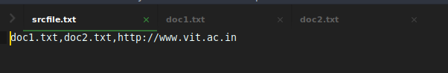
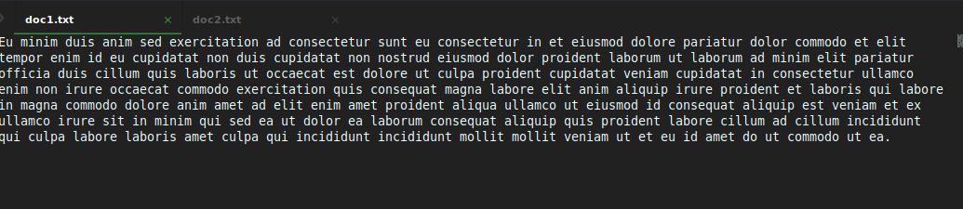
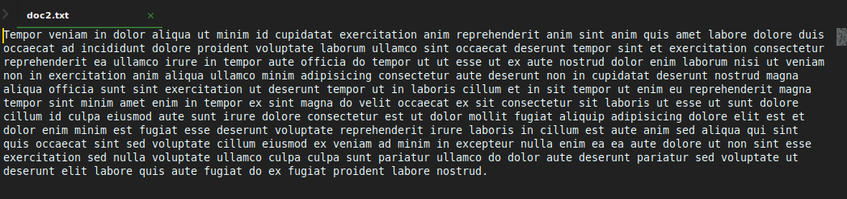
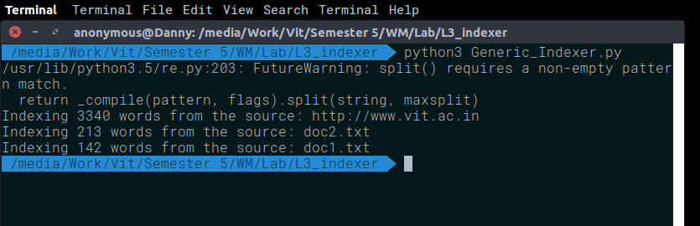
Output:

Output (index.idx):
//Since the file has an output of 4000 lines, noly screenshots of some of the output is shown.
