Web Mining – CSE3024

Page Ranking Algorithm – Simple and Weighted
By Abhijeet Ambadekar (16BCE1156)

Aim:
To find the ranks of the pages using the page ranking algorithm and the weighted page ranking algorithm.
Program Code:

from pprint import pprint

class PageRanker(object):
def __init__(self, dampening=0.85, num_iter=100):
self.dampening = dampening
self.num_iter = num_iter

def fit(self, idx):
self.idx = idx
self.idxmat = [self.idx[k] for k in sorted(self.idx.keys())]
self.idxmap = {i:sorted(self.idx.keys())[i] for i in range(len(self.idx.keys()))}
self.inlinks = self.gen_inlinks()
self.outlinks = self.gen_outlinks()
self.pageranks = {k:1 for k in self.idx.keys()}

def gen_inlinks(self):
inlinks = {}
for index, k in enumerate(sorted(self.idx.keys())):
inlinks[k] = sum([self.idxmat[i][index] for i in range(len(self.idxmat))])

return inlinks

def gen_outlinks(self):
outlinks = {}
for k in self.idx.keys():
outlinks[k] = sum(self.idx[k])

return outlinks

def calculatePR(self):
for i in range(self.num_iter):
new_page_ranks = {}
for id1, curr_page in enumerate(sorted(self.idx.keys())):
# for pg in self.inlinks.keys():
new_page_ranks[curr_page] = 1 - self.dampening
sum_of_inlinks = 0
for id2, page in enumerate(sorted(self.idx.keys())):
# for page in range(len(self.idxmat)):
# print(page)
if self.idxmat[id2][id1]:
sum_of_inlinks += self.pageranks[page]/self.outlinks[page]
new_page_ranks[curr_page] += self.dampening * sum_of_inlinks

self.pageranks = new_page_ranks.copy()

def print_details(self):
print("The inlinks of the graph are:")
pprint(self.inlinks)

print("The outlinks of the graph are:")
pprint(self.outlinks)

print("The page ranks of the page after {} iterations are: ".format(self.num_iter))
pprint(self.pageranks)

print("Sum of page ranks", sum(self.pageranks.values()))

if __name__ == "__main__":
dummy_index = {
"A" : [0, 1, 1, 1, 0],
"B" : [1, 0, 1, 1, 0],
"C" : [0, 0, 0, 1, 0],
"D" : [0, 0, 1, 0, 1],
"E" : [0, 1, 1, 1, 0],
}

pr = PageRanker(0.85, 1000)
pr.fit(dummy_index)
pr.calculatePR()
pr.print_details()

Output:
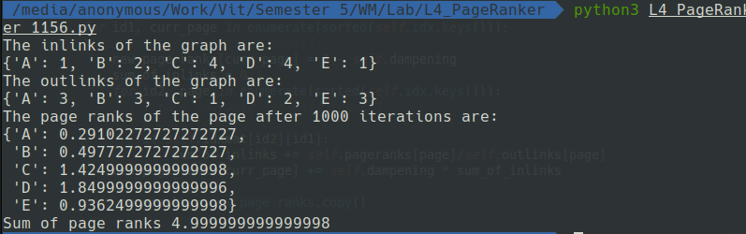
Program Code: Weighted Page Ranker
from pprint import pprint
from L4_PageRanker_1156 import PageRanker

class WeightedPageRanker(PageRanker):

def fit(self, idx):
super(WeightedPageRanker, self).fit(idx)
self.revidxmap = {self.idxmap[k]:k for k in sorted(self.idxmap.keys())}

def get_win(self, a, b):
win_sum = 0
id1 = self.revidxmap[a]
for id2, k in enumerate(sorted(self.idx.keys())):
if self.idxmat[id2][id1]:
win_sum += self.inlinks[k]
return self.inlinks[k] / win_sum

def get_wout(self, a, b):
win_sum = 0
id1 = self.revidxmap[a]
for id2, k in enumerate(sorted(self.idx.keys())):
if self.idxmat[id2][id1]:
win_sum += self.outlinks[k]
return self.outlinks[k] / win_sum

def calculateWeightedPR(self):
for i in range(self.num_iter):
new_page_ranks = {}
for id1, curr_page in enumerate(sorted(self.idx.keys())):
new_page_ranks[curr_page] = 1 - self.dampening
sum_of_inlinks = 0
for id2, page in enumerate(sorted(self.idx.keys())):
if self.idxmat[id2][id1]:
sum_of_inlinks += self.pageranks[page] * self.get_win(curr_page, page) * self.get_wout(curr_page, page)
new_page_ranks[curr_page] += self.dampening * sum_of_inlinks

self.pageranks = new_page_ranks.copy()

if __name__ == "__main__":
dummy_index = {
"A" : [0, 1, 1, 1, 0],
"B" : [1, 0, 1, 1, 0],
"C" : [0, 0, 0, 1, 0],
"D" : [0, 0, 1, 0, 1],
"E" : [0, 1, 1, 1, 0],
}

pr = WeightedPageRanker(0.85, 1000)
pr.fit(dummy_index)
pr.calculateWeightedPR()
pr.print_details()
Output:
