Web Mining – Lab 6
Clustering of Web documents using KMeans
By Abhijeet Ambadekar (16BCE1156)

Problem statement:

Part A -

You are given 9 one-line documents here. Consider the following keywords to represent the documents in the vector space model:

[1] Automotive [2] Car [3] motorcycles [4] self-drive [5] IoT [6] hire [7] Dhoni
Represent the documents in vector space Model using these keywords and use it as input to cluster the
documents using Manhattan distance as parameter. Ignore case differences.
You also need to do K- means clustering with K=4.

Part B -
Use the same program which you have developed for part A to do “ K-means clustering” of the following web documents with K=4. Use the keywords
[1] Tesla [2] Electric [3] Car/Vehicle/Automobile [4] pollution [5] de-monetisation [6] GST [7] black money
Download the webpage into a .txt file [ ignore images,tables and limit the size of the document to 500 words Max] and build your vector space model using Term frequency.
Ignore case differences. Treat singular and plural of nouns as same. Treat Car/vehicle/automobile as one word [synonyms]. Treat “black money” as a single word.
Program Code:

import numpy as np
import re

import requests
from bs4 import BeautifulSoup

def get_web_text(url):
try:
page = requests.get(url)
except Exception as e:
try:
print("Failed to reached {}".format(url))
except UnicodeEncodeError:
print("Failed to reached and cant show the URL")
return None

soup = BeautifulSoup(page.text, 'html.parser')

# Removing style blocks
[tag.decompose() for tag in soup("style")]

# Removing scripts
[tag.decompose() for tag in soup("script")]

text = re.sub('\n+', ' ', soup.get_text()).strip().lower()
return text

def get_word_count(words, text):
if type(words) == str:
return text.count(words)
elif type(words) == list:
return sum([text.count(wordi) for wordi in words])

class KMeans_Clusterer():
def __init__(self, k = 4, num_iter = 20):
self.k = k
self.num_iter = num_iter

self.wordlist = []
self.doclist = {}
self.doc_vecs = {}

self.clusters = {}
self.cluster_centroids = {}

def get_text_data(self, docfile):
with open(docfile) as fp:
content = list(map(str.lower, fp.readlines()))

for textline in content:
docname, doctext = textline.split(" : ")
self.doclist[docname] = doctext

def get_URL_data(self, docfile):
with open(docfile) as fp:
urls = list(map(str.strip, fp.readlines()))

for url in urls:
self.doclist[url] = get_web_text(url)

def get_word_freq(self):
for doc in self.doclist:
self.doc_vecs[doc] = np.array([get_word_count(word, self.doclist[doc]) for word in self.wordlist])

def get_doc_vec(self, doc):
return self.doc_vecs[doc]

def fit(self, wordlist, docfile, input_type = None):
self.wordlist = wordlist
if input_type == "TEXT":
self.get_text_data(docfile)
elif input_type == "URL":
self.get_URL_data(docfile)
else:
print("Input type unspecified while fitting the data.")

self.get_word_freq()
self.freq_matrix = [[0 for i in range(self.k)] for i in range(len(self.doc_vecs.keys()))]

def get_doc_dist(self, doc1, doc2, metric="manhattan"):
if metric == "manhattan":
return round(np.sum(abs(doc1 - doc2)), 4)
elif metric == "euclidean":
return round((sum((self.doc_vecs[doc1] - self.doc_vecs[doc2])**2))**(0.5), 4)

def update_cluster_centroids(self):
for curr_clus in sorted(self.clusters.keys()):
clus_doc_vecs = [self.doc_vecs[doc] for doc in self.clusters[curr_clus]]
# print(clus_doc_vecs)
self.cluster_centroids[curr_clus] = np.around(np.mean(clus_doc_vecs, axis = 0), 4)

def update_freq_matrix(self):
for i, doci in enumerate(sorted(self.doc_vecs.keys())):
for j, clusj in enumerate(sorted(self.clusters.keys())):
self.freq_matrix[i][j] = self.get_doc_dist(self.doc_vecs[doci], self.cluster_centroids[clusj], metric="manhattan")

def cluster_init(self):
self.clusters = {"Cluster"+str(i): [sorted(self.doclist.keys())[i]] for i in range(self.k)}

# Adding nearest Neighbour for the remaining documents
for i, doci in enumerate(sorted(self.doclist.keys())[self.k:]):
self.clusters[sorted(self.clusters.keys())[i % self.k]].append(doci)
self.update_cluster_centroids()
self.update_freq_matrix()

def cluster(self):
self.cluster_init()

for i in range(self.num_iter):

temp_clus = {clus : [] for clus in sorted(self.clusters.keys())}

for i, doci in enumerate(sorted(self.doc_vecs.keys())):
j = self.freq_matrix[i].index(min(self.freq_matrix[i]))
temp_clus[sorted(temp_clus.keys())[j]].append(doci)

if temp_clus == self.clusters:
print("Clusters converged at {} iterations of {}.".format(i, self.num_iter))
break
else:
self.clusters = temp_clus

self.update_cluster_centroids()
self.update_freq_matrix()

def print_details(self):
print("The clusters created are as follows:")
for clus in self.clusters:
print(clus, ":", self.clusters[clus])

print("\n\nThe document vectors of these clusters are:")
for clus in self.cluster_centroids:
print(clus, ":", self.cluster_centroids[clus])

print("(a) Clustering given one line documents")

wordlist = ["automotive", "car", "motorcycle", "self-drive", "iot", "hire", "dhoni"]
docfile = "docfile.txt"

textcls = KMeans_Clusterer(k=4, num_iter=20)
textcls.fit(wordlist, docfile, input_type="TEXT")
textcls.cluster()
textcls.print_details()

print("\n\n(b) Clustering given URLs")

urlwordlist = ["tesla", "electric", ["car", "vehicle", "automobile"], "pollution", "de-monetisation" , "gst" , "black money"]
urldocfile = "urldocfile.txt"

urlcls = KMeans_Clusterer()
urlcls.fit(urlwordlist, urldocfile, input_type="URL")
urlcls.cluster()
urlcls.print_details()

Source Documents:
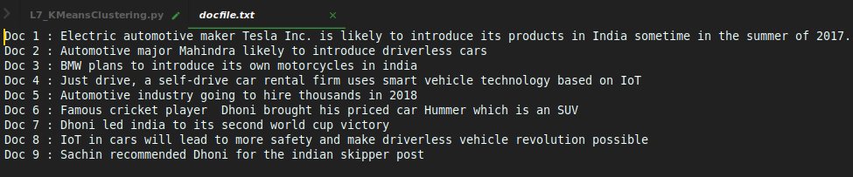
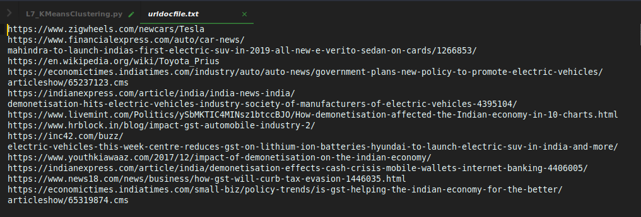

Output:
