性能評估方法(查文獻)

0.8+0.8+0.3+0.15=2.05

嘴巴開啟閥值0.6

眼睛閉上閥值0.3

模型動作閥值:兩個動作的絕對值 0.8

眨眼頻率閥值:0.3

哈欠頻率閥值:0.15

總體疲勞閥值2.05

# 統計後實驗數值:

1. 總筆數:3800筆

2. 數值平均統計

|  |  |  |
| --- | --- | --- |
| 非疲勞平均溫度 | 非疲勞平均濕度 | 非疲勞平均co2濃度 |
| 27.6203466 | 55.18806162 | 450.5096919 |
| 疲勞平均溫度 | 疲勞平均濕度 | 疲勞平均co2濃度 |
| 26.93245228 | 54.55506608 | 451.8716593 |

3. 數值分佈

疲勞時的數值分佈

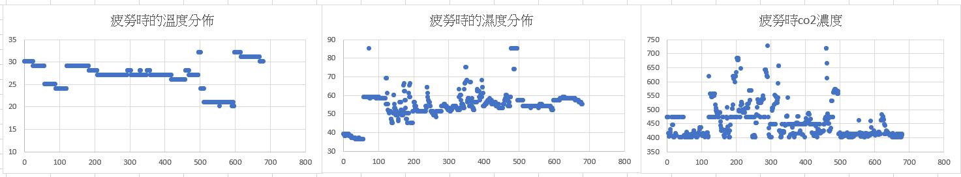

非疲勞時的數值分佈

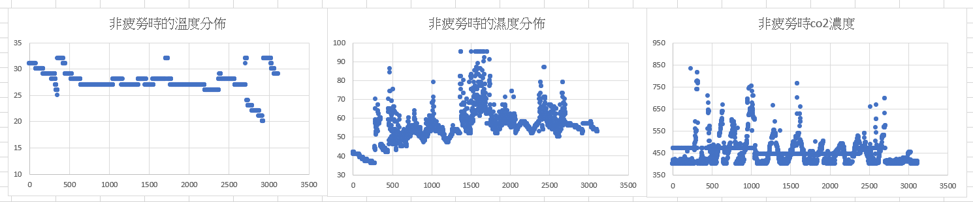

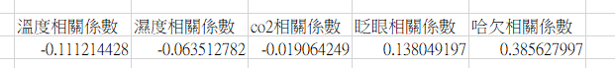

ac_temp_humi_co2訓練結果(虛擬環境比較)

|  |  |  |
| --- | --- | --- |
|  | 獎勵曲線 | 10 episode平均獎勵 |
| DDPG(50w次) |  | 44.61 |
| DDPG(10w次) |  | 40.38 |
| TD3 |  | 42.69 |
| SAC |  | 45.17 |
| PPO |  | 53.70 |

win_temp_humi_co2訓練結果(虛擬環境比較)

|  |  |  |
| --- | --- | --- |
|  | 獎勵曲線 | 10 episode平均獎勵 |
| DDPG |  | 56.62 |
| TD3 |  | 57.51 |
| SAC |  | 57.36 |
| PPO |  | 61.70 |

ac_temp_humi_co2訓練結果(使用綜合情境dataset)

|  |  |
| --- | --- |
|  | dataset各指標 |
| DDPG |  |
| TD3 |  |
| SAC |  |
| PPO |  |

win_temp_humi_co2訓練結果(使用綜合情境的dataset)

|  |  |
| --- | --- |
|  | dataset各指標 |
| DDPG |  |
| TD3 |  |
| SAC |  |
| PPO |  |

兩種模型動作總準確度(無模型輔助準度為0.72)

|  |  |  |  |  |
| --- | --- | --- | --- | --- |
|  | DDPG | TD3 | SAC | PPO |
| Ac | 0.78 | 0.79 | 0.78 | 0.81 |
| Window | 0.78 | 0.78 | 0.79 | 0.80 |

ac四情境分數(資料增加後)

單純臉部判別

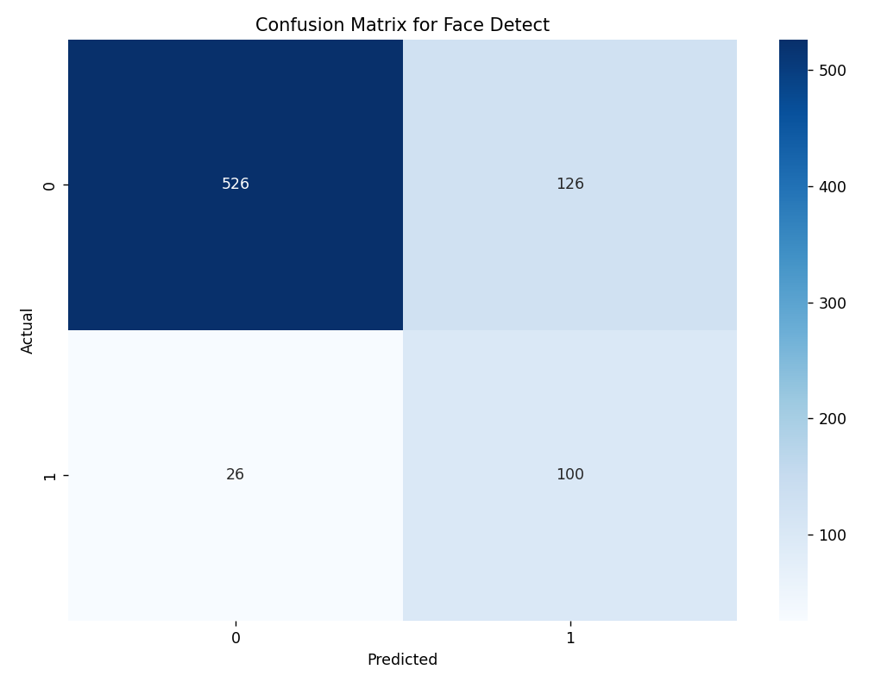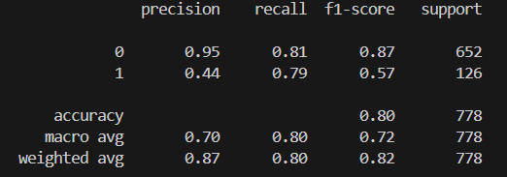

綜合情境

|  |  |  |  |  |  |
| --- | --- | --- | --- | --- | --- |
|  | Only face detect | PPO | DDPG | SAC | TD3 |
| Precision | 0.66 | 0.78(+18%) | 0.73(+11%) | 0.73(+11%) | 0.74(+12%) |
| Recall | 0.70 | 0.74(+6%) | 0.75(+7%) | 0.75(+7%) | 0.75(+7%) |
| F1-score | 0.67 | 0.75(+12%) | 0.74(+10%) | 0.74(+10%) | 0.84(+25%) |
| Accuracy | 0.78 | 0.87(+12%) | 0.84(+8%) | 0.84(+8%) | 0.84(+8%) |

白天/雨天

|  |  |  |  |  |  |
| --- | --- | --- | --- | --- | --- |
|  | Only face detect | PPO | DDPG | SAC | TD3 |
| Precision | 0.70 | 0.94(+34%) | 0.92(+31%) | 0.84(+20%) | 0.84(+20%) |
| Recall | 0.80 | 0.84(+5%) | 0.85(+6%) | 0.86(+8%) | 0.88(+10%) |
| F1-score | 0.72 | 0.88(+22%) | 0.88(+22%) | 0.85(+18%) | 0.85(+18%) |
| Accuracy | 0.80 | 0.94(+18%) | 0.94(+18%) | 0.92(+15%) | 0.92(+15%) |

白天/無雨

|  |  |  |  |  |  |
| --- | --- | --- | --- | --- | --- |
|  | Only face detect | PPO | DDPG | SAC | TD3 |
| Precision | 0.62 | 0.74(+19%) | 0.69(+11%) | 0.69(+11%) | 0.70(+13%) |
| Recall | 0.65 | 0.68(+5%) | 0.69(+6%) | 0.69(+6%) | 0.69(+6%) |
| F1-score | 0.63 | 0.70(+11%) | 0.69(+10%) | 0.69(+10%) | 0.70(+11%) |
| Accuracy | 0.74 | 0.83(+12%) | 0.80(+8%) | 0.80(+8%) | 0.81(+9%) |

夜晚/雨天

|  |  |  |  |  |  |
| --- | --- | --- | --- | --- | --- |
|  | Only face detect | PPO | DDPG | SAC | TD3 |
| Precision | 0.85 | 0.90(+6%) | 0.86(+1%) | 0.86(+1%) | 0.85(+0%) |
| Recall | 0.93 | 0.95(+2%) | 0.94(+1%) | 0.94(+1%) | 0.94(+1%) |
| F1-score | 0.89 | 0.92(+3%) | 0.89(+0%) | 0.89(+0%) | 0.89(+0%) |
| Accuracy | 0.93 | 0.95(+2%) | 0.94(+1%) | 0.93(+0%) | 0.93(+0%) |

夜晚/無雨

|  |  |  |  |  |  |
| --- | --- | --- | --- | --- | --- |
|  | Only face detect | PPO | DDPG | SAC | TD3 |
| Precision | 0.63 | 0.74(+17%) | 0.70(+11%) | 0.71(+13%) | 0.71(+13%) |
| Recall | 0.70 | 0.76(+9%) | 0.70 | 0.79(+13%) | 0.79(+13%) |
| F1-score | 0.65 | 0.75(+15%) | 0.73(+12%) | 0.74(+14%) | 0.74(+14%) |
| Accuracy | 0.80 | 0.89(+11%) | 0.86(+8%) | 0.86(+8%) | 0.87(+9%) |

win四情境分數(資料增加後)

綜合情境

|  |  |  |  |  |  |
| --- | --- | --- | --- | --- | --- |
|  | Only face detect | PPO | DDPG | SAC | TD3 |
| Precision | 0.66 | 0.76(+15%) | 0.74(+12%) | 0.74(+12%) | 0.73(+11%) |
| Recall | 0.70 | 0.73(+4%) | 0.74(+6%) | 0.74(+6%) | 0.74(+6%) |
| F1-score | 0.67 | 0.74(+10%) | 0.74(+10%) | 0.74(+10%) | 0.74(+10%) |
| Accuracy | 0.78 | 0.86(+10%) | 0.84(+8%) | 0.85(+9%) | 0.84(+8%) |

白天/雨天

|  |  |  |  |  |  |
| --- | --- | --- | --- | --- | --- |
|  | Only face detect | PPO | DDPG | SAC | TD3 |
| Precision | 0.70 | 0.93(+33%) | 0.90(+29%) | 0.90(+29%) | 0.85(+21%) |
| Recall | 0.80 | 0.84(+5%) | 0.86(+8%) | 0.86(+8%) | 0.87(+9%) |
| F1-score | 0.72 | 0.88(+22%) | 0.88(+22%) | 0.88(+22%) | 0.86(+19%) |
| Accuracy | 0.80 | 0.94(+18%) | 0.94(+18%) | 0.94(+18%) | 0.92(+15%) |

白天/無雨

|  |  |  |  |  |  |
| --- | --- | --- | --- | --- | --- |
|  | Only face detect | PPO | DDPG | SAC | TD3 |
| Precision | 0.62 | 0.72(+16%) | 0.70(+13%) | 0.70(+13%) | 0.70(+13%) |
| Recall | 0.65 | 0.69(+6%) | 0.69(+6%) | 0.69(+6%) | 0.69(+6%) |
| F1-score | 0.63 | 0.70(+11%) | 0.69(+10%) | 0.70(+11%) | 0.70(+11%) |
| Accuracy | 0.74 | 0.82(+11%) | 0.80(+8%) | 0.81(+9%) | 0.81(+9%) |

夜晚/雨天

|  |  |  |  |  |  |
| --- | --- | --- | --- | --- | --- |
|  | Only face detect | PPO | DDPG | SAC | TD3 |
| Precision | 0.85 | 0.88(+4%) | 0.85 | 0.87(+2%) | 0.85 |
| Recall | 0.93 | 0.94(+1%) | 0.94(+1%) | 0.95(+2%) | 0.94(+1%) |
| F1-score | 0.89 | 0.91(+2%) | 0.88(-1%) | 0.90(+1%) | 0.89 |
| Accuracy | 0.93 | 0.95(+2%) | 0.93 | 0.94(+1%) | 0.93 |

夜晚/無雨

|  |  |  |  |  |  |
| --- | --- | --- | --- | --- | --- |
|  | Only face detect | PPO | DDPG | SAC | TD3 |
| Precision | 0.63 | 0.71(+13%) | 0.70(+11%) | 0.71(+13%) | 0.70(+11%) |
| Recall | 0.70 | 0.74(+6%) | 0.79(+13%) | 0.80(+14%) | 0.78(+11%) |
| F1-score | 0.65 | 0.72(+11%) | 0.73(+12%) | 0.74(+14%) | 0.73(12%) |
| Accuracy | 0.80 | 0.87(+9%) | 0.86(+8%) | 0.87(+9%) | 0.86(+8%) |

ac四情境分數(資料增加後+訓練5萬次)

綜合情境

|  |  |  |  |  |  |
| --- | --- | --- | --- | --- | --- |
|  | Only face detect | PPO | DDPG | SAC | TD3 |
| Precision | 0.66 | 0.78(+18%) | 0.73(+11%) | 0.73(+11%) | 0.76(+15%) |
| Recall | 0.70 | 0.73(+4%) | 0.75(+7%) | 0.74(+6%) | 0.74(+6%) |
| F1-score | 0.67 | 0.75(+12%) | 0.74(+10%) | 0.74(+10%) | 0.75(+12%) |
| Accuracy | 0.78 | 0.87(+12%) | 0.84(+8%) | 0.84(+8%) | 0.86(+10%) |

白天/雨天

|  |  |  |  |  |  |
| --- | --- | --- | --- | --- | --- |
|  | Only face detect | PPO | DDPG | SAC | TD3 |
| Precision | 0.70 | 0.93(+33%) | 0.83(+19%) | 0.85(+21%) | 0.89(27%) |
| Recall | 0.80 | 0.84(+5%) | 0.87(+9%) | 0.86(+8%) | 0.85(+6%) |
| F1-score | 0.72 | 0.88(+22%) | 0.85(+18%) | 0.85(+18%) | 0.87(+21%) |
| Accuracy | 0.80 | 0.94(+18%) | 0.91(+14%) | 0.92(+15%) | 0.93(16%) |

白天/無雨

|  |  |  |  |  |  |
| --- | --- | --- | --- | --- | --- |
|  | Only face detect | PPO | DDPG | SAC | TD3 |
| Precision | 0.62 | 0.75(+21%) | 0.79(+27%) | 0.69(+11%) | 0.72(+16%) |
| Recall | 0.65 | 0.68(+5%) | 0.70(+8%) | 0.69(+6%) | 0.69(+6%) |
| F1-score | 0.63 | 0.70(+11%) | 0.69(+10%) | 0.69(+10%) | 0.70(+11%) |
| Accuracy | 0.74 | 0.83(+12%) | 0.80(+8%) | 0.80(+8%) | 0.82(+11%) |

夜晚/雨天

|  |  |  |  |  |  |
| --- | --- | --- | --- | --- | --- |
|  | Only face detect | PPO | DDPG | SAC | TD3 |
| Precision | 0.85 | 0.89(+5%) | 0.85 | 0.85 | 0.87(+2%) |
| Recall | 0.93 | 0.94(+1%) | 0.94(+1%) | 0.94(+1%) | 0.94(+1%) |
| F1-score | 0.89 | 0.91(+2%) | 0.88(-1%) | 0.89 | 0.90(+1%) |
| Accuracy | 0.93 | 0.95(+2%) | 0.93 | 0.93 | 0.94(+1%) |

夜晚/無雨

|  |  |  |  |  |  |
| --- | --- | --- | --- | --- | --- |
|  | Only face detect | PPO | DDPG | SAC | TD3 |
| Precision | 0.63 | 0.72(+14%) | 0.70(+11%) | 0.71(+13%) | 0.73(+16%) |
| Recall | 0.70 | 0.74(+6%) | 0.79(+13%) | 0.78(+11%) | 0.79(+13%) |
| F1-score | 0.65 | 0.73(+12%) | 0.73(+12%) | 0.74(+14%) | 0.75(+15%) |
| Accuracy | 0.80 | 0.88(+10%) | 0.85(+6%) | 0.86(+8%) | 0.88(+10%) |