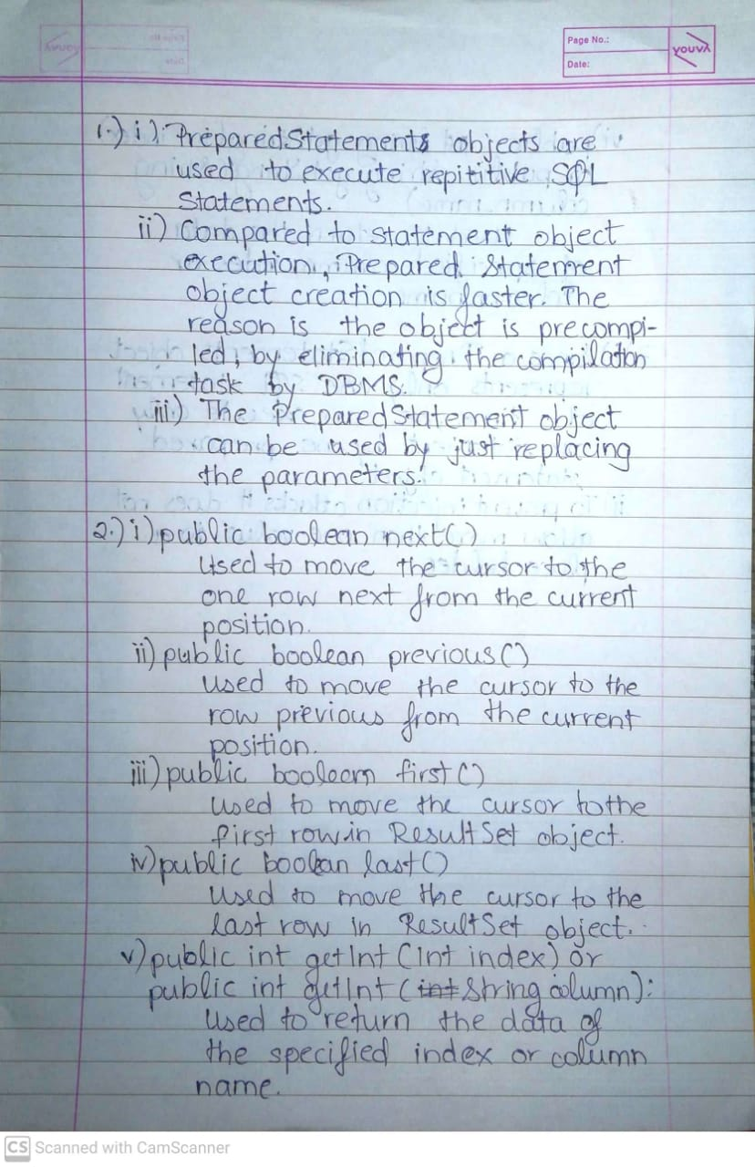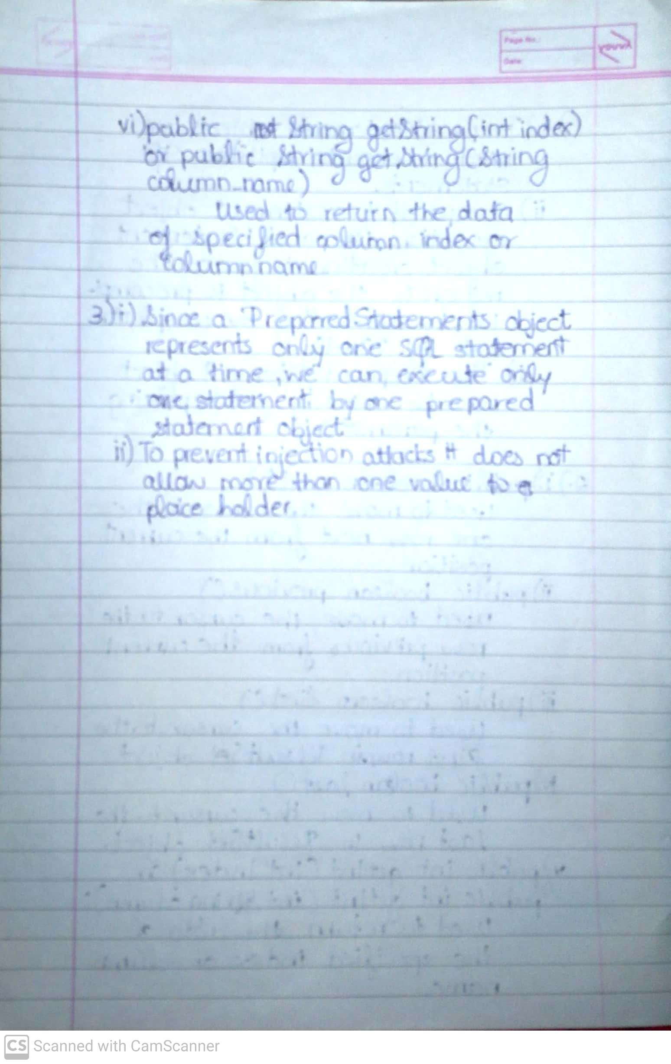

import java.sql.*;

class Exp19a {

public String database = "C:\\Users\\deong\\College\\Java\\Manual-Programs\\Experiment19\\MSBTE.accdb";

private Connection conn;

// Create Connection

public void createConnection() {

try {

conn = DriverManager.getConnection("jdbc:ucanaccess://" + database);

} catch (SQLException e) {

System.out.println("Connection Failed");

System.exit(1);

}

}

public void closeConnection() {

try {

conn.close();

} catch (SQLException e) {

System.out.println("Close Connection Failed ?");

}

}

public void updateQuery(String query) {

try {

Statement statement = conn.createStatement();

statement.executeUpdate(query);

} catch (SQLException e) {

System.out.println("Error in updateQuery()");

}

}

public static void main(String[] args) {

Exp19a dbconn = new Exp19a();

try {

Class.forName("net.ucanaccess.jdbc.UcanaccessDriver");

} catch (Exception e) {

System.out.println("Error in Loading Driver");

}

dbconn.createConnection();

dbconn.updateQuery("UPDATE Students SET FirstName = 'Deon' , LastName = 'Gracias' WHERE ID = 3;");

}

}

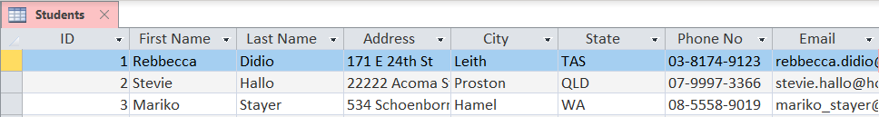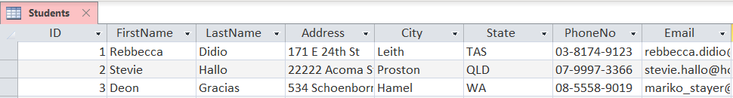

import java.sql.*;

class Exp19b {

public String database = "C:\\Users\\deong\\College\\Java\\Manual-Programs\\Experiment19\\SampleDatabase.accdb";

private Connection conn;

// Create Connection

public void createConnection() {

try {

conn = DriverManager.getConnection("jdbc:ucanaccess://" + database);

} catch (SQLException e) {

System.out.println("Connection Failed");

System.exit(1);

}

}

public void closeConnection() {

try {

conn.close();

} catch (SQLException e) {

System.out.println("Close Connection Failed ?");

}

}

public void updateQuery(int id, String firstName, String lastName) {

try {

PreparedStatement stmt = conn.prepareStatement("insert into student values(?,?,?)");

stmt.setInt(1, id);

stmt.setString(2, firstName);

stmt.setString(3, lastName);

int i = stmt.executeUpdate();

System.out.println(i + " records inserted");

} catch (SQLException e) {

System.out.println("Error in updateQuery()");

}

}

public static void main(String[] args) {

Exp19b dbconn = new Exp19b();

try {

Class.forName("net.ucanaccess.jdbc.UcanaccessDriver");

} catch (Exception e) {

System.out.println("Error in Loading Driver");

}

dbconn.createConnection();

dbconn.updateQuery(101, "Abhishek", "Yadav");

}

}



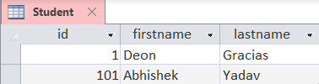

import java.sql.*;

public class Exp19c {

public String database = "C:\\Users\\deong\\College\\Java\\Manual-Programs\\Experiment19\\MSBTE.accdb";

private Connection conn;

// Create Connection

public void createConnection() {

try {

conn = DriverManager.getConnection("jdbc:ucanaccess://" + database);

} catch (SQLException e) {

System.out.println("Connection Failed");

System.exit(1);

}

}

public void closeConnection() {

try {

conn.close();

} catch (SQLException e) {

System.out.println("Close Connection Failed ?");

}

}

public void selectQuery() {

try {

Statement stmt = conn.createStatement();

ResultSet rs = stmt.executeQuery("SELECT ID, first_name, last_name FROM Student;");

System.out.println("--------------------------------------");

System.out.printf("%5s | %13s | %13s\n", "ID", "FirstName", "LastName");

System.out.println("--------------------------------------");

while (rs.next()) {

System.out.printf("%5s | %13s |%13s\n", Integer.toString(rs.getInt("ID")), rs.getString("first_name"),

rs.getString("last_name"));

}

} catch (SQLException e) {

e.printStackTrace();

System.out.println("Error in selectQuery()");

}

}

public static void main(String[] args) {

Exp19c dbconn = new Exp19c();

try {

Class.forName("net.ucanaccess.jdbc.UcanaccessDriver");

} catch (Exception e) {

System.out.println("Error in Loading Driver");

}

dbconn.createConnection();

dbconn.selectQuery();

}

}

