# Types of Servlets

# Generic servlets

* + 1. Extend javax.servlet.GenericServlet.
    2. Are protocol independent. They contain no inherent HTTP support or any other transport protocol.
    3. The default port for the Apache Tomcat service is 8080. This port is defined for HTML traffic along with the more often used port 80.

# HTTP servlets

* + 1. Extend javax.servlet.HttpServlet.
    2. Have built-in HTTP protocol support and are more useful in a Sun Java System Web Server environment.
    3. The GlassFish Server port number: The default is 8080. The administration server's port number: The default is 4848. An administration user name and password: The default user name is admin , and by default no password is required.

1. Difference Between doGet() and doPost()
   1. doGet() :-
      1. Parameters are appended to the URL, and sent along with the header information. So it brings up a security issues (eg. Password).
      2. We can send maximum size of data 240 bytes.
      3. Parameters are not encrypted.
      4. Processing is Faster
      5. Bookmark is possible
   2. doPost() :-
      1. Parameters are sent through Request body.
      2. We can send a large amount of data.
      3. Parameters are encrypted.
      4. Processing is Slower
      5. Bookmark is not possible.
2. Explain ServletConfig and ServletContext
   1. ServletConfig
      1. ServletConfig is servlet specific
      2. Parameters of servletConfig are present as name-value pair in inside .
      3. ServletConfig object is obtained by getServletConfig() method
      4. Each servlet has got its own ServletConfig object
      5. Use ServletConfig when only one servlet needs information shared by it.
   2. ServletContext
      1. ServletContext is for whole application
      2. Parameters of servletContext are present as namevalue pair in which is outside of and inside
      3. ServletContext object is obtained by getServletContext() method.
      4. ServletContext object is only one and used by different servlets of the application.
      5. Use ServletContext when whole application needs information shared by it.

# ServletInputStream and ServletoutputStream

* 1. ServletInputStream
     1. The ServletInputStream class extends java.io.InputStream. It is implemented by the servlet container and provides an input stream, that a developer can use to read the data from a client request.
     2. Methods of ServletInputStream
        1. readline() : is used to read the input values.
  2. ServletOutputStream
     1. ServletOutputStream is an abstract class in the javax.servlet package. It is used in servlets to write the response to the client.
     2. ServletOutputStream class extends java.io.OutputStream. It also defines the print( ) and println( ) methods, which output data to the stream.
     3. Methods of ServletOutputStream
        1. print(boolean) : Prints Boolean value(true/false).
        2. print(String) : Prints string values.
        3. print(char) : Prints a single character.
        4. print(float) : Prints float value( uses 32 bits).
        5. print(double) : Prints double value.
        6. print(int) : Prints an integer type value.
        7. print(long) : Prints long value.

# X

1. **GetLength.javaindex.html**

import java.io.*;

import javax.servlet.*;

import javax.servlet.annotation.WebServlet;

import javax.servlet.http.*;

@WebServlet("/GetLength")

public class GetLength extends HttpServlet {

private static final long serialVersionUID = 1L;

public GetLength() {

super();

}

protected void doGet(HttpServletRequest request, HttpServletResponse response)

throws ServletException, IOException {

String responseString[] = {

"<link rel='stylesheet' href='https://cdnjs.cloudflare.com/ajax/libs/materialize/1.0.0/css/materialize.min.css'>",

"<script defer src='https://cdnjs.cloudflare.com/ajax/libs/materialize/1.0.0/js/materialize.min.js'></script>" };

response.setContentType("text/html");

PrintWriter pw = response.getWriter();

String s = request.getParameter("username");

for (String str : responseString) {

pw.println(str);

}

pw.println("<div class='container'><h3>The Length of the Username is " + s.length() + "</h3></div>");

pw.close();

}

protected void doPost(HttpServletRequest request, HttpServletResponse response)

throws ServletException, IOException {

doGet(request, response);

}

}

<!DOCTYPE html><html><head><meta charset="ISO-8859-1" /><link rel="stylesheet" href="https://cdnjs.cloudflare.com/ajax/libs/materialize/1.0.0/css/materialize.min.css" /> <script defer src="https://cdnjs.cloudflare.com/ajax/libs/materialize/1.0.0/js/materialize.min.js" ></script> <title>Experiment 22</title></head><style>.container{padding:15px;width:100vw;height:100vh;display:flex;flex-direction:column;justify-content:center;align-items:center}.row{width:100%;margin:5px 0px 5px 0px}.col{display:flex;flex-direction:column;justify-content:center;align-items:center}#username{width:50%;text-align:center}::placeholder{text-align:center}input[type="submit"]{width:100%;color:white}.btn{width:50%}</style><body><form action="GetLength" method="GET" class="container"><div class="row"><div class="col s12"><h4>Enter Username</h4></div></div><div class="row"><div class="input-field col s12"> <input id="username" name="username" type="text" class="validate" placeholder="Username" /></div></div><div class="row"><div class="col s12"> <input type="submit" class="waves-effect waves-light btn" value="Submit" /></div></div></form></body></html>

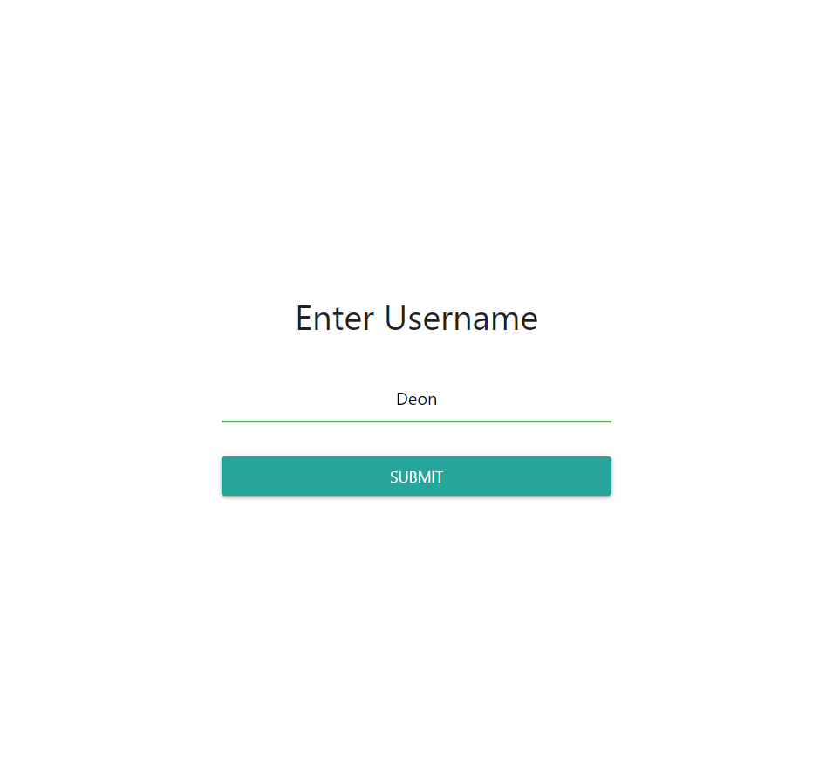

1. **AuthenticationServlet.javaindex.html** 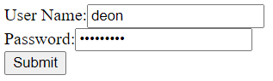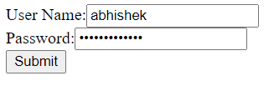

import java.io.IOException;

import java.io.PrintWriter;

import javax.servlet.ServletException;

import javax.servlet.http.HttpServlet;

import javax.servlet.http.HttpServletRequest;

import javax.servlet.http.HttpServletResponse;

public class AthenticationServlet extends HttpServlet {

protected void doPost(HttpServletRequest request, HttpServletResponse response)

throws ServletException, IOException {

response.setContentType("text/html;charset=UTF-8");

PrintWriter out = response.getWriter();

String pass = "abhishek12345";

String username, password;

username = request.getParameter("username");

password = request.getParameter("password");

if (username.equals(uname) && password.equals(pass)) {

out.println("Login Successfull");

} else {

out.println("Login Unsuccessfull");

}

}

}

<html> <body>

<form action="AthenticationServlet”

method=”POST”>

User Name:<input type="text" name="username"><br>

Password:<input type="password" name="password" ><br>

<input type="submit">

</form>

</body><html>

1. **ReturnMarks.javaindex.html**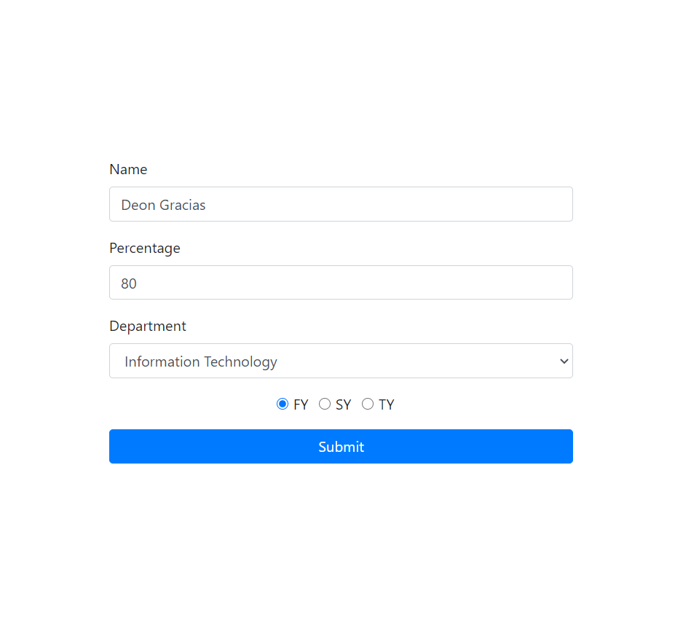 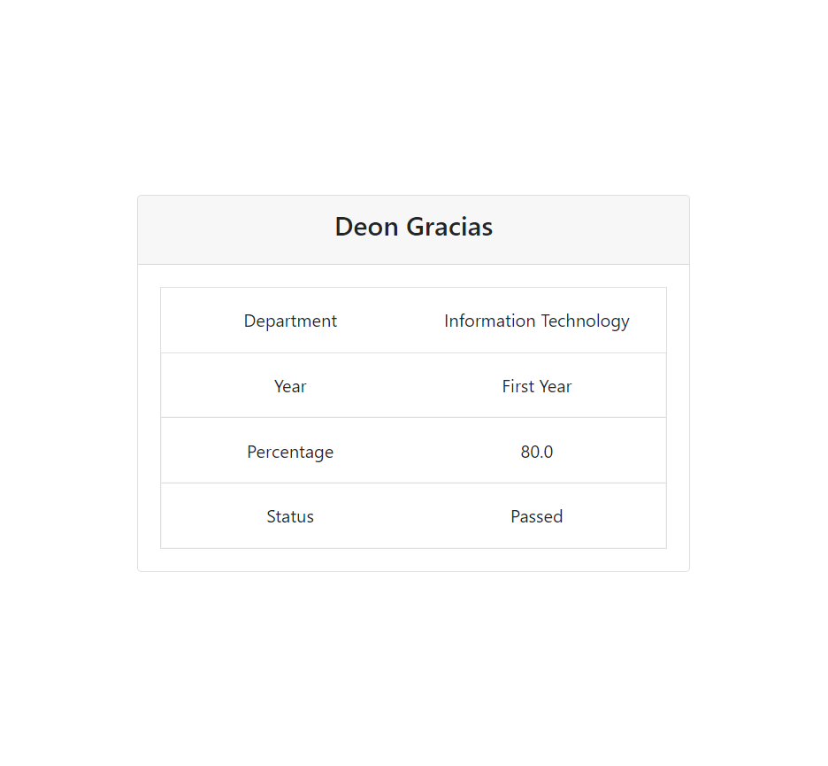

import java.io.*;

import javax.servlet.*;

import javax.servlet.annotation.WebServlet;

import javax.servlet.http.*;

@WebServlet("/ReturnMarks")

public class ReturnMarks extends HttpServlet {

private static final long serialVersionUID = 1L;

public ReturnMarks() {

super();

}

protected void doGet(HttpServletRequest request, HttpServletResponse response)

throws ServletException, IOException {

response.setContentType("text/html");

PrintWriter pw = response.getWriter();

String name = request.getParameter("name");

String department = request.getParameter("department");

float percentage = Float.parseFloat(request.getParameter("percentage"));

String year = request.getParameter("year");

pw.println("<link rel='stylesheet' href='https://cdn.jsdelivr.net/npm/bootstrap@4.5.3/dist/css/bootstrap.min.css' integrity='sha384-TX8t27EcRE3e/ihU7zmQxVncDAy5uIKz4rEkgIXeMed4M0jlfIDPvg6uqKI2xXr2' crossorigin='anonymous' /> <script defer src='https://code.jquery.com/jquery-3.5.1.slim.min.js' integrity='sha384-DfXdz2htPH0lsSSs5nCTpuj/zy4C+OGpamoFVy38MVBnE+IbbVYUew+OrCXaRkfj' crossorigin='anonymous' ></script> <script defer src='https://cdn.jsdelivr.net/npm/bootstrap@4.5.3/dist/js/bootstrap.bundle.min.js' integrity='sha384-ho+j7jyWK8fNQe+A12Hb8AhRq26LrZ/JpcUGGOn+Y7RsweNrtN/tE3MoK7ZeZDyx' crossorigin='anonymous' ></script> <style>.main{width:100vw;height:100vh;display:flex;justify-content:center;align-items:center}.card{text-align:center}.row{margin-bottom:5px;margin-top:5px}</style><div class='container main'><div class='card' style='width: 500px'><div class='card-header'><h4>" + name + "</h4></div><div class='card-body'><ul class='list-group list-group-flush'></ul><li class='list-group-item'><div class='row'><div class='col-6'>Department</div><div class='col-6'>"+ department + "</div></div></li><li class='list-group-item'><div class='row'><div class='col-6'>Year</div><div class='col-6'>"+ year + "</div></div></li><li class='list-group-item'><div class='row'><div class='col-6'>Percentage</div><div class='col-6'>"+ percentage

+"</div></div></li><li class='list-group-item'><div class='row'><div class='col-6'>Status</div><div class='col-6'>"+ (percentage > 35 ? "Passed" : "Failed") + "</div></div></li></ul></div></div></div>");

pw.close();

}

protected void doPost(HttpServletRequest request, HttpServletResponse response)

throws ServletException, IOException {

doGet(request, response);

}

}

<!DOCTYPE html><html><head><meta charset="ISO-8859-1" /><link rel="stylesheet" href="https://cdn.jsdelivr.net/npm/bootstrap@4.5.3/dist/css/bootstrap.min.css" integrity="sha384-TX8t27EcRE3e/ihU7zmQxVncDAy5uIKz4rEkgIXeMed4M0jlfIDPvg6uqKI2xXr2" crossorigin="anonymous" /> <script defer src="https://code.jquery.com/jquery-3.5.1.slim.min.js" integrity="sha384-DfXdz2htPH0lsSSs5nCTpuj/zy4C+OGpamoFVy38MVBnE+IbbVYUew+OrCXaRkfj" crossorigin="anonymous" ></script> <script defer src="https://cdn.jsdelivr.net/npm/bootstrap@4.5.3/dist/js/bootstrap.bundle.min.js" integrity="sha384-ho+j7jyWK8fNQe+A12Hb8AhRq26LrZ/JpcUGGOn+Y7RsweNrtN/tE3MoK7ZeZDyx" crossorigin="anonymous" ></script> <title>Experiment 22</title></head><style>.container{padding:15px;width:100vw;height:100vh;display:flex;flex-direction:column;justify-content:center;align-items:center}.form-group{width:100%}.check{display:flex;flex-direction:row;justify-content:center;align-items:center}</style><body><form action="ReturnMarks" method="GET" class="container"><div class="form-group"> <label for="name">Name</label> <input type="text" class="form-control" id="name" placeholder="Enter Name" name="name" /></div><div class="form-group"> <label for="percentage">Percentage</label> <input type="text" class="form-control" id="percentage" placeholder="Enter Percentage" name="percentage" /></div><div class="form-group"> <label for="department">Department</label> <select class="form-control" id="department" name="department"><option value="Information Technology">Information Technology</option><option value="Computer Engineering">Computer Engineering</option><option value="Civil Engineering">Civil Engineering</option><option value="Mechanical Engineering">Mechanical Engineering</option> </select></div><div class="form-group check"><div class="form-check form-check-inline"> <input class="form-check-input" type="radio" name="year" id="FY" value="First Year" checked /> <label class="form-check-label" for="FY"> FY </label></div><div class="form-check form-check-inline"> <input class="form-check-input" type="radio" name="year" id="SY" value="Second Year" /> <label class="form-check-label" for="SY"> SY </label></div><div class="form-check form-check-inline"> <input class="form-check-input" type="radio" name="year" id="TY" value="Third Year" /> <label class="form-check-label" for="TY"> TY </label></div></div><div class="form-group"> <button type="submit" class="btn btn-primary btn-block">Submit</button></div></form></body></html>