**Web Technology**

**Lab Portfolio website**

Aditya Taware

TY CS D 38

Web page

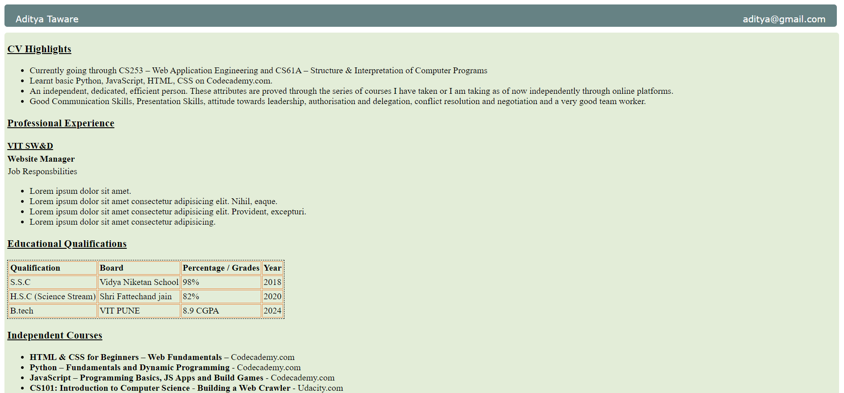

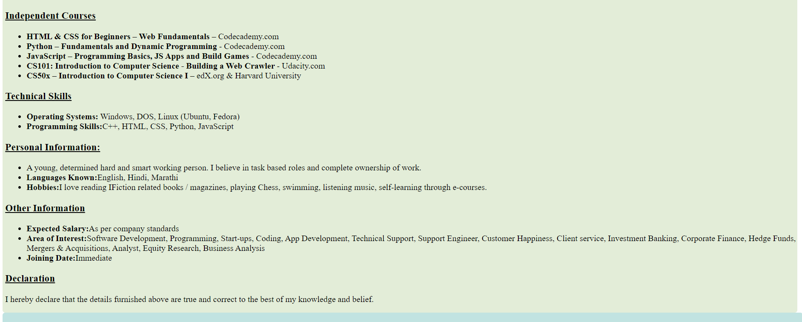

Code:

HTML:

<!DOCTYPE html>

<html lang="en">

<head>

    <meta charset="UTF-8">

    <meta http-equiv="X-UA-Compatible" content="IE=edge">

    <meta name="viewport" content="width=device-width, initial-scale=1.0">

    <title>Document</title>

    <link rel="stylesheet" href="cv.css.css">

    <link type="text/css" rel="stylesheet" href="https://www.dropbox.com/s/trsldt0me90jzs8/resume.css" />

</head>

<body>

    <style>

        div {

            border-radius: 5px;

        }

        #header {

            position: fixed;

            z-index: 1;

            height: 40px;

            width: 98%;

            background-color: #668284;

            margin-bottom: 10px

        }

        #name {

            float: left;

            margin-left: 20px;

            padding-bottom: 10px;

            font-size: 16px;

            font-family: Verdana, sans-serif;

            color: #ffffff;

        }

        #email {

            float: right;

            margin-right: 20px;

            padding-bottom: 10px;

            font-size: 16px;

            font-family: Verdana, sans-serif;

            color: #ffffff;

        }

        #contact {

            margin-left: 45%;

            padding-bottom: 10px;

            font-size: 16px;

            font-family: Verdana, sans-serif;

            color: #ffffff;

        }

        a:hover {

            font-weight: bold;

        }

        .right {

            float: left;

            margin-top: 50px;

            padding-left: 5px;

            /*margin-right: -10px;

    margin-left: 14%;*/

            height: auto;

            width: 99%;

            background-color: #E3EDD8;

        }

        /*.left

{

    float: left;

    margin-top: 50px;

    /*margin-right: -90px;

    height: relative;

    width: 10%;

    background-color: #4160E8;

    }*/

        #footer {

            height: 40px;

            clear: both;

            position: relative;

            background-color: #C1E3E1;

        }

        h3 {

            text-decoration: underline;

        }

        #job-responsibilities {

            padding: 1px;

        }

        .job-title {

            font-weight: bold;

        }

        table {

            border: 1px dashed black;

        }

        td {

            padding: 2px;

            border: 1px solid #E88741;

        }

        #course-name {

            font-weight: bold;

        }

        #company-name {

            height: 2px;

            text-decoration: underline;

        }

        #job-title {

            height: 5px;

        }

        .job-duration {

            float: right;

        }

        #heading {

            font-weight: bold;

        }

    </style>

    <div id="header">

        <p id="name">Aditya Taware</p>

        <a href="mailto:deepsukhwani@gmail.com" target="_blank">

            <p id="email">aditya@gmail.com</p>

        </a>

    </div>

    <div class="left">

    </div>

    <div class="right">

        <h3>CV Highlights</h3>

        <p>

        <ul>

            <li>Currently going through CS253 – Web Application Engineering and CS61A – Structure & Interpretation of

                Computer Programs</li>

            <li>Learnt basic Python, JavaScript, HTML, CSS on Codecademy.com.</li>

            <li>An independent, dedicated, efficient person. These attributes are proved through the series of courses I

                have taken or I am taking as of now independently through online platforms.</li>

            <li>Good Communication Skills, Presentation Skills, attitude towards leadership, authorisation and

                delegation, conflict resolution and negotiation and a very good team worker.</li>

        </ul>

        </p>

        <h3>Professional Experience</h3>

        <h4 id="company-name">VIT SW&D</h4>

        <p id="job-title"><strong>Website Manager</strong></p>

        <p id="job-responsibilities">Job Responsbilities</p>

        <p>

        <ul>

            <li>Lorem ipsum dolor sit amet.</li>

            <li>Lorem ipsum dolor sit amet consectetur adipisicing elit. Nihil, eaque.</li>

            <li>Lorem ipsum dolor sit amet consectetur adipisicing elit. Provident, excepturi.</li>

            <li>Lorem ipsum dolor sit amet consectetur adipisicing.</li>

        </ul>

        </p>

        <h3>Educational Qualifications</h3>

        <table>

            <tr id="heading">

                <td>Qualification</td>

                <td>Board</td>

                <td>Percentage / Grades</td>

                <td>Year</td>

            </tr>

            <tr>

                <td>S.S.C</td>

                <td>Vidya Niketan School</td>

                <td>98%</td>

                <td>2018</td>

            </tr>

            <tr>

                <td>H.S.C (Science Stream)</td>

                <td>Shri Fattechand jain</td>

                <td>82%</td>

                <td>2020</td>

            </tr>

            <tr>

                <td>B.tech</td>

                <td>VIT PUNE</td>

                <td>8.9 CGPA</td>

                <td>2024</td>

            </tr>

        </table>

        <h3>Independent Courses</h3>

        <p>

        <ul>

            <li>

                <span id="course-name">HTML & CSS for Beginners – Web Fundamentals</span> – Codecademy.com

            </li>

            <li>

                <span id="course-name">Python – Fundamentals and Dynamic Programming </span> - Codecademy.com

            </li>

            <li>

                <span id="course-name">JavaScript – Programming Basics, JS Apps and Build Games </span> - Codecademy.com

            </li>

            <li>

                <span id="course-name">CS101: Introduction to Computer Science - Building a Web Crawler</span> -

                Udacity.com

            </li>

            <li>

                <span id="course-name">CS50x – Introduction to Computer Science I</span> – edX.org & Harvard University

            </li>

        </ul>

        <h3>Technical Skills</h3>

        <p>

        <ul>

            <li>

                <span id="course-name">Operating Systems:</span> Windows, DOS, Linux (Ubuntu, Fedora)

            </li>

            <li>

                <span id="course-name">Programming Skills:</span>C++, HTML, CSS, Python, JavaScript

            </li>

        </ul>

        </p>

        <h3>Personal Information:</h3>

        <p>

        <ul>

            <li>

                A young, determined hard and smart working person. I believe in task based roles and complete ownership

                of work.

            <li>

                <span id="course-name">Languages Known:</span>English, Hindi, Marathi

            </li>

            <li>

                <span id="course-name">Hobbies:</span>I love reading IFiction related books / magazines, playing

                Chess, swimming, listening music, self-learning through e-courses.

            </li>

        </ul>

        </p>

        <h3>Other Information</h3>

        <p>

        <ul>

            <li>

                <span id="course-name">Expected Salary:</span>As per company standards

            </li>

            <li>

                <span id="course-name">Area of Interest:</span>Software Development, Programming, Start-ups, Coding, App

                Development, Technical Support, Support Engineer, Customer Happiness, Client service, Investment

                Banking, Corporate Finance, Hedge Funds, Mergers & Acquisitions, Analyst, Equity Research, Business

                Analysis

            </li>

            <li>

                <span id="course-name">Joining Date:</span>Immediate

            </li>

        </ul>

        </p>

        <h3>Declaration</h3>

        <p>

            I hereby declare that the details furnished above are true and correct to the best of my knowledge and

            belief.</p>

    </div>

    <div id="footer"></div>

</body>

</html>

CSS:

div

{

    border-radius: 5px;

    }

#header

{

    position: fixed;

    z-index: 1;

    height:40px;

    width: 98%;

    background-color: #668284;

    margin-bottom: 10px

    }

#name {

    float:left;

    margin-left: 20px;

    padding-bottom: 10px;

    font-size: 16px;

    font-family: Verdana, sans-serif;

    color: #ffffff;

}

#email{

    float:right;

    margin-right: 20px;

    padding-bottom: 10px;

    font-size: 16px;

    font-family: Verdana, sans-serif;

    color: #ffffff;

}

#contact

{

    margin-left:45%;

    padding-bottom: 10px;

    font-size: 16px;

    font-family: Verdana, sans-serif;

    color: #ffffff;

    }

a:hover {

    font-weight: bold;

}

.right

{

    float: left;

    margin-top: 50px;

    padding-left:5px;

    /*margin-right: -10px;

    margin-left: 14%;*/

    height: auto;

    width: 99%;

    background-color: #E3EDD8;

    }

/*.left

{

    float: left;

    margin-top: 50px;

    /*margin-right: -90px;

    height: relative;

    width: 10%;

    background-color: #4160E8;

    }*/

#footer

{

    height:40px;

    clear:both;

    position: relative;

    background-color: #C1E3E1;

    }

h3

{

    text-decoration: underline;

    }

#job-responsibilities

{

    padding: 1px;

    }

.job-title

{

    font-weight: bold;

    }

table

{

    border: 1px dashed black;

    }

td

{

    padding: 2px;

    border: 1px solid #E88741;

    }

#course-name

{

    font-weight:bold;

    }

#company-name

{

    height:2px;

    text-decoration:underline;

    }

#job-title

{

    height: 5px;

    }

.job-duration

{

    float:right;

    }

#heading

{

    font-weight:bold;

    }

.gap{

    margin:15px;

}