Shanoir NG – Import

Software Design Description

Table des matières

1 Microservice context 1

1.1 Microservice presentation 1

1.2 Main functionalities 2

1.3 Application users 2

2 Functional architecture 2

2.1 Imports 2

2.1.1 Import from DICOM CD/DVD 2

2.1.2 Import from PACS 2

2.1.3 Import from ShanoirUploader 2

2.1.4 Import processed dataset (NifTi) 3

2.1.5 Import from files 3

2.2 Steps 3

2.2.1 Choose modality 3

2.2.2 Upload files 3

2.2.3 Select series 3

2.2.4 Select clinical context 3

2.2.5 Describe dataset 3

2.2.6 Select/create data processing 3

2.2.7 Anonymization 3

2.2.8 Nifti conversion 4

2.2.9 Select settings for research study 4

3 Software/technical Architecture 4

3.1 Anonymization 4

# Microservice context

## Microservice presentation

This microservice is a part of the Shanoir-NG application and is used to import data.

## Main functionalities

Shanoir NG main functionalities are:

* Import from DICOM CD/DVD
* Import from PACS
* Import from ShanoirUploader
* Import processed dataset (NifTi)
* Import from files

## Application users

Target population is:

* Administrators
* Experts
* Users

# Functional architecture

## Imports

### Import from DICOM CD/DVD

Steps of this import are:

* Choose modality
* Upload dataset (DICOM zip)
* Select series
* Select clinical context
* Anonymization
* Nifti conversion
* Select settings for research study

### Import from PACS

Steps of this import are:

* Choose modality
* Define DICOM query and import data
* Select clinical context
* Anonymization
* Nifti conversion
* Select settings for research study

### Import from ShanoirUploader

Steps of this import are:

* Choose modality
* Upload files
* Anonymization
* Select series
* Nifti conversion

### Import processed dataset (NifTi)

Steps of this import are:

* Upload files
* Describe dataset
* Select/create data processing
* Nifti conversion

### Import from files

Import from files allows to upload:

* Processed dataset (NifTi)
* Extra data
* Spectroscopy data

Steps to import processed dataset are:

* Upload files
* Describe dataset
* Select/create data processing
* Nifti conversion

Steps to import extra data are:

* Upload files
* Select clinical context

Steps to import spectroscopy data are:

* Upload files
* Select clinical context

## Steps

### Choose modality

### Upload files

### Select series

A tree is displayed here to let users select series. Here is the structure of the tree:

* Patient
* Study
* Serie
* Serie
* Serie
* …

The tree is an response from the upload MS and is a json object in this format:

{

“patient”: {

“id”: string,

“sex”: string,

“name”: string,

“birthDate”: date,

“study”: {

“name”: string

},

“serie”: [{

“id”: string,

“protocol”: string,

“description”: string,

“seriesDate”: date,

“seriesNumber”: number,

“numberOfImages”: number,

“modality”: string,

“numberOfNonImageObjects”: number,

“images”: [{

“imageId”: number,

“imageUrl”: string

}]

}]

}

### Select clinical context

### Describe dataset

### Select/create data processing

### Anonymization

### Nifti conversion

### Select settings for research study

# Software/technical Architecture

## Anonymization

### Anonymized fields :

See anonymization.xlsx document

### Prerequisite

Zip files should be unzipped.

Check if zip files are unzipped during anonymization step or before.

### Steps

* Anonymization
* Send email
* Create folders

### Technical Specification of Shanoir NG Anonymization

To anonymize a DICOM image, the anonymization service starts with reading the set of DICOM tags to anonymize. The DICOM tags to anonymize are listed in an excel document named anonymization.xlsx. Thus, the anonymization service parses the excel file, reads the list of tags and the operation to do to anonymize each tag based on the anonymization profile that should be applied (figure 2). Then it reads the DICOM tags of the image and anonymizes each tag mentioned in the excel file. For so, it follows several steps:

* Treats private tags: assume that a dicom tag is represented by (gggg, eeee) form. All private tags recognized when the “gggg” part is odd should be anonymized (see figure 1).
* Treats public tags: public tags specified in the excel file have to be anonymized. We distinguish DigitalSignaturesSequence tag and DataSetTrailingPadding tag that can not be converted to “int” using “Integer.decode”, so we treat them differently (see figure 1).
* Treats “xx” tags: some tags belonging to the same interval have to be anonymized the same way. For instance, curve data recognized when the tag is beginning with “50” should be removed. Thus all tags (50xx,xxxx) should be removed after anonymization.

In this step, we treat three particular use cases which are: (50xx,xxxx), (60xx,4000) and (60xx,3000) tags (see figure 1).

For each tag, there is an appropriate way to anonymize it: some of them should be removed, others should be replaced with a zero length value …etc . According to the anonymization profile, a different value will replace the original one as described by figures 3 and 4. Moreover, to replace the tag’s original value, the anonymization service have to respect its VR as described by figure 3.

The whole anonymization process is described by figure 1.

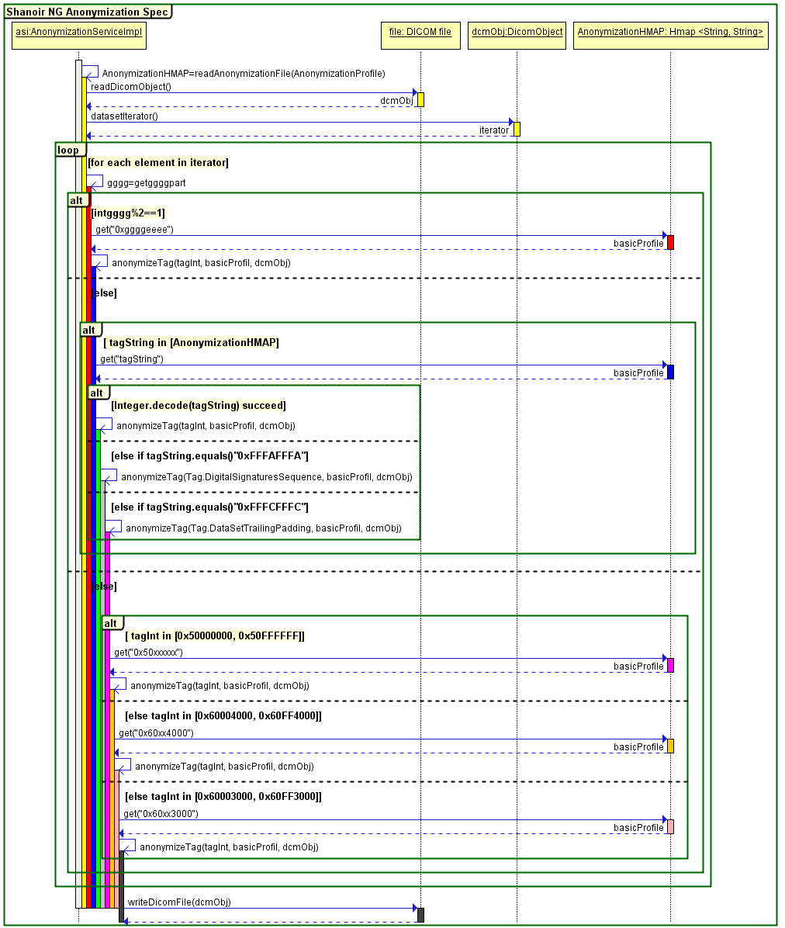

Figure 1. DICOM image anonymization process

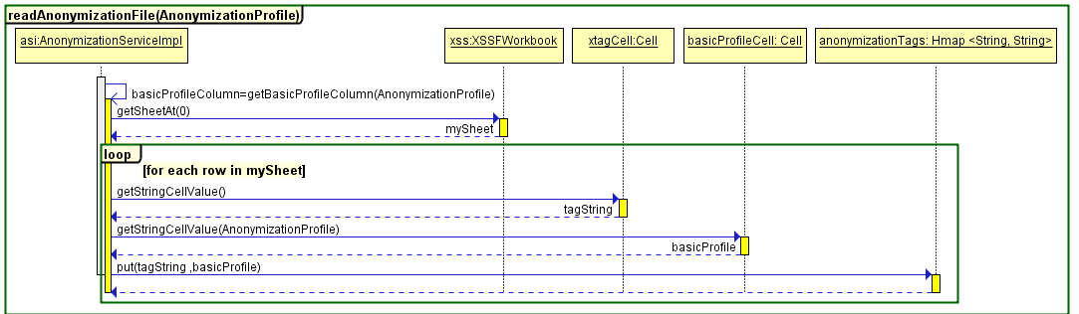

Figure 2. Excel anonymization tags file reading

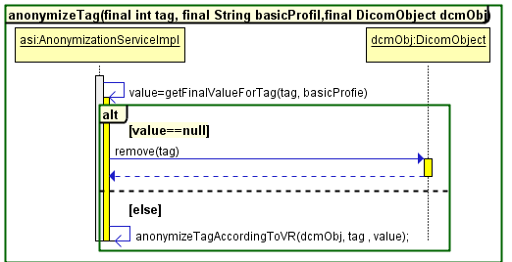

Figure 3. DICOM tag anonymization process

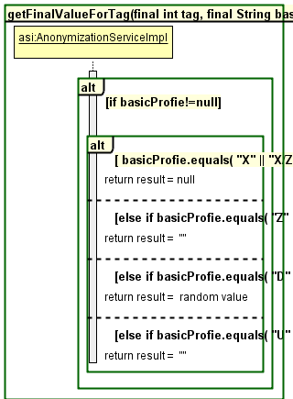

Figure 4. Anonymized tag value based on profile

### Email

Send email

Define email content and when it is sent.

### New folders

TODO