Shanoir NG – Import

Software Design Description

Table des matières

1 Microservice context 2

1.1 Microservice presentation 2

1.2 Main functionalities 2

1.3 Application users 2

2 Functional architecture 2

2.1 Imports 2

2.1.1 Import from DICOM CD/DVD 2

2.1.2 Import from PACS 2

2.1.3 Import from ShanoirUploader 2

2.1.4 Import processed dataset (NifTi) 2

2.1.5 Import processed dataset (Special case for Nifti files) 3

2.1.6 Import from files 3

2.2 Steps 3

2.2.1 Choose modality 3

2.2.2 Upload files 3

2.2.3 Select series 4

2.2.4 Select clinical context 4

2.2.5 Describe dataset 5

2.2.6 Select/create data processing 6

2.2.7 Anonymization 6

2.2.8 Nifti conversion 6

2.2.9 Select settings for research study 6

3 Software/technical Architecture 7

3.1 Anonymization 7

3.1.1 Anonymized fields : 7

3.1.2 Prerequisite 7

3.1.3 Steps 7

3.1.4 Technical Specification of Shanoir NG Anonymization 7

3.1.5 Email 12

3.1.6 New folders 12

# Microservice context

## Microservice presentation

This microservice is a part of the Shanoir-NG application and is used to import data.

## Main functionalities

Shanoir NG main functionalities are:

* Import from DICOM CD/DVD
* Import from PACS
* Import from ShanoirUploader
* Import processed dataset (NifTi)
* Import from files

## Application users

Target population is:

* Administrators
* Experts
* Users

# Functional architecture

## Imports

### Import from DICOM CD/DVD

Steps of this import are:

* Choose modality
* Upload dataset (DICOM zip)
* Select series
* Select clinical context
* Anonymization
* Nifti conversion
* Select settings for research study

### Import from PACS

Steps of this import are:

* Choose modality
* Define DICOM query and import data
* Select clinical context
* Anonymization
* Nifti conversion
* Select settings for research study

### Import from ShanoirUploader

Steps of this import are:

* Choose modality
* Upload files
* Anonymization
* Select series
* Nifti conversion

### Import processed dataset (NifTi)

Steps of this import are:

* Upload files
* Describe dataset
* Select/create data processing
* Nifti conversion

### Import processed dataset (Special case for Nifti files)

For imports started directly on the Details’ page of dataset/study

Steps of this import are:

* Upload files
* Describe dataset – without Study and Subject.
* Create data processing – new processing is automatically created - user chooses the type, date and comment

### Import from files

Import from files allows to upload:

* Processed dataset (NifTi)
* Extra data
* Spectroscopy data

Steps to import processed dataset are:

* Upload files
* Describe dataset
* Select/create data processing
* Nifti conversion

Steps to import extra data are:

* Upload files
* Select clinical context

Steps to import spectroscopy data are:

* Upload files
* Select clinical context

## Steps

### Choose modality

Two modalities are available:

* MRI
* PET

### Upload files

User selects a file to upload.

* For import from Pacs: zip with DICOM images DICOMDIR file
* Import Nifti: .nii or .nii.gz files
* Extradata (From files): any files

### Select series

A tree is displayed here to let users select series. Here is the structure of the tree:

* Patient
* Study
* Serie
* Serie
* Serie
* …

The tree is an response from the upload MS and is a json object in this format:

{

“patient”: {

“id”: string,

“sex”: string,

“name”: string,

“irthdate”: date,

“study”: {

“name”: string

},

“serie”: [{

“id”: string,

“protocol”: string,

“description”: string,

“seriesDate”: date,

“seriesNumber”: number,

“numberOfImages”: number,

“modality”: string,

“numberOfNonImageObjects”: number,

“images”: [{

“imageId”: number,

“imageUrl”: string

}]

}]

}

### Select clinical context

#### Research study

* User chooses from the list of studies available (studies he has access to with right import dataset or responsible)
* Once chosen, link Details appears on the right that shows details on the study (user can click Back/Cancel or X button to close this window and go back to the import page)

#### Study card

* Uses chooses from the list of study cards associated to the study. On the list the name appears as: Study + City + (Equipment name and number + Center)
* Once the study card chosen, user can click on Edit or Details link

#### Subject

* User chooses either a subject that exist already in the research study or decided to create a new one.
* If existing subject: chooses one from the list of common names. On the side, there is a link to details page. On the bottom there is an information about the subject:
  + Common name (cannot be modified)
  + Subject name in study
  + “Is physically involved” checkbox
  + Subject type (patient or healthy volunteer)
* If new subject: new pop-up appears (same as for the new subject creation in microservice Study)
  + After creation, this subject is automatically chosen

#### Examination

* Use can select from an existing examination (if there is any for this subject in this study) or can create a new one
* If existing: list of examination appears in the form: Date + Comment/Name + (ID). Once chosen, Details link appears as well.
* If new: pop-up appears (same as for the examination form in Dataset microservice)
  + On the side we can see the details from the DICOM fields.
  + After creation this examination is automatically chosen

### Describe dataset

This process includes the following steps:

#### Choose Research Study

User can choose from the list of studies he has access to with right *Can import datasets* or *Is responsible for research study.*

In this place, he can also create a new research study if he has sufficient rights (Expert)

#### Choose Subject

Can select subject that belongs to the study or create a new one (in pop-up window).

Link to the details on subject is visible.

#### Dataset type

MrDataset, PetDataset, CtDataset etc

For Mr Dataset: optional fields appear (ref to specific tables):

* MR dataset nature
* MR dataset Quality Procedure Type

#### Dataset name

Optional. If empty, the id of the dataset will appear as name

#### Dataset comment

Optional

### Select/create data processing

In this step, a table containing all the processing linked to the study appears with the following columns:

* ID
* Processing name (type)
* Date
* Comment
* Details/Edit/Delete

After clicking on one of them, the details appear:

* Id of the processing
* Name
* Study
* Date
* Input datasets
* Output datasets

User can choose an existing one or create a new one (pop-up).

### Anonymization

This page shows all the fields that are going to be anonymized. The column in the table are as follow:

* DICOM field number
* DICOM field description (Signification)
* Initial value
* Final value

After clicking on Anonymize, the process starts and once finished, the information “Anonymization successfully completed” appears.

The study card rules are applied in this process as well.

The result of these two steps can be seen at the end of the import process. The table displays the details on the (modality) protocol. Some fields may be updated according to the study card rules but user still has the possibility to modify them.

### Nifti conversion

Nifti conversion is done after anonymization.

For DICOM import: Nifti converter is defined in Study Card

For Nifti import: conversion only to one nifti file.

Once process is finished, a message ‘Conversion to Nifti successfully completed’ appears.

Link Details is available. Details include conversion logs and path to output folder.

### Select settings for research study

# Software/technical Architecture

## Anonymization

### Anonymized fields :

See anonymization.xlsx document

### Prerequisite

Zip files should be unzipped.

Check if zip files are unzipped during anonymization step or before.

### Steps

* Anonymization
* Send email
* Create folders

### Technical Specification of Shanoir NG Anonymization

DICOM tags to anonymize are listed in an excel document named anonymization.xlsx. This document is based on [*DICOM Supplement 142: Clinical Trial De-identication Profiles*](ftp://medical.nema.org/medical/dicom/final/sup142_ft.pdf). This document matches one tag to anonymize to a code. Depending on this code, an action applies to the tag. The following actions are used in the table:

* D – replace with a non-zero length value that may be a dummy value and consistent with the VR
* Z – replace with a zero length value, or a non-zero length value that may be a dummy value and consistent with the VR
* X – remove
* K – keep (unchanged for non-sequence attributes, cleaned for sequences)
* C – clean, that is replace with values of similar meaning known not to contain identifying information and consistent with the VR
* U – replace with a non-zero length UID that is internally consistent within a set of Instances
* Z/D – Z unless D is required to maintain IOD conformance (Type 2 versus Type 1)
* X/Z – X unless Z is required to maintain IOD conformance (Type 3 versus Type 2)
* X/D – X unless D is required to maintain IOD conformance (Type 3 versus Type 1)
* X/Z/D – X unless Z or D is required to maintain IOD conformance (Type 3 versus Type 2 versus Type 1)
* X/Z/U* – X unless Z or replacement of contained instance UIDs (U) is required to maintain IOD conformance (Type 3 versus Type 2 versus Type 1 sequences containing UID references)

The document contains many profile. These profiles, based on a basic one, allow to different kinds of anonymization. A profile matches an action to a tag. For a tag, anonymization action can be different depending on profile.

Thus, the anonymization service parses the excel file, reads the list of tags and the operation to do to anonymize each tag based on the anonymization profile that should be applied (figure 2).

The algorithm reads the DICOM tags of DICOM image using DCM4CHE3 library and anonymizes each tag present in the DICOM file that are mentioned in the excel file. For so, it follows several steps:

* Treats public tags: public tags specified in the excel file have to be anonymized.

We distinguish some tags that should be anonymized differently to keep coherent dicom file or to be able to store the resulting anonymized file in DCM4CHEE PACS (see figure 1).

* Treats private tags: assume that a DICOM tag is represented by (gggg, eeee) form. All private tags recognized when the “gggg” part is odd should be anonymized (see figure 1).
* Treats “xx” tags: some tags belonging to the same interval have to be anonymized the same way. For instance, curve data recognized when the tag is beginning with “50” should be removed. Thus all tags (50xx,xxxx) should be removed after anonymization.

In this step, we treat three particular use cases which are: (50xx,xxxx), (60xx,4000) and (60xx,3000) tags (see figure 1).

* Treats Shanoir special tags: to map to Shanoir specifications, some tags should be differently anonymized:
  + SOPInstanceUID (0008,0018)
  + SeriesInstanceUID (0020,000e)
  + StudyInstanceUID (0020,000d)
  + PatientName (0010,0010)
  + PatientID (0010,0020)
  + PatientBirthDate (0010,0030)
  + ContrastBolusAgent (0018,0010)

The whole anonymization process is described by figure 1.

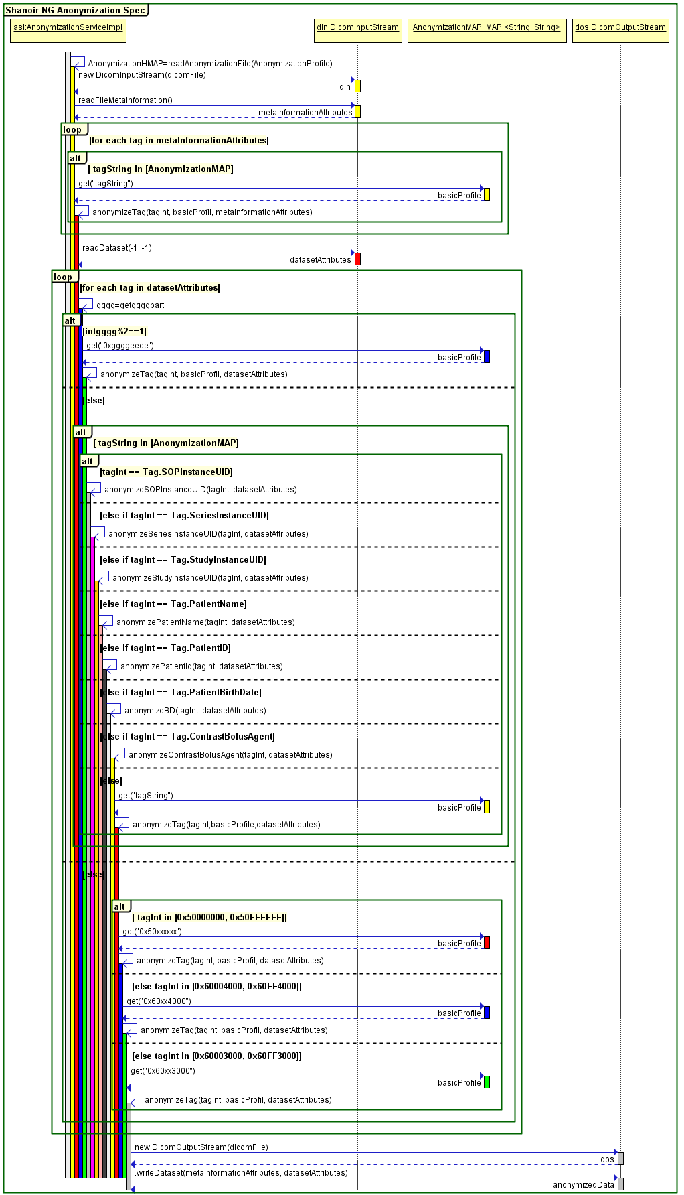

Figure 1. DICOM image anonymization process

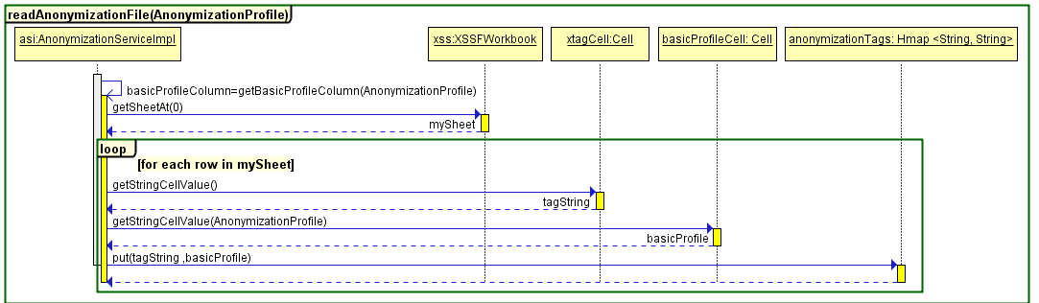

Figure 2. Excel anonymization tags file reading

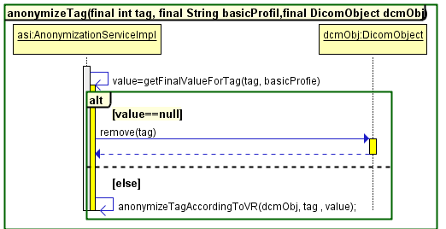

Figure 3. DICOM tag anonymization process

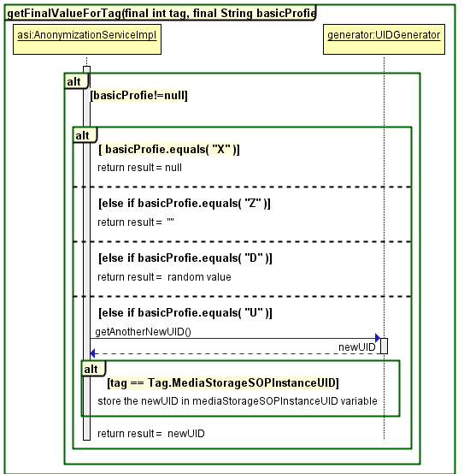

Figure 4. Anonymized tag value based on profile

#### UIDs anonymization

##### UIDs rules

To anonymize UIDs, they should be replaced by non-zero length UIDs that are internally consistent within a set of Instances.

There are several rules to be followed when making UIDs (<https://www.medicalconnections.co.uk/kb/UID_Rules>):

* Total length must be <= 64 characters, including the stops
* Must contain **only** digits 0-9 and full stops
* Each numeric "component" (between stops) must be a valid and unambiguous integer number, and so must **not** have a leading zero (unless the whole component is zero)
* Must be guaranteed to be unique - this means:
  + It must be derived from a proper official root under **your** sole control.
  + It must **not** be created by appending digits (however special you consider the combination!) to **someone else's** UID.
  + In particular, series UIDs for secondary capture images, KIN objects etc. must **not** be created as derivatives of the Study UID (unless you own that root!)
* Related to the above, there is **no** expectation or requirement that the Study UID, Series UID and Instance UID for images should be derived from the same root (though in practice, Series UID and Instance UID normally are, as both must be generated internally by the equipment which generates the images)
* Date and Time are useful for generating UIDs, but only if:
  + Each machine has a unique root (normally your company UID root + a machine specific suffix such as a serial number
  + If it is possible for UIDs to be generated at > 1 per second, then a sequential counter should also be used
  + If on a multi-threaded machine, then the thread ID or a properly interlocked counter are needed to prevent 2 applications or 2 threads in the same application from generating identical UIDs simultaneously.
  + Do not use time on its own - it is too easy to end up with a leading zero 0 - e.g. 20060724.093017 use instead 20060724093017

##### New UIDs generation

The anonymized UIDs are generated using the java source code of PixelMed Toolkit.

PixelMed toolkit is a stand-alone DICOM toolkit that implements code for reading and creating DICOM data, DICOM network and file support, a database of DICOM objects, support for display of directories, images, reports and spectra, and DICOM object validation.

The toolkit is a completely new implementation, which does not depend on any other DICOM tools, commercial or free. It does make use of other freely available pure Java tools for compression and XML and database support.

The toolkit is open source and made freely available for both non-commercial and commercial use, under [BSD License](http://www.opensource.org/licenses/bsd-license.php) terms.

##### DCM4CHEE constraints to correctly store DICOM data

###### DCM4CHEE constraints to accept to store data

SOPInstanceUID is a unique identifier (0008,0018) for the DICOM dataset. MediaStorageSOPInstanceUIDis thefirst value of the Media Storage SOP Instance UID (0002,0003).

**MediaStorageSOPInstanceUID should have the same value as in the SOPInstanceUID**. The only difference is that MediaStorageSOPInstanceUID is stored in the meta-information header of the DICOM file so that it becomes easy to read and fast to access while the SOPInstanceUID is stored in the dataset.

###### DCM4CHEE constraints to correctly visualize data

**Patient Identification**

If the issuer of patient id is null, dcm4chee attempts to identify the patient by name+id+dob[1].

The Patient Matching code has problem if the patient name in the database is incomplete and is "truncated", e.g. the patient has no middle name and the patient name in the database is 'SURNAME^GIVEN_NAME' rather than 'SURNAME^GIVEN_NAME^^^'.

**Study/Serie** **Identification**

Study Instance UID Attribute is a unique identifier for study, so all images acquired for the same study should have the same Study Instance UID.

Series Instance UID Attribute is a unique identifier for the Series that is part of the Study identified in Study Instance UID (0020,000D). So all images acquired for the same series should have the same Series Instance UID.

### Email

Send email

Define email content and when it is sent.

### New folders

TODO

1. dob: date of birth